

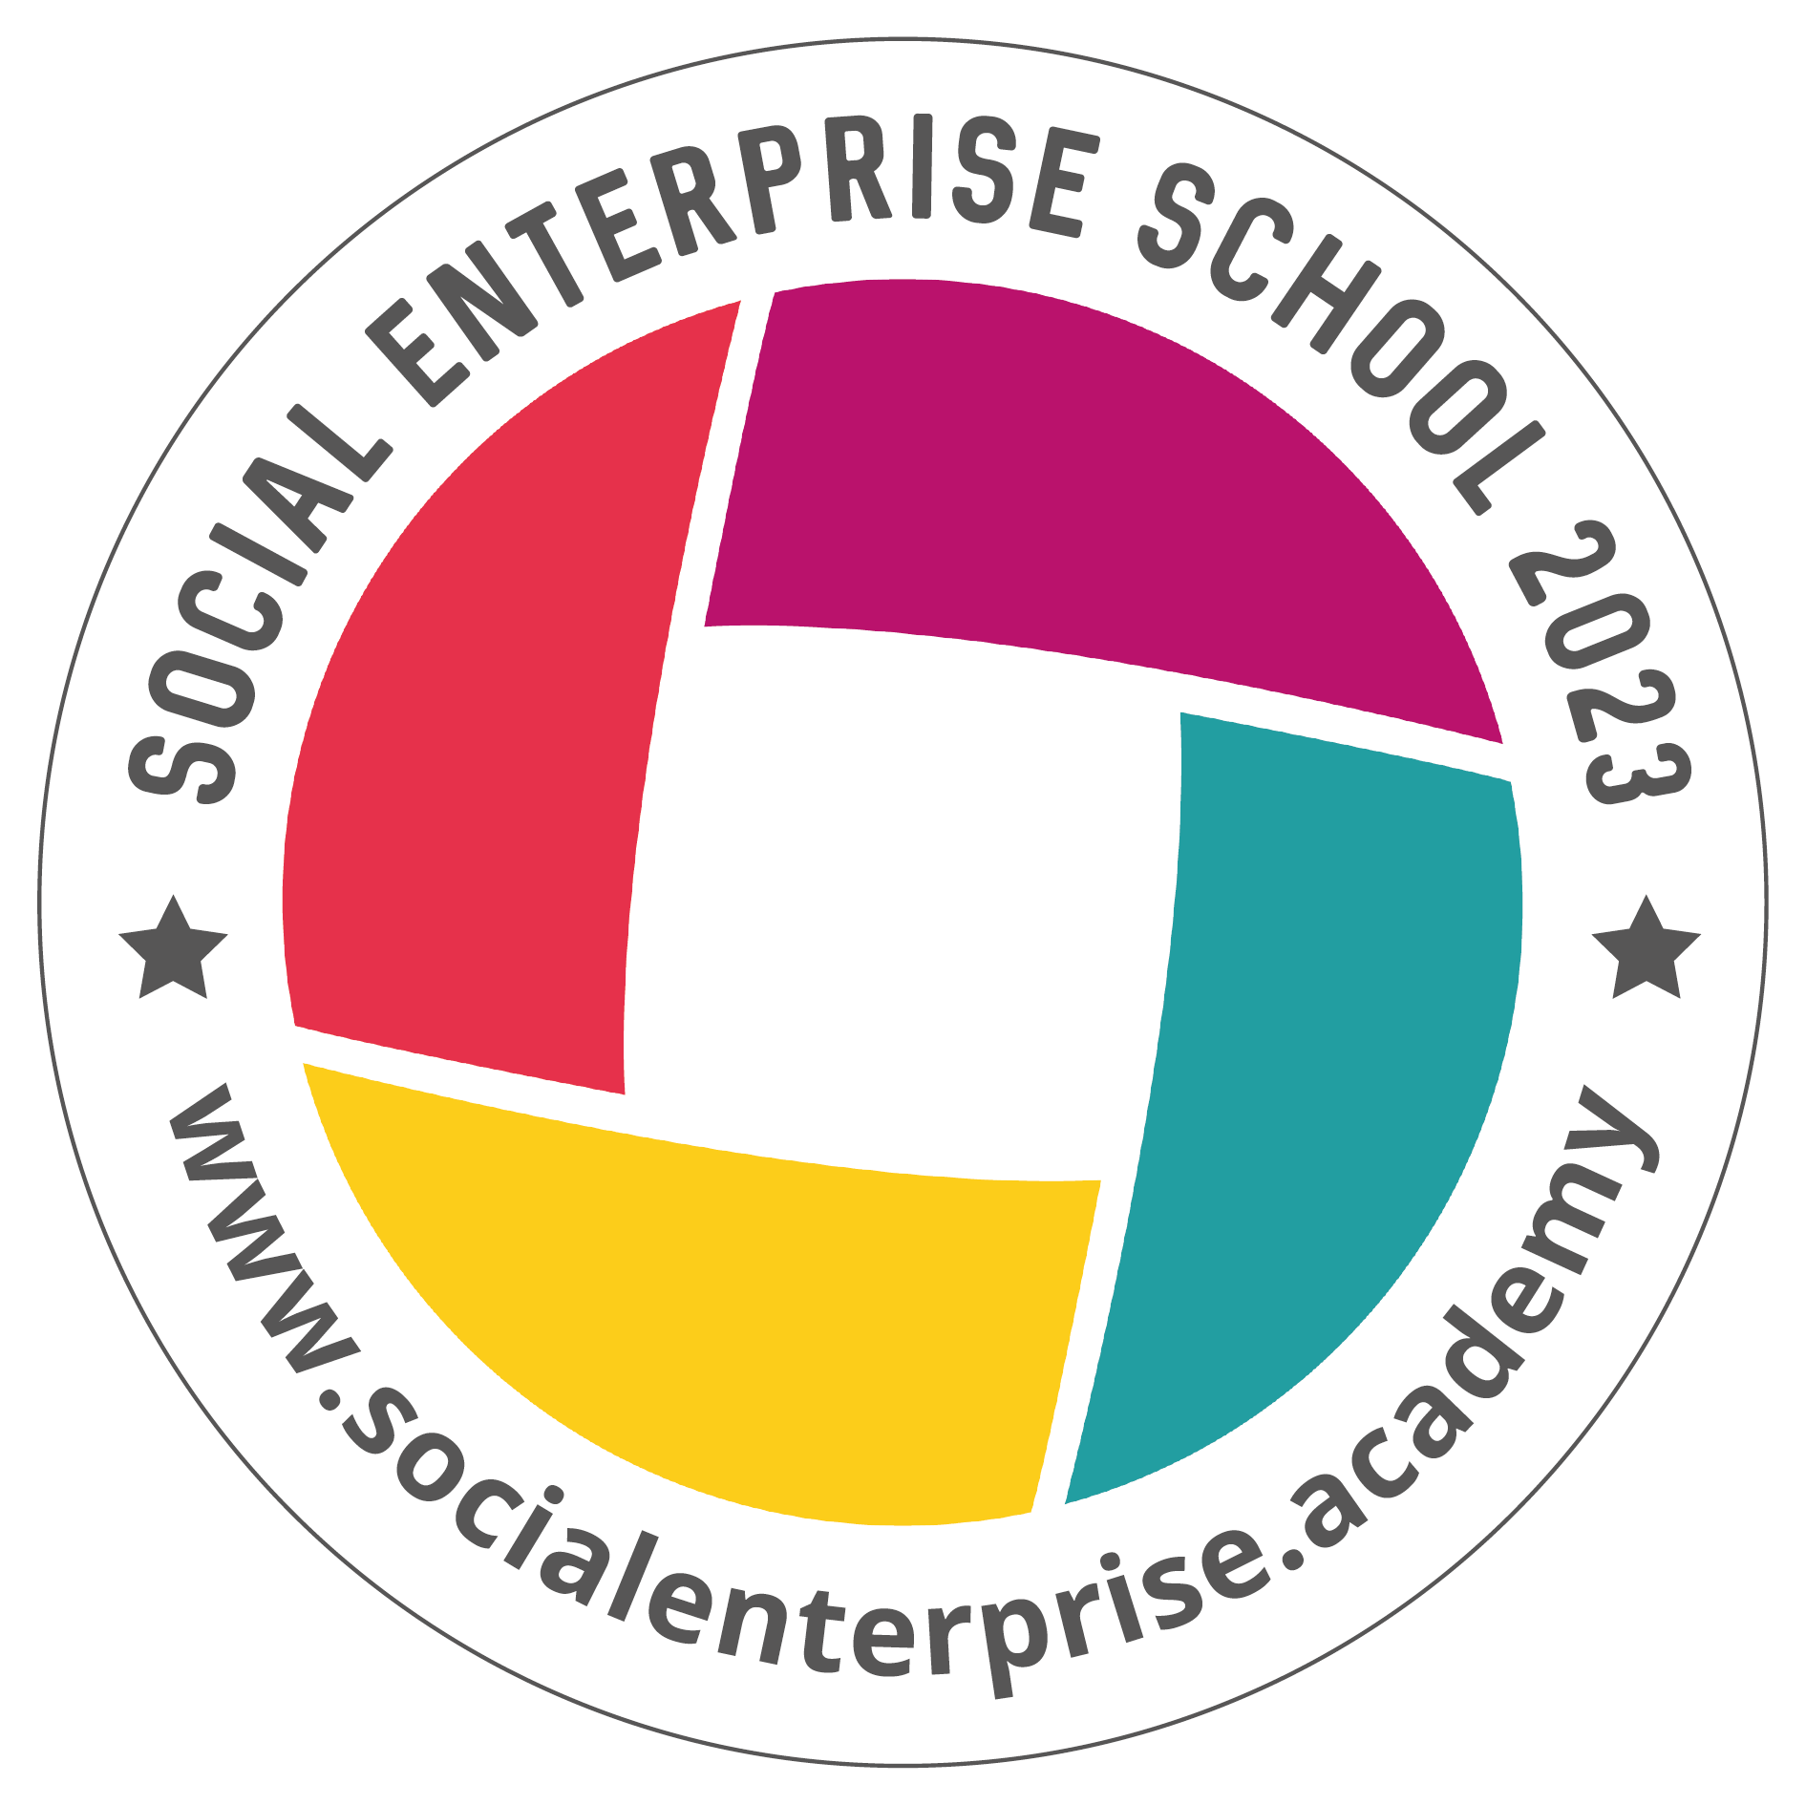 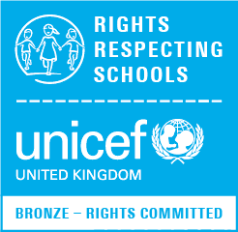

**Blairhall Primary School**

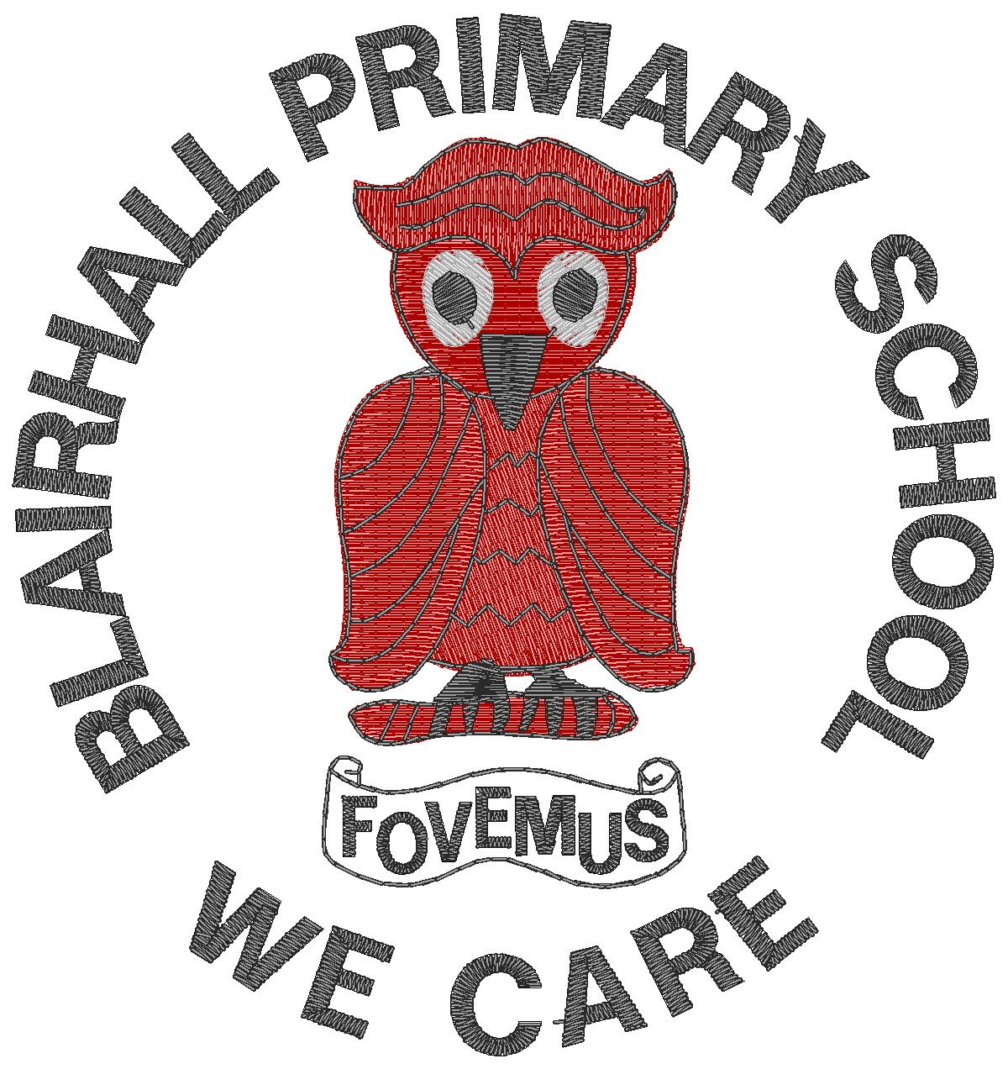

**Primary Four Family Learning Grid – Term 1**

The tasks on each home learning grid are designed to cover a variety of curricular areas and important life skills as well as making connections with the United Nations Convention on the Rights of the Child. The UNCRC promotes children’s rights including the right to education, family guidance and rest, play, culture and arts**. Completing at least one task a week**

allows children the opportunity to make links between these rights at school and at home.

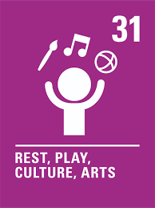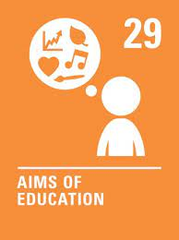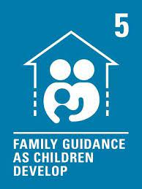

|  |  |  |  |
| --- | --- | --- | --- |
| I can take part regularly in a sports class or club. | I can cross the road safely using the green cross code.  . | Create an informative poster to share information about a club in my local area such as rainbows or cubs. | I can dance/move along to music and follow a dance/ choreography within a group. |
| I can list the items that a new born baby would need. | I can read and follow a set of instructions to create something, for example, food, model, game etc. | I can be active by going for a local walk with my family. | I can use a variety of methods to time activities and investigate what I can do in 1 minute. |
| I can explain how the local foodbank works and what it is for. | I am learning to ride my bike. | I can keep myself organised and take care of my belongings making sure they are labelled. | I can create a feeding station for local wildlife e.g. a bird feeder or bug hotel. |
| I can create my own pattern. | I can describe the special qualities that are important in friendships and say why. | I can show what a strong password is. | I can share some Scottish country dancing at home. |

**You will have a chance to share your completed tasks in class every…………**

You can also choose to upload any photos or written pieces of work to Teams.