

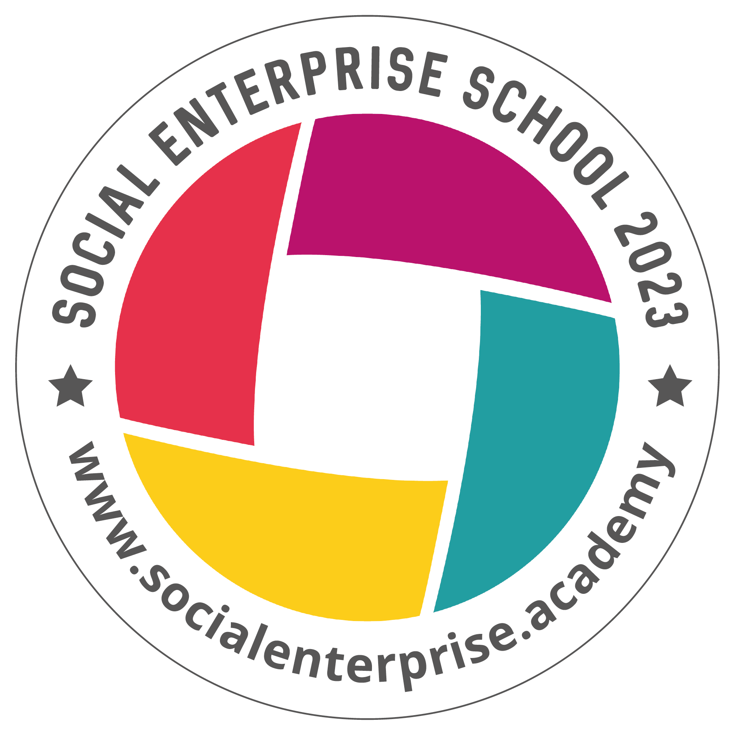 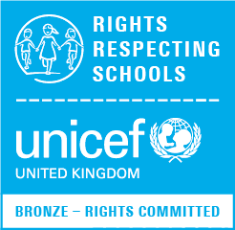 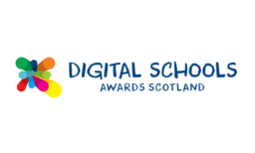

**Blairhall Primary School**

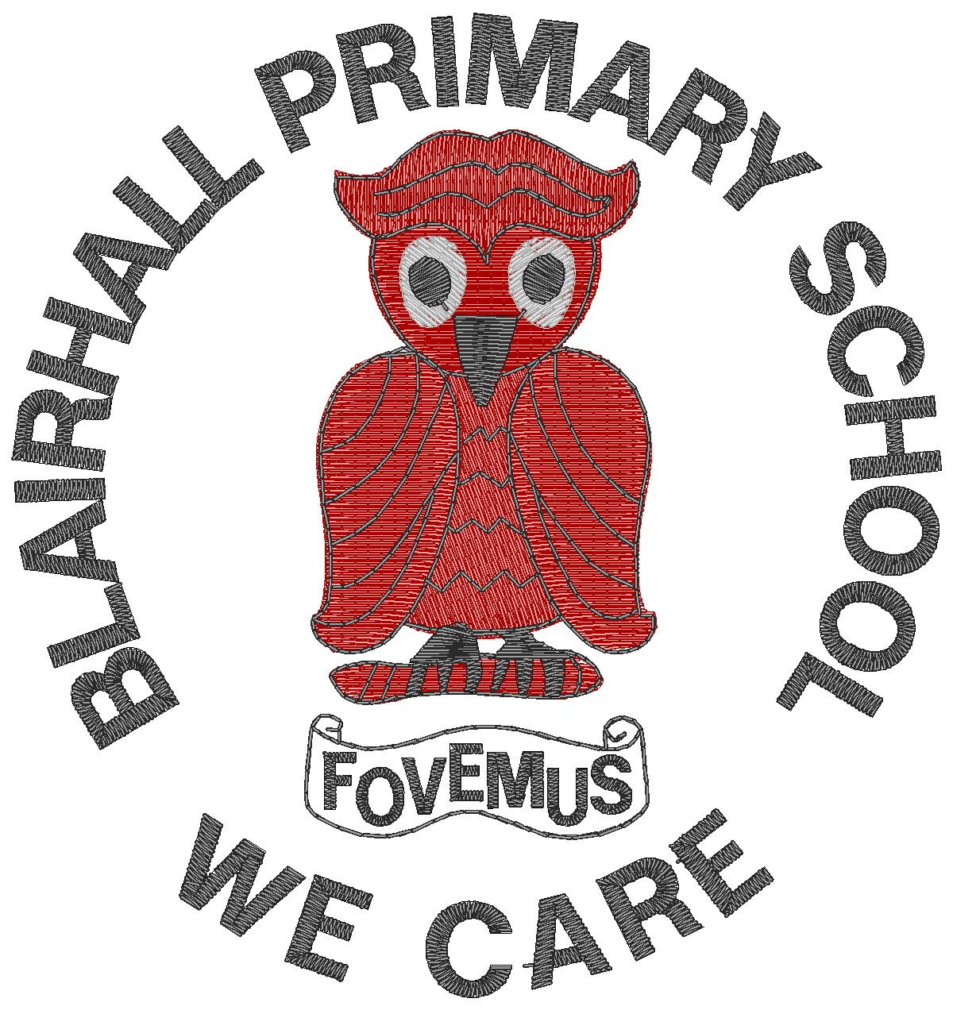

**Primary Five Family Learning Grid – Term 1**

The tasks on each home learning grid are designed to cover a variety of curricular areas and important life skills as well as making connections with the United Nations Convention on the Rights of the Child. The UNCRC promotes children’s rights including the right to education, family guidance and rest, play, culture and arts**. Completing at least one task a week**

allows children the opportunity to make links between these rights at school and at home.

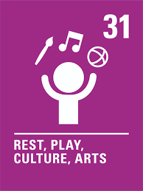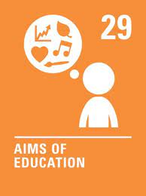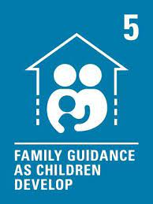

|  |  |  |  |
| --- | --- | --- | --- |
| I can demonstrate an increased level or skill through my club. | I can take responsibility for my own safety when crossing the road.  . | I can carry out an act of kindness for a family member or a person in my community. | I can dance/move to music and start to create some of my own steps/choreography. |
| I can give an example of a good and bad role model. | I can create a set of instructions for making a meal | I can take part in a gentle jog or walk in my local area. | I can tell the time to 5-minute intervals on analogue and digital clocks. |
| I can talk about Global Goal 13, Climate Action; I know where the recycling points are in my local environment. | I can appreciate the work of an artist. | I can explain my own ambitions and create a plan to achieve it. | I can add to my Digital Learning Journal. |
| I can support and spectate at a local sporting event and share the results. | I can calculate the change when making a purchase. | I can give examples of different dietary requirements for different lifestyles e.g. athlete, diabetic etc. | I can think of an invention which will make the world a better place to live. |

**You will have a chance to share your completed tasks in class every…………**

You can also choose to upload any photos or written pieces of work to Teams.