BLAIRHALL PRIMARY SCHOOL
PARENT COUNCIL MEETING
SESSION 2022
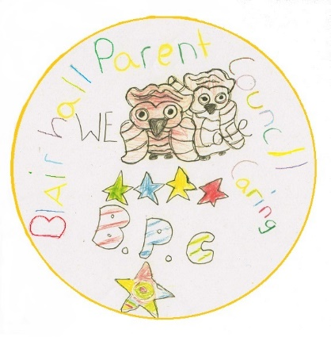
ACTION POINTS
Minutes from Parent Council Meeting held on Thursday 1st December 2022 @ 6pm.

Blairhall Primary twitter page @Blairhallps

PRESENT: William Laing (Chairperson), Anitta Jeffs-Watts (Secretary), Nicola Bow, Gemma Graham

APOLOGISES: Louise Scott (Treasurer)

Willie welcomed everyone for attending and the following was discussed:

TOPIC | ACTION | DEADLINE | INITIALS
School  Update | - Mrs Bow advised us that Shirley-Anne Somerville who is the Scottish Government Cabinet Secretary for Education and Skills visited the school and the children lead the visit which lasted 2 hours.  - The preparation for the Nativity is underway  - All Christmas Partied dates have been confirmed and all parents/carers have been notified.  - Christmas lunch shall be served in the school on Wednesday 14th December – Children can wear their Christmas jumpers.  - Sally McElroy in the office and Mrs Taylor from the nursery shall be leaving – Letter to be sent to all parents/carers.  - Both posts have ben advertised and Interviews for these positions have commenced.  - The Office shall be manned up until Christmas by staff who have covered this role in the past, so they know the school. |  | FOR INFO ONLY
Treasurer Report | - TSB account, £44.60  - B.O.S account £1067.73  - Cash in Hand £57 |  | FOR INFO ONLY
Other Business | - There shall be a tombola stall at the nativity on Tuesday 20th December @ 09:30am to help raise funds for the school.  - The children shall be sending out a letter to advise that they are hosting a Christmas book exchange on Monday 12th December and are asked to bring books in Friday 9th December, Nursery children shall be exchanging books in the afternoon.  - A Jeffs-Watts has received responses from all who donated supplies to the Children Halloween Parties.  - Mrs Bow asked for donations of cuttings and/or pots for growing plants within the school building.  - Mrs Bow asked the parent council for support for buying books for the school to help with the reading and interpretation skills of the kids. Everyone agreed and a donation of £100 pounds will be made by the Parent council in support of this initiative.  - School calendars this year shall be distributed in the coming weeks as well as the school photographs.  - Some parents highlighted concerns over the use of ipayment – they would prefer to make payments by cash or ipayment  - Thank you to the parents who attended the meeting it was nice to see new faces, if you are interested in becoming a committee member or just wish to volunteer at any event, please get in touch or even better pop along to our next meeting.  - There is no planned strike action for the remainder of the year. |  | FOR INFO ONLY  L.Scott
Next Meeting | Easy Fund Raising  Please can we encourage parents/guardians to use www.easyfundraising.org.uk especially this time of year if they are shopping online.  Next meeting shall be held in February date to be confirmed |  | INFO ONLY  INFO ONLY

