BLAIRHALL PRIMARY SCHOOL
PARENT COUNCIL MEETING
SESSION 2022
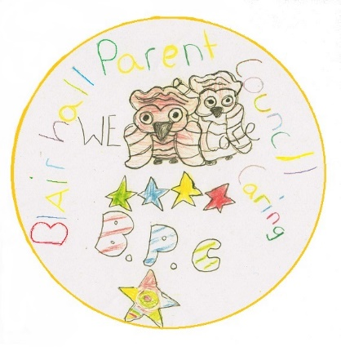
ACTION POINTS
Minutes from Parent Council Meeting held on Thursday 1st September 2022 @ 6pm.

Blairhall Primary twitter page @Blairhallps

PRESENT: William Laing (Chairperson), Louise Scott (Treasurer), Anitta Jeffs-Watts (Secretary). Nicola Bow, Ann Chalmers and Lorna Lamond

APOLOGISES: N/A

Willie welcomed everyone for attending and the following was discussed:

TOPIC | ACTION | DEADLINE | INITIALS
School  Update | - Mrs Bow advised all children have settled in well.  - Three teachers have joined Blairhall who were previously from Tulliallan therefore have a similar teaching approach.  - Children looking for Leadership opportunities > Playground boxes to encourage play  - P6/7 – Planters have been weeded and all gutted out, Planters have been used for pupils to grow food for them to use for Blairhall Bakes  - Suzanne our office member of staff has left due to returning to work in the nursery therefore there has been a few people covering and Michelle Riley shall cover until permanent member of staff Sally McElroy starts on Tuesday 20th September. |  | FOR INFO ONLY
Treasurer Report | TSB account, £41.70  B.O.S account £1067.73  TSB account balance is low with the review to hopefully close the account. |  | FOR INFO ONLY
Other Business | - Halloween Party shall take place on Thursday 27th October:  Timings are as follows: Nursery – P3 4:30pm - 5:30pm  P4 – P7 6:00pm – 7:00pm  We have asked the school to organise a competition for all children to design a flyer for the Halloween party  We will be requiring some carers/parents to help at the party/parties – if you are interested please get in touch with either one of the parent council members.  - As per our notification on Facebook we are trying to gather numbers of children who would use the breakfast club, once we have collated all the numbers, we then can make an official application to the school to see if we can get this service reinstated.  Please note: If you are not on face book and are interested contact the school, spread the word if you can the more kids the better the chances of success  - Thank you to the two mums who attended the meeting it was nice to see new faces, if you are interested in becoming a committee member or just wish to volunteer at any event, please get in touch or even better pop along to our next meeting. |  | FOR INFO ONLY  ACTION  ACTION
Next Meeting | Easy Fund Raising  Please can we encourage parents/guardians to use www.easyfundraising.org.uk especially this time of year if they are shopping online.  Next meeting shall be Thursday 6th October at 6pm |  | INFO ONLY  INFO ONLY

