BLAIRHALL PRIMARY SCHOOL
PARENT COUNCIL MEETING (AGM)
SESSION 2020
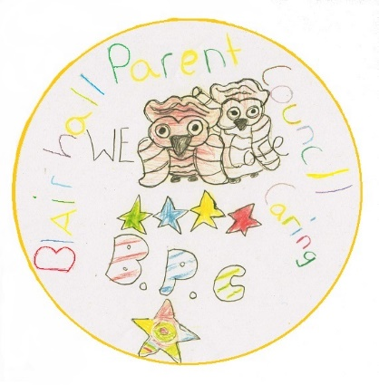
ACTION POINTS
Minutes from Virtual Parent Council Meeting held on Thursday 23rd September 2021 @ 6pm.

Blairhall Primary twitter page @Blairhallps

PRESENT: William Laing (Chairperson) , Nicola Bow, Anitta Jeffs-Watts (Secretary)

APOLOGISES: Louise Scott (Treasurer)

Willie welcomed everyone for attending and the following was discussed:

TOPIC | ACTION | DEADLINE | INITIALS
School  Update | - N. Bow gave a brief summary of how things were at the school, things are operating much as they were at the end of last term, the school is waiting for guidance from the Scottish government and the local authority before any changes are implemented. |  | FOR INFO ONLY
Treasurer Report | TSB account, £461.70  B.O.S account £267.73  W.Laing stated that the balance of the accounts remain unchanged since the AGM as there has been no expenditure in the interim period. |  | FOR INFO ONLY
Other Business | - W. Laing informed the meeting that the Parent Council has formally registered itself with the third party insurer used by the local authority to cover events within the school.  - W .Laing brokered at joint fundraising event with Blairhall Bakes sometime later in the year, after some discussion it was decided that this topic would be discussed again in November when restrictions may be more amenable to this.  - Nicola Bow informed the meeting that the Coalfields Trust had been in to talk about the new planters for the grow your own initiative.  - Nicola Bow informed the meeting about the ongoing problem with vandalism at the school. The council are considering what preventative measures are appropriate, and the school are actively seeking advice from the local community policing officer. The advice to parents or individuals who witness such acts of vandalism is not to confront the culprits directly but to report it to the police.  - After some discussion it was agreed that going forward W.Laing would provide a document giving details of the Parent Council that would be available through the new school website, it was also agreed that going forward minutes of any Parent Council meetings would also be available in this section of the website. | A.S.A.P | FOR INFO ONLY  FOR INFO ONLY  L.S  FOR INFO  ONLY  W.Laing
Next Meeting | Easy Fund Raising  Please can we encourage parents/guardians to use www.easyfundraising.org.uk especially this time of year if they are shopping online.  This has raised only £18 over the last 2 years, we would urge parents to support the school with their online purchases.  Next meeting shall be Thursday the 4th of November. |  | INFO ONLY  INFO ONLY

