BLAIRHALL PRIMARY SCHOOL
PARENT COUNCIL MEETING
SESSION 2021
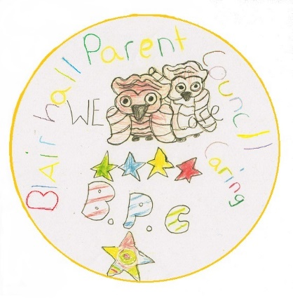
ACTION POINTS
Minutes from Virtual Parent Council Meeting held on Thursday 4th November 2021 @ 6pm.

Blairhall Primary twitter page @Blairhallps

PRESENT: William Laing (Chairperson) , Louise Scott (Treasurer), Anitta Jeffs-Watts (Secretary)

APOLOGISES: Nicola Bow

Willie welcomed everyone for attending and the following was discussed:

TOPIC | ACTION | DEADLINE | INITIALS
School  Update | - No Direct update from school |  | FOR INFO ONLY
Treasurer Report | TSB account, £211.70  B.O.S account £267.73 |  | FOR INFO ONLY
Other Business | - Reminder to all Parent/Carers to use Easy Fund Raising when order good online  - An Email has been sent to all Parent/Carers to advise that the Breakfast Club shall cease on Friday 19/11/2021 due to the lack of use.  - W. Laing had brokered a joint fundraising event with Blairhall Bakes sometime later in the year, at the last meeting after some discussion it was decided that this topic would be suggested again to the school, since no school representative was present at meeting W.Laing shall contact the school to establish if the school are in a position to take this forward.  - An Email has been sent to all Parent/Carers about the ongoing problem with vandalism at the school. The council are considering what preventative measures are appropriate, and the school are actively seeking advice from the local community policing officer. As no school representative was present at meeting W. Laing shall contact the school to establish if the school are in a position share minutes from that meeting. A Jeff-Watts suggested posting something on the Blairhall Gala site as well to keep the wider community appraised of the situation, W.laing agreed to do this.  Reminder to all follow the protocols and contact Fife Council/Police Scotland should you witness such acts of vandalism to the school and do not confront the culprits directly.  - W.Laing shall contact to school to establish :-  1/ If the Dalguise trip for the P7’s is going ahead this year or not.  2/ Are the nursery are doing anything at Christmas for the children and if Parent Council could help out with. | A.S.A.P  A.S.A.P  A.S.A.P | FOR INFO ONLY  W.Laing  W.Laing  W. Laing
Next Meeting | Easy Fund Raising  Please can we encourage parents/guardians to use www.easyfundraising.org.uk especially this time of year if they are shopping online.  This has raised only £18 over the last 2 years, we would urge parents to support the school with their online purchases.  Next meeting shall be Thursday the 3rd of February 2022 |  | INFO ONLY  INFO ONLY

