Blairhall Primary School

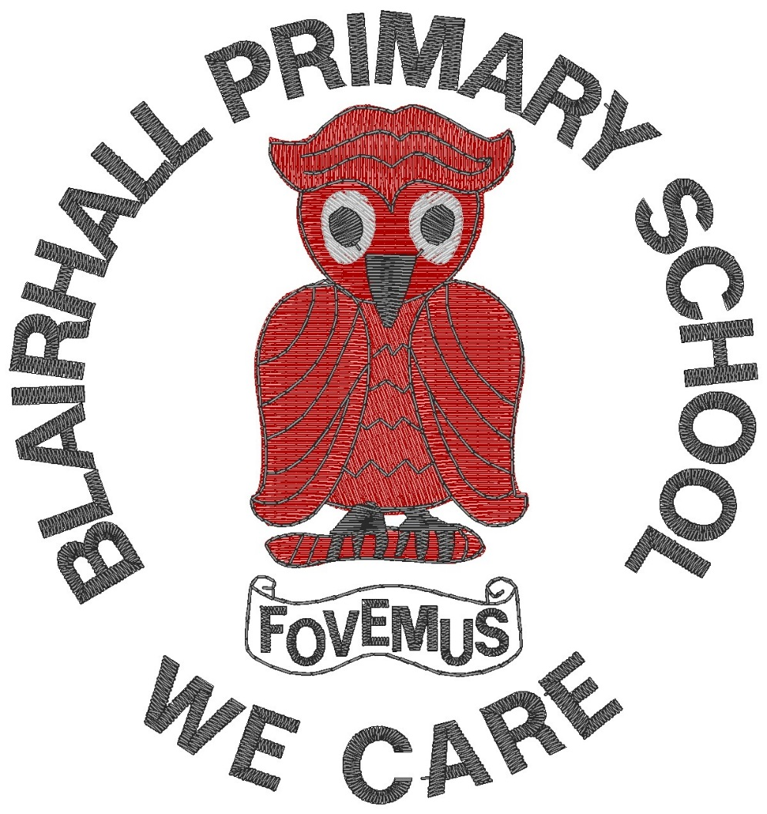

Anti-Bullying Policy

Reviewed | March 2016

Policy Statement

Blairhall Primary aims to:
- Reduce, prevent and respond effectively to bullying;
- Improve social behaviour through an effective strategy which actively involves children, parents/carers and staff in positive approaches (See Relationships, Care and Welfare Policy and Procedures)
- Ensure, through training and participation, the underlying values of Blairhall Primary School are understood and implemented by all those involved.
- Ensure that there are effective methods for monitoring, evaluating and reporting on the effectiveness of this policy including any effects on minority or protected characteristic groups.

Definition of Bullying

For the purposes of this policy we have adopted Fife Council’s definition of bullying which is as follows.

Bullying is defined as behaviour, which may or may not be deliberate, by one person or a group, which upsets, hurts, harms or injures another, impacting directly on their quality of life. Bullying may take many forms, including verbal, physical and social behaviour, and increasingly it may involve the use of technology, such as mobile phones or computers. It is likely to be associated with a power difference between those who bully and those who are bullied, to lead to hurt, fear and anxiety, and is often the result of a difference, perceived or real.

We will develop the capacity to respond to any form of prejudice based bullying, recognising the importance of the protected characteristics identified in the Equality Act 2010:
- age;
- disability;
- gender reassignment;
- marriage and civil partnership;
- pregnancy and maternity;
- race;
- religion or belief;
- sex;
- sexual orientation
Expectations

Staff, pupils and parents share the responsibility of fostering respectful relationships. See p4/5 of Relationships, Care and Welfare Policy for further information.

Prevention of Bullying

Our approach to anti-bullying is set within our Relationships, Care and Welfare Policy.

Staff must ensure that anti-bullying education underpins all classroom practice. The approach taken in our school is one of prevention and disclosure. We encourage children to talk and share concerns relevant to bullying behaviour and adults closely monitor the playground areas. Role-playing situations in drama, IDL topics, HWB and RME will focus on bullying behaviours at various times.

In order to be pro-active in addressing bullying behaviours, our school will:
- ensure staff attend annual anti-bullying training
- have a named member of staff as an Anti-bullying Single Point of Contact
- maintain a noticeboard with advice and information for pupils, and parents/carers
- ensure that all stakeholders have an awareness of, and access to, the school’s Anti-bullying Policy.

Action

- All alleged incidents or accusations of bullying behaviours, which are brought to the attention of school staff, will be fully investigated using a restorative approach.
- Parents will be informed
  - if the bullying behaviour persists
  - if the bullying behaviour is deemed to be of a serious nature
- Bullying incidents will be recorded and monitored, where appropriate, using the council-side recording system SEEMiS in line with guidance issued by the Directorate.

For further information and resources go to www.respectme.org.uk

