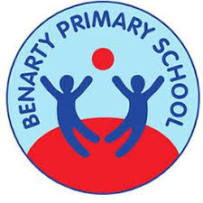 Benarty Primary School 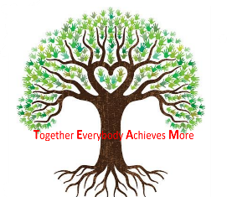

Curriculum Rationale

Q.I. 2.2 Curriculum

March 2020

**Contents**

Vision Statement, Aims and Values

What Makes Benarty Unique

National Guidance

Four Capacities in Action

A Benarty Learner

Contexts for Learning

Organisation and Consistency of Classrooms

The Seven Principals

Appendix 1 – The 4 contexts of learning

Appendix 2 – Curriculum Making

**School Vision Statement, Values and Aims**

**Vision statement**

Our children, Our school, Our community, Our future.

**School aims**

* We value and create a safe and purposeful atmosphere where everyone is respected, responsible and included.
* We value fairness, tolerance, integrity, happiness and loyalty.
* We promote and value healthy and supportive relationships within our school community (all staff, all pupils and parents).

**School values**

**Ambition, Success, Perseverance, Inclusion, Respect, Empower**

We aim to provide an engaging curriculum for all.

* We aim to develop and sustain a trusting partnership with parents, valuing everyone’s role in developing each child’s full potential.
* As a staff team, we aim to work collaboratively, share and develop practice and we are focussed on improvement.
* We aim to work effectively with partners to ensure achievement for **all.**

**What makes Benarty unique?**

Our Children (knowledge, skills and attributes), Our school (factual information), Our community (environment), Our future (ethos)

**OUR CHILDREN**

* Playful pedagogy has been recognised at local authority level.
* Learning and Teaching Policy creates a framework for consistency.
* Universal progressive learning pathways are planned for, and implemented across the curriculum.
* The HIVE provision offers targeted emotional support.
* We work in partnership with the local secondary provision to develop a pupil improvement group which will develop the language of learning and improvement.

**OUR SCHOOL**

* Additional Support Classes that offers a provision for local Primary Schools in our surrounding locality.
* As part of Benarty Primary School we have two nursery provisions. Dunmore nursery is a standalone Nursery based in the centre of the community.
* Strong set of embedded school values.
* We share and celebrate our children’s achievements and successes. We have designed a tracking system to address inequity in wider achievement.
* The breakfast Café is well attended and offers a positive start to the school day.
* Children who require enhanced transition into the school day use our HIVE provision.
* There is a staff wellbeing monthly get together to develop a staff health and wellbeing support network.
* The Senior Leadership Team are based centrally and easily accessible.

**OUR COMMUNITY**

* Establishing community links with stakeholders and partners
* Expansive outdoor learning environment
* Generations of our families have attended Benarty Primary school
* Family area created to offer privacy and information sharing.

**OUR FUTURE**

* First Chances St Andrews University programme for targeted senior pupils gives a gateway into higher education.
* Developing the Young Workforce is prominent within our Curriculum.
* The school works in partnership with local organisations to improve the outcomes for our children.
* STEAM has provided successful and lifelong learning experiences for our children

**National Guidance**

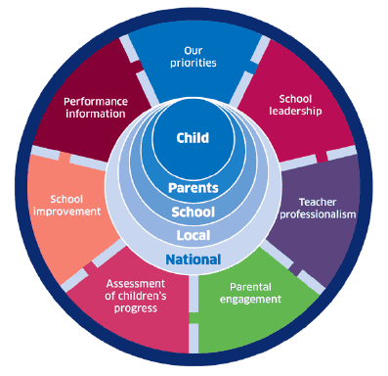

National Improvement Framework for Scotland

The National Improvement Framework and HGIOS 4, help inform and guide our learning and teaching at Benarty Primary. Our school improvement targets are focused around the NIF drivers and we continuously evaluate ourselves against the quality indicators of HGIOS 4.

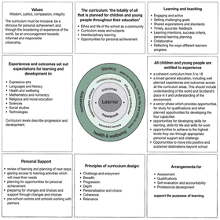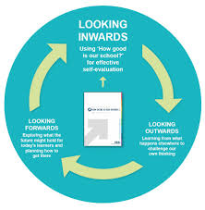

How Good is Our School?

**4 Capacities in Action**

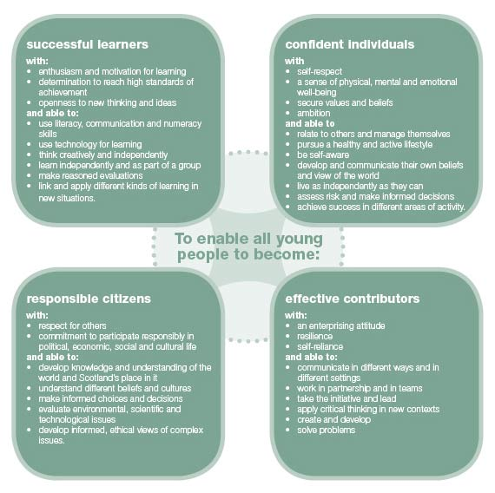

Empowered learning community

Enterprise

Our Minds Matter

Outdoor Education

Growth Mindset

Nurture/Relationships

Wider Achievement

Creativity

Expressive arts

Wellbeing indicators

Community building

High Expectations for all

Learning and Teaching

Attendance

Raising attainment for all

Professional learning and empowerment – leadership at all levels

Skills for learning, life and work

Equity and equality

**A Benarty Learner**

From whole staff consultation, we have identified the following characteristics. We are all responsible in supporting every child to be able to demonstrate the following:

Every Benarty Learners

* Knows what they are learning and why
* Can talk about their learning
* Is supported to progress and identify next steps
* Contributes in a team
* Enjoys what they are learning
* Learns in their classroom, home, and the wider community
* Has their success celebrated

**Equality and Diversity**

[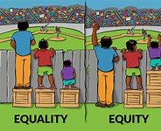](https://www.bing.com/images/search?q=equity+and+equality+image&id=C4E77E69A3CCE49ACFAAB1193C7120EB6F5593C9&FORM=IQFRBA)

At Benarty Primary School everyone is treated fairly. Barriers are removed to support learners in achieving their educational potential; our learners are well supported to secure a positive well-being, skills for learning, life and work.

We always consider the cost of the school day for our children, families and wider community.

**The Four Contexts for Learning**

**Curricular Areas and Subjects**

*Scottish Maths Week

* Writing moderation at school and cluster level

* Forward Plan dialogue

* Maths challenge moderation

* Daily writing from p3-7

* Health week to promote a healthy lifestyle—several visitors and specialist leading learning

* Modern Languages

* Floor books and Learning Walls

* Visible Learning ethos embedding into our everyday learning and teaching

* Independent Learning and Learning through Play

* Outdoor Learning

* Our Minds Matter

* Emotion Works

* Conceptual Numeracy

* Workshop for Literacy

* Fife pathway and progression documents used across the whole school

* Termly planning and tracking meetings/dialogue

**Ethos and Life of the School and Community**

*Use of Twitter, school website and Facebook to share events and information

* House point system with House Captains * Class charter

* P5s are playground buddies

* Prefect roles for P7

* P7 Head boy and Head Girl responsibilities

* Weekly Benarty Gatherings share what is happening across the school and celebrate success of school values

* Shared start last Friday of the month

* Staff model good friendships

* Making use of our local community for visits linked to learning

* Parent workshops

* Welcoming office staff

* Pupils share success with ALL staff, not just teaching staff

* Social Enterprise Group

*Pupil Council

* Parent Council & Parent Helpers

* Weekly ASPIRE groups

* Parent/Carer Communications (Drop-Ins, open door policy, newsletters, e-mail)

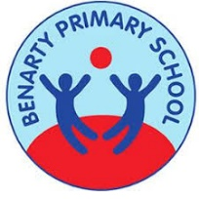

**IDL**

* Independent Learning opportunities in each class/area

* Links are made to the community and to real world examples

* Outdoor learning

* IDL planners encourage bundling of experiences and outcomes together

* School trips are linked to class learning

**Opportunities for Personal Achievement**

* Lets Talk About my Learning book

* Growth Mindset

* Benarty Gathering

* Seesaw

* Wider Achievement Wall

* Bikeability

* Outdoor Education sessions

* Active Schools Sessions

* Prefects, buddies and house captains

* P7 residential

* Sports Day

* Glee Club

* Karate club

* Netball and football club

* OMM group

* Pupil Improvement Group

* Social Enterprise Group

* Seasons for Growth

**Organisation and Consistency of Classrooms**

In every classroom in Benarty Primary School the following will be evident:

* Welcome sign with class teachers name, photograph, and stage of class
* Our Value Tree
* Our Wellbeing Indicators poster
* A Literacy learning wall
* A Numeracy learning wall
* A Health and Wellbeing learning wall
* An IDL learning wall

Displays I classrooms and other learning spaces can be a great way of celebrating learner’s work, and also play an important part in supporting the learning **“Used to their best effect, displays can be part and parcel of the differentiation that goes on in your classroom”** (Cowley, 2018)

* When class is elsewhere in the building or outdoors, sign is posted on door to communicate where class are. At PE, in assembly hall, outdoor learning in woods, at library and so on.
* Register within confidential folder to accompany teacher when out of class.
* Fire safety procedures
* Guidance within *Written Presentation Policy* adhered to regarding jotter storage and easy access for children
* Numeracy resource trolley shared between two classes
* Playground and Lunch hall expectations displayed

**The Seven Principles of Curriculum Design**

Staff at Benarty Primary School consider all seven principles when planning for learning. They help inform our curriculum, learning, teaching and assessment practices. (2.2 2.3, and 2.4 HGIOS)

|  |  |
| --- | --- |
| **Principle** | **How we address this at Benarty** |
| ***Challenge and Enjoyment***  Children and young people should find their learning challenging, engaging and motivating. The curriculum should encourage high aspirations and ambitions for all. At every stage, children should experience an appropriate level of challenge. They should be active in their learning and have opportunities to develop and demonstrate their creativity. There should be support, to enable children to sustain their efforts. | * All members of our learning community have high expectations of everyone. * Learning opportunities are differentiated to suit the needs of all learners. * Staff engage with current educational research that develops our skills in providing progression and challenge. * Learners are encouraged to challenge themselves and embrace mistakes made. |
| ***Breadth***  All children should have the opportunities for a broad range of experiences. Their learning should be planned and organised so that they will learn and develop through a variety of contexts within both the classroom and other aspects of school life. | * Staff design learning opportunities that are based on all of the Experiences and Outcomes. * Transition information includes detailed discussion of what has been covered. * We ensure that skills in literacy, numeracy and health and wellbeing are evident across all other areas of the curriculum. |
| ***Progression***  Children should experience continuous progression in their learning from 3 to 18 years. Each stage should build upon earlier knowledge and achievements. Children and young people should be able to progress at a rate which meets their individual needs and aptitudes. | * School planning documents provide opportunity to plan for progression and these are shared during transition meetings. * Enhanced transitions are planned for nursery to p1 and P7 to S1, where prior learning is shared with appropriate stakeholders. * Planning for progression in children and young people’s learning is in place for the four contexts and shows how knowledge, understanding and skills are built over time. * Learners requiring additional support have high-quality individualised and meaningful progression pathways. * The school reviews the progress of all learners, including those with additional support needs through termly planning meetings. |
| ***Personalisation and Choice***  The learning planned for children should respond to their individual needs and support particular aptitudes and talents. It should provide opportunities for exercising responsible personal choice. Once children have achieved suitable levels of attainment across a wide range of areas of learning, the choice should become as open as possible | * Learners’ experiences are appropriately challenging and enjoyable and well matched to their needs and interests. * Learners are involved in the planning process of how they are assessed by working collaboratively to create rich tasks and given choices on how to complete. * Learners can identify their own next steps in learning. |
| ***Coherence***  Children’s learning activities should combine to form a coherent experience. There should be clear links between different aspects of learning. Such links should be discussed with children in order to bring different strands of learning together. | * We work to make clear links between the skills used in lessons to those used in an interdisciplinary experience. * Staff encourage learners to understand and reflect on the development of these skills. * Learners learn to become aware of ‘progression’ and develop the ability to talk about their learning. * Staff use planning overviews effectively to ensure consistency and coherence across a term or whole session. |
| ***Relevance***  Children and young people should understand the purpose of their learning. They should see the value of what they are learning and its relevance to their lives, present and future. | * Our learners know why, what and how their learning relates to everyday life. * Staff consider the interests and activities of learners outside of school when planning contexts for learning. * Learners develop skills for learning, skills for life and skills for work. |
| ***Depth***  There should be opportunities for children to develop their full capacity for different types of thinking and learning, exploring and achieving more advanced levels of understanding. | * Staff create a depth of learning by starting with skills development and the acquiring of knowledge, to applying those skills and knowledge to different and more challenging contexts. * Learners are encouraged to show their learning in different ways. * Staff work to ensure assessments include the application of skills. |

**Appendix 1**

**The Curriculum – the 4 contexts of learning**

**Interdisciplinary learning**

The curriculum should include space/opportunities that enable children and young people to make connections between different areas of learning. Interdisciplinary learning should be stimulating, relevant and challenging. Revisiting a concept or skill from different perspectives deepens understanding and can make the curriculum more coherent and meaningful for learners. It can take advantage of opportunities to work with partners who are able to offer and support enriched learning experiences and opportunities for young people’s wider involvement in society.

Effective interdisciplinary learning:

• can take the form of individual one-off projects or longer courses of study

• is planned around clear purposes

• is based upon experiences and outcomes drawn from different curriculum

• areas or subjects within them

• ensures progression in skills and in knowledge and understanding

• can provide opportunities for mixed stage learning which is interest based.

**Curriculum areas and subjects**

The curriculum areas are the organisers for setting out the experiences and outcomes and contribute to developing the four capacities. There are eight curriculum areas. Curriculum areas are not structures for timetabling: establishments and partnerships have the freedom to think creatively about how they can organise and plan for deep, sustained learning which meet the needs of their children and young people.

Subjects are drawn from the curriculum areas and provide a familiar structure for organising knowledge and skills. As young people move through the broad general education and into the senior phase they will experience increasing specialisation and greater depth, with a wide variety of subjects increasingly being the principal means of structuring learning and delivering outcomes.

**Opportunities for personal achievement**

Personal achievement provides children and young people with a sense of satisfaction and helps to build motivation, resilience and confidence. The experiences and outcomes include opportunities for a range of achievements in the learning setting and beyond. All establishments need to plan to offer opportunities for achievement and to provide the support and encouragement which will enable children and young people to step forward to undertake activities which they find challenging. This is one of the key areas where schools need to work closely with a wide range of partners to help young people access information and opportunities and make their voices heard.

**Ethos and life of school as a community**

The starting point for learning is a positive ethos and climate of respect and trust based upon shared values across the school community. All practitioners should contribute through open, positive, supportive relationships where children and young people will feel that they are listened to; promoting a climate in which children and young people feel safe and secure; modelling behaviour which promotes effective learning and wellbeing within the school community; and by being sensitive and responsive to each young person’s wellbeing.

Children and young people should be encouraged to contribute to the life and work of the school and to exercise their responsibilities as members of a community. This includes opportunities to participate responsibly in decision-making, to contribute as leaders and role models, offer support and service to others and play an active part   
in putting the values of the school community into practice.

**Appendix 2**

**Curriculum Making**

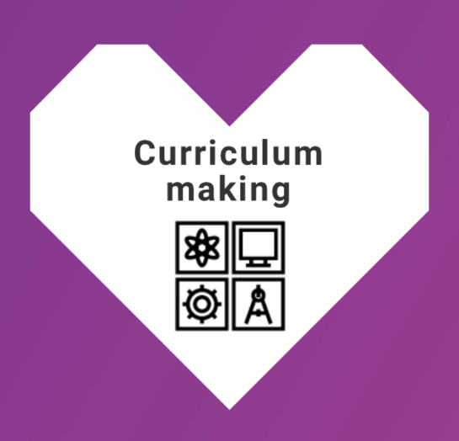

**Understanding the learners**

• Knowing children and young people and where they are on their individual

learner journeys

• Listening to learners and being informed by their motivations and aspirations

• Empowering learners to have agency in their learning with opportunities

for personalisation

• Using observations, assessments and feedback to design and develop

the learning

**Knowing the big ideas**

• Maximising opportunities that develop the four capacities for learners, making

clear links to future skills, for example [**meta-skills**](https://www.skillsdevelopmentscotland.co.uk/what-we-do/skills-planning/skills4-0/)

• Understanding and sharing the pleasure and benefits that come from learning

• Being clear on the knowledge and skills that underpin individual [**curriculum areas**](https://education.gov.scot/scottish-education-system/policy-for-scottish-education/policy-drivers/CfE-(building-from-the-statement-appendix-incl-btc1-5)/Curriculum-areas)

• Being informed by shared vision, values and aims, locally and nationally

• Understanding drivers for improvement and how they align at national

and local levels

• Being responsible for the development of literacy, numeracy and health

and wellbeing across the whole curriculum for all learners. This includes

digital literacy skills

**Being clear on practical approaches**

• Having clear strategies for delivering excellence and equity for learners

• Agreeing the pedagogies that are best for purpose and the development

needs of learners

• Reviewing and refining the curriculum against the seven design principles.

• Ensuring learners have clear progression pathways

• Making clear links between learning and the world of work

• Embedding [**Creativity**](https://education.gov.scot/improvement/learning-resources/what-are-creativity-skills/) and [**Learning for Sustainability**](https://education.gov.scot/improvement/learning-resources/a-summary-of-learning-for-sustainability-resources/) in curriculum design

• Using knowledge of the local community and robust data to inform the

curriculum offer

• Articulating and sharing curriculum rationale and narrative

**Using meaningful learning networks**

• Planning, enquiring and reflecting with other practitioners to optimise impact

• Collaborating with parents, carers, families and the community

• Developing and maximising the opportunities derived from partnerships across

clusters, local authorities and Regional Improvement Collaboratives

• Building partnerships with colleges, employers, universities, the third sector

and others to co-design the curriculum

• Using the outdoors and our built and cultural heritage to support learning

• Sharing, celebrating and reflecting on successes

**Knowing your own learning and support needs**

• Committing to career-long professional learning based around high quality,

rigorous professional standards

• Committing to meaningful professional review and development

• Belonging to communities of practice and enquiry

• Developing collaborative practice locally, nationally and globally