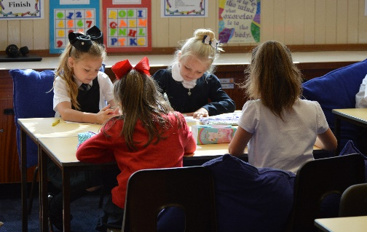 | 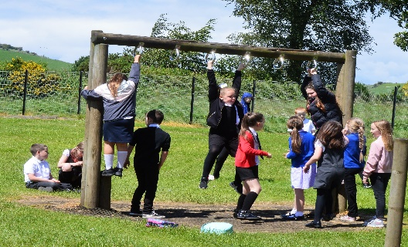 | 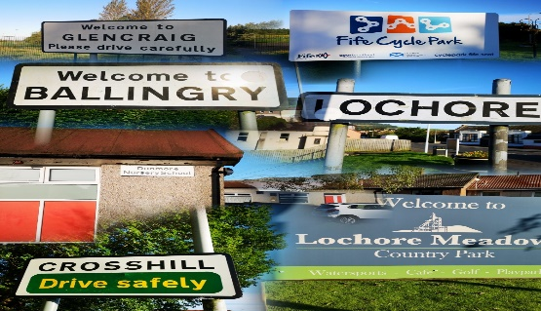 | 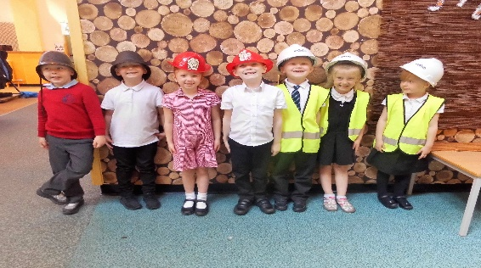
Our Children | Our School | Our Community | Our Future
Meeting learners needs to ensure each child can fulfil their potential. | Improve every child’s attendance and raise attainment and engagement by daily school/ELC attendance. | To enhance family partnerships and community links. | Focus on Professional Learning across the team to raise attainment.
QI2.2 CURRICULUM  QI 2.3 LEARNING, TEACHING AND ASSESSMENT  QI 2.4 PERSONALISED SUPPORT  QI 3.2 RAISING ATTAINMENT AND ACHIEVEMENT | QI1.1 SELF-EVALUATION FOR  SELF-IMPROVEMENT  QI 1.3 LEADERSHIP OF CHANGE  QI 2.1 SAFEGULARDING AND CHILD PROTECTION  QI 2.4 PERSONALISED SUPPORT  QI 2.5 FAMILY LEARNING  QI 3.1 ENSURING WELLBEING, EQUALITY, AND INCLUSION  QI 3.2 RAISING ATTAINMENT AND ACHIEVEMENT | QI 2.5 FAMILY LEARNING  QI 2.7 PARTNERSHIPS  QI 1.5 MANAGEMENT OF RESOURCES TO PROMOTE EQUITY  QI 3.1 ENSURING WELLBEING, EQUALITY AND INCLUSION | QI 1.1 SELF-EVALUATION FOR SELF IMPROVEMENT  QI 1.2 LEADERSHIP OF LEARNING  QI1.3 LEADERSHIP OF CHANGE  QI 1.5 MANAGEMENT OF RESOURCES TO PROMOTE EQUITY
NIF: Improvement in children and young people’s health and wellbeing | NIF: to improve the learning progress of every child, by reducing inequality in education | NIF: Improvement in children and young people’s health and wellbeing | NIF: Improvement in attainment, particularly in literacy and numeracy.

