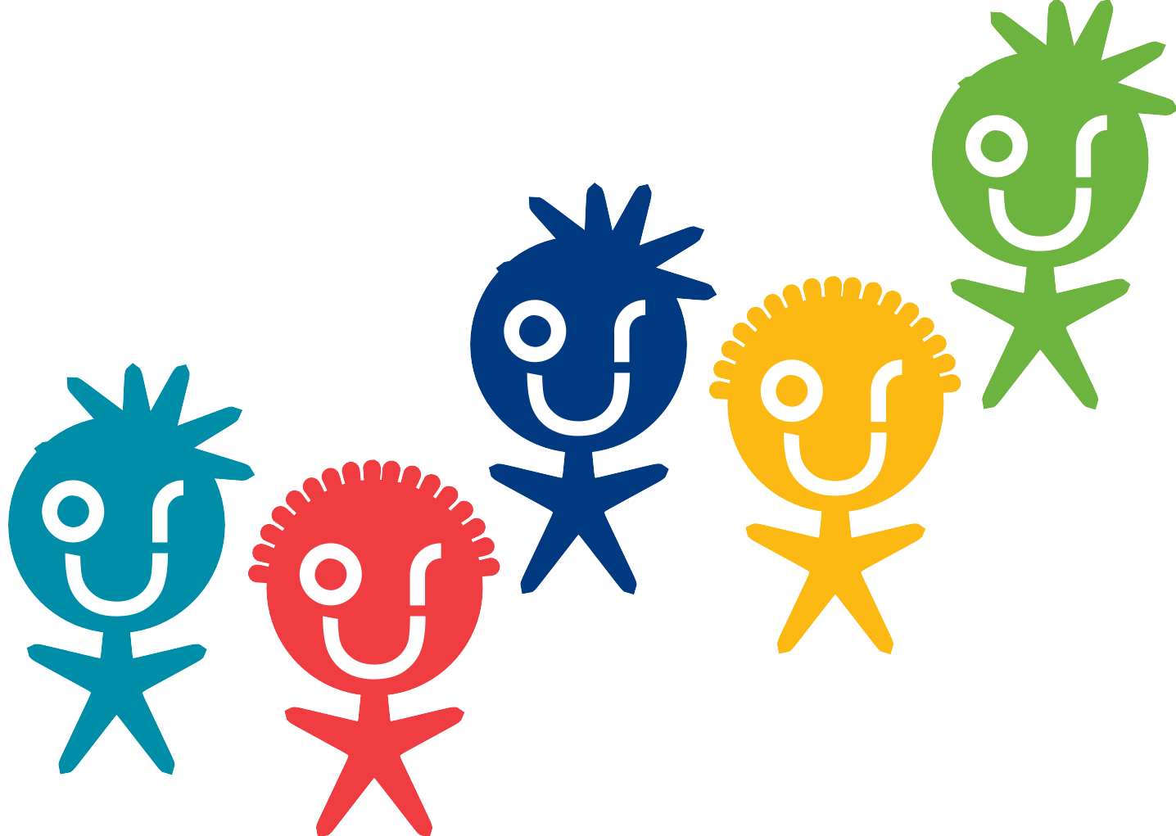

minds matter

A framework to support children and young people’s emotional wellbeing in Fife

Community Planning Strengthening Fife’s Future

OMM: a framework to support children and young people’s emotional wellbeing in Fife:

Introduction
Why do we need this framework? Page 3
What do we know about young people’s emotional wellbeing? Page 4

Overview of support
Who needs support? Page 5
How do we get that support right? Pages 5/6
What does support look like? Page 7

Stages of support

Universal Support:
What are the key features of Universal Support? Page 8
Who provides Universal Support? Pages 8/9
What does Universal Support look like? Pages 9-10
- Curriculum
- Interwoven practices and ways of working
- Listening and Talking
What do we do to help people to feel informed and able to support? Pages 11-13
- We support Parents and Carers
- We support and enable Young People’s to access relevant and suitable information
- We promote young people’s involvement in peer networks and their social interaction
- We supporting professionals around the child

Additional Support:
What are the key features of Additional Support? Page 14 Who are the partners who can support at the Additional level? Page 14 How do we work together to consider needs and identify next steps? Page 15 What might Additional Support look like? Pages 16-17
- Individual and group support designed to respond to needs
- Coaching and person-centred planning
- Supporting professionals around the child
- Supporting Parents and Carers

Intensive Support:
What are the key features of Intensive Support? Page 18
Who are the partners who can provide intensive support? Page 18 How do we work together to consider needs and identify next steps? Page 18 What might Intensive support look like? Pages 19/20

  - Longer term support and treatment
  - Multi systemic therapies
  - Tailored, one to one professional support to help young people to build skills, self- confidence and resilience and to stop harmful behaviours
  - Regular checking to ensure that support is meeting needs
  - Listening – which could include counselling
  - Supporting the professionals around the child

Introduction

Why do we need this framework?

This framework recognises that children and young people need support from good, broad pastoral care around them and a means of support if they experience difficulties. The responsibility for children and young people’s health lies with the wide range of supporters around them – families, friends and professionals.

As such the audience for this framework is all partners involved in supporting young people’s mental and emotional wellbeing.

This overarching framework aims to give focus to services for children and young people to clarify who is involved in this support, what it looks like at different levels and to encourage integration and sharing of approaches.

Emotional health does not sit separately to general health and wellbeing and must be seen in the context of wider needs. It is recognised widely that young people face many challenges growing up and so some restraint should be exercised in labelling young people with ‘mental illness’ diagnoses or medicalising the normal growing up process.

All partners involved in producing this framework have agreed the following definition of good mental health:

Positive emotional wellbeing, or what is sometimes referred to as good mental health, can be defined as:

“A state of wellbeing in which every individual realises his or her own potential, can cope with the normal stresses of life, can work productively and fruitfully and is able to make a contribution to his or her community.”

World Health Organisation 2009, GIRFEC

“The majority of young people will face difficulties as they grow up: it’s a given. Most are healthy, despite these expected highs and lows.”

Making Sense: A report by young people on their well-being and mental health”, HAFAL group: For recovery from serious Mental illness, January 2016.

International, national and local research on young people’s mental health and wellbeing indicates:

- Internationally, young people report increasing levels of stress and anxiety.

- Poorer mental health is associated with poor physical health.

- Scottish adolescents’ mental health is deteriorating.

- The decline in Scottish adolescent’s mental health is steeper than in other countries.

- There is a strong link between Socio Economic Status and mental health.

- Evidence suggests that the decline is strongly linked to body image.

- Fife pupils tell us they need more help with building friendships, developing resilience and the ability to cope with peer issues.

References: SALSUS (2015) Data, Fife Pupilwise survey data (2015)
Ipsos MORI Scotland: Young People in Scotland Survey (2016)

Who needs support?

Potentially everyone at some point, to some extent needs support.

It is important to remember that:

» It is normal to worry.

» It is normal to have challenges when growing up.

» Most young people handle these challenges well, with the support of family and friends.

» Some young people need additional support.

» A small number may struggle to cope more than others, and may need specific support from health or other agencies to develop their coping skills.

How do we get support right?

We listen and respond to what young people tell us they need.

In their report, entitled ‘Our Generation’s Epidemic’ (July 2016), the Scottish Youth Parliament tell us that:

- The majority of young people do not know what mental health information, support and services are available in their local area.

- One in five young people do not know where to go to for advice and support for a mental health problem.

- Young people feel more comfortable talking about their mental health to a GP or other medical professional, and someone they are close to.

- Young people feel that there is a range of barriers to talking openly about mental health, including embarrassment, fear of being judged and a lack of understanding about mental health.

- Twenty-seven percent of young people surveyed do not feel supported to talk about mental health in their school, college, university or workplace.

This feedback from young people has informed the design of this framework.

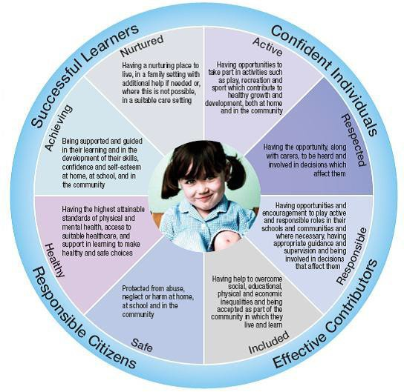We use GIRFEC approaches.

The ‘Getting it Right in Fife Framework’ describes the agreed common language and approaches regarding
when and how services engage with
children, young people and families.

The GIRFEC wellbeing indicators wheel and the ‘National practice model’ are tools which support practitioners not only to identify need as early as possible but to work together effectively to meet the needs of the child or young person concerned.

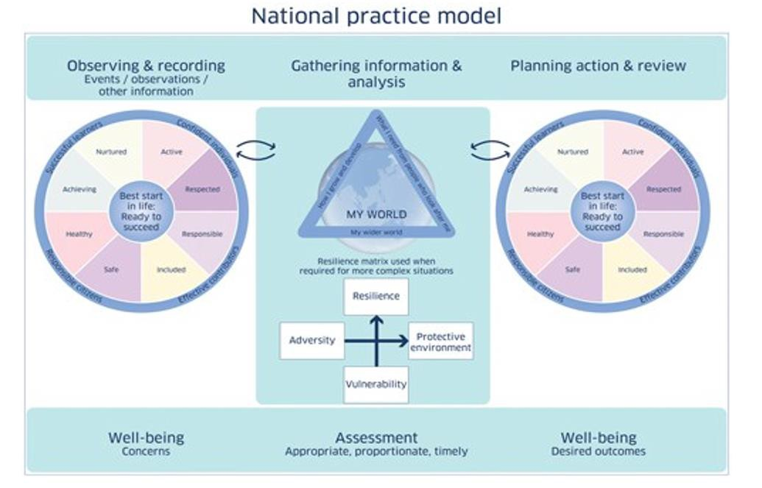

What does support look like?

It can be Universal, Additional or Intensive

The ‘Getting it Right in Fife Framework’ explains how Universal, Additional and Intensive services can work effectively as single agencies, jointly or within an integrated approach, to help develop and promote children and young people’s well-being.

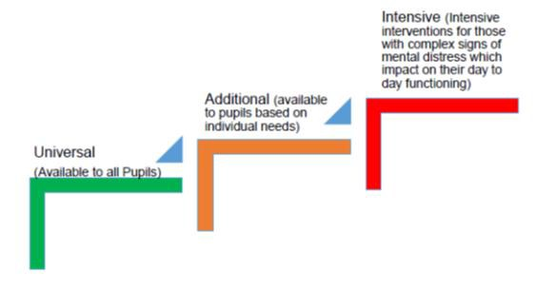For the purposes of this framework the following definitions of Universal, Additional and Intensive have been agreed:

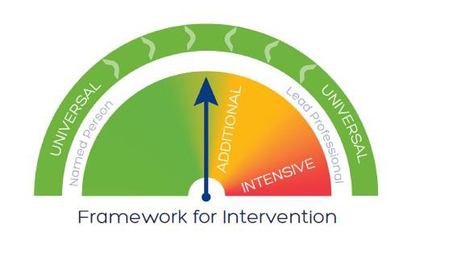
Whilst the framework appears to describe three different stages of intervention in fact these are seen as a continuum where services move across the categories responding to needs in a flexible and proportionate way.

A fundamental principle that underpins the framework is that as far as possible children, young people and families are supported by Universal provisions as this reduces the need to move into Additional and/or Intensive support.

What are the key features of Universal Support?

- It is available to all young people and values diversity.

- It promotes the holistic development and wellbeing of the young person as an effective contributor, confident individual, responsible citizen and successful learner.

- It supports and enables positive and effective relationships around the young person.

- It listens to young people and encourages resilience and a solution focused approach.

It enables the people around the young person to feel informed and able to support.

- It informs young people where to seek advice and information.

Who provides Universal Support?

“All young people need the support and guidance of friends, family, teachers, youth workers and others to enjoy and sustain a healthy lifestyle. In most circumstances these people support young people to maintain their well-being even when they face significant problems: for families this normally happens instinctively; for professionals it should be a core part of
their role.”

Making Sense: A report by young people on their well-being and mental health”, HAFAL group: For recovery from serious Mental illness, January 2016.

A wide range of people around the young person provide Universal support.

- Friends and peers
- Parents, carers
- Family Members
- Youth Workers
- Community (e.g. Clubs and groups)
- School Staff (e.g. Teachers, Pupil Support Assistants, Support Staff)
- GPs
- School Nursing Service

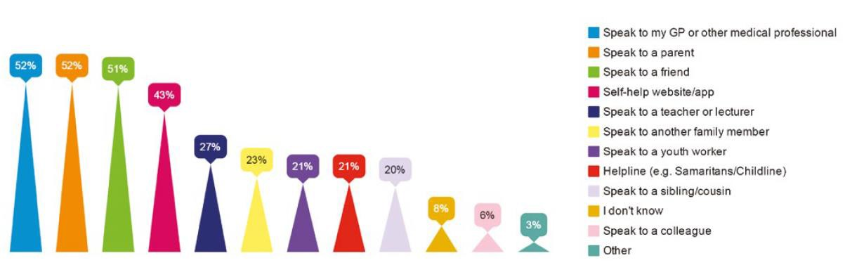Who provides Universal Support ? (continued)

Young people remind us of the importance of having support from people they trust. This could be from friends, families or trusted adults. In the Scottish Youth Parliament’s report, young people reported on who they choose to go to for information about mental health:

What does Universal support look like?

- Curriculum:

Curriculum for Excellence supports all young people. All children and young people are entitled to experience a coherent curriculum from 3 to 18 which provides a broad general education including well planned experiences and outcomes across all the curriculum areas. Children and young people’s health and wellbeing is the responsibility of all school staff.

Within the Health and Wellbeing curriculum children and young people develop the knowledge and understanding, skills, capabilities and attributes which they need for mental, emotional, social and physical wellbeing now and in the future. Learning through health and wellbeing enables young people to:

- Make informed decisions in order to improve their mental, emotional, social and physical wellbeing.
- Develop emotional intelligence, resilience and mindful approaches
- Experience challenge and enjoyment
- Experience positive aspects of healthy living and activity for themselves
- Apply their mental, emotional, social and physical skills to pursue a healthy lifestyle
- Establish a pattern of health and wellbeing which will be sustained into adult life and which will help to promote the health and wellbeing of the next generation of Scottish children.

Many Youth and Community groups also use Curriculum for Excellence to inform their approaches and see aspects of practice from the above list as being core to their work.

- Interwoven practices and ways of working:

A number of key features are interwoven into our Universal practices and ways of working to support young people:

- Respectful and inclusive cultures which reinforce positive values and build effective relationships
- Positive, holistic approaches which recognise the connectedness of the different aspects of wellbeing and which emphasises young peoples’ strengths and capacities
- Effective partnerships with families and community organisations
- Encouragement of young people to be active by undertaking opportunities for broad achievement (e.g. leadership, volunteering, personal development)
- Recognition of the importance of young people’s voice, membership of
groups and valuing of peer networks
- Promotion of quality conversations between adults and children
- De-stigmatisation of mental health (e.g. using the Respect Me resource)
- Programmes of support in school and community contexts to enable young people to cope with known stressors such as exams and social media (e.g. annual workshops for particular age groups, whole school assemblies etc.)

  - 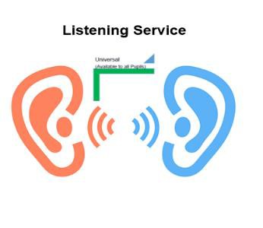Listening and Talking:

Listening and talking with young people on an informal and formal basis can be very effective in helping them to manage their emotions effectively and to develop resilience. This involves making and taking opportunities to:

- Talk with young people about the things that have gone well and reflecting on challenges and how they dealt with them.
- Encourage young people to recognise and talk openly about their feelings in a supportive environment.
- Support and help young people to think about solutions to problems themselves when things don’t go well.
- Help young people to recognise that people have different qualities and
outlooks on life.
- Support young people to explore ways to resolve issues independently and to know how, when and where to seek help and advice.
- Encourage young people to keep a sense of humour and perspective
- Reinforce young people’s perseverance when things don't work out.
- Let young people know that you are there to help if needs be but not insisting on giving help.

  - We support parents and carers:

All professionals working with children and families have a role to offer support and advice to parents. For example:

» Circulation / sharing of parental information leaflets and website information.

» Involvement in universally available family learning experiences (e.g.
Induction for new Primary One parents, Health Weeks, Open days, Parents’ Evenings, etc.).

Professionals need to look for all opportunities to meet families’ needs for information.

Advice is available to young people and their families within the local community (For example Youth Clubs and uniformed organisations). Additionally School Nurses are involved in activities within schools and are well placed to sign-post people to other agencies/services as appropriate.

  - We support and enable Young People to access relevant and suitable information:

Information needs to be easily accessed by young people. This can be achieved by:

- Publicising online resources which are available as sources of further information on a) general health and wellbeing b) key themes of mental and emotional wellbeing

- Displaying sources of information on notice boards, leaflets and posters.

- Signposting to a range of people who can help, e.g. Named Person or trusted adult within the establishment/support network.

- Providing information sessions to particular age groups or at particular calendar times to address identified stressful themes, such as social media and exam stress.

- Promoting strong partnership working to ensure shared messages and consistency of approaches.

  - We promote young people’s involvement in peer networks and their social interaction:

“Peer support should be encouraged. It is no surprise that nearly two-thirds of young people (64 percent) said that they would turn to their friends if they started experiencing problems with their mental health. Young people are often dealing with similar issues; we should actively encourage conversation on these matters”.

Making Sense: A report by young people on their well-being and mental health”, HAFAL group: For recovery from serious Mental illness, January 2016.

Partners across services have a shared responsibility to provide information and advice and to support peer networks and social interactions. :

Key actions in facilitating and enabling effective peer and social interactions are:

» Facilitating young people’s access to information to answer any questions as they arise and to enable them to signpost support to friends.

» Making use of existing Peer Networks to ensure key messages around emotional health are shared with young people who are in lead roles either within a school or community group. (e.g. Prefects, House Captains, Sports Ambassadors)

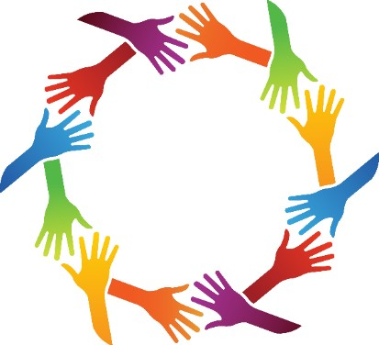» Providing training for peer support networks in schools or communities so that young people can talk to, and seek advice from, trained peers.

  - We support professionals around the child:

Professionals get information and support in the following ways:

» Professional Support and Development:

Named Persons’ training to develop skills and confidence in supporting young people’s emotional wellbeing, along with associated supervision to support them in their role.

All practitioners have access to a range of courses relating to aspects of emotional wellbeing, which they can opt into depending on their individual development needs and interests.

A core training programme is being developed which will overlap with School Nursing service training. CAMHS will be key partners in developing and delivering this training with the aim of building practitioners confidence across partners at the Universal level.

» Access to further information, for example:

Policies and Guidance, e.g. Anti-Bullying Policy, Behaviours and Relationships Strategy, Getting it Right in Fife (GIRIF) Framework.

Websites with wide range of wellbeing guidance (See Appendix)

A link Educational Psychologist is in place for every educational provision in Fife. They provide:

    - Advice and support to school staff, pupils and parents on a wide range of support needs, including young person’s emotional wellbeing and mental health issues.
    - Assessment support
    - Training for school and multi-agency staff in providing support to understand, identify and intervene with young people presenting with a wide range of wellbeing needs. In line with relationships and behaviour strategy (e.g. nurturing approaches, emotional literacy, mind-set, Cognitive Behavioural Therapy etc.)
    - School Development Support (e.g. around Attachment, Building
Resilience, Development of Growth Mindset)
    - Partnership through Wellbeing Pathway Processes
    - Support to school management to develop organisational environments which support positive emotional wellbeing

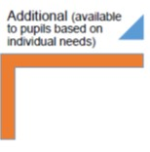What are the key features of Additional Support?

It is available to Fife pupils based on their individual needs.
- It uses the Child Wellbeing Pathway along with the variety of available assessment tools
- It applies resources available across Fife (e.g. parenting programmes, pupil group support programmes)
- It involves partners (e.g. parents and/or other professionals) in assessing
and responding to individual children’s needs
- Partners and young people have access to appropriate information at a suitable level
- It listens and coaches young people to support them to be resilient and explore solutions.

It draws upon locally available support.

Who are the partners who can support at the Additional level?

“We are calling for non-mental health professionals; teachers; school, college and university counselling services and youth groups to share the responsibility for the majority of children and young people’s emotional needs and overall development. Specialist CAMHS should support the much smaller numbers of young people with the highest needs.”

Making Sense: A report by young people on their well-being and mental health”, HAFAL group: For recovery from serious Mental illness, January 2016.

- Educational Psychology Service
- Pupil Support Service
- Support for Learners Service
- School Nursing Service
- Family and Community Support Team (FACST)
- Social Work Teams
- Third Sector Organisations
- Clinical Psychology
- Child and Adolescent Metal health Service (CAMHS)
- Relevant community clubs and organisations

  - We use the Child Wellbeing Pathway.

Mental Health does not sit separately to general health and wellbeing. To understand and support young people’s mental and emotional wellbeing we must take a more holistic overview of their general wellbeing and circumstances. To do this we use the Child Wellbeing Pathway processes.

The Child Wellbeing Pathway:

- Is consistent with the National Practice Model and identifies proportionate, appropriate and timely early intervention.

- Includes children, young people and their families in the decision making process in a structured way.

- Is complemented by agreed single agency Wellbeing and Risk Assessment Tools which are available to Education and Health staff. This supports discussion of the risk and protective factors around the young person.

- Outlines a Getting It Right, early intervention approach to addressing emerging needs or risks.

- Sits firmly within the context of GIRFEC and the Wellbeing Indicators (SHANARRI) to assist broader assessments relating to the needs, risks and strengths pertaining to a child.

The Child Wellbeing Pathway is used where the Named Person identifies, or receives information that would indicate there are, or may be, wellbeing concerns around a child or young person.

Central to the process are the five key questions which practitioners should routinely ask if they have concerns about the growth and development of the child or young person:

- What is getting in the way of this child’s or young person’s well-being?
- Do I have all the information I need to help this child and young person?
- What can I do now to help this child and young person?
- What can my agency do to help this child or young person?
- What additional help, if any, may be needed from others?

  - Individual and group support designed to respond to needs:

Direct work with young people can support the development of coping strategies in relation to a wide range of presenting difficulties. This could be provided by a wide range of partners such as Educational Psychology Service, School Nursing, Commissioned Services or locally available Third Sector services.

School Nurses provide additional support to young people and parents using a range of resources, for example:

» That Feels Better – recognising and dealing with difficult feelings
» The Five Areas – overcoming mood and depression
» The Wellbeing Cards

Further information is available on these from School Nurses or www.moodcafe.co.uk Fife’s website for promoting mental health).

- Coaching and Person Centred planning:

Coaching can be used in everyday interactions with young people to support them to identify their own strengths and to develop their own coping skills and resilience. Coaching is not about teaching or counselling; it is about creating the environment in which young people can learn from themselves, about themselves and make their own
changes”.

“Mental Health and Wellbeing: Fife Council Educational Psychology Support to Schools”, Viv Sutherland, Principal Psychologist, August 2016

Listening at the Additional stage counsels young people through coaching and person centred planning. These have three main characteristics:

  - 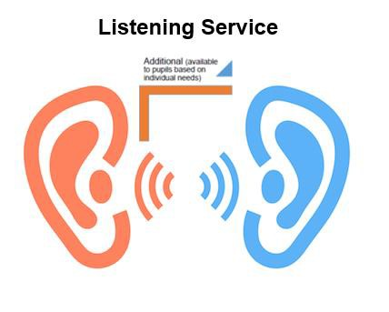They are more than just spur of the moment informal interactions.
  - They are focused on the other person – the strengths, challenges and attributes they bring to
the conversation.
  - Their purpose is to stimulate thinking, growth and change that will lead to action.

Many practitioners carry out coaching and person centred planning on a daily basis and training is provided for those who wish to develop further skills.

What might Additional support look like? (continued)

- Supporting Professionals around the child

Direct advice, consultation and coaching support to school staff working directly with young people (e.g. nurturing and attachment strategies).

Training for school staff on particular identified difficulties and how best to support them e.g. grief and bereavement, anger management, behaviour management, attachment difficulties, anxiety etc.

Access to range of assessment tools (e.g. WEMWB and Strengths and Difficulty Questionnaires)

Signposting to and liaison with specialist partners (e.g. Educational Psychologists, School Nursing). There is a wide range of online resources that can support children and young people, parents/carers and professionals. Some of these have been developed by partners in Fife and others are available nationally. Examples of these are included in Appendix One.

- Supporting Parents and Carers

All professionals working with children and families have a role to offer additional, tailored support and advice to parents as required. For example:

» Emotional support for parents experiencing challenge related to their child’s additional support needs.

» Sharing of advice and information and signposting to other sources of guidance (e.g. leaflets, support groups and websites).

» Access to specific family learning/parenting programmes, (e.g. Incredible Year, Mellow Bumps).

Professionals need to look for all opportunities to meet families’ needs for directed support according to their young person’s additional support requirements or to their own needs as parents.

What are the key features of Intensive Support?

- 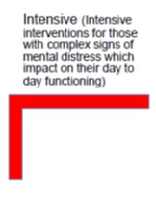It is for those with complex signs of mental distress which impact on their day to day functioning.

- It is designed to meet specific needs, which are identified through multi-agency assessment and planning through the Wellbeing Pathway.

It is coordinated by the Named Person or Lead Professional, with support from specialist agencies.

- It may involve intensive, individual or group
interventions specifically targeted to meet the need identified.

- It involves partnership with specialist providers.

Who are the partners who can provide intensive support?

Intensive support responds to a high level of need, risk and vulnerability experienced by a small proportion of young people.

It is likely at this intensive stage that specialist providers will work in partnership with existing supports. This would include NHS services such as CAMHS and specialist commissioned services.

How do we work together to consider needs and identify next steps?

A small number of children over time may need agencies to work together more intensively to promote their well-being, requiring carefully coordinated intervention and access to those resources that are not generally available.

To do this we continue to use the Child Wellbeing Pathway with appropriate partners’ involvement, drawing upon multi-agency assessment processes.

What might intensive support look like?

Due to the complex and varied nature of mental distress it is likely that bespoke packages of therapeutic interventions and care will be created for individual young people.

This may include:

  - Longer term support and treatment for those with conditions likely to have an enduring, inhibiting effect on normal emotional, psychological and social development.
  - Multi systemic therapy including approaches such as behavioural therapy, cognitive behavioural therapy and structured family therapy to work with young people and their families.
  - Tailored, one to one professional support to help young people to build skills, self-confidence and resilience and to stop harmful behaviours.
  - Regularly checking to ensure that support is meeting needs. Specialist deliverers share information on the type of support provided for the young person their approaches through the wellbeing pathway processes on and advise on whether it is successfully meeting needs. This enables partners involved in the Wellbeing Pathway to consider appropriate next steps.

“Counsellors offer troubled and/or distressed children and young people an opportunity to talk about their difficulties, within a relationship of agreed confidentiality”.

The British Association for Counselling and Psychotherapy (BACP)

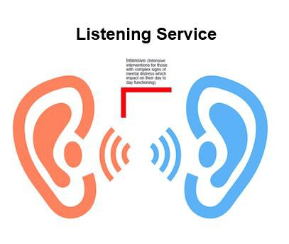Listening at the intensive stage could involve counselling.

The option of Counselling as a mental health intervention that children or young people can voluntarily enter into if they wish. Counselling give young people the opportunity to explore, understand and overcome issues in their lives which may be causing them difficulty, distress and/or confusion. A counselling relationship has identified boundaries and an explicit contract agreed between the young person, counsellor and, where appropriate, parent and carer.

What might intensive support look like? (continued)

Supporting professionals around the child

Direct advice, consultation and coaching support to school staff working directly with young people (e.g. nurturing and attachment strategies).

Liaison and partnership working with specialist services Health led Assessment and Management Plans
Partners around the young people and young people themselves need access to high quality information about mental health.

Fife's Community Planning Partners: Fife Council • NHS Fife • Fife's Voluntary Sedor • Police Scotland • Scottish Fire & Rescue Service • Fife College • Scottish Enterprise • St Andrews University • SEStran • Skills Development Scotland • Scottish Government Working together to deliver our Community Plan and strengthen Fife's future • www.fifedirect.org.uk/communityplanning

