Beath High School

HIGHER CHEMISTRY
Exam Questions

Unit 3
Chemistry in Society

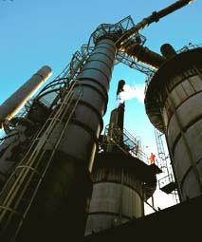

3.1 Oxidising or Reducing Agents

1. The iodate ion, IO3–, can be converted to iodine.
Which is the correct ion-electron equation for the reaction?
A 2IO3–_{(aq)} + 12H⁺_{(aq)} + 12e– 2I–_{(aq)} + 6H₂O_{(l)}
B IO3–_{(aq)} + 6H⁺_{(aq)} + 7e– I–_{(aq)} + 3H₂O_{(l)}
C 2IO3–_{(aq)} + 12H⁺_{(aq)} + 11e– I_{2(aq)} + 6H₂O_{(l)}
D 2IO3–_{(aq)} + 12H⁺_{(aq)} + 10e– I_{2(aq)} + 6H₂O_{(l)}

2. The ion-electron equations for a redox reaction are:
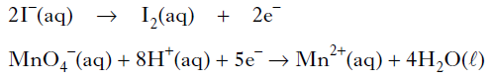
How many moles of iodide ions are oxidized by one mole of permanganate ions?
A 0.2
B 0.4
C 2
D 5

3. In which of the following reactions is the hydrogen ion acting as an oxidising agent?
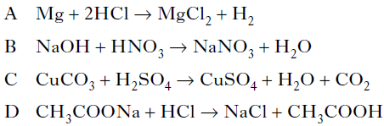

4. During a redox process in acid solution, iodate ions IO₃⁻_{(aq)} are converted into iodine I_{2(aq).}
IO₃⁻_{(aq)} → I_{2(aq)}
The numbers of H⁺(_{aq)} and H₂O_{(l)} required to balance the ion-electron equation for the
formation of 1 mol of I_{2(aq)} are, respectively
A 3 and 6
B 6 and 3
C 6 and 12
D 12 and 6.

5. In which of the following reactions is a positive ion reduced?
A Iodide iodine
B Nickel(II) nickel(III)
C Cobalt(III) cobalt(II)
D Sulfate sulfite

6. In which reaction is hydrogen gas acting as an oxidising agent?
A H₂ + CuO → H₂O + Cu
B H₂ + C₂H₄ → C₂H₆
C H₂ + Cl₂ → 2HCl
D H₂ + 2Na → 2NaH

7. Iodide ions can be oxidised using acidified potassium permanganate solution.
The equations are:
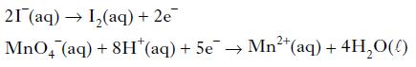
How many moles of iodide ions are oxidized by one mole of permanganate ions?
A 1.0
B 2.0
C 2.5
D 5.0

8. During a redox process in acid solution, iodate ions are converted into iodine.
2IO₃–_{(aq)} + 12H⁺_{(aq)} + xe– → I_{2(aq)} + 6H₂O_{(l)}
To balance the equation, what is the value of x?
A 2
B 6
C 10
D 12

9. The following reactions take place when nitric acid is added to zinc.
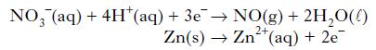
How many moles of NO3– _{(aq)} are reduced by one mole of zinc?
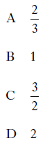

10. One of the reactions taking place within a carbon monoxide sensor is
2CO + 2H₂O → 2CO₂ + 4H⁺ + 4e⁻
This reaction is an example of
A reduction
B redox
C oxidation
D hydration.

11. The concentration of ethanol in a person’s breath can be determined by measuring the voltage produced in an electrochemical cell.
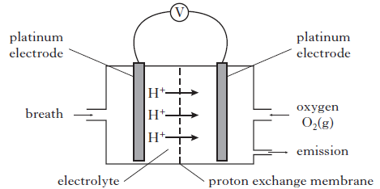
Different ethanol vapour concentrations produce different voltages as is shown in
the graph below.

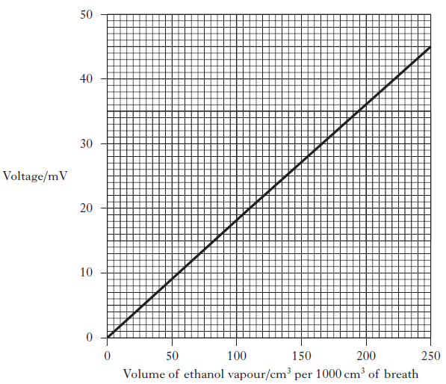

(a) Calculate the mass of ethanol, in g, in 1000 cm3 of breath when a voltage of 20 mV was recorded. (Take the molar volume of ethanol, C₂H₅OH, vapour to be
24 litres mol⁻¹.) Show your working clearly. (3)

(b) The ion-electron equations for the reduction and oxidation reactions occurring in the cell are shown below.
O₂ + 4H⁺ + 4e⁻ → 2H₂O
CH₃CH₂OH + H₂O → CH₃COOH + 4H⁺ + 4e⁻
Write the overall redox equation for the reaction taking place. (1)

12. Oxalic acid is found in rhubarb. The number of moles of oxalic acid in a carton of rhubarb juice can be found by titrating samples of the juice with a solution of potassium permanganate, a powerful oxidising agent.
The equation for the overall reaction is:
5(COOH)_{2(aq)} + 6H⁺_{(aq)} + 2MnO₄ –_{(aq)} → 2Mn²⁺ _{(aq)} + 10CO2(aq) + 8H₂O_{(l)}

Write the ion-electron equation for the reduction reaction. (1)
3.2 Getting the Most from Reactants

1. Which of the following has the largest volume under the same conditions of temperature and pressure?
A 1 g hydrogen
B 14 g nitrogen
C 20·2 g neon
D 35·5 g chlorine

2. The equation for the complete combustion of propane is:
C₃H_{8(g)} + 5O_{2(g)} → 3CO_{2(g)} + 4H₂O_{(l)}
30cm³ of propane is mixed with 200cm³ of oxygen and the mixture is ignited. What is the volume of the resulting gas mixture? (All volumes are measured at the same temperature and pressure.)
A 90cm³
B 120cm³
C 140cm³
D 210cm³

3. 2NO_{(g)} + O_{2(g)} → 2NO_{2(g)}
How many litres of nitrogen dioxide gas could theoretically be obtained in the reaction of 1 litre of nitrogen monoxide gas with 2 litres of oxygen gas? (All volumes are measured under the same conditions of temperature and pressure.)
A 1
B 2
C 3
D 4

4. What volume of oxygen (in litres) would be required for the complete combustion of a
gaseous mixture containing 1 litre of carbon monoxide and 3 litres of hydrogen?
(All volumes are measured at the same temperature and pressure.)
A 1
B 2
C 3
D 4

5. 2C₂H_{2(g)} + 5O_{2(g)} → 4CO_{2(g)} + 2H₂O_{(l)}
ethyne
What volume of gas would be produced by the complete combustion of 100 cm3 of ethyne gas? All volumes were measured at atmospheric pressure and room temperature.
A 200 cm³
B 300 cm³
C 400 cm³
D 800 cm³

6. 20cm3 of ammonia gas reacted with an excess of heated copper(II) oxide.
3CuO + 2NH₃ → 3Cu + 3H₂O + N₂
Assuming all measurements were made at 200 °C, what would be the volume of gaseous
products?
A 10cm³
B 20cm³
C 30cm³
D 40cm³

7. Calcium carbonate reacts with nitric acid as follows.
CaCO_{3(s)} + 2HNO_{3(aq)} → Ca(NO₃)_{2(aq)} + H₂O_{(l)} + CO_{2(g)}
0·05 mol of calcium carbonate was added to a solution containing 0·08 mol of nitric acid. Which of the following statements is true?
A 0·05 mol of carbon dioxide is produced.
B 0·08 mol of calcium nitrate is produced.
C Calcium carbonate is in excess by 0·01 mol.
D Nitric acid is in excess by 0·03 mol.

8. A mixture of magnesium bromide and magnesium sulfate is known to contain 3 mol
of magnesium and 4 mol of bromide ions. How many moles of sulfate ions are present?
A 1
B 2
C 3
D 4

9. 5 g of copper is added to excess silver nitrate solution. The equation for the reaction that takes place is:
After some time, the solid present is filtered off from the solution, washed with water,
dried and weighed. The final mass of the solid will be
A less than 5 g
B 5g
C 10g
D more than 10 g.

10. A pupil added 0·1 mol of zinc to a solution containing 0·05 mol of silver(I) nitrate.
Zn_{(s)} + 2AgNO_{3(aq)} → Zn(NO₃)_{2(aq)} + 2Ag_{(s)}
Which of the following statements about the experiment is correct?
A 0·05 mol of zinc reacts.
B 0·05 mol of silver is displaced.
C Silver nitrate is in excess.
D All of the zinc reacts.

11. 0·5 mol of copper(II) chloride and 0·5 mol of copper(II) sulphate are dissolved together in water and made up to 500 cm3 of solution. What is the concentration of Cu²⁺_{(aq)} ions in the solution in mol l^{–1}?
A 0·5
B 1·0
C 2·0
D 4·0

12. 10 g of magnesium is added to 1 litre of 1 mol l^{–1} copper(II) sulphate solution and the
mixture stirred until the reaction is complete. Which of these is a result of this reaction?
A All the magnesium reacts.
B 63 . 5 g of copper is displaced.
C 2 mol of copper is displaced.
D The resulting solution is colourless.

13. Ammonia is manufactured from hydrogen and nitrogen by the Haber Process.
3H_{2(g)} + N_{2(g)}  2NH_{3(g)}
If 80 kg of ammonia is produced from 60 kg of hydrogen, what is the percentage yield?
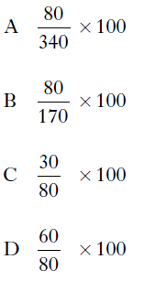

14. Two identical samples of copper(II) carbonate were added to an excess of 1 mol l^{–1}
hydrochloric acid and 1 mol l^{–1} sulphuric acid respectively.
Which of the following would have been different for the two reactions?
A The pH of the final solution
B The volume of gas produced
C The mass of water formed
D The mass of copper(II) carbonate dissolved

15. Ammonia is made by the Haber Process.
N_{2(g)} + 3H_{2(g)} 2NH_{3(g)}
The equilibrium position lies to the left. Which line in the table is correct?
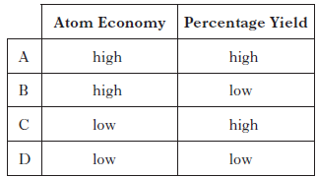

16. Magnesium metal can be extracted from sea water.
An outline of the reactions involved is shown in the flow diagram.

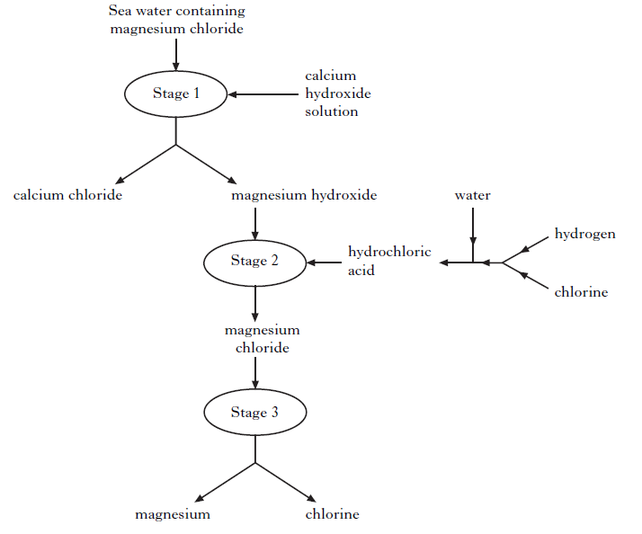

(a) Why can the magnesium hydroxide be easily separated from the calcium chloride at Stage 1? (1)

(b) Name the type of chemical reaction taking place at Stage 2. (1)

(c) Give two different features of this process that make it economical. (2)

17. Chlorine gas can be produced by heating calcium hypochlorite, Ca(OCl)2, in dilute
hydrochloric acid.
Ca(OCl)_{2(s)} + 2HCl_{(aq)} → Ca(OH)_{2(aq)} + 2Cl_{2(g)}
Calculate the mass of calcium hypochlorite that would be needed to produce 0·096 litres of chlorine gas. (Take the molar volume of chlorine gas to be 24 litres mol^{–1}.)
Show your working clearly. (2)

18. A student bubbled 240 cm³ of carbon dioxide into 400cm³ of 0.10 mol l^{–1} lithium hydroxide solution.
The equation for the reaction is:
2LiOH_{(aq)} + CO_{2(g)} → Li₂CO_{3(aq)} + H₂O_{(l)}
Calculate the number of moles of lithium hydroxide that would not have reacted.
(Take the molar volume of carbon dioxide to be 24 litres mol^{–1}.)
Show your working clearly. (2)

19. (a) In the lab, nitrogen dioxide gas can be prepared by heating copper(II) nitrate.
Cu(NO₃)_{2(s)} → CuO_{(s)} + 2NO_{2(g)} + ½ O_{2(g)}
Calculate the volume of nitrogen dioxide gas produced when 2.0g of copper(II) nitrate is completely decomposed on heating. (Take the molar volume of nitrogen dioxide to be 24 litres mol^{–1}.) Show your working clearly. (2)

(b) Nitrogen dioxide has a boiling point of 22 °C. Complete the diagram to show how nitrogen dioxide can be separated and collected. (1)

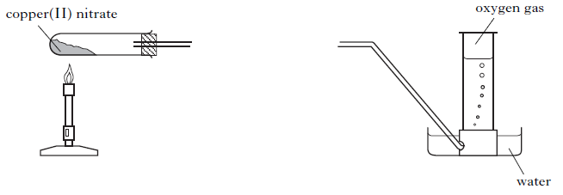
20. Sherbet contains a mixture of sodium hydrogencarbonate and tartaric acid. The
fizzing sensation in the mouth is due to the carbon dioxide produced in the
following reaction.
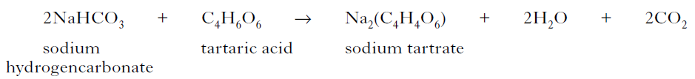
In an experiment, a student found that adding water to 20 sherbet sweets produced
105 cm³ of carbon dioxide. Assuming that sodium hydrogencarbonate is in excess, calculate the average mass of tartaric acid, in grams, in one sweet.
(Take the molar volume of carbon dioxide to be 24 litre mol^{–1}.)
Show your working clearly. (2)

21. Hydrogen fluoride gas is manufactured by reacting calcium fluoride with concentrated sulphuric acid.
CaF₂ + H₂SO₄ CaSO₄ + 2HF
What volume of hydrogen fluoride gas is produced when 1.0 kg of calcium fluoride reacts completely with concentrated sulphuric acid?
(Take the molar volume of hydrogen fluoride gas to be 24 litres mol–1.)
Show your working clearly. (2)

22. Methanamide, HCONH2, is widely used in industry to make nitrogen compounds.
It is also used as a solvent as it can dissolve ionic compounds.
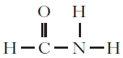

(a) Why is methanamide a suitable solvent for ionic compounds? (1)

(b) In industry, methanamide is produced by the reaction of an ester with ammonia.

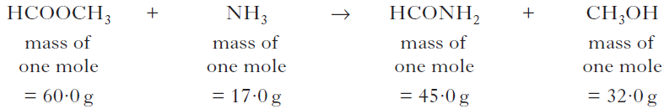

(i) Name the ester used in the industrial manufacture of methanamide. (1)

(ii) Calculate the atom economy for the production of methanamide. (1)

(c) In the lab, methanamide can be prepared by the reaction of methanoic acid
with ammonia.
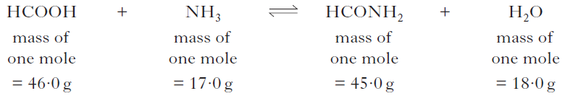

When 1·38 g of methanoic acid was reacted with excess ammonia, 0·945 g of methanamide was produced. Calculate the percentage yield of methanamide. Show your working clearly. (2)

23. Aspirin, a common pain-killer, can be made by the reaction of salicylic acid with
ethanoic anhydride.
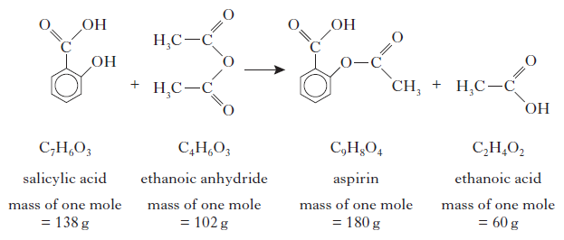
(a) Calculate the atom economy for the formation of aspirin using this method.
Show your working clearly. (2)

(b) In a laboratory preparation of aspirin, 5·02 g of salicylic acid produced 2·62 g
of aspirin. Calculate the percentage yield of aspirin. Show your working clearly. (2)

24. From the 1990s, ibuprofen has been synthesised by a three step process. The equation below shows the final step of the synthesis.

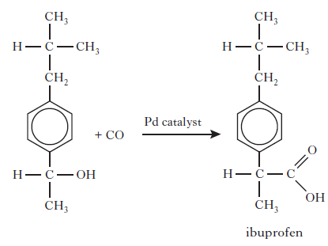
What is the atom economy of this step? (1)

25. One of the chemicals released in a bee sting is an ester that has the structure shown.
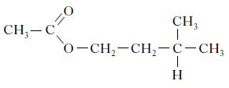
This ester can be produced by the reaction of 2-methylbutan-1-ol with ethanoic acid.
If there is a 65% yield, calculate the mass of ester produced, in grams, when 4.0 g of the alcohol reacts with a slight excess of the acid.
(Mass of one mole of the alcohol = 88 g; mass of one mole of the ester = 130 g)
Show your working clearly. (2)

26. Ammonia is produced in industry by the Haber Process.
N_{2(g)} + 3H_{2(g)} 2NH_{3(g)}
Under certain conditions, 500 kg of nitrogen reacts with excess hydrogen to produce
405 kg of ammonia. Calculate the percentage yield of ammonia under these conditions. Show your working clearly. (2)

27. Ethane-1,2-diol is produced in industry by reacting glycerol with hydrogen.
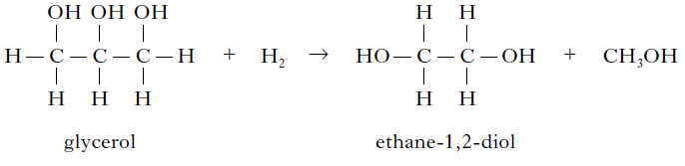
Excess hydrogen reacts with 27·6 kg of glycerol to produce 13·4 kg of ethane-1,2-diol.
Calculate the percentage yield of ethane-1,2-diol. Show your working clearly. (2)

3.3 Equilibria

1. A catalyst is used in the Haber Process.
N_{2(g)} + 3H_{2(g)} 2NH_{3(g)}
Which of the following best describes the action of the catalyst?
A Increases the rate of the forward reaction only
B Increases the rate of the reverse reaction only
C Increases the rate of both the forward and reverse reactions
D Changes the position of the equilibrium of the reaction

2. In which of the following systems will the equilibrium be unaffected by a change in
pressure?
A 2NO_{2(g)} N₂O_{4(g)}
B H_{2(g)} + I_{2(g)} 2HI_{(g)}
C N_{2(g)} + 3H_{2(g)} 2NH_{3(g)}
D 2NO_{(g)} + O_{2(g)} 2NO_{2(g)}

3. A few drops of concentrated sulphuric acid were added to a mixture of 0·1 mol of
methanol and 0·2 mol of ethanoic acid. Even after a considerable time, the reaction mixture was found to contain some of each reactant. Which of the following is the best explanation for the incomplete reaction?
A The temperature was too low.
B An equilibrium mixture was formed.
C Insufficient methanol was used.
D Insufficient ethanoic acid was used.

4. Which line in the table shows the effect of a catalyst on the reaction rates and position of equilibrium in a reversible reaction?
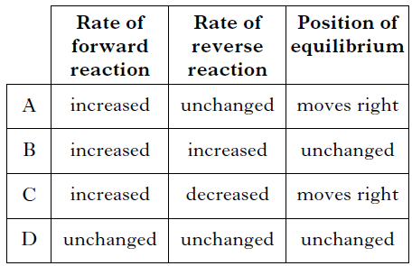

5. The following equilibrium exists in bromine water.
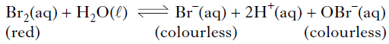
The red colour of bromine water would fade on adding a few drops of a concentrated
solution of
A HCl
B KBr
C AgNO3
D NaOBr.

6. A catalyst is added to a reaction at equilibrium. Which of the following does not apply?
A The rate of the forward reaction increases.
B The rate of the reverse reaction increases.
C The position of equilibrium remains unchanged.
D The position of equilibrium shifts to the right.

7. In which of the following reactions would an increase in pressure cause the equilibrium position to move to the left?
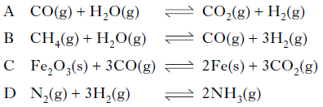

8. If ammonia is added to a solution containing copper(II) ions an equilibrium is set up.
Cu²⁺_{(aq)} + 2OH–_{(aq)} + 4NH_{3(aq)} Cu(NH₃)₄(OH)_{2(aq)}
(deep blue)
If acid is added to this equilibrium system
A the intensity of the deep blue colour will increase
B the equilibrium position will move to the right
C the concentration of Cu2+(aq) ions will increase
D the equilibrium position will not be affected.

9. Steam and carbon monoxide react to form an equilibrium mixture.
CO_{(g)} + H₂O_{(g)} H_{2(g)} + CO_{2(g)}
Which of the following graphs shows how the rates of the forward and reverse reactions
change when carbon monoxide and steam are mixed?
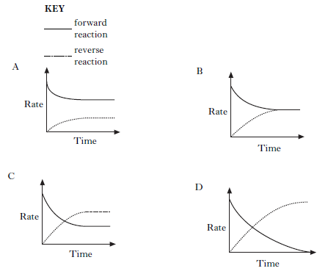

10. 2SO_{2(g)} + O2_{(g)} 2SO_{3(g)}
The equation represents a mixture at equilibrium. Which line in the table is true for the mixture after a further 2 hours of reaction?
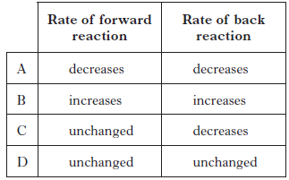

11. In which of the following would an increase in pressure result in the equilibrium position
being moved to the left?
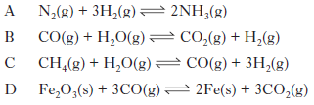

12. Nitrogen dioxide gas can be prepared in different ways. It is manufactured industrially as part of the Ostwald process. In the first stage of the process, nitrogen monoxide is produced by passing ammonia and oxygen over a platinum catalyst.
NH_{3(g)} + O_{2(g)} NO_{(g)} + H₂O_{(g)}

(a) Balance the above equation. (1)

(b) Platinum metal is a heterogeneous catalyst for this reaction. What is meant by a heterogeneous catalyst? (1)

(c) The nitrogen monoxide then combines with oxygen in an exothermic reaction to form nitrogen dioxide.
2NO_{(g)} + O_{2(g)} 2NO_{2(g)}
What happens to the yield of nitrogen dioxide gas if the reaction mixture is cooled? (1)

13. Atmospheric oxygen, O_{2(g),} dissolves in the Earth’s oceans forming dissolved oxygen, O_{2(aq)}, which is essential for aquatic life. An equilibrium is established.
O_{2(g)} + (aq) O_{2(aq)} ΔH = –12·1 kJ mol–1

(a) (i) What is meant by a reaction at “equilibrium”?

(ii) What would happen to the concentration of dissolved oxygen if the temperature of the Earth’s oceans increased?

(b) A sample of oceanic water was found to contain 0·010 g of dissolved oxygen.
Calculate the number of moles of dissolved oxygen present in the sample. (1)

14. When cyclopropane gas is heated over a catalyst, it isomerises to form propene gas and an equilibrium is obtained.
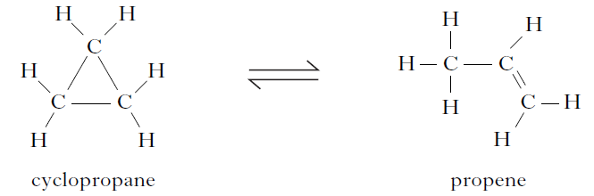

The graph shows the concentrations of cyclopropane and propene as equilibrium is established in the reaction.
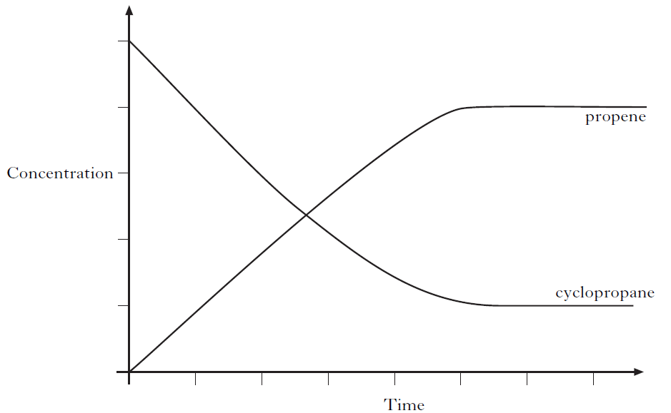
(a) Mark clearly on the graph the point at which equilibrium has just been reached. (1)

(b) Why does increasing the pressure have no effect on the position of this equilibrium? (1)

15. Tetrafluoroethene, C₂F₄, is produced in industry by a series of reactions. The final reaction in its manufacture is shown below.
2CHClF_{2(g)} C₂F_{4(g)} + 2HCl_{(g)}
The graph shows the variation in concentration of C₂F₄ formed as temperature is increased.
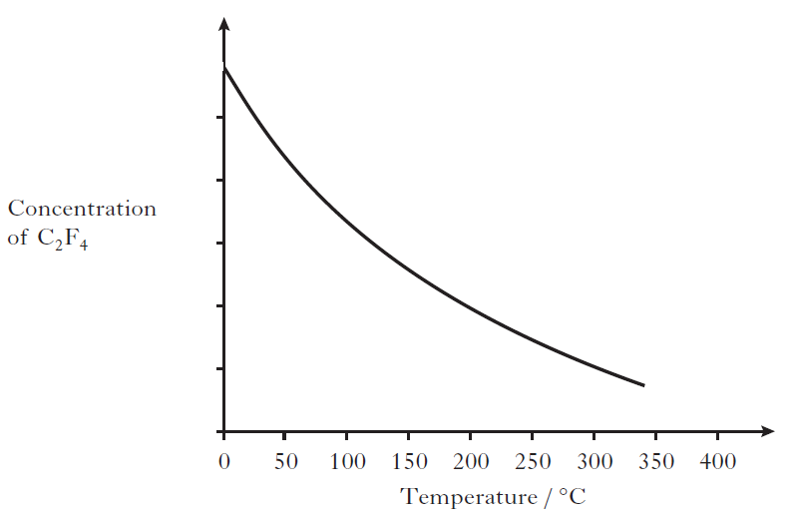
What conclusion can be drawn about the enthalpy change for the formation of tetrafluoroethene? (1)
16. Ammonia is produced in industry by the Haber Process.
N_{2(g)} + 3H_{2(g)} 2NH_{3(g)}

The graph shows how the percentage yield of ammonia changes with temperature at a pressure of 100 atmospheres.
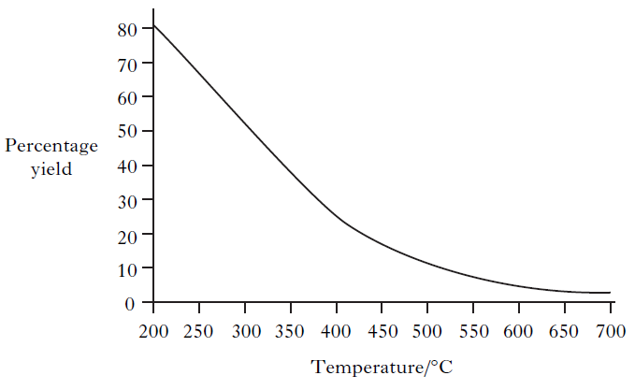
(i) A student correctly concludes from the graph that the production of ammonia is an exothermic process. What is the reasoning that leads to this conclusion? (1)

(ii) Explain clearly why the industrial manufacture of ammonia is carried out at a pressure greater than 100 atmospheres. (2)

17. Rivers and drains are carefully monitored to ensure that they remain uncontaminated by potentially harmful substances from nearby industries. Chromate ions, CrO42–, are particularly hazardous.
When chromate ions dissolve in water the following equilibrium is established.
2CrO4^{2–}_{(aq)} + 2H⁺(aq) Cr₂O₇ 2–_{(aq)} + H₂O_{(l)}
yellow orange
Explain fully the colour change that would be observed when solid sodium hydroxide is added to the solution. (2)

3.4 Hess’s Law

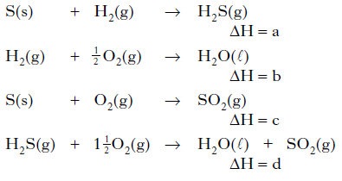
1.

What is the relationship between a, b, c and d?
A a = b + c – d
B a = d – b – c
C a = b – c – d
D a = d + c – b

2. Given the equations
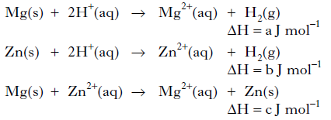
then, according to Hess’s Law
A c = a – b
B c = a + b
C c = b – a
D c = – b – a.

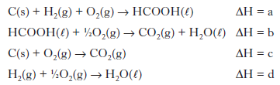
3.

What is the relationship between a, b, c and d?
A a = c + d − b
B a = b − c − d
C a = −b − c − d
D a = c + b + d

4. The compound diborane (B₂H₆) is used as a rocket fuel.
(a) It can be prepared as shown.
BF₃ + NaBH₄ → B₂H₆ + NaBF₄
Balance this equation. (1)

(b) The equation for the combustion of diborane is shown below.
B₂H_{6(g)} + 3O_{2(g)} → B₂O_{3(s)} + 3H₂O_{(l)}
Calculate the enthalpy of combustion of diborane (B₂H₆) in kJ mol−1, using the following data. (2)
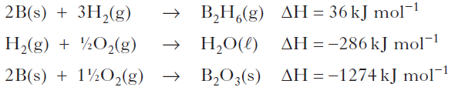
5. Mobile phones are being developed that can be powered by methanol. Methanol can be made by a two-stage process.
In the first stage, methane is reacted with steam to produce a mixture of carbon monoxide and hydrogen.
CH_{4(g)} + H₂O_{(g)} CO_{(g)} + 3H_{2(g)}
Use the data below to calculate the enthalpy change, in kJ mol^{–1}, for the forward reaction.
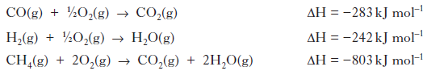
Show your working clearly. (2)

6. Enthalpy changes can also be calculated using Hess’s Law. The enthalpy of formation for pentan-1-ol is shown below.
5C_{(s)} + 6H_{2(g)} + ½ O_{2(g)} → C₅H₁₁OH_{(l)} ΔH = –354 kJ mol^{–1}
Using this value, and the enthalpies of combustion of carbon and hydrogen from the data booklet, calculate the enthalpy of combustion of pentan-1-ol, in kJ mol^{–1}. (2)

7. Hydrogen has been named as a ‘fuel for the future’. In a recent article researchers
reported success in making hydrogen from glycerol:
C₃H₈O_{3(l)} → CO_{2(g)} + CH_{4(g)} + H_{2(g)}

(a) Balance this equation. (1)

(b) The enthalpy of formation of glycerol is the enthalpy change for the reaction:
3C_{(s)} + 4H_{2(g)} + 1½O_{2(g)} → C₃H₈O_{3(l)}
(graphite)

Calculate the enthalpy of formation of glycerol, in kJ mol^{–1}, using information from the data booklet and the following data.
C₃H₈O_{3(l)} + 3½O_{2(g)} → 3CO_{2(g)} + 4H₂O_{(l)} ΔH = –1654 kJ mol^{–1}
Show your working clearly. (2)

8. The equation for the enthalpy of formation of ethyne is:
2C_{(s)} + H_{2(g)} C₂H_{2(g)}
Use the enthalpies of combustion of carbon, hydrogen and ethyne given in the data booklet to calculate the enthalpy of formation of ethyne, in kJ mol–¹. Show your working clearly. (2)

9. When in danger, bombardier beetles can fire a hot, toxic mixture of chemicals at the
attacker. This mixture contains quinone, C₆H₄O₂, a compound that is formed by the reaction of hydroquinone, C₆H₄(OH)₂, with hydrogen peroxide, H₂O₂. The reaction is catalysed by an enzyme called catalase.

(a) Most enzymes can catalyse only specific reactions, eg catalase cannot catalyse the hydrolysis of starch. Give a reason for this. (1)

(b) The equation for the overall reaction is:
C₆H₄(OH)_{2(aq)} + H₂O_{2(aq)} C₆H₄O_{2(aq)} + 2H₂O(l)
Use the following data to calculate the enthalpy change, in kJ mol^{–1}, for the above
reaction.
C₆H₄(OH)_{2(aq}) → C₆H₄O_{2(aq)} + H_{2(g)} ΔH = +177.4 kJ mol^{–1}
H_{2(g)} + O_{2(g)} → H₂O_{2(aq)} ΔH = –191.2 kJ mol^{–1}
H_{2(g)} + ½ O_{2(g)} → H₂O_{(g)} ΔH = –241.8 kJ mol^{–1}
H₂O_{(g)} → H₂O_{(l)} ΔH = –43.8 kJ mol^{–1}
Show your working clearly. (2)

10. (a) Methane is produced in the reaction of aluminium carbide with water.
Al₄C₃ + H₂O → Al(OH)₃ + CH₄
Balance the above equation. (1)

(b) Silane, silicon hydride, is formed in the reaction of silicon with hydrogen.
Si_{(s)} + 2H_{2(g)} → SiH_{4(g)}
silane

The enthalpy change for this reaction is called the enthalpy of formation of silane.
The combustion of silane gives silicon dioxide and water.
SiH_{4(g)} + 2O_{2(g)} → SiO_{2(s)} + 2H₂O_{(l)} ΔH = –1517 kJ mol^{–1}
The enthalpy of combustion of silicon is –911 kJ mol^{–1}.
Use this information and the enthalpy of combustion of hydrogen in the data booklet to calculate the enthalpy of formation of silane, in kJ mol–¹. Show your working clearly. (2)

3.5 Chemical Analysis

1. An organic chemist is attempting to synthesise a fragrance compound by the following chemical reaction.
compound X + compound Y → fragrance compound
After one hour, a sample is removed and compared with pure samples of compounds X and Y using thin-layer chromatography. Which of the following chromatograms shows that the reaction has produced a pure sample of the fragrance compound?
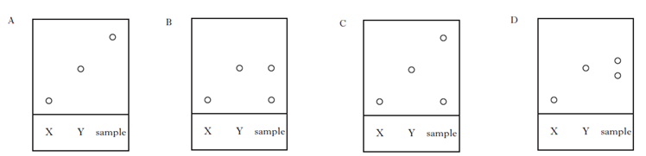

2. The alcohol content of wine was analysed by four students. Each student carried out the experiment three times.
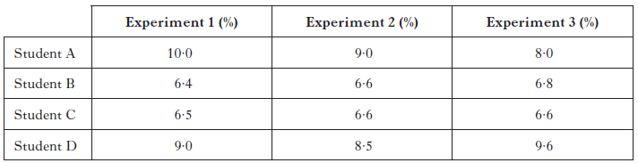

The most reproducible results were obtained by
A Student A
B Student B
C Student C
D Student D

3. 45 cm³ of a solution could be most accurately measured out using a
A 50 cm³ beaker
B 50 cm³ burette
C 50 cm³ pipette
D 50 cm³ measuring cylinder.

4. Aluminium carbonate can be produced by the following reaction.
2AlCl_{3(aq)} + 3K₂CO_{3(aq)} → Al₂(CO₃)_{3(s)} + 6KCl_{(aq)}
The most suitable method for obtaining a sample of the aluminium carbonate is
A collection over water
B distillation
C evaporation
D filtration.
5. Seaweeds are a rich source of iodine in the form of iodide ions. The mass of iodine in a seaweed can be found using the procedure outlined below.

(a) Step 1
The seaweed is dried in an oven and ground into a fine powder. Hydrogen peroxide solution is then added to oxidise the iodide ions to iodine molecules.
The ion-electron equation for the reduction reaction is shown.
H₂O_{2(aq)} + 2H⁺_{(aq)} + 2e– → 2H₂O_{(l)}
Write a balanced redox equation for the reaction of hydrogen peroxide with iodide ions. (1)

(b) Step 2
Using starch solution as an indicator, the iodine solution is then titrated with sodium thiosulphate solution to find the mass of iodine in the sample. The balanced equation for the reaction is shown.
2Na₂S₂O_{3(aq)} + I_{2(aq)} → 2NaI_{(aq)} + Na₂S₄O_{6(aq)}
In an analysis of seaweed, 14.9cm³ of 0.00500 mol l^{–1} sodium thiosulphate solution was required to reach the end-point. Calculate the mass of iodine present in the seaweed sample. Show your working clearly. (3)

6. Oxalic acid is found in rhubarb. The number of moles of oxalic acid in a carton of rhubarb juice can be found by titrating samples of the juice with a solution of potassium permanganate, a powerful oxidising agent.
The equation for the overall reaction is:
5(COOH)_{2(aq)} + 6H⁺_{(aq)} + 2MnO₄ –_{(aq)} → 2Mn²⁺ _{(aq)} + 10CO2(aq) + 8H₂O_{(l)}

(a) Write the ion-electron equation for the reduction reaction. (1)

(b) In an investigation using a 500 cm³ carton of rhubarb juice, separate 25.0cm³ samples were measured out. Three samples were then titrated with 0.040 mol l^{–1} potassium permanganate solution, giving the following results.
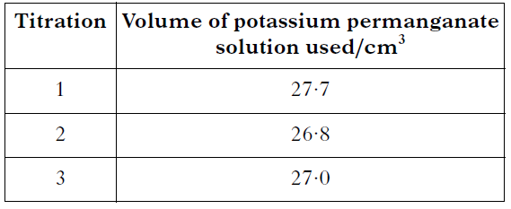

Average volume of potassium permanganate solution used = 26.9cm³.
(i) Why was the first titration result not included in calculating the average volume of potassium permanganate solution used? (1)

(ii) Calculate the number of moles of oxalic acid in the 500 cm³ carton of rhubarb juice.
Show your working clearly. (2)

7. The number of moles of carbon monoxide in a sample of air can be measured as follows.

Step 1 The carbon monoxide reacts with iodine(V) oxide, producing iodine.
5CO_{(g)} + I₂O_{5(s)} → I_{2(s)} + 5CO_{2(g)}

Step 2 The iodine is then dissolved in potassium iodide solution and titrated
against sodium thiosulphate solution.
I_{2(aq)} + 2S₂O₃^{2–}_{(aq)} → S₄O₆^{2–}_{(aq)} + 2I–_{(aq)}

(a) Write the ion-electron equation for the oxidation reaction in Step 2. (1)

(b) Name a chemical that can be used to indicate when all of the iodine has been
removed in the reaction taking place in Step 2. (1)

(c) If 50.4cm³ of 0.10 mol l^{–1} sodium thiosulphate solution was used in a titration,
calculate the number of moles of carbon monoxide in the sample of air.
Show your working clearly. (2)

8. A major problem for the developed world is the pollution of rivers and streams by nitrite and nitrate ions. The concentration of nitrite ions, NO₂ ^{–(}aq), in water can be determined by titrating samples against acidified permanganate solution.

(a) Suggest two points of good practice that should be followed to ensure that an accurate end-point is achieved in a titration.

(b) An average of 21·6cm³ of 0·0150 mol l^{–1} acidified permanganate solution was required to react completely with the nitrite ions in a 25·0 cm³ sample of river water. The equation for the reaction taking place is:
2MnO₄– _{(aq)} + 5NO₂–_{(aq)} + 6H⁺_{(aq)} → 2Mn²⁺_{(aq)} + 5NO₃–_{(aq)} + 3H₂O_{(l)}

(i) Calculate the nitrite ion concentration, in mol l^{–1}, in the river water. Show your working clearly. (2)

(ii) During the reaction the nitrite ion is oxidised to the nitrate ion. Complete the ion-electron equation for the oxidation of the nitrite ions.
NO₂–_{(aq)} → NO₃–_{(aq)} (1)

9. (a) The concentration of chromate ions in water can be measured by titrating with a solution of iron(II) sulphate solution. To prepare the iron(II) sulphate solution used in this titration, iron(II) sulphate crystals were weighed accurately into a dry beaker. Describe how these crystals should be dissolved and then transferred to a standard flask in order to produce a solution of accurately known concentration. (2)

(b) A 50·0cm³ sample of contaminated water containing chromate ions was titrated and found to require 27·4 cm³ of 0·0200 mol l^{–1} iron(II) sulphate solution to reach the end-point. The redox equation for the reaction is:
3Fe²⁺_{(aq)} + CrO₄^{2–}_{(aq)} + 8H⁺_{(aq)} → 3Fe³⁺_{(aq)} + Cr³⁺_{(aq)} + 4H₂O_{(l)}
Calculate the chromate ion concentration, in mol l^{–1}, present in the sample of water. Show your working clearly. (2)
10. Hydrogen sulfide, H₂S, can cause an unpleasant smell in water supplies. The concentration of hydrogen sulfide can be measured by titrating with a chlorine standard solution. The equation for the reaction taking place is
4Cl_{2(aq)} + H₂S_{(aq)} + 4H₂O_{(l)} → SO₄²⁻_{(aq)} + 10H⁺_{(aq)} + 8Cl⁻_{(aq)}
50·0 cm³ samples of water were titrated using a 0∙010 mol l⁻¹ chlorine solution.

(a) Name an appropriate piece of apparatus which could be used to measure out the water samples. (1)

(b) What is meant by the term standard solution? (1)

(c) An average of 29·4 cm³ of 0∙010 mol l⁻¹ chlorine solution was required to react completely with a 50·0 cm³ sample of water. Calculate the hydrogen sulfide concentration, in mol l⁻¹, present in the water sample. Show your working clearly. (3)

11. Zinc is an essential element for the body and is found in a variety of foods.
(a) The mass of zinc in four 100 g samples taken from a cheese spread was measured.
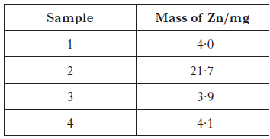

Calculate the average mass of Zn, in mg, in 100 g of this cheese spread. (1)

(b) The recommended daily allowance of zinc is 9·5 mg for an adult male. 100 g of peanuts contains 3·3 mg of zinc. Calculate the mass of peanuts which would provide the recommended daily allowance of zinc. (2)

12. Solutions containing iodine are used to treat foot rot in sheep. The concentration of iodine in a solution can be determined by titrating with a solution of thiosulfate ions.
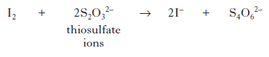
(a) Write an ion-electron equation for the reaction of the oxidising agent in the titration. (1)

(b) Three 20·0 cm³ samples of a sheep treatment solution were titrated with 0·10 mol l^{–1} thiosulfate solution. The results are shown below.

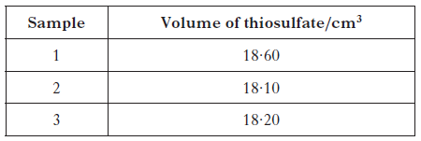

(i) Why is the volume of sodium thiosulfate used in the calculation taken to be
18·15 cm³, although this is not the average of the three titres in the table? (1)

(ii) Calculate the concentration of iodine, in mol l^{–1}, in the foot rot treatment solution. Show your working clearly. (3)

(iii) Describe how to prepare 250 cm³ of a 0·10 mol l⁻¹ standard solution of sodium thiosulfate, Na₂S₂O₃. Your answer should include the mass, in g, of sodium thiosulfate required. (3)

