
Beath High School
Chemistry Department
Higher Chemistry
Unit 3 Chemistry in Society

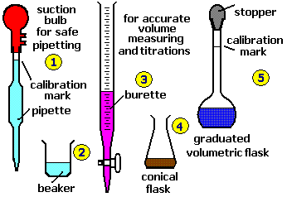

Unit 3: Chemistry in Society
Key Area: Chemical Analysis
Student Notes

Name
Class

Chromatography

Chromatography is a term used to describe a set of techniques that can be used to s___________ and i__________ substances from complex mixtures. There are many different chromatographic methods, however the underlying principles are the same.

The basic concept of chromatography is that is uses differences in size and polarities of substances to separate them.
Types of chromatography include:
- Paper Chromatography
- Thin Layer Chromatography (TLC)
- Gas Chromatography
- Gas-Liquid Chromatography
- High Performance Liquid Chromatography (HPLC).





How Does Chromatography Work?
All chromatographic techniques work on the same principle. There is a mobile phase which is a liquid or gas that carries a substance over a stationary phase which is a solid or liquid absorbed onto a solid.
The most common examples of chromatography used in the laboratory are paper chromatography and thin layer chromatography (TLC).

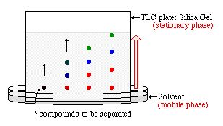
The speed at which compounds move depends on two factors:
1. how attracted they are to the stationary phase
2. their solubility in the solvent.

Both of these factors depend on intermolecular forces.

Gas Chromatography
In gas chromatography (GC), the mobile phase is an inert gas e.g. helium.
The stationary phase is a very thin layer of an inert liquid on an inert solid support - such as beads of silica packed into a long thin tube (this flexible tube is coiled many times inside a thermostatically-controlled oven to keep it at a constant temperature).
GC is used to separate complex mixtures. It is much better at this than thin-layer or paper chromatography.
This is because it is more sensitive - allowing the determination not only of what chemicals are in the mixture, but also how much of each chemical there is.
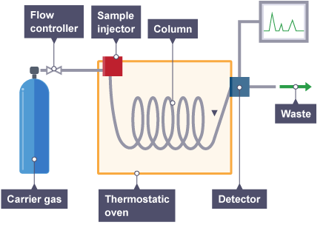

The mixture to be analysed is injected into the stream of carrier gas. As it passes along the column (long thin tube) it separates into the different substances.

Substances with a greater affinity (attraction) for the mobile phase reach the detector at the end of the column more quickly. Substances with a greater affinity for the stationary phase move more slowly through the column.

Gas chromatography can be used to detect banned substances in urine samples from athletes, or by forensic investigators to detect the presence of fuels that may have been used to deliberately start fires.
A gas chromatogram might show the time along the x-axis and the strength of response along the y-axis. The amount of time that a substance takes to pass through the column is called it retention time. The retention time of an unknown substance can be compared with standard reference data to help to identify it.
Three main pieces of information can be gathered from a gas chromatogram:
  - the number of compounds in the mixture - represented by the number of peaks
  - how much of each compound is present - represented by the height of the peak (higher = more)
  - the retention time - indicated by the position of the peak

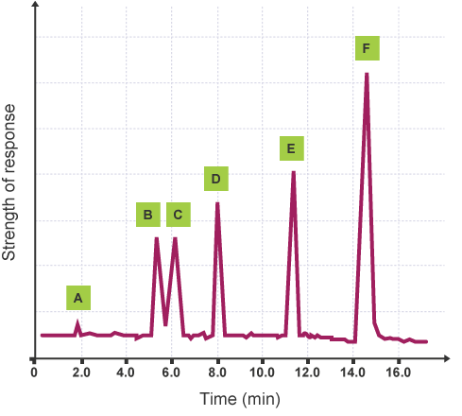
This gas chromatogram shows that:
- substance A was present in the smallest quantity (it has the smallest peak)
- substance A had the shortest retention time
- substances B and C were present in equal amounts
- substance F had the longest retention time
- substance F was present in the greatest quantity (it has the largest peak)
- substance F had the greatest affinity for the stationary phase

Volumetric Analysis
A titration experiment can be carried out to accurately measure the volume of substances that react in chemical reactions.
This technique uses a standard solution i.e. a solution of an accurately known concentration, which is titrated against portions of an unknown concentration until the reaction is just complete.
This end-point can be shown by using an indicator. Volumetric titrations are popular in acid-base reactions.
When titrating, it is essential to measure things as accurately as possible.
The experiment is carried out by following these steps:
Step one
If the sample is a solid, it is weighed using an accurate balance, and then dissolved to make up a known volume of solution (usually 100 cm³).
Step two
A pipette is used to measure accurately a volume of this solution - for example, 10 cm³. A safety pipette filler is used to draw solution into the pipette. This is emptied into a conical flask.
Step three
A few drops of an indicator may be added to the conical flask. This will show a change of colour when the titration is complete.
Step four
A second chemical is placed in a burette. This other solution is of a chemical that will react with the synthesised chemical sample in the conical flask. Often the solution in the burette is an acid of a precise, known concentration.
Step five
The solution from the burette is run into the conical flask. The solution is added one drop at a time, with swirling to mix the solutions as the end-point is approached. Eventually, a colour change shows that the correct amount has been added to react completely with the synthesised chemical in the sample.
Step six
The volume of solution added from the burette is noted. The titration results can then be used to calculate the amount of the synthesised chemical in the sample, and therefore find its purity.

The apparatus used for volumetric analysis is shown in the diagram on the next page.
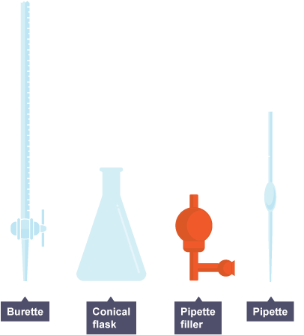
Redox Titrations
The quantity of oxidising or reducing agent present in a redox reaction can be calculated from the results of a titration by using the balanced redox equation - this tells us the molar ratio of reactants, and the formula triangle linking number of moles with concentration and volume.
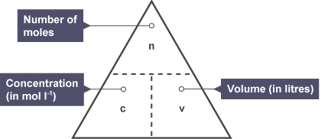
The mass of vitamin C in a tablet can be determined by redox titration. An iodine solution of known concentration and starch indicator are used.
A vitamin C tablet is dissolved in deionised water in a beaker and transferred to a 250 cm³ standard flask. This is made up to the graduation mark using deionised water (and the washings of the beaker).
25 cm³ of this solution is transferred by pipette, to a conical flask and starch indicator is added. The iodine can be added by burette until the vitamin C solution turns blue/black.
This can be repeated and an average taken.

Worked Example
The results of the titration described above show that 17.6 cm³ of 0.031 mol l⁻¹ iodine solution was required to reach the end-point with 25 cm³ of vitamin C solution.
Calculate the mass of vitamin C (C₆H₈O₆) in the original tablet.

The balanced redox equation for the process is:
C₆H₈O₆ ₊ I₂ → C₆H₆O₆ ₊ 2H⁺ + 2I—
1 mole 1 mole

This shows that one mole of vitamin C will react with one mole of iodine. You can use n = c x v to calculate how many moles of iodine are required from the average volume (17.6/1000 l) and concentration (0.031 mol l⁻¹) in the question.

n = c x v c = 0.031 mol l⁻¹ v = 0.0176 l
= 0.031 x 0.0176
= 5.456 x10⁻⁴ moles

1 mole of I₂ → 1 mole of C₆H₈O₆
5.456 x10⁻⁴ moles of I₂ → 5.456 x10⁻⁴ moles of C₆H₈O₆

This means that a 25 cm³ sample of vitamin C solution contains 5.5456 x 10⁻⁴ moles of vitamin C. The original vitamin C tablet was dissolved in 250 cm³ of water, so:

25 cm³ of vitamin C solution = 5.456 x10⁻⁴ moles of vitamin C
250 cm³ of vitamin C solution = 5.456 x10⁻⁴ x 10
= 5.456 x10⁻³ moles of vitamin C in one tablet

The GFM of vitamin C is 176g.
The mass of vitamin C in the sample can be calculated from:
m = n x GFM
= 5.456 x10⁻³ x 176
= 0.96g
The mass of vitamin C present in the tablet is 0.96g

Key Area Check Test – Volumetric calculations
1. 25 cm³ of a solution of sodium hydroxide was added to a flask and titrated with a 0.2 mol l⁻¹ solution of hydrochloric acid.
HCl + NaOH → NaCl + H₂O
The experiment was carried out three times and the volumes of HCl titrated in each
experiment are shown in the table.
Titration | Volume of 0.2 mol l⁻¹ solution of HCl (cm³)
1 | 11.3
2 | 10.4
3 | 10.6
Calculate the concentration of the NaOH solution in mol l ^{–1}.

2. 20 cm³ of a solution of potassium hydroxide was added to a flask and titrated with a 0.1 mol l⁻¹ solution of hydrochloric acid.
HCl + KOH → KCl + H₂O
The experiment was carried out three times and the volumes of HCl titrated in each
experiment are shown in the table.
Titration | Volume of 0.2 mol l⁻¹ solution of HCl (cm³)
1 | 20.6
2 | 19.9
3 | 20.0
Calculate the concentration of the KOH solution in mol l ^{–1}.

3. 10 cm³ of a solution of KOH was added to a flask and titrated with a 0.05 mol l⁻¹ solution of H₂SO₄.
H₂SO₄ + 2KOH → K₂SO₄ + 2H₂O
The experiment was carried out three times and the volumes of HCl titrated in each
experiment are shown in the table.
Titration | Volume of 0.2 mol l⁻¹ solution of HCl (cm³)
1 | 15.9
2 | 15.2
3 | 15.3
Calculate the concentration of the KOH solution in mol l ^{–1}.
4. Rhubarb leaves contain oxalic acid, (COOH)₂. A pupil found that it required 17 cm³ of
0.001 mol l⁻¹ of sodium hydroxide to neutralise 25 cm³ of a solution made from rhubarb
leaves.
Calculate the concentration of oxalic acid in the solution given that the equation
for the reaction is:
(COOH)₂ + 2NaOH Na₂(COO)₂ + 2H₂O

5. Acidified potassium permanganate can be used to determine the concentration of hydrogen peroxide solution; the solutions react in the ratio of 2 mol of potassium permanganate: 5mol of hydrogen peroxide.
In an analysis it is found that 16.8 cm³ of 0.025 mol l⁻¹ potassium permanganate reacts exactly with a 50 cm³ sample of hydrogen peroxide solution.
What is the concentration, in mol l⁻¹ of the hydrogen peroxide solution?

6. Iodine reacts with thiosulphate ions as follows:
I₂(aq) + 2S₂O₃²⁻(aq) 2I ⁻(aq) + S₄O₆²⁻(aq)
In an experiment it was found that 1.2 x 10⁻⁵ mol of iodine reacted with 3.0 cm³ of the sodium thiosulphate solution.
Use this information to calculate the concentration of the thiosulphate solution in moll ⁻¹.

7. Vitamin C, C₆H₈O₆, is a powerful reducing agent. The concentration of vitamin C in a solution can be found by titrating it with a standard solution of iodine, using starch as an indicator. The equation for the reaction is:

C₆H₈O₆(aq) + I₂(aq) C₆H₆O₆(aq) + 2H⁺(aq) + 2I⁻(aq)

A vitamin C tablet was crushed and dissolved in some water. The solution was then transferred to a standard 250 cm³ flask and made up to the 250 cm³ mark with distilled water.

In one investigation it was found that an average of 29.5 cm³ of 0.02 mol l⁻¹ iodine solution was required to react completely with 25.0 cm³ of vitamin C solution.
Use this result to calculate the mass, in grams, of vitamin C in the tablet.

8. Hydrogen sulfide, H₂S, can cause an unpleasant smell in water supplies. The concentration of hydrogen sulfide can be measured by titrating with a chlorine standard solution.
The equation for the reaction taking place is

4Cl_{2(aq)} + H₂S_{(aq)} + 4H₂O_{(l)} → SO₄²⁻_{(aq)} + 10H⁺_{(aq)} + 8Cl⁻_{(aq)}

50·0 cm³ samples of water were titrated using a 0∙010 mol l⁻¹ chlorine solution.
(a) Name an appropriate piece of apparatus which could be used to measure out the water samples.
(b) What is meant by the term standard solution?
(c) An average of 29·4 cm³ of 0∙010 mol l⁻¹ chlorine solution was required to react completely with a 50·0 cm³ sample of water. Calculate the hydrogen sulfide concentration, in mol l⁻¹, present in the water sample. Show your working clearly.

9. A compound known as ethylenediaminetetraacetic acid(EDTA) is useful for measuring the quantities of certain metal ions in solution.
For example, Ca²⁺ ions and EDTA react in a 1 mol:1 mol ratio.
It is found that 14.6 cm³ of 0.1 mol l⁻¹ EDTA reacts exactly with a 25cm³ sample of a solution containing Ca²⁺ ions.
Calculate the concentration, in mol l⁻¹, of the calcium ion solution.

