
Beath High School
Chemistry Department
Higher Chemistry
Unit 3 Chemistry in Society

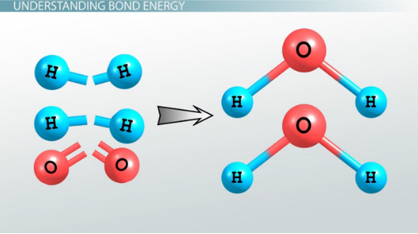

Unit 3: Chemistry in Society
Key Area: Hess’s Law
Student Notes

Name
Class

Calculating Enthalpy Changes Using Hess’s Law
Hess’s Law
Hess’s Law: This is a rule which states that the enthalpy change for a chemical reaction is independent of the route taken.





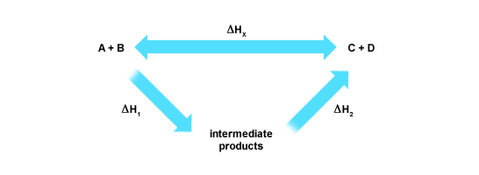
Hess’s Law states that ∆H_{x} = ∆H₁ + ∆H₂

Example Hess’s Law Calculation
Calculate the enthalpy change for the following reaction using the enthalpies of combustion of carbon, hydrogen and methane.
C(s) + 2H₂(g) CH₄(g)

Quick Method (Your teacher will give a more detailed method)

∆H = 1 X ∆H_{carbon} + 2 X ∆H_{hydrogen} + (-∆H_{methane})
∆H = -394 + 2 X -286 + 891
∆H = -75 kJ mol⁻¹

