
Beath High School
Chemistry Department
Higher Chemistry
Unit 2: Natures Chemistry

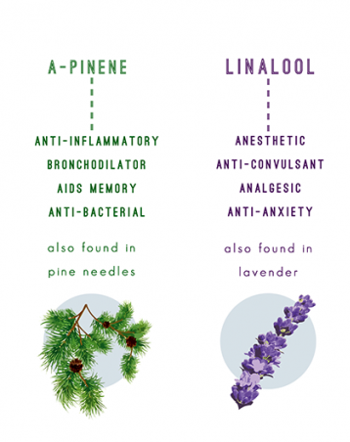
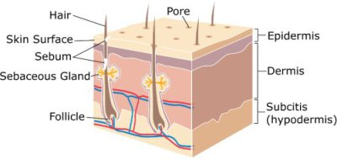

Unit 2: Nature’s Chemistry
Fragrances and Skin Care

Name
Class

ESSENTIAL OILS

Essential oils are hydrophobic liquids containing mixtures of volatile compounds that evaporate easily instantly in air giving distinctive fragrances.
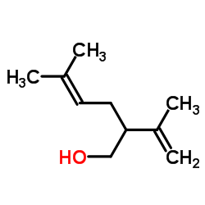
The oils have the aroma of the plant from which they are extracted for example lavender, peppermint, orange, lemon, and eucalyptus oils.
Lavandulol

Every essential oil contains a mixtures of organic compounds rather than just one pure compound, but it is often the aromatic molecules that provide the distinct fragrances.

Essential oils are extracted from plant material using steam distillation

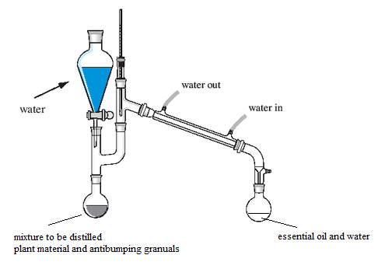
Steam Distillation

In this process the volatility (ease of evaporation) of the oil is important as it is carried by the steam. More water can be added from the funnel.

The essential oil collects as a mixture of oil and water, but as the two do not mix, they are easily separated.

Essential oils are used in perfumes, cosmetics, soaps and other products, for flavoring food and drink, and for adding scents to incense and household cleaning products.
An important component in essential oils are known as terpenes.
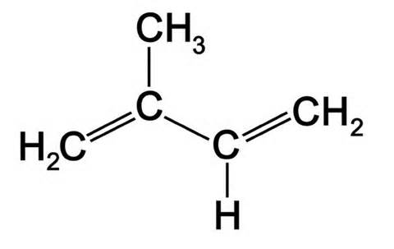
Terpenes
Terpenes are u__________d compounds formed by joining together isoprene (2-methylbuta-1,3-diene) units.
The basic molecular formulae of terpenes are multiples of that, (C₅H₈)_{n} where n is the number of linked isoprene units. This is called the isoprene rule. To figure out the number of isoprene unit in a terpene, you can count the number of carbons present and divide that by ____.
The isoprene units may be linked together "head to tail" to form linear chains or they may be arranged to form rings. One can consider the isoprene unit as one of nature's common building blocks
Isoprene unit
Isoprene unit

Limonene is known for its ability to act as a natural solvent and a cleanser.

Myrcene is a component of plants, including bay, ylang-ylang and thyme.

Terpenes are components in a wide variety of fruit and floral f___________ and aromas.
Terpenes can be oxidised within plants producing some of the compounds responsible for the distinctive aroma of spices.
Terpenes containing oxygen or other functional groups are known as terpenoids

Key area check test- Fragrances

- Draw an isoprene unit

- What is the chemical name for an isoprene unit?

- How many isoprene units are found in this molecule?

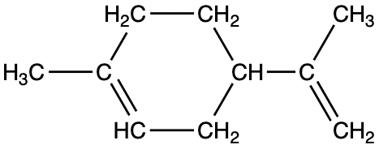

- What family are made from isoprene units?

- When terpenes are oxidised, what type of compound is formed?

- Why are terpenes described as being unsaturated compounds?

- How many isoprene units are found in this molecule of linalool?

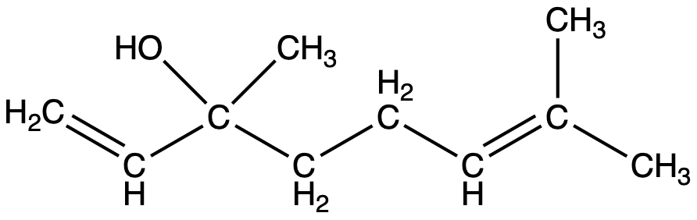

SKIN CARE

Effect of UV Radiation

Ultraviolet radiation (UV) is a high-energy form of ________, present in sunlight.

Exposure to UV light can result in molecules gaining sufficient energy for bonds to be __________. This is the process responsible for sunburn and also contributes to aging of the skin. Sun-block products prevent UV light reaching the skin.
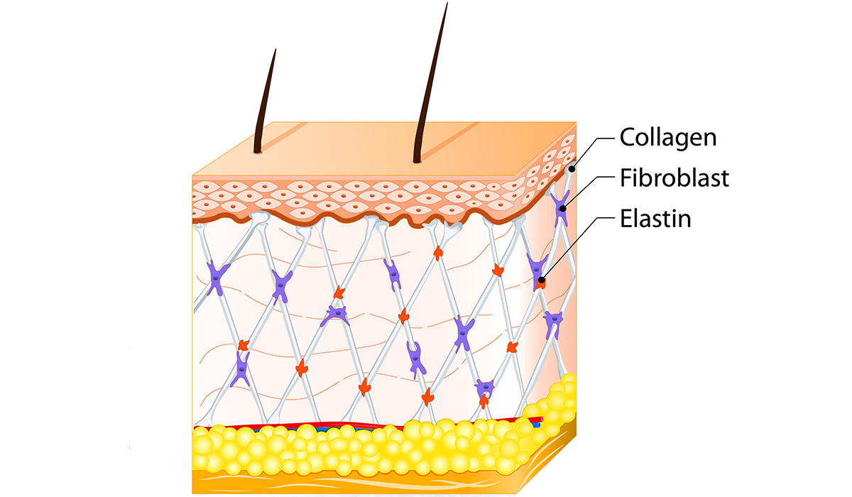
UVA and UVB cause wrinkles by breaking down collagen, creating substances called free radicals that inhibit the natural the repair of the skin.

UVB light (but not UVA light) is stopped by glass. You may notice labels on sunglasses to indicate their effectiveness.

UV Photography reveals the effects of "photo aging", or aging of skin caused by light.

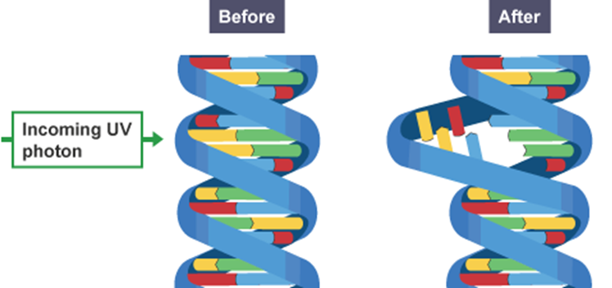
Photo aging refers to the damage that is done to the skin from prolonged exposure to UV radiation, over a person's lifetime. Most of the skin changes that occur as we get older are accelerated by sun exposure. Examples of skin changes from photo aging include dark spots, wrinkles, leathery skin and skin cancer (malignant melanoma).

Free Radical Reactions

Free radicals are highly r_________ atoms or molecules that have one unpaired __________. They are unstable as there is a tendency for unpaired electrons to pair up and so the free radicals react very __________.

Free radicals can be formed when a covalent bond is broken by energy supplied by ___ light. Due to their reactivity, they are able to cause c______ r_________, as they often react to produce other free radicals.

Free Radical: A highly reactive substance with a single unpaired electron.



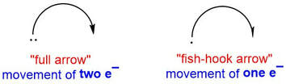

Free radical reactions happen in a three stage process.

Stage one: Initiation

free radicals
molecule

The dot next to each of the bromine atoms in the above equation represents the unpaired electron each has from the shared pair of the c_________ bond. Dividing one bromine molecule produces two highly reactive r__________s.
UV light is needed to begin the process, but further reactions do not need UV light. The chain reaction can continue, even in total darkness.

Stage two: Propagation

The highly reactive radicals formed can remove atoms from other (stable) compounds to re-establish stable covalent bonds. This reaction will produce a new free radical.
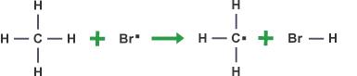
For example, a bromine radical can react with an alkane e.g. methane.

The new radical formed can in turn react with another bromine molecule. This is also a propagation step as it also generates a free radical product.
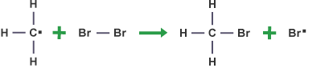

As free radicals are produced in this stage, a chain reaction occurs

Stage three: Termination

The chain reaction will only end when a reaction takes place in which no new radicals are formed. This can occur whenever radicals react with each other forming a stable product.
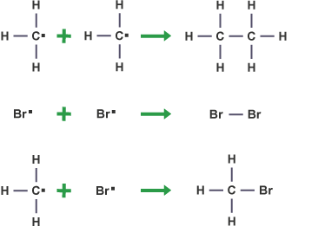

Free radical reactions have 3 steps:
- Initiation
- Propagation
- Termination

Free radical Substitution of Hydrogen and Chlorine
Another free radical reaction takes place when hydrogen and chlorine react in the presence of UV light.
The reaction can be shown as follows:
H₂(g) + Cl₂(g) → 2HCl(g)

The reaction follows is an example of a free radical chain reaction, initiated by U.V. light. For convenience, the reaction takes place in three stages.

1) Initiation
U.V. light provides the energy for the fission of chlorine into reactive chlorine free radicals (atoms or molecular fragments with an unpaired electron).
Cl₂(g) → Cl•(g) + •Cl(g)

2) Propagation
In this stage, free radicals collide with other species but the number of free radicals is maintained (hence the term propagation).

Cl•(g) + H₂(g) →HCl(g) + H• (g)
Cl₂(g) + •H → Cl•(g) + HCl(g)
These reactions continue until reactants are used up, or until free radicals collide with each other.
3) Termination
In this stage, free radicals are collide with each other.
H• (g) + •H(g) → H₂(g)
Cl•(g) + •Cl(g) → Cl₂(g)
H•(g) + •Cl(g) → HCl(g)

Free Radical Scavengers

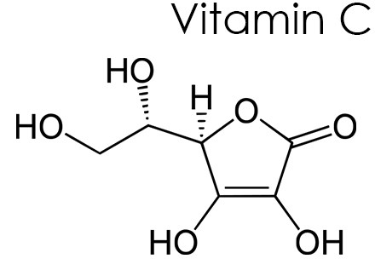
Free radical scavengers are chemicals (usually vitamins, minerals or enzymes) that react with free radicals to produce stable molecules and so prevent _________ __________.

This is often desirable to help protect our s_____ (so they are present in cosmetics) and our food (present both in some foods and in plastics).

Many free radical s___________ are antioxidants. For example, green tea contains polyphenols which act as free __________ scavengers. These ________ quickly with two of the most common radicals, hydroxyl radicals () and oxygen radicals (), formed from the breakdown of water and oxygen respectively. When p____________s react with these radicals, further reactions are prevented.

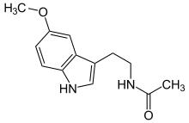
Melatonin

Key area check test- Skin care and Free Radicals

- What is a free radical?

- Describe what causes free radicals to form?

- How does sunblock protect human skin from damage?

- Name the three main steps in every chain reaction.

- In which step are the free radicals neutralised and stabilised?

- Complete the missing steps in this chain reaction;
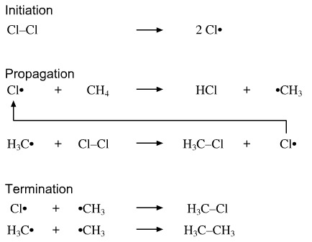

- What is the job of a free radical scavenger?

- In what stage do free radicals collide to produce more free radicals?

- What is the difference between these two types of arrows? What do they show?

- What does the • indicate in Br•?

