
Beath High School
Chemistry Department
Higher Chemistry
Unit 2: Natures Chemistry

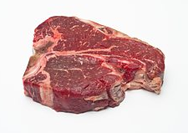

Unit 2: Nature Chemistry
Key Area: Oxidation of food
Course Notes

Name
Class

Chemistry of Cooking
Many of the f_________ in foods are due to the presence of volatile molecules. Normally these molecules are trapped in cells. However, during cooking the cell walls can be ruptured by evaporating.
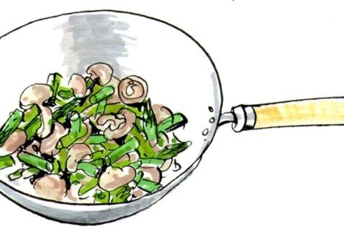
Volatile flavour molecules can then leave the food and enter the air. However, some may dissolve in the cooking liquid and be lost. So the method and time of cooking is important in preserving flavours. Flavour molecules can be water-soluble or oil/fat-soluble.
Flavour in foods can be preserved by choosing the appropriate cooking method i.e. using water for cooking foods that contain oil/fat-soluble flavours e.g. green beans and broccoli, using oil/fat to cook foods that are richer in water-soluble flavours e.g. asparagus.
Overcooking food using either method will cause more flavour to be l____.
The f__________ groups present in flavour molecules will give an indication whether they are likely to be water or oil s______. The size and functional groups present can be considered in predicting their relative b______ point and hence probable volatility. The important feature here is whether the functional groups present can hydrogen bond with water, making them water soluble, or whether they are unable to h_________ b_____ with water in which case they will be fat- or oil-soluble.
To recognise flavours we use both our sense of t_____ and sense of s_____. There are at least five basic taste qualities: sweet, sour, bitter, salty, and umami. (Umami, or savoury, is the taste we comes from glutamate, found in chicken broth, meat extracts, and some cheeses.) Our nose can detect more than 10 000 different smells. If there is hydrogen bonding between the molecules responsible to smell, this will reduce the volatility of the molecule.
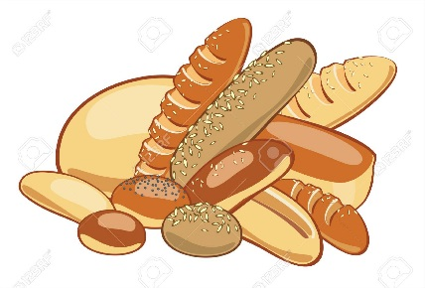
To complicate matters some chemical reactions that take place during cooking can result in new, desirable flavours. The chemistry here is complicated but a simple example to illustrate that more desirable flavours appear happens when bread is toasted. Bread contains a carbohydrate and its carbonyl group (>C=O) reacts with amino groups (-NH₂) in protein to make this desirable smell.

Some functional groups are included in the table below for reference. However, the presence of a particular functional group is no guarantee of the substance being water- or oil-soluble. e.g. a long hydrocarbon chain (which is non-polar) with a single polar group would be unlikely to be able to hydrogen bond with water and would make the molecule more likely to be oil-soluble.
Functional group name | Functional group structure | Can it form hydrogen bonds? | Water- or oil-soluble
Alkane | C-C | No | oil-soluble
Alkene | C=C | No | oil-soluble
Alkyne | C=C | No | oil-soluble
Hydroxyl | -O-H | Yes | water-soluble
Carbonyl | >C=O or | Yes | water-soluble
Carboxylic acid | -COOH or | Yes | water-soluble
Aldehyde | -CHO or | Yes | water-soluble
Amino | -NH₂ or | Yes | water-soluble
Phenyl | C₆H₅- or | No | oil-soluble
Amide | -CONH- or | Yes | water-soluble
Ester | -COO- | Yes | water-soluble

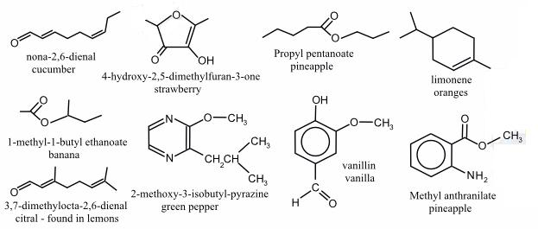
As a general rule, if the molecule contains only C and H atoms it will be non-polar, while if it also contains O or and N atoms it is more likely to be ______. However, the non-polarity of long hydrocarbon chains/rings can cancel the effect of a single polar group and make the molecule behave as non-polar.

Many common flavours from different foods are caused by molecules within the foods called aldehydes and ketones.
Both of these molecules contain the same f__________ group (the carbonyl group) and are named in similar ways.

Aldehydes
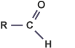
Aldehyde molecules (also known as alkanals) have their c________l functional group (C=O) at the end of the carbon chain. Their names end in -al.

Naming any molecule is straightforward if you follow these rules:
- Find the longest carbon chain and name it. For example, a chain of five carbon atoms will have a name based on pentane.
- Number the carbon atoms in the chain so that the functional group has the lowest possible number. For aldehydes, since the carbonyl group is at the end of the chain, the carbon of the C=O is always on carbon number one.
- Identify any branches joined onto the main chain and name them.
- Identify each branch by a number indicating its position. If more than one branch is present then a prefix must be used (di = 2 branches, tri = 3 branches, tetra = 4 branches).
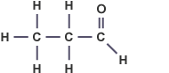
When naming a__________ molecules, the carbonyl functional group does not need to be numbered as it will always be on the _____ carbon.

Look at the following aldehyde molecules. The above naming rules have been applied to give them their systematic names.
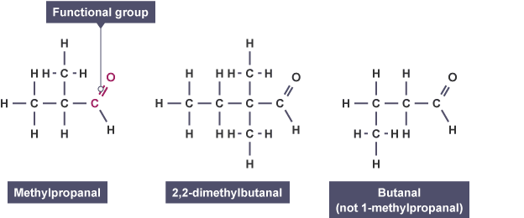
Be careful when naming molecules to number the longest possible c_________ c_____, and that when writing the name, you follow the convention of using commas between numbers and dashes between numbers and words.

Ketones
Ketones (also known as alkanones) are similar to a__________ in that they also contain the carbonyl functional group.

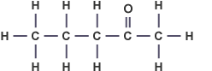
When naming ketones, the same rules as before are followed, however the position of the carbonyl functional group must be identified.
In ketones the carbonyl group is ________ at the end of the carbon chain. Their names all end in -one.

Look at the following ketone molecules. For unbranched propanone and butanone molecules, no numbers are required as the carbonyl group must be on carbon number two in both molecules.
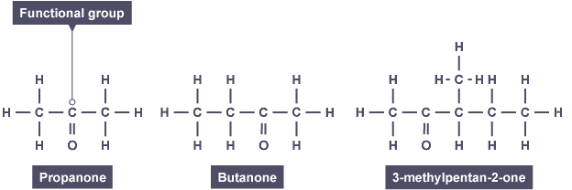

Oxidation of Food

When chemicals in food are exposed to oxygen in the air, their chemical composition changes and they begin to b_______ d______.
Animal and plant tissues contain antioxidant molecules to prevent this from happening. These molecules can slow the rate of __________ in our foods.
However foods will lose their nutritional value over time as they begin to discolour and break down.

Key area check test – Aldehydes and Ketones

- What is functional group found in both the aldehydes and ketones?

- What is the systematic name for these molecules?

a)

b)

c)

d) CH₃CH₂CH₂CH₂CHO

e) CH₃CH₂CH₂CH₂COCH₂CH₃

f) CHOCH₃CH₂CH₂(CH₃)CH₃

Oxidation of alcohols
The partial oxidation of an alcohol can be brought about by using an oxidising agent.
Some typical oxidising agents are:
- Acidified potassium dichromate solution
- Acidified potassium permanganate solution
- Hot copper (II) oxide (black solid)
- Benedict’s reagent
- Tollen’s reagent (silver-mirror)

Primary alcohols
Oxidation of primary alcohols forms two products in a two stage reaction.
When carbon compounds are oxidised, the oxygen to hydrogen ratio increases, so either oxygen atoms are being added to the compound, or hydrogen atoms removed.

Consider the oxidation of propan-1-ol.

Stage one
The first stage oxidation of a primary alcohol involves the molecule losing two hydrogen atoms to form an __________.
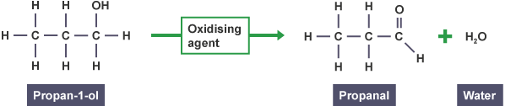

Stage two
In the second stage, oxygen is added to the aldehyde molecule to form a ___________ _______.
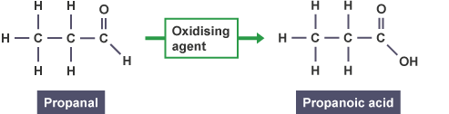

Secondary alcohols
Unlike primary alcohols, __________ alcohols can only be oxidised once.
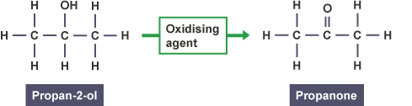

Summary of oxidation

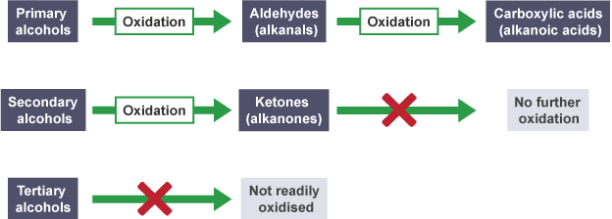

Aldehydes and ketones - Telling the difference
While they both contain the same functional group, aldehyde and ketone molecules react differently.
Telling the difference between the structures of the molecules is simple enough based on the ___________ of the carbonyl group. Chemically you can tell them apart using an ___________ agent. Only aldehyde molecules will show any reaction when heated with an oxidising agent.
Some typical oxidising agents and their colour changes are shown in the table below.
Oxidising agent | Colour change
Acidified potassium dichromate solution | Orange → __________
Fehling's solution | ________ → Brick red precipitate
Tollen’s reagent | Clear → __________________

Key area check test – Oxidation for Foods
- What is formed when a primary alcohol is oxidised?

- What is formed when an aldehyde is oxidised?

- What is produced as a product of a ketone being oxidised?

- Complete these word equations;

- Hexan-1-ol + oxidising agent -> ___________

- Butan-2-ol + oxidising agent -> ___________

- Propanal + oxidising agent -> ___________

- ______________+ oxidising agent -> Butanone

- 3-methyloctan-3-ol + oxidising agent -> ____________

- Draw the structure of the product formed when Butan-2-ol is oxidised;

- Draw the structure of the product formed when 2-methylpropan-2-ol is oxidised;

- Two examples of oxidising agents are;

A-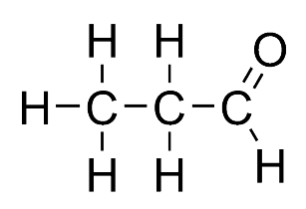 | B- 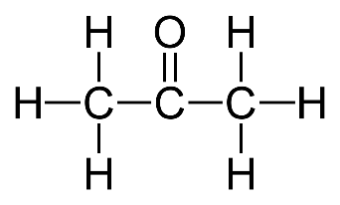 | C-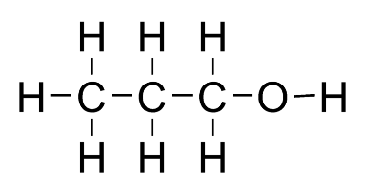
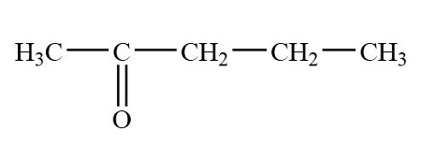D- | 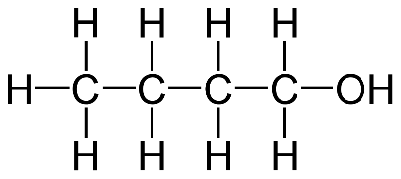  E- | 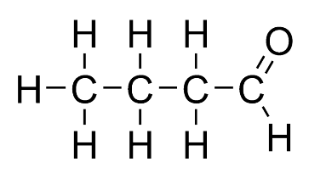  F-

a) Which is/are part of the alcohol homologous series?
b) Which is/are part of the aldehyde homologous series?
c) Which is/are part of the ketone homologous series?
d) Which is/are isomers of each other?
e) Which is butanal?
f) Which is propanol?
g) Which has the formula C₄H₁₀O?
h) Which is made when Butanal is reduced?
i) Which is made when Propanal is reduced
j) Which when oxidised would make propanoic acid?
k) Which is/are primary alcohols?
l) Which would make secondary alcohol when reduced?
m) Which is made when Butanoic acid is oxidised?

- Which oxidising agent turns silver when added to an Hexanal?

- Draw the structural formula for all the products formed when Pentanoic acid is reduced. Include all possible reductions.

