
Beath High School
Chemistry Department
Higher Chemistry
Unit 2: Natures Chemistry

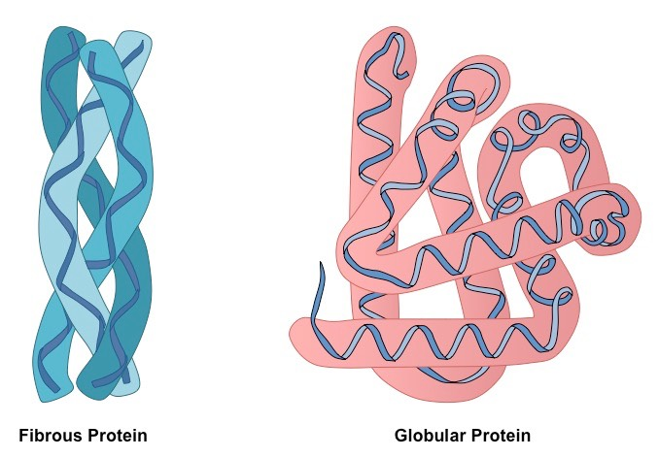

Unit 2: Nature’s Chemistry
Key Area: Proteins
Course Notes

Name
Class

Previous Knowledge from National 5 and Higher
Knowledge from National 5 & Higher

- Carboxylic acids are a homologous series of compounds containing the carboxyl functional group (-COOH)

- The names of straight chain carboxylic acids with up to 8 carbons in the chain.

- Condensation reactions involve molecules joining together with the loss of water.

What are proteins?
Nitrogen is an important essential element for plant growth. It is used in building proteins. The nitrogen is usually taken in by the roots of plants as nitrate ions dissolved in w______. However, some plants, e.g. bean, clover and pea, have root nodules containing bacteria which allow them to take in nitrogen directly from the _____.
Proteins are taken in by animals when plants or other animals are eaten. Animals need proteins as a part of a balanced diet for body-building and repair.
High protein foods are:- fish, meat, chicken, cheese, beans, pulses, etc.
Proteins are natural polymers made from monomers called a________ a_______.
Amino acids are molecules with both a __________ and an _________ functional group
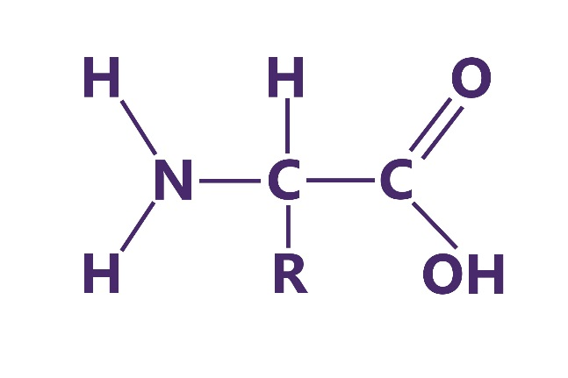

Carboxyl
Amine

Testing for Proteins

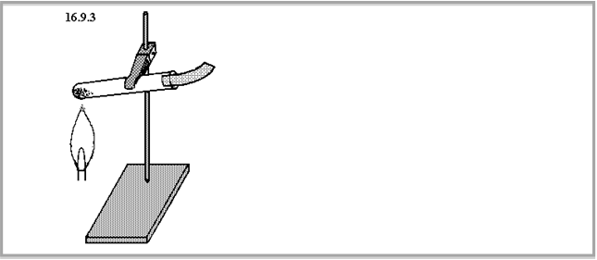When a protein is heated in the presence of soda lime (a mixture of calcium and sodium hydroxide) an unpleasant basic gas is produced which turns the pH paper blue.
protein and soda lime mixture
moist pH paper
The gases formed are amines or ammonia, which are chemicals that contain nitrogen. This shows us that proteins contain nitrogen.
Proteins are substances that contain the elements carbon, oxygen, nitrogen, and hydrogen.



Amines
Amines are a homologous series of compounds that contain carbon, hydrogen and nitrogen. The functional group is an amine (or amino), -NH₂.

The first few members of the amine homologous series are shown below.

Name | Structural Formula
methylamine | 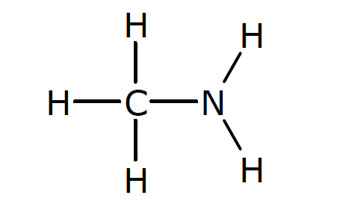
ethylamine | 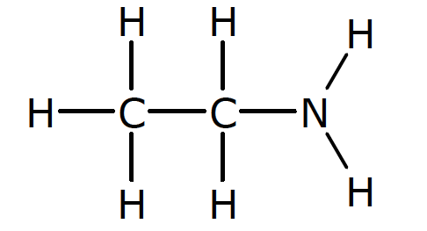
1-aminopropane | 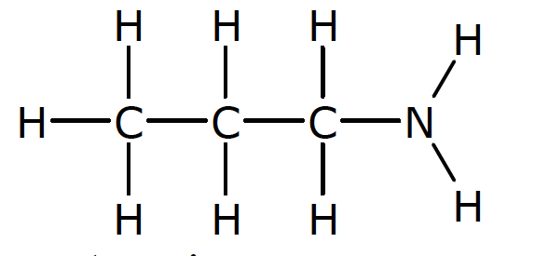
2-aminopropane
1-aminobutane
2-aminobutane
1-aminopentane
3-aminopentane

Amino Acids
Amino acids are compounds that contain an amino functional group (-NH₂) and a carboxyl (-COOH) functional group.

An example of an amino acid structure is shown below.
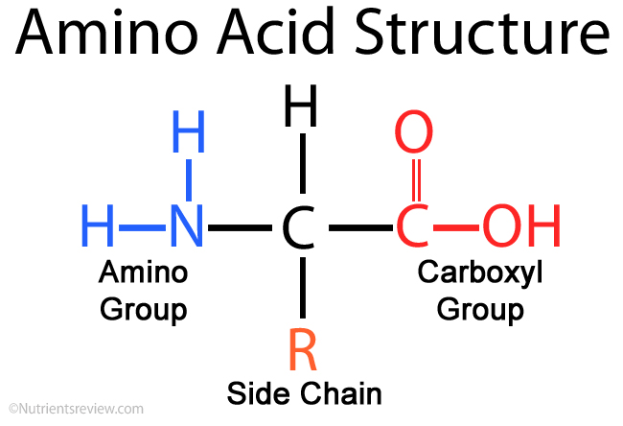
‘R’ represents a side chain that may contain the other elements

Name of Amino Acid | ‘R’ Side Chain | Amino Acid Structure
Glycine | H
Alanine | CH₃
Valine | CHCH₃CH₃
Aspartic Acid | CH₂COOH
Methionine | CH₂CH₂SCH₃
When amino acids react together they form ___________. There are 20 amino acids that are required for the synthesis of body proteins.
Ten of these amino acids cannot be made our bodies and must be obtained from our diet. These are called e__________ amino acids.

Essential amino acids must be obtained from our diet as our bodies cannot synthesise them.

Our bodies cannot store amino acids.
When amino acids react, they join together by an amide link (peptide link) in a condensation reaction. This results in the formation of a new product and water.
- When two amino acids react together the new product is a ____peptide.
- When three amino acids react together the new product is a ____peptide.
- When many amino acids join together a ____peptide is formed. A protein is a polypeptide.

The diagram below shows the formation of a dipeptide.
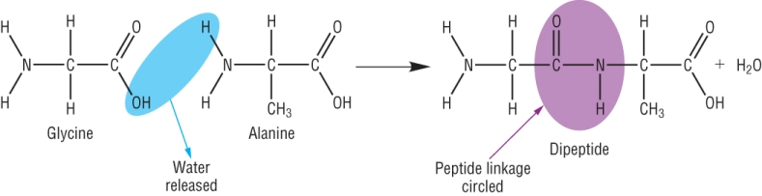

Making Proteins
Amino acids contain both an amino group and carboxyl group, this enables the amino acids to condense and form larger molecules. Making a protein from amino acids is an example of a c_____________ reaction.
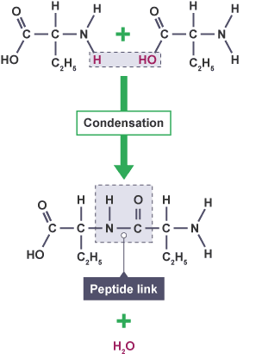

When amino acids join together an amide link (or peptide link) is formed and w________ is produced. The amide link is formed by the reaction of an amino group with a carboxyl group.

The structure of a section of protein is based on the constituent amino acids. The sequence by which the amino acids are joined differs in different protein molecules. The sequences of amino acids are controlled from information (DNA) in the _________ of the cell.

Chemistry of Cooking
Proteins can be classified as fibrous or globular.
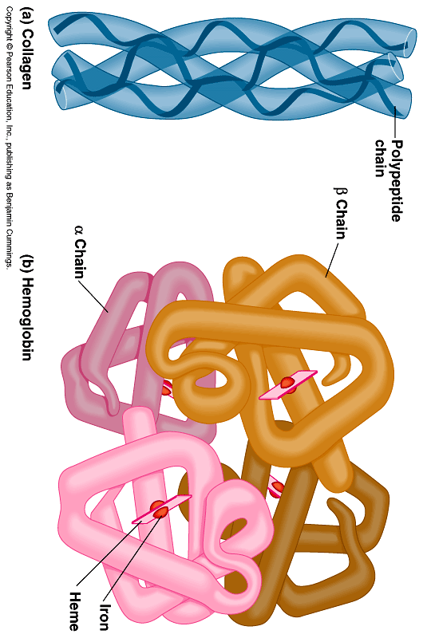

Fibrous proteins are long and thin and are the major structural materials of animal tissue.
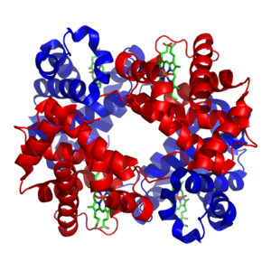e.g. muscle fibres, collagen found in the skin

Globular proteins have the spiral chains folded into compact units. G_________ proteins are involved in the maintenance and regulation of life processes and include e_________ and many hormones.
e.g. haemoglobin- the important iron-containing oxygen-transport protein in red blood cells
Proteins are complex molecules made from many _________ _______ joining together. Chains of proteins are held together by van der Waals forces between the side chains of the amino acids used to form the protein.
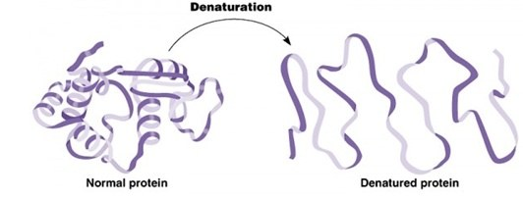When proteins are heated during cooking, the van der Waals forces are ________ which allows proteins to change their s_______. This d____________ them. This then changes the texture and taste of the food.
Enzymes
Enzymes are proteins, which act as b___________ c__________.
They are specific to particular chemical reactions e.g. the enzyme amylase only catalyses the breakdown of starch into smaller sugars and not any other chemical reaction.
The area of the enzyme where the reaction happens is called the active site.
The shape of the active site allows specific reactants, called substrates, to attach. Substrates have a specific shape to be able to react with the enzyme.
Enzymes are sensitive to ____ and ____________. If they are exposed to extremes of pH or temperature the shape of the active site is changed so that they no longer function.
When this occurs, the enzyme is said to be denatured.
All proteins, not just enzymes, can be denatured by extremes of pH or temperature.
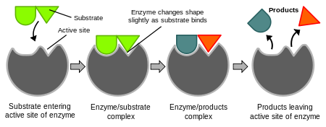

Enzymes are proteins.
They are biological catalysts that work under certain conditions of pH or temperature.
Reactions take place in the active site of an enzyme.
If an enzyme is denatured, the shape is changed so it can no longer function.

Hydrolysis of Proteins
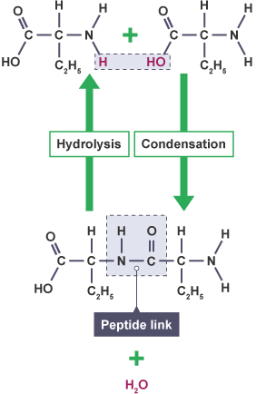
During digestion, enzymes in our bodies hydrolyse proteins in food to form amino acids. These amino acids then pass through the gut wall into the blood stream.

In our stomach the enzyme pepsin starts the digestion of protein by h____________g it to smaller polypeptides. Additional enzymes then continue to the hydrolysis process to form the constituent amino acids.

During hydrolysis l______ protein molecules are broken down into smaller molecules by ________.
Protein hydrolysis involves using water to break down proteins into amino acids.

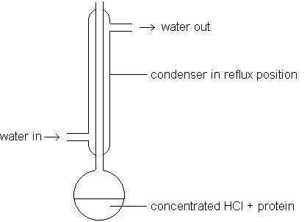
In the lab a protein can be hydrolysed back to its constituent amino acids by refluxing with concentrated hydrochloric acid for several hours.

Amino acids can be identified by the use of paper (or thin layer) chromatography.

Chromatography of Amino Acids
A piece of c_______________y paper is spotted with some amino acids suspected as being present and also with the hydrolysed protein.
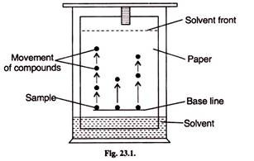By comparing the p__________ of the spots of the known amino acids with that of the hydrolysed protein, the amino acids in the protein can be identified. The different amino acids will travel different distances due to their size and solubility.

Key area check test- Proteins and Amino Acids
- What function groups are present in amino acids?

- What is an essential amino acid?

- What type of reaction occurs when amino acids form a protein?

- What is produced alongside amino acids in this reaction?

- When a protein is heated to high temperatures what happens to it?

- Why does temperature cause this change to occur?

- What other factor can cause the denaturing of a protein?

- Draw the tripeptide formed when three glycine amino acids condense together. (glycine shown below)

