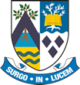
Beath High School
Chemistry Department
Higher Chemistry
Unit 2: Natures Chemistry

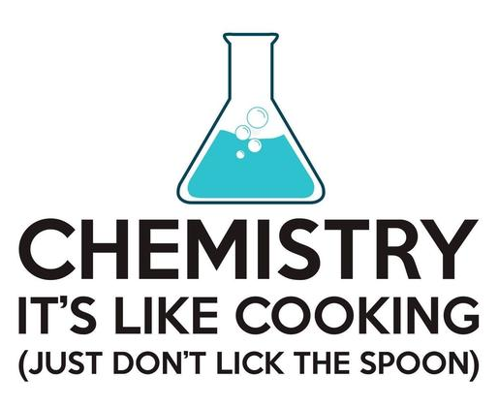

Unit 2: Nature Chemistry
Key Area: Alcohols and Carboxylic Acids
Course Notes

Name
Class

Alcohols

Alcohol molecules contain the h________ (-OH) functional group. They are a homologous series and have the general formula C_{n}H_{2n+1}OH. Their names end in -ol.
The rules for naming an alcohol are:
- Find the longest carbon chain and name it.
- Number the carbon atoms in the chain so that the functional group (in this case, the hydroxyl group) has the lowest possible number.
- Identify any branches joined onto the main chain and name them.
- Identify each branch by a number indicating its position. If more than one branch is present then a prefix must be used.

This simple alcohol molecule is called butan-2-ol.

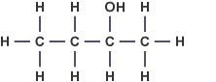
The names, molecular and structural formulae of some straight chain alcohols are shown in the table below.
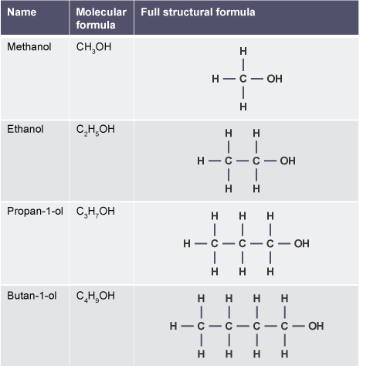

When naming branched chain alcohols, be careful to number the longest possible carbon chain first.
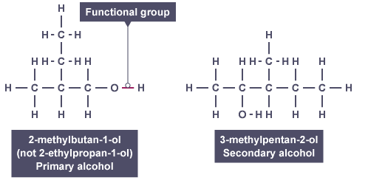

When writing the name, follow the convention of using commas between numbers and dashes between numbers and words.

Types of alcohols
There are _____ types of alcohol molecules. The type of alcohol is determined by the position of the __________ functional group.

Primary alcohols
A primary alcohol is one in which the h__________ group (–OH) is attached to a carbon atom with at least two hydrogen atoms.
This will only occur when the hydroxyl group is at the ______ of the molecule chain.
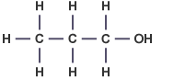
Propan-1-ol is a primary alcohol.

Secondary alcohols
A secondary alcohol is one in which the hydroxyl group (-OH) is attached to a carbon with only _______ hydrogen atom attached.
This can happen somewhere in the middle of a carbon chain.
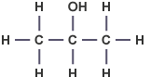
Propan-2-ol is a secondary alcohol.

Tertiary alcohols
A tertiary alcohol is one in which the hydroxyl group is attached to a carbon with ________ hydrogen atoms attached.
This will normally mean that the hydroxyl group is joined to the same carbon atom as a branch.
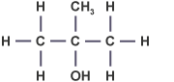
2-methylpropan-2-ol is a tertiary alcohol.

Properties of alcohols

Compared with alkanes, alcohols have significantly h________ boiling points. The hydroxyl groups in alcohol molecules are responsible for h________ b_______ between the alcohol molecules.
As greater energy is required to overcome these ________ intermolecular forces, the melting points and boiling points of alcohols are higher than those of alkanes with a corresponding chain length.
Alcohols with a greater number of hydroxyl groups will have even ________ boiling points. When an alcohol has two hydroxyl groups it is called a diol. A molecule with three hydroxyl groups is a triol.
Compare these three molecules:

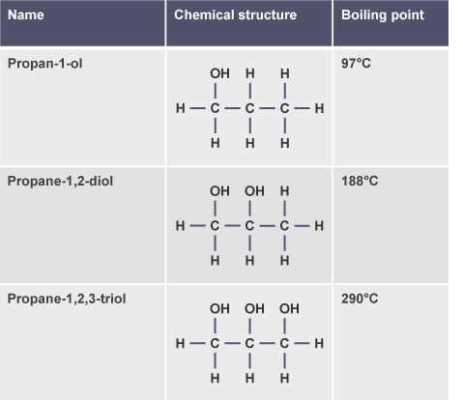

The large increase in the boiling point of alcohols occurs because as the number of hydroxyl groups increases, there is a greater degree of hydrogen bonding between the molecules.

Carboxylic Acids
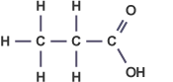
Carboxylic acids contain the carboxyl group (-______). When naming carboxylic acids, the same rules as before are followed, but the position of the carboxyl group does not need to be identified, as it is always on the first carbon.
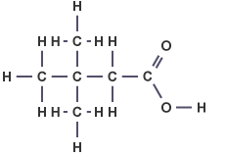
Carboxylic acids with branches can also be named following the rules.
The longest carbon chain in the molecule below contains ___ carbon atoms. As the carbon of the carboxyl group is the first of the chain, then both branches are on the third carbon.
This molecule is therefore called 3,3-dimethylbutanoic acid.

Reactions of carboxylic acids
Carboxylic acids can undergo reduction reactions. Reduction is the opposite of __________.
For example, ethanoic acid (CH₃COOH) can be formed by the oxidation of ethanol as shown below.
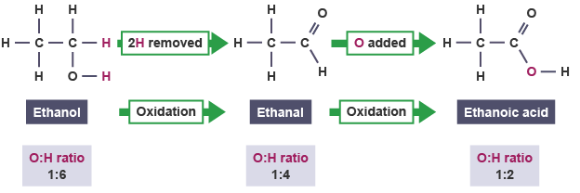

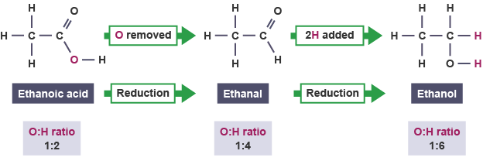
As reduction is the opposite of oxidation, it can be defined as the removal of ________ or the addition of __________ to a molecule.

Carboxylic acids can also react with b_____ to form a salt and water in n_____________ reactions. When long chain 'fatty' acids are used, the _____ formed is a soap.
For example:
Key area check test – Alcohols and Carboxylic Acids
1. Explain why methanol can be classified as a primary alcohol.

2. Identify which type of alcohol the following are:
- pentan-3-ol
- 3-methyloctan-3-ol
- 2-methylheptan-3-ol

3. What 2 products are formed when a carboxylic acid reacts with an alkali?

4. Draw a full structural formula for the following molecules:
- Pentanoic acid
- 2-methylbutanoic acid
- Butan-2-ol

