Beath High School
National 4/5 Homework
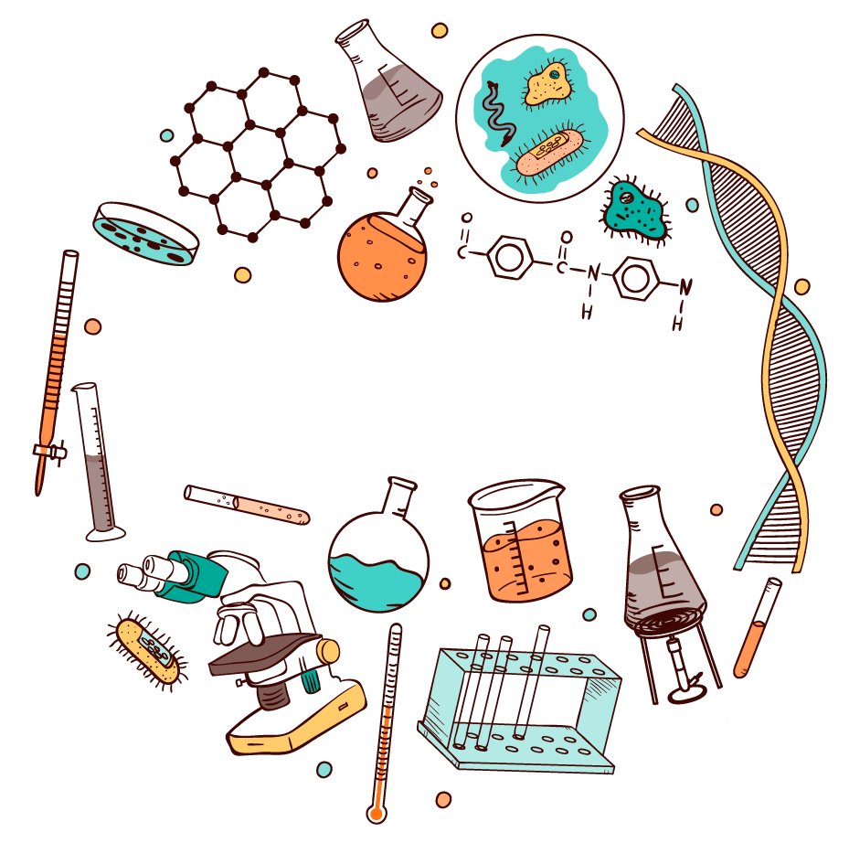

The Chemistry of
Consumer Products

 | Due Date: | Completed: |  | Due Date: | Completed:
Exercise 1 |  |  | Exercise 3
Exercise 2 |  |  | Exercise 4

Exercise 1: Alcohols and Carboxylic Acids

- What is the name of the functional group for the alcohols?

- Give the name for the member of the alcohols which has 3 carbon atoms and no branches.

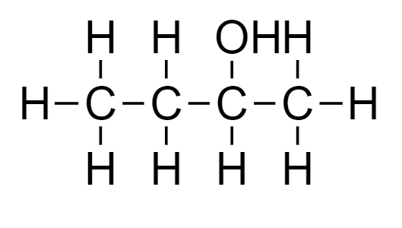
- What is the systematic name for this alcohol?

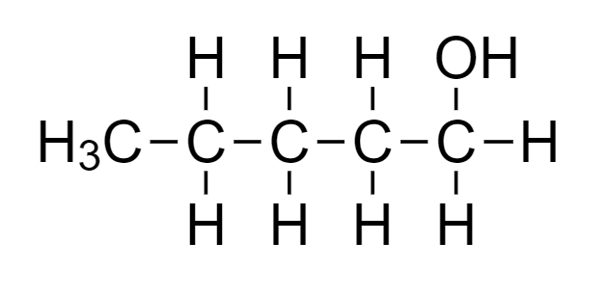
- What is the systematic name for this alcohol?

- What is the functional group for the carboxylic acids called?

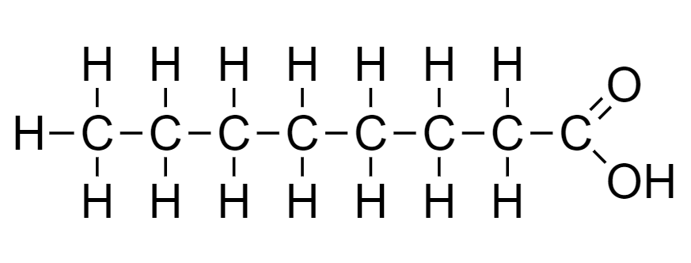
- Name this carboxylic acid.

- Draw 2-methyl hexan-3-ol

- Name the type of alcohol is found in drinks such as beer and wine?

- Describe what fermentation is.

- Complete this equation;

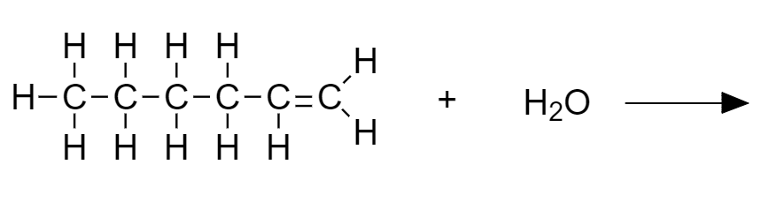

Exercise 2: Fertilisers
- Wr

Exercise 3: Plastics

- Exp

Exercise 4: Past Paper Questions
1)
2)
3)
4)
5)
6)
7)

