Beath High School
National 4/5 Homework



Analytical Chemistry

 | Due Date: | Completed: |  | Due Date: | Completed:
Exercise 1 |  |  | Exercise 3
Exercise 2 |  |  | Exercise 4

Exercise 1: Acid/Base Reactions

- Write the definition of a base.

- Where on the pH scale would you find acids?

- An acid was added to a base, explain how this would affect the pH of the solution.

- Name 3 common acids.

- Names 3 common alkalis.

- What is always formed when an acid and a base are combined? Write a simple equation to show this reaction.

- Describe which and how ions play a role in classifying a solution as an acid or alkali.

- Complete the table to identify the following compounds.
Name: | Acid/Base/Salt?
Sulphuric Acid
Sodium Hydroxide
Nitrogen Oxide
Calcium Chloride
Nitric Acid
Carbon Dioxide
Copper Oxide
Nitrate
Ammonia
Lithium Carbonate

- Describe what is happen when someone experiences heartburn/ indigestion and how it can be treated.

- Using your knowledge of Chemistry, explain why and how dilution affects the pH of acids. Make references to ions in your answer.

Exercise 2: Acid/Base Equations
- Write the names and symbols of the two ions that present in acids and bases.

- Match the acids to their salt name endings:

Sulphuric Acid - | - Nitrate
Hydrochloric Acid - | - Phosphate
Nitric Acid - | - Sulphate
Phosphoric Acid - | - Chloride

- Complete the following equations.
i) | Acid | + | Base | -> | Water | +
ii) | Sulphuric Acid | + | Potassium Hydroxide | -> | Water | +
iii) |  | + | Lithium Oxide | -> |  | + | Lithium Chloride
iv) |  | + |  | -> |  | + | Copper Nitrate

- Write the formulas for 3 the following acids;
- Hydrochloric Acid

- Sulphuric Acid

- Nitic Acid

- Write the formulas for 3 the following bases;
- Sodium Hydroxide

- Magnesium Carbonate

- Lithium Oxide

- Write a word equation for the reaction of Copper carbonate with Hydrochloric acid

- Turn the following word equations into balanced chemical equations;
- Sodium Carbonate + Nitric Acid -> Sodium Nitrate + Carbon Dioxide + Water

- Lithium Hydroxide + Hydrochloric Acid -> Lithium Chloride + Water

- Calcium Oxide + Sulphuric Acid -> Calcium Sulphate + Water

Exercise 3: Titrations

- Explain why we always repeat experiments including titrations.

- Name the pieces of equipment that are needed for a titration.

- What is a standard solution?

- How do we know when a titration is complete and to stop adding?

- In the formula: $\frac{c_{1}V_{1}}{N_{1}}=\frac{c_{2}V_{2}}{N_{2}}$ , what do C, V and N stand for?

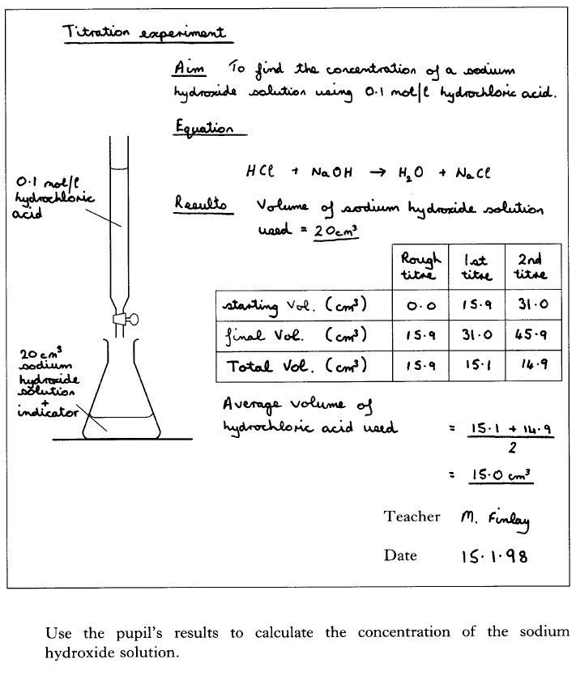

- Using your knowledge of chemistry, discuss experimental titrations. Refer to the procedure, calculations and any other relevant chemistry techniques.

Exercise 4: Past Paper Questions
1) | 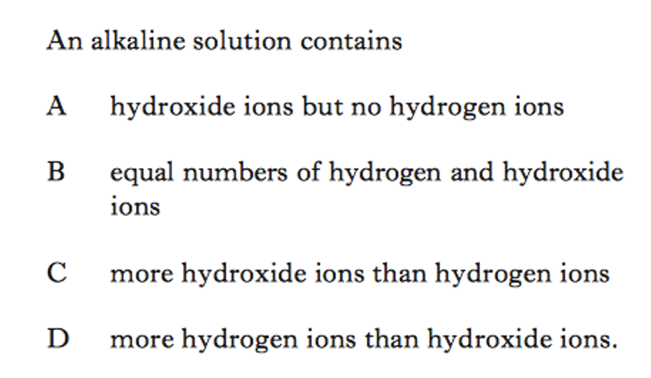
2) | 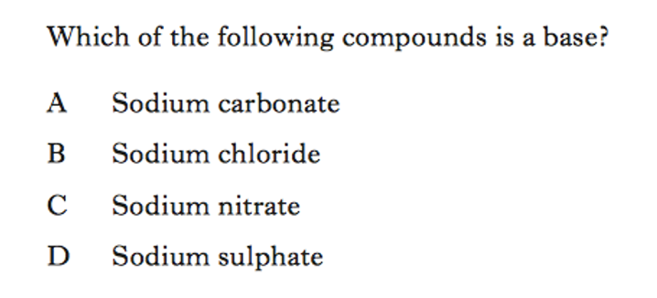
3) | 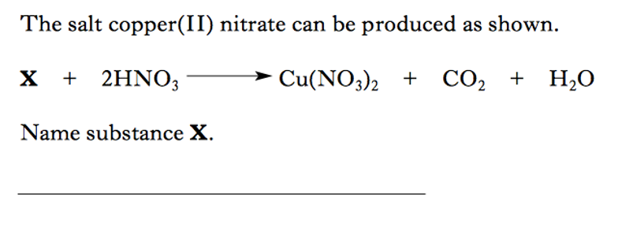
4) | 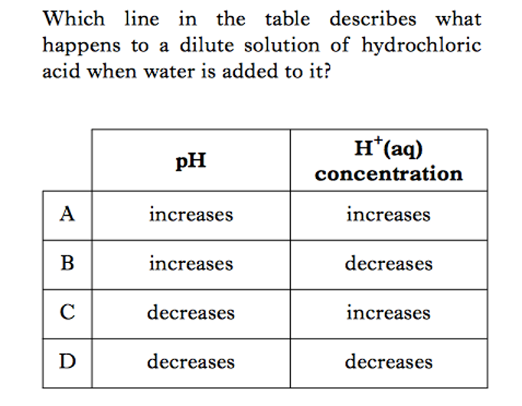
5) | 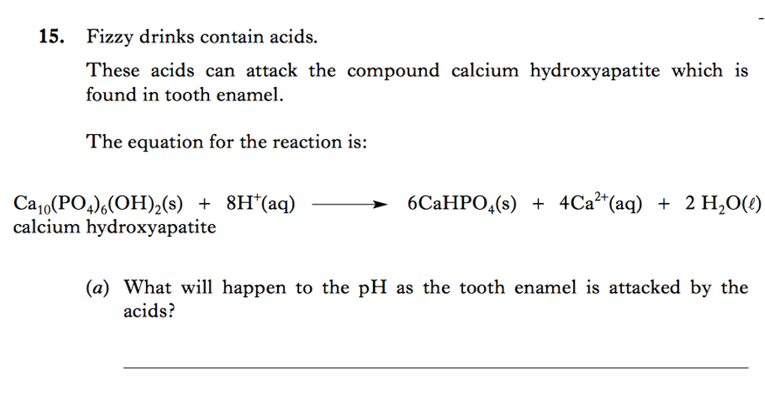
6) | 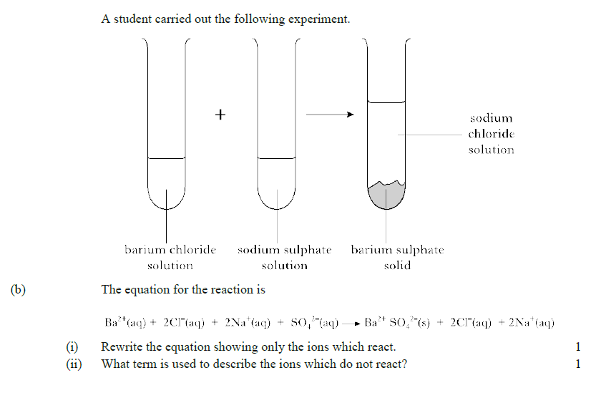
7) | 