
Beath High School
National 4/5 Homework

Elements and the Periodic Table

 | Due Date: | Completed: |  | Due Date: | Completed:
Exercise 1 |  |  | Exercise 5
Exercise 2 |  |  | Exercise 6
Exercise 3 |  |  | Exercise 7
Exercise 4 |  |  | Exercise 8

Exercise 1: Covalent Bonding and Structure

- If a compound ends in -ide how many elements are present?

- What element is always present in a compound which ends in -ate or -ite?

- Complete this table;
Group: | Period: | Element Name:
1 | 3
5 | 2
 |  | Chlorine
 | 5 | Xenon
3 |  | Aluminium
 |  | Phosphorus
2 | 4

- What is a covalent bond?

- Draw the bonding diagram of Cl₂

- When a metal and a non-metal join together, what type of bond is formed?

- Complete these sentences;
When a covalent bond is formed between two ___-________ atoms they are sharing a pair of electrons. These covalent compounds cannot conduct e___________, all the d_______ elements will form covalent molecules.

- List all of the diatomic elements

- Draw the electron arrangement/target diagram for the element Fluorine

- How many electrons does Fluorine need to gain or lose for it to become stable?

- Why is Neon far more stable than Fluorine?

- Explain what is meant when Oxygen is described as having a valency of 2?

- Complete;
Element | Group | Valency
Carbon
Magnesium
Nitrogen
Bromine

- Explain, using your knowledge of Chemistry; the difference between an ionic bond and a covalent bond.

Exercise 2: Formula and Shapes

- What is the valency of an element?

- What do the following prefixes mean?
    - Tetra =
    - Tri =
    - Di =
    - Mono =
- Write the formula for the following compounds, show your working;
    - Magnesium Oxide

    - Nitrogen Sulphide

    - Carbon Dioxide

    - Vanadium Trioxide

    - Potassium Chloride

    - Gallium Fluoride

    - Cobalt Tetrachloride

    - Zinc Dibromide

- What are the 4 covalent molecule shapes?

- What shape does water have?

- Draw the bonding diagram for Nitrogen Hydride.

- What shape does Nitrogen Hydride have?

- Why do electrons repel each other?

- Why are electrons and Protons attracted to each other?

- Why are atoms overall neutral if they contain charges?

- Name and draw the shape that Methane (CH₄) would have.

- Complete the following sentences;
When a covalent b_____ forms, atoms s______ a pair of e__________ between them. Elements in group 5 will have __ shared electrons from them and an extra __ shared from the other element.

An ionic bond is different as e_________ would not share electrons, instead the l_____ or g______ electrons to become s________.

- Using your knowledge of Chemistry; explain why an atom of Potassium is more stable in potassium Chloride than it is on its own.

Exercise 3: Ionic Compounds and Formulae

- Write the definition of an ionic bond

- Draw the electron arrangement for a Fluoride ion

- Why do atoms lose or gain electrons to become ions?

- Complete;
I_____ bonds can only form between elements that are different, one must be a m_______ and the other a n___-________. This is because the metal will _______ electrons and _______ them to the non-metal. This is different from a covalent bond, in which atoms ________ electrons.

- Draw a diagram showing the structure of an ionic lattice, must include charges for ions.

- Explain why when an ionic substance is melted or dissolved it will conduct electricity but when it is a solid it does not?

- A student tested the melting and boiling points of water and sodium chloride, they found that sodium chloride had a much higher melting and boiling point. Explain, with reference to their bonding, why this is the case.

- What does it mean if a substance is soluble?

- Complete this table;
Name: | Element type: | Ion charge:
Lithium
Calcium
Oxygen
Aluminium
Chlorine
Caesium

- Write the formula for the following covalent compounds;
    - Silicon Oxide

    - Boron Hydride

    - Nitrogen Bromide

    - Carbon Hydride

- Write the ionic formula for;
    - Lithium Fluoride

    - Manganese (II) Bromide

    - Iron (III) Oxide

- What are all of the state symbols and their meanings?

- Write this as an ionic equation;

Magnesium and Hydrochloric acid are reacted to form Magnesium Chloride solution and Hydrogen gas.

- Using your knowledge of chemistry, compare the compounds Magnesium oxide and Sulphur oxide commenting on their structure, bonding and chemical reactions.

Exercise 4: Writing and Balancing Equations
- What do the + and -> symbols mean in equations?

- Write the word equations for the following sentences;

    - When liquid hexane burns in a plentiful supply of oxygen gas it produces a flame and makes liquid water, and the clear, colourless gas carbon dioxide

    - Flammable oxygen gas is made when hydrogen peroxide decomposes naturally, is also produces water.

    - When Potassium is added to water is reacts violently, producing a lilac flame and lots of Hydrogen gas. It also turns the water into and alkaline solution by creating the base Potassium hydroxide.

- Now write the chemical equations for the previous question;

- Balance the following equations;
- H₂ + O₂ -> H₂O

- Zn + HCl -> ZnCl₂ + H₂

- Pb(NO₃)₂ + AlCl₃ -> PbCl₂ + Al(NO₃)₃

- Aluminium + Iron (III) oxide -> Iron + Aluminium oxide

- Using your knowledge of chemistry, explain why it is important to balance equations before using them.

Exercise 5: The Mole, GFM and Percentage Mass

- What is the definition for GFM?

- Explain what the Relative Atomic Mass of an element is?

- Calculate the GFM of the following substance;
- NO₃

- Cu₂O₃

- HNO₃

- HgBr₂(NH₃)

- NaMgAl₅(Si₄O₁₀)₃(OH)₆

- Write the formula for calculating the percentage mass of a compound.

- Calculate the following;
- Percentage of Nitrogen in NH₃

- Percentage of Oxygen in water

- Percentage of Potassium in K₂CO₃

- Percentage of Carbon in Sn(CH3COO)₄

Exercise 6: More Calculations

- Draw both the triangles/equations show the relationships between number of moles, mass, GFM, concentration and volume.

- Calculate the mass for the following compounds;
- 2 moles of NH₃

- 3 moles of H₂O₂

- 4 moles of Carbon Dioxide

- 5 moles of Nickel(II) Oxide

- Calculate the concentration of a 500cm³ which contains 3.5 moles of Copper Chloride.

- Explain the difference between the following words; Solute, Solvent and Solution.

- Using both triangles solve the following calculations;

- Calculate the mass needed to make 600cm³ of a 0.5mol/l solution of Magnesium Chloride (MgCl₂).

- Calculate the concentration of a 400cm³ solution containing 5g of Lithium Bromide.

- Calculate the volume produced when a solution of 0.6mol/l solution of Ammonium Nitrate (NH₄NO₃) was made using 3.5g.

Exercise 7: Metals

- Give three common properties of metallic elements

- Explain why, using reference to their structure, metal and great conductors of electricity.

- Draw a diagram showing the structure of a metallic lattice

- Complete the following;
- Metal + Oxygen -> _______________________

- Calcium + Oxygen -> _______________________

- Metal + _______ -> Metal Hydroxide + Hydrogen

- Magnesium + Water -> _______________________

- When a metal forms an ion, what would the charge be on that ion?

- What are the three methods of extracting metals from their ores? Explain why there needs to be more than one method.

- Complete the table using the word-bank;
Metal name: | Reactivity |  | Word-bank:  Lithium  Copper  Calcium  Potassium  Magnesium  Sodium  Gold  Iron
 | Most Reactive
 | Least Reactive

- Explain the origin of the word Electrolysis, what does this word mean?

- During an electrochemical cell, how could we tell which direction the electron will be moving in?

- Which combination of metals in a cell would produce the highest voltage?
- Magnesium and Zinc
- Lithium and Copper
- Calcium and Aluminium
- Iron and Tin

- Explain the reason for using an ion bridge or salt bridge in an electrochemical cell.

- Describe what the difference is between an oxidation reaction and a reduction reaction.

- On this cell, label the direction of flow of electrons and ions with arrows;

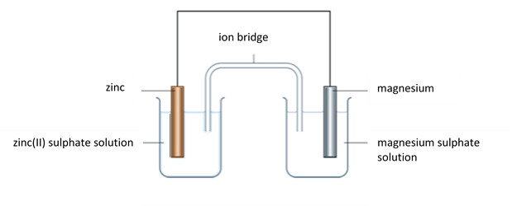

- In the previous question; which metal was being oxidised and which reduced?

- Write the reduction equation for Silver.

- Write the oxidation equation for Iron.

- Using your knowledge of Chemistry, discuss the similarity between metals and graphite and how the different from other substances. Refer to their use for electrochemical cells.

Exercise 8: Past Paper Questions
1) | 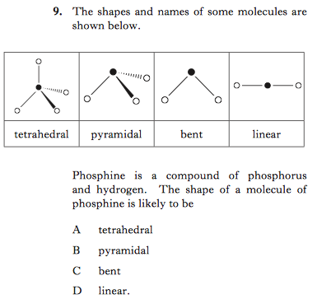
2) | 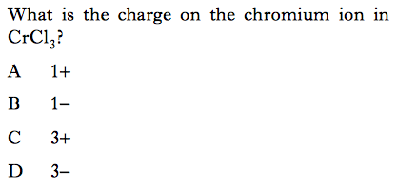
3) | 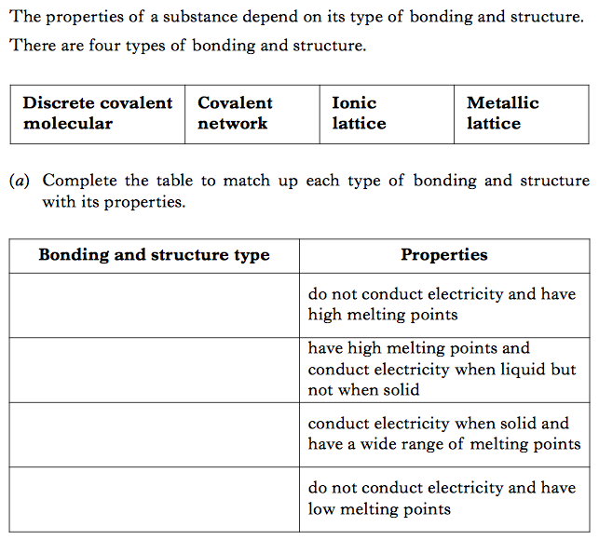
4) | 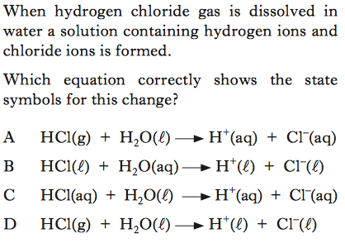
5) | 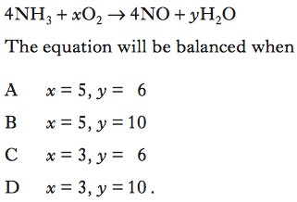
6) | 