
Beath High School
Chemistry Department

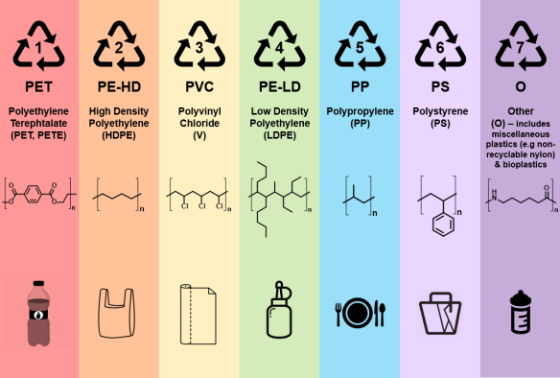

The Dependence for Fossil Fuels
Formation of Plastics

Pupil Name:
Class:
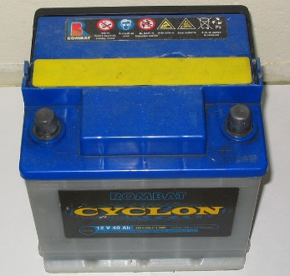
Plastics

It is very difficult to realise how important plastics have become to our everyday lives. We always seem to have used these materials, and we tend to take it for granted that they exist around us, for example in our clothing, the pen with which we write, the chair on which we sit or the wrapping of the food that we eat.

Look around the room, list five objects you can see that are made of plastic.

Plastics are said to be synthetic which means that they do not occur naturally; they have to be made by people. Most of the chemicals used to make plastics come from crude oil. Most plastics are non-biodegradable which means they are not broken down by bacteria in the soil and do not rot away.

Plastics can be made to have a variety of properties and as such they have many uses. They are generally very good insulators of heat and electricity and are long lasting as they do not rust or rot.

Carry out some research using to complete the following table.

Name of plastic | Uses
Nylon | clothing, carpets, machine parts

There are two main classifications of plastics:

A thermo-softening plastic is a plastic which will soften when heated and as a result can be shaped and moulded.

A thermosetting plastic is a plastic which, once formed into a particular shape, cannot be melted again.
The difference in the properties of thermosetting plastics and thermos-softening plastics is due to their structure. Thermo-softening plastics are formed when long polymer chains have only weak interactions between the polymer chains. When the chains form ‘cross-links’, by forming stronger interactions between chains, a thermosetting plastic is formed.
strong
interactions
thermo-softening plastic thermosetting plastic

Recycling Plastics

- Suggest two reasons why it is important to recycle plastics.

- Explain whether thermos-softening plastics or thermosetting plastics are easier to recycle.

- Suggest why the following materials have been commonly replaced with plastic.

  - Wooden front doors

  - Metal window frames

Polymerisation

Plastics are made of very long molecules called polymers. These polymers are formed when small molecules called monomers join together in a process known as polymerisation.

Polymers are large molecules which make plastics. (POLY means ‘many’)

Monomers are small molecules used to make polymers. (MONO means ‘one’)

Polymerisation is the process of joining monomers into polymers.

Naming Polymers

The name of a polymer is based on the name of the monomer used to make it. You simply start with the word ‘poly’ and then add the name of the monomer (sometimes in brackets).

e.g. ethene is used to make poly(ethene). This plastic is commonly called polythene.

Complete the following table of monomer and polymer names.

Monomer | Polymer
ethene | poly(ethene)
propene
 | poly(chloroethene)
phenylethene
 | poly(tetrafluoroethene)

Look at the names of the monomers in the table above. Do they have anything in common?

Suggest a structural feature that these monomers share.

Addition Polymerisation

Addition polymerisation involves the reactions of alkenes to form polymers. You have seen addition reactions in the previous topic.

To understand this we can look at the formation of poly(ethene).

Ethene molecules contain a carbon to carbon double bond. During polymerisation these double bonds are opened up and neighbouring ethene molecules link together to form new single bonds. This continues forming giant chains.

This can be shown by drawing three ethene monomers joining together.

monomers

Tip: You will lose an exam mark if you don’t include the open bonds
polymer

Note that there are open bonds at either end of the polymer. This is because it represents only a section of a much larger chain.

From the polymer we can also draw a repeating unit and a polymer formula.

Repeating unit
This shows the part of the polymer structure that repeats. For an addition polymer it always two carbons long.

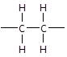
e.g.

This can be applied to any molecule with a C=C in the molecule.
When drawing the polymer formed from an alkene the first step is to draw the alkene in the shape of ethene, in the ‘H-shape’.

e.g. propene

but-1-ene

but-2-ene

- Redraw the following alkenes in the ‘H-shape’ of ethene.

hex-1-ene

hex-2-ene

  - hex-3-ene

- Propenonitrile has the following structure.

- Draw a diagram to show how three monomers join to form part of a polymer chain.

- Draw the repeating unit

- Draw the polymer formula

Complete the following table:

polymer name | monomer structure | repeating unit | polymer section
poly(ethene) |  | n
poly(propene)
poly(chloroethene)
poly(tetrafluoroethene)

