
Beath High School
Chemistry Department

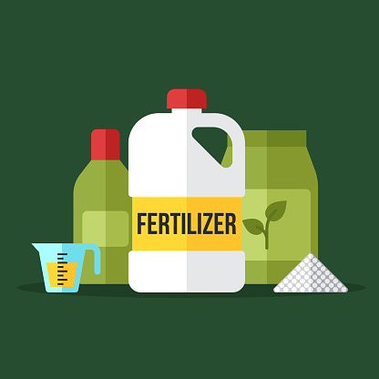

Consumer Products
Fertilisers

Pupil Name:

Class:


World Population

The world’s population grew very slowly for thousands of years from an estimated five million people in 8000 BC to one billion people in around 1820. The population since then has increased very quickly reaching three billion in the early 1970s before doubling in around 30 years to six billion in 1999. It is estimated that a population of eight billion will occur as early as 2024.
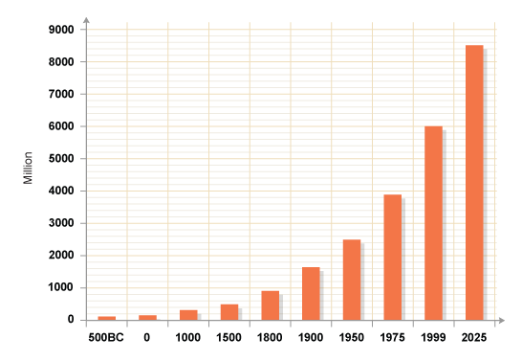

Why do you think the world’s population has increased so much in the past 100 years?

Essential Elements

This massive increase in world population has led to an increased demand for food. Farmers soon found that they could not continually grow crops in the same soil due to a lack of certain nutrients in the soil.
Plants require nutrients from the soil in order to have healthy growth. These nutrients are chemical compounds which provide plants with three essential elements.

The elements essential for healthy growth of plants are nitrogen (N), phosphorus (P) and potassium (K).

When a plant grows in soil, the nutrients from the soil are used by the plant. This results in soil which is less fertile and therefore less able to grow another plant.

Fertilisers

In order to deal with the world’s ever increasing demand for food farmers have to be able to replace the nutrients in the soil to allow them to grow more crops.

A farmer will use a chemical called a fertiliser which will replace the nutrients lost from the soil during plant growth.

There are two kinds of fertilisers used by farmers, natural and synthetic.

Natural fertilisers include decaying animal or plant remains as well as decayed animal and plant waste e.g. manure, leafmould, compost

Synthetic fertilisers are man-made fertilisers, usually salts, which contain one or more of the essential elements, nitrogen, phosphorus and potassium. Examples include potassium phosphate or ammonium nitrate.
Due to the presence of these elements, the fertilisers are often called ‘NPK fertilisers’.

Without fertilisers, the world would only be able to feed about half of its people. Modern fertilisers can double crop yields. Without man-made fertilisers, the world would need the manure from up to seven billion more cattle and to feed those cattle we would need to clear nearly all our remaining forests to grow grass.

How do plants absorb nutrients?
The only way for nutrients to get into the plant is via their roots. Plants absorb water through their roots and anything that is dissolved in the water will also be absorbed by the plants.

Fertiliser chemicals must be soluble in water if they are to be of any use.

- Give the chemical formula and the ionic formula for potassium phosphate and ammonium nitrate.

- Suggest why ammonium phosphate would make a better fertiliser than magnesium phosphate.

Percentage by Mass

Some plants require more of certain essential elements, for example wheat, barley and oats require a lot of nitrogen in the soil. As a result, some fertilisers could be considered more efficient than others if they contain more of the required nutrients than others.
A good way to compare fertilisers is to be able to calculate the percentage of a compound’s mass which is made up by a certain element.

This is called the percentage by mass.

e.g.
- Calculate the percentage of nitrogen in potassium nitrate.

The gram formula mass must first be calculated:

KNO₃ – 1xK = 1 x 39 = 39
1xN = 1 x 14 = 14
3xO = 3 x 16 = 48
= 101 g

Next the total mass of nitrogen in the compound is calculated:

KNO₃ contains 1 x N = 14 g

The percentage is calculated as
=

= 13.9 %

- Calculate the percentage of nitrogen in ammonium nitrate.

NH₄NO₃ – 2xN = 2 x 14 = 28
4xH = 4 x 1 = 4
3xO = 3 x 16 = 48
= 80 g

2 x N = 2 x 14 = 28 g

% mass = (28 / 80) x 100 = 35 %

Calculate the percentage of nitrogen in:

a) NH₃ | b) (NH₄)₂SO₄
c) ammonium phosphate | d) ammonium chloride
Which of the four fertilisers above would be the best choice if growing a field of barley? Give a reason for your answer.

This calculation can also be used to compare other chemical such as metal ores.

Calculate the percentage of the metal in the following ores:

a) malachite - CuCO₃ | b) Bauxite - Al₂O₃
c) Galena - lead sulphide | d) Haematite - iron(III) oxide

Production of Fertilisers

Many synthetic fertilisers are salts and as such they can be produced by a neutralisation reaction (see unit 1).

For example the production of potassium phosphate can be achieved by reacting a base containing the potassium ion such as potassium hydroxide with phosphoric acid.

potassium hydroxide + phosphoric acid → potassium phosphate + water
Write a word equation and a balanced chemical equation for the neutralisation reaction which could be used to produce the fertiliser potassium nitrate.

Ammonia solutions can also react with acids to form soluble salts.

ammonia solution + an acid an ammonium salt + water

Two common ions found in synthetic fertilisers are the ammonium ion (NH₄⁺) and the nitrate ion (NO₃⁻).
The ammonium ion is formed from the base ammonia and the nitrate ion from the acid nitric acid.
The increasing demand for chemical fertilisers has resulted in two very important industrial processes; the Haber process which produces ammonia, the Ostwald process which produces nitric acid.
The Haber Process
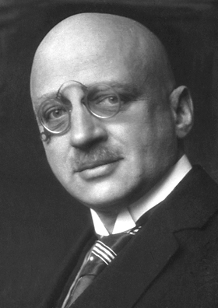
The commercial synthesis of ammonia began, not with the peaceful use of fertiliser, but with the necessities of war. In the early years of the 20th century, Germany understood that any war that it might have with England would, at least initially, result in the blockade of critical war materials from abroad. The most important of these resources was nitrate chemicals, the basis of the German manufacture of explosives, which had to be shipped by the tanker-load across the Atlantic and past patrolling British warships.
During this period, the chemistry of ammonia synthesis was being explored by the German chemist Fritz Haber who found that it was possible to produce ammonia using nitrogen from air and hydrogen from methane.

nitrogen + hydrogen ⇌ ammonia

Ammonia is a gas at room temperature with a very distinctive smell. It is very soluble in water and dissolves to produce an alkaline solution called ammonium hydroxide.

- What does the arrow (⇌) used in this reaction tell us about the Haber process?

- Write a balanced chemical equation for the Haber process.

- Suggest the advantages of using air as a feedstock for this reaction.
Key facts about the Haber process

- The process is carried out with the use of an iron catalyst.

- The use of high temperatures results in a small yield of ammonia and low temperatures are too slow. A compromise between speed and yield is achieved with an operating temperature of around 450 °C.

- A high pressure improves the yield but is expensive to operate. Again a compromise is reached with a pressure of around 200-300 atmospheres.

- The ammonia produced is removed by cooling it until it condenses into a liquid and unreacted nitrogen and hydrogen are recycled in the process.

Flow chart of the Haber process:
unreacted
nitrogen + hydrogen
liquid ammonia
Cooling coils
Catalyst chamber
350 °C
nitrogen from air
Compressor above 200 atmospheres
hydrogen from methane

Ammonia dissolves in water to form an alkaline solution (see unit 1)

The Ostwald Process
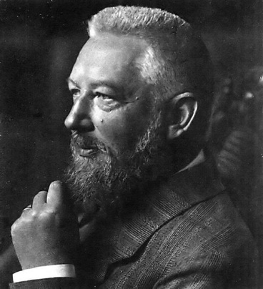
In 1902, Wilhelm Ostwald developed a process for reacting ammonia with oxygen in the air to form nitrogen dioxide. This nitrogen dioxide could then be dissolved in water to form nitric acid.

This process, coupled with the Haber process (which provides the ammonia) allows the production of nitrate fertilisers.
The process is carried out with the use of a platinum catalyst.

Nitrogen dioxide can also be formed by reacting the nitrogen and oxygen in the air. Unfortunately this is very expensive due to the large quantity of energy required to make the reaction occur. Nitrogen and oxygen will react together when a large voltage spark is passed through air, this also occurs during lightning storms.

Environmental Effect of Fertilisers

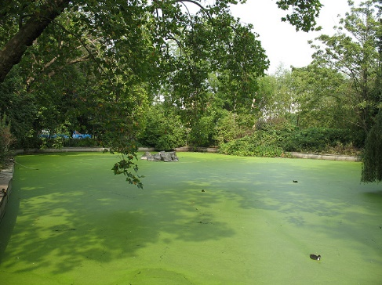
Due to the high solubility of fertilisers, heavy rains can result in fertilisers being washed into rivers, lakes and lochs. This can have an impact on the environment.

This can result in ‘algal blooms’ where algae (microscopic plants) are produced in large quantities. This can reduce the concentration of oxygen in the water harming fish and plants which live in the water.

