
Beath High School
Chemistry Department

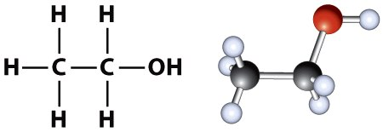

Consumer Products
Alcohols and Carboxylic Acids

Pupil Name:
Class:

Recap from S3

A homologous series is a group of compounds with:
- similar chemical properties
- the same general formula
- a gradual change in physical properties such as melting and boiling point.
Examples of homologous series include groups of compounds called the alkanes, cycloalkanes and alkenes.
The Alkanes
The alkanes are the simplest homologous series of hydrocarbons.
- The names of the first eight alkanes are:
No. C’s | 1 | 2 | 3 | 4 | 5 | 6 | 7 | 8
Name | methane | ethane | propane | butane | pentane | hexane | heptane | octane

- You need to be able to name and draw the first eight alkanes.
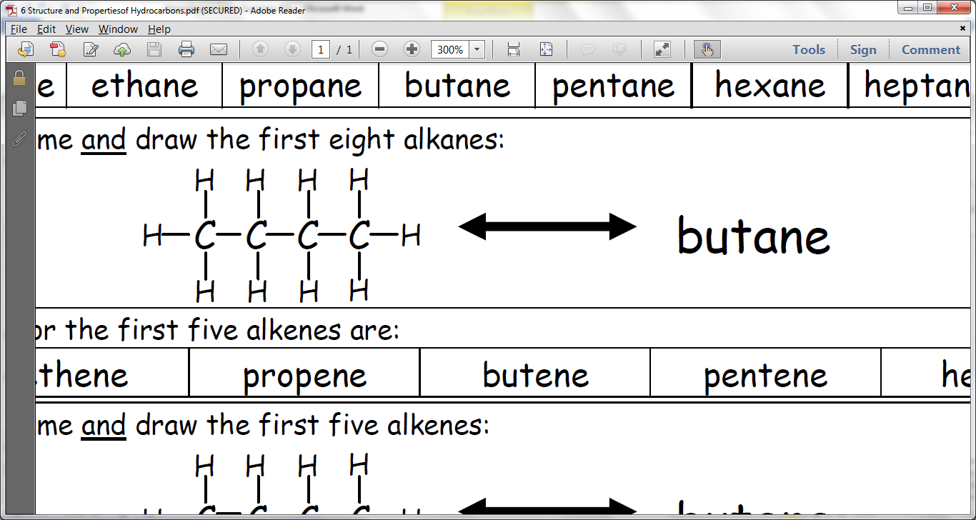
- The names of the alkanes always end in …ANE.
- The alkanes contain C-C single bonds.
- The general formula for the alkanes is C_{n}H_{2n+2}.
Alkanes can be straight chained like the above, or branched.
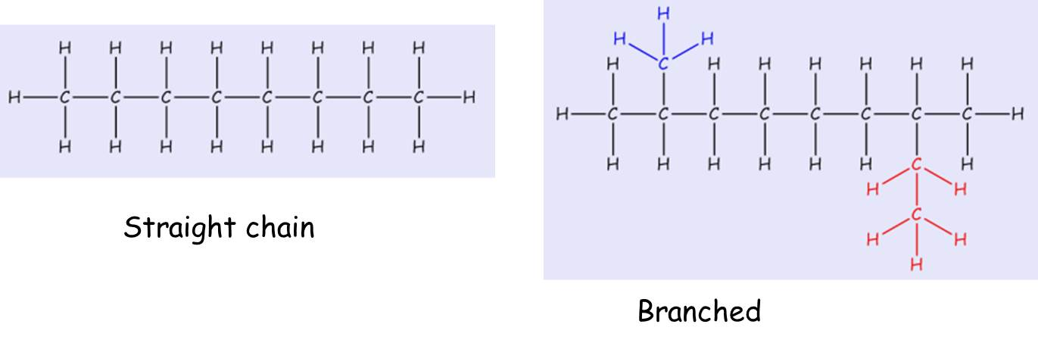
Branched alkanes can be named systematically according to rules set down by the International Union of Pure and Applied Chemistry (IUPAC).
- Find the longest continuous chain of carbons
- Identify any branches off the longest chain, e.g. methyl or ethyl
- Put the name together with the branches first and the name of the long chain last. The longest chain should be numbered to give branches the lowest possible number.
e.g.
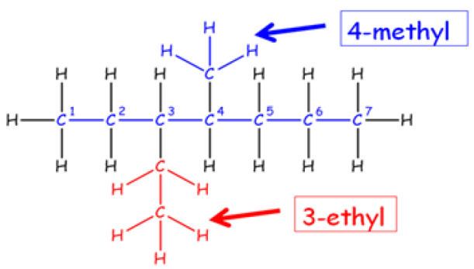

The Cycloalkanes
The cycloalkanes are a homologous series of hydrocarbons with cyclic shapes.
- The names of the first five cycloalkanes are:
No. C’s | 1 | 2 | 3 | 4 | 5 | 6 | 7
Name | Doesn’t exist | Doesn’t exist | cyclopropane | cyclobutane | cyclopentane | cyclohexane | cycloheptane

- You need to be able to draw and name the cycloalkanes.
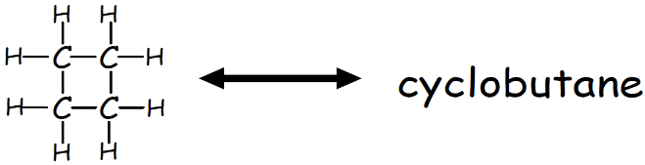
- The names of the cycloalkanes start with CYCLO… and end with ….ANE.
- The cycloalkanes contain C-C single bonds.
- The general formula for the cycloalkanes is C_{n}H_{2n}.
The Alkenes
The alkenes are another homologous series of hydrocarbons.
- The names of the first seven alkenes are:
No. C’s | 1 | 2 | 3 | 4 | 5 | 6 | 7 | 8
Name | Doesn’t exist | ethene | propene | butene* | pentene* | hexene* | heptene* | octene*
*Names should have numbers to show the position of C=C
- You need to be able to name and draw the alkenes.
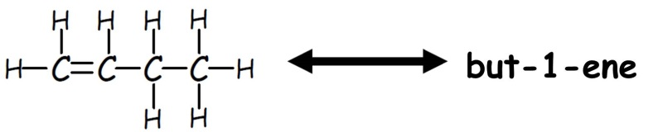
- The names of the alkenes always end in …ENE.
- The name of alkenes sometimes has a number in it, e.g. pent-1-ene. The number tells us where the C=C is. The number should be the lowest possible value.
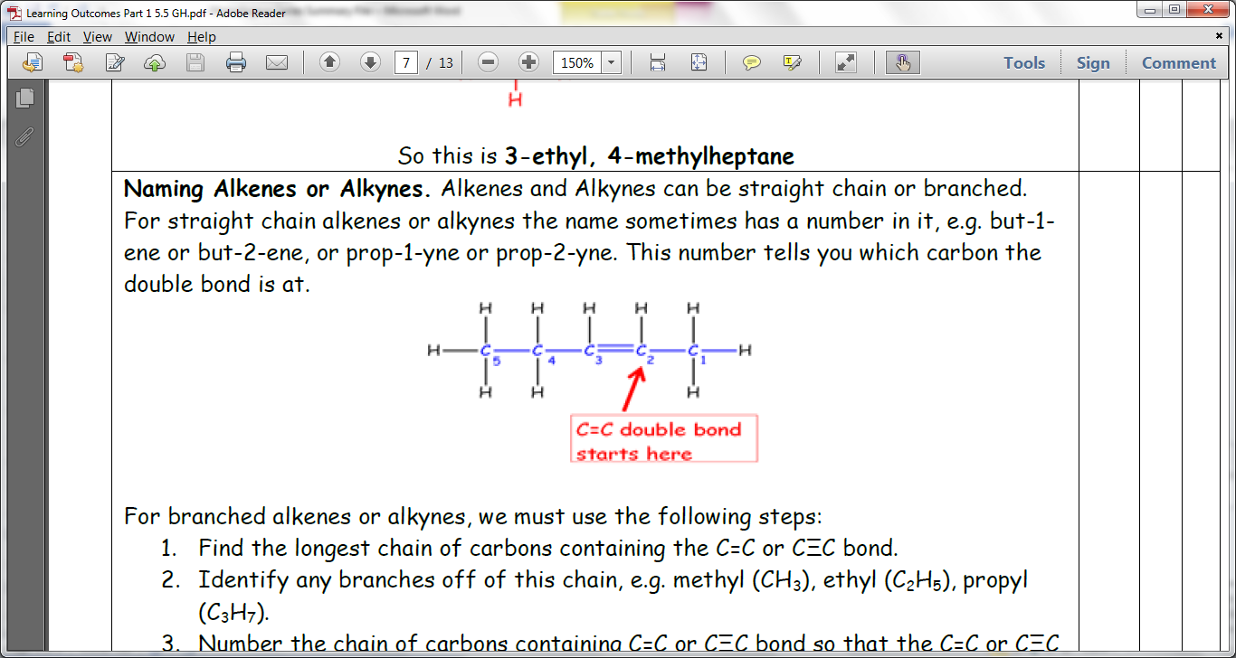

- Alkenes contain at least one C=C double bond. This is called the functional group, which means it is the part of the molecule that reacts.
- The general formula for the alkenes is C_{n}H_{2n}.
Alkenes can also be straight chain or branched. Branched alkenes are named in the same way we named branched alkanes.

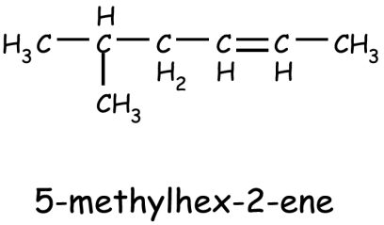
The position of the C=C double bond is numbered first and then the branches are numbered in this case however. For example:

An isomer is when you have compounds that have the same molecular formula but a different structural formula.
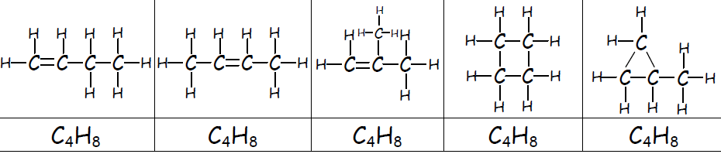
Saturated hydrocarbons contain only C-C single bonds.
- The alkanes are saturated hydrocarbons.
- The cycloalkanes are saturated hydrocarbons.
Unsaturated hydrocarbons contain C=C double bonds.
- The alkenes are unsaturated hydrocarbons.
The bromine solution test can be used to distinguish between saturated and unsaturated hydrocarbons.
- Unsaturated hydrocarbons immediately decolourise bromine solution.
- Saturated hydrocarbons do not immediately decolourise bromine solution.
When an unsaturated hydrocarbon, such as an alkene, reacts with bromine solution a reaction called ADDITION has occurred.
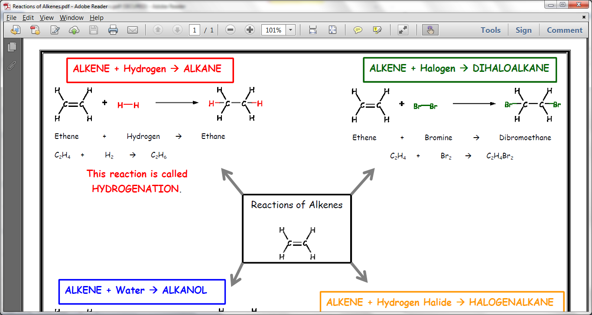
The addition of hydrogen to an alkene is called HYDROGENATION. Adding hydrogen to an alkene forms an alkane.
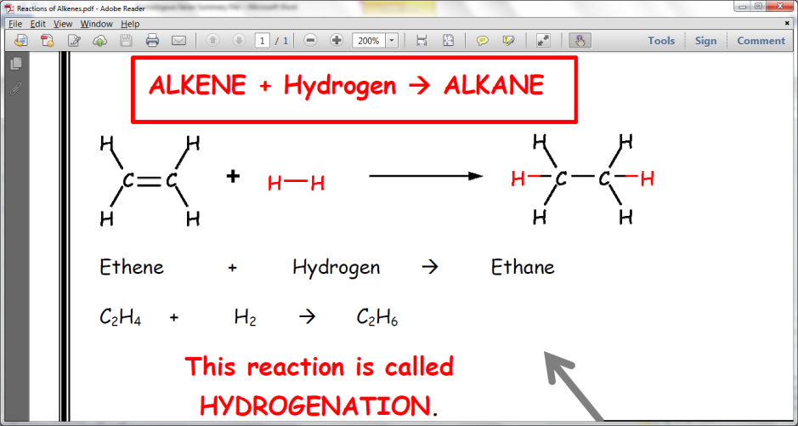
The addition of water to an alkene is called HYDRATION.
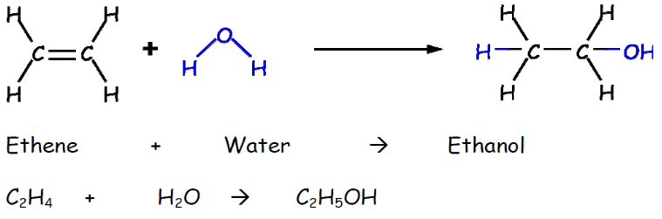
Cracking is when you take a large alkane and break it down into a smaller alkane and a smaller alkene. The smaller alkane and alkene are more useful products than the larger alkane reactant.
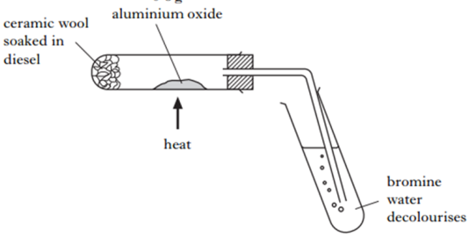
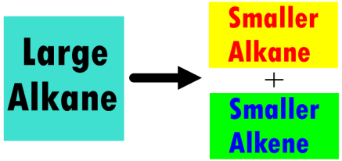
The following apparatus can be used to carry out cracking in a laboratory.

Alcohols

The alcohols are an example of a homologous series of compounds which are not hydrocarbons.

The alcohols are named in the same way as hydrocarbons, they have a prefix which indicates the number of carbon atoms and they each end with the suffix –anol.

Alcohols contain a functional group, this is the part of the molecule responsible for their chemistry.

The functional group in the alcohols is called the hydroxyl group and consists of an oxygen and a hydrogen atom bonded together

e.g.

The chemical formula for this alcohol can be written in one of two ways, either showing the functional group or not, both of these are correct. e.g. C₃H₇OH or C₃H₈O

The structure is also often drawn without showing the bond between the oxygen and the hydrogen.

e.g.

Complete this table for the alcohol series

No. Carbon atoms | Name | Chemical Formula | Structural Formula
1 | methanol | CH₃OH
2
3
4
5
6
7
8

Systematic Naming

As with hydrocarbons, the alcohols can form isomers which each have their own systematic name. Isomers of alcohols differ in the position of the hydroxyl group, some isomers can also have branches.

The rules for systematically naming alcohols are very similar to those for naming alkanes and alkenes. First identify the longest chain of carbons, count so that the functional group is on the smallest number and then name the alcohol.

Examples

Longest chain – butanol
OH on C₁

butan-1-ol

Longest chain – butanol
OH on C₂

butan-2-ol

Name the following structures

1. 2.

3. 4.

Below is an example of a branched alcohol. It is systematically named just like a branched alkane or alkene. Priority is given to the hydroxyl functional group when counting.
Longest chain – butanol
OH on C₁
Methyl branch on C₂

2-methylbutan-1-ol

State the systematic name of the alcohol below.

How many straight-chain isomers does this molecule have?
Draw and name each of them.

Alcohols can make good fuels. Predict the products of combustion when an alcohol such as ethanol is burned in a good supply of oxygen.

ethanol + oxygen → ______________________ + ___________________

Making and Using Alcohols

When we think of alcohol, we often think of alcoholic drinks. The alcohol present in alcoholic drinks is ethanol.
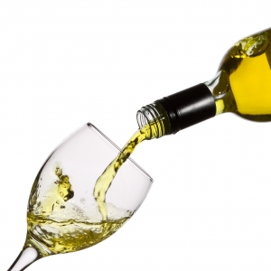
The ethanol in drinks is produced by a process known as fermentation. In this process, a carbohydrate such as sugar or starch is broken down by yeast forming ethanol. Plants are a good cheap source of carbohydrates and therefore almost any fruit or vegetable can be used to make an alcoholic drink. The type of plant determines the final flavour and type of alcoholic drink.
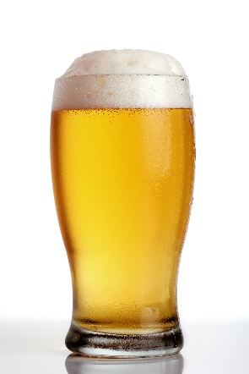
Beers and are made from grain such as wheat or barley. Beers are typically around 3-8% alcohol. Cider is made in a similar way using apples or pears.

Wines are fermented from fruits such as grapes and usually contain 7-14% alcohol. Japanese Saki is a wine made from rice.

Spirits such as whiskey, gin and vodka contain around 40% alcohol. To achieve this alcohol has to be distilled after the fermentation process. Whiskey is made from barley, vodka from potatoes and gin from juniper berries.

Complete the table for the drinks listed above. Include one from each group.
Name of Drink | What it is made from | % of alcohol | Distilled?

Fermentation
During fermentation, glucose is broken down by yeast, forming ethanol and carbon dioxide.
Balance the following equation

glucose → ethanol + carbon dioxide

C₆H₁₂O₆ → C₂H₅OH + CO₂

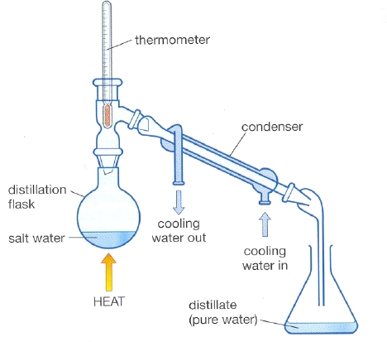
Distillation

Yeast is a living organism and when the concentration of ethanol is high enough the yeast dies and the fermentation process stops. This is why fermented drinks have low alcoholic content, around 12-15% at most.
thermometer
fermentation mixture
water out
water in
ethanol
condenser
HEAT

When a higher concentration of alcohol is required (for whiskey etc) the ethanol must be separated from the mixture by the process of distillation.

This involves boiling the fermentation mixture, which contains ethanol, water and other substances. Ethanol boils at a lower temperature than water and so will boil before water does.

Other Uses
Ethanol has a wide variety of other uses. It can dissolve a lot of different chemicals, many of which cannot dissolve in water, so is used as a solvent in a variety of chemicals including perfumes and medicines.

Ethanol is used in many countries as a fuel for cars, either in its pure form or by adding it to petrol. A mixture of 10% ethanol and 90% petrol can be used in an unmodified car engine. Countries such as Brazil use specially modified car engines which can run on a mixture of 25% ethanol and 75% petrol.

There is much debate as to whether crops should be grown for fuel rather than for food.

What are the benefits of using ethanol with/instead of petrol in a car engine?

Properties of Alcohols

Alcohols, burn with a cleaner flame producing very little soot or carbon monoxide pollution.

Methanol, ethanol and propanol all dissolve in water, as they are liquids they are described as being miscible rather than soluble. Alcohols larger than propanol become increasingly less miscible as they get larger.

Just like hydrocarbons, the alcohols have intermolecular forces which get stronger as the molecules get larger.

Industrial Preparation of Alcohols
When large quantities of alcohol are needed or a specific alcohol is needed alkenes can be used to form alcohols.
Water molecules can be reacted with alkenes in a process known as hydration.
Hydration is another example of an _________________ reaction.
e.g. + →

Some alkenes can produce more than one alcohol
Alcohol 1
e.g. +
Alcohol 2

In the above reaction 2 alcohols are formed.

Name the two alcohols and state the term used to describe the two.


Draw and name all the possible products of the hydration of

- pent-2-ene

- but-2-ene

Calculations from Balanced Equations

When the number of moles of a reactant or product is known, a balanced equation can be used to calculate the quantity of any other chemical in the equation.

This is a skill which is used throughout Chemistry, for example in calculating the quantity of a reactant required to make a given quantity of product or calculating how much carbon dioxide will be released when a hydrocarbon is to be burned as a fuel.

e.g. 66 g of propane is burned in a plentiful supply of oxygen. Calculate the mass of carbon dioxide produced in the reaction.

The steps to answer this question are
- Write a balanced equation

C₃H₈ + 5O₂ → 3CO₂ + 4H₂O

- Calculate the number of moles of the ‘known’ substance from the equation.

Moles of methane = mass / GFM
= 66 g / 44 g
= 1.5 moles

- Use the balanced equation to identify the molar ratio of ‘known’ substance to ‘required’ substance and then calculate the number of moles of the ‘required’ substance

propane : carbon dioxide
1 mole : 3 moles
1.5 moles : 4.5 moles

- Answer the question by calculating the required value of the ‘required’ substance.

Mass of carbon dioxide = moles x GFM
= 4.5 x 44 g
= 198 g

Example 2
What mass of hydrogen gas is produced when an excess of magnesium is added to 100 cm³ of dilute hydrochloric acid, concentration 1 mol l⁻¹?

Mg + 2HCl → MgCl₂ + H₂

Moles of HCl = conc x vol
= 1 x 0.1
= 0.1 mol

HCl : H₂
2 mol : 1 mol
0.1 mol : 0.05 mol

Mass of H₂ = mol x GFM
= 0.05 x 2
= 0.1 g

Carboxylic Acids

The carboxylic acids are another example of a homologous series of compounds which are not hydrocarbons.

The carboxylic acids are names just like other homologous series and can be identified by the suffix –anoic acid

Carboxylic acids contain a functional group called the carboxyl group.

e.g.
carboxyl group

Again the chemical formula is often written to show the functional group
e.g. C₂H₅COOH

The structure is also often drawn without showing the bond between the oxygen and the hydrogen.
e.g.

The carboxyl group can only be located on the carbon atoms at the end of a chain and so there is no need for them to be systematically named.

Complete this table for the carboxylic acid series
No. Carbon atoms | Name | Chemical Formula | Structural Formula
1 | methanoic acid | HCOOH
2 |  | CH₃COOH
3
4
5
6
7
8

Uses of Carboxylic Acids

Carboxylic acids react just like any other acids and so can be reacted with a base to make a salt. The salt names for carboxylic acids are names just like those in unit 1 but the ending of the salt name comes from the name of carboxylic acid.

To name the salt, the end of the acid name is changed from “–anoic acid” to “-oate”.
e.g.

Carboxylic Acid | Salt Name
methanoic | methanoate
ethanoic | ethanoate
propanoic | propanoate
pentanoic | pentanoate
hexanoic | hexanoate
heptanoic | heptanoate
octanoic | octanoate

Write a word equation for the reaction between:

- propanoic acid and lithium hydroxide

- butanoic acid and sodium oxide

- hexanoic acid and magnesium carbonate

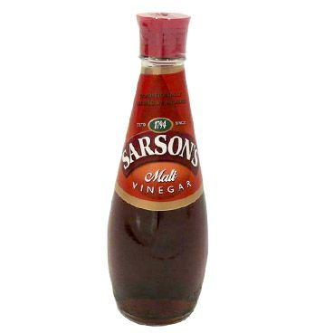
Carboxylic acids have a variety of uses but the most commonly used acid is ethanoic acid. Vinegar is a solution of ethanoic acid which has many uses including for flavouring and preserving food.

Carboxylic acids occur regularly in nature, including formic acid which is found in the sting of some ants, citric acid in citrus fruits and butanoic acid which is found in vomit and parmesan cheese and is partly responsible for their smell. Carboxylic acids, extracted from fats and oils, are also used to make soaps.

In industry they are used as a solvent, in the production of many medicines and other products.

The concentration of a carboxylic acid can be calculated by titrating it against an alkali such as sodium hydroxide.

A group of students titrated 10 cm³ of ethanoic acid, of unknown concentration, against 0.025 moll⁻¹ sodium hydroxide solution.

CH₃COOH + NaOH → CH₃COONa + H₂O

The students results are shown in the table.

Titration | 1 | 2 | 3
Final Volume / cm³ | 23.4 | 43.5 | 21.5
Initial Volume / cm³ | 0 | 23.4 | 1.6
Volume used / cm³ | 23.4 | 20.1 | 19.9

Calculate the concentration of the ethanoic acid used.

Esters

Carboxylic acids and alcohols are used to make compounds known as esters.

Esters have characteristically sweet smells and are commonly used in perfumes and as flavourings in sweets and drinks. They also make good solvents for paints and lacquers.

This involves the joining of two molecules with the removal of water, esters can be identified by the presence of an ester linkage.

e.g.
+

ester linkage

Ester smells

The following table shows some common smells and the alcohol and carboxylic acid used to make them.

Alcohol | Carboxylic acid | Smell
pentan-1-ol | ethanoic | pears
2-methylbutan-1-ol | ethanoic | bananas
octan-1-ol | ethanoic | oranges
2-methylpropan-1-ol | methanoic | raspberries
ethanol | butanoic | pineapple
methanol | salycilic | wintergreen/deep heat

