
Beath High School
Chemistry Department

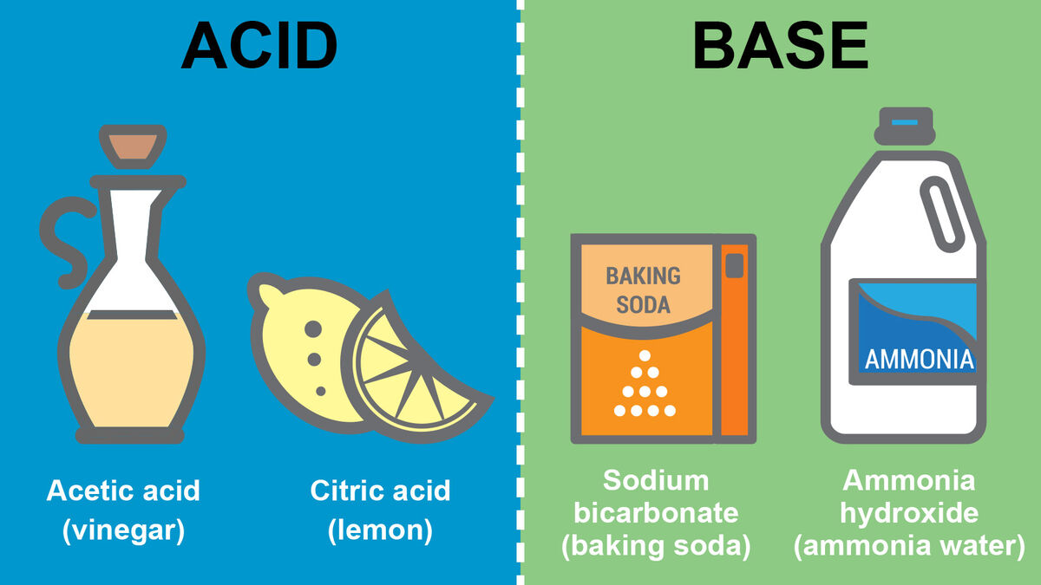

Analytical Chemistry
Acids and Bases: Part II

Pupil Name:
Class:
Recap from S3

Reactions of Acids and Bases

The pH scale is a continuous range of numbers.
0 | 1 | 2 | 3 | 4 | 5 | 6 | 7 | 8 | 9 | 10 | 11 | 12 | 13 | 14
Acids |  |  |  |  |  |  | Neutral | Bases
it is possible to get values below 0 and above 14.
pH below 7 | pH equal to 7 | pH above 7
Acid | Neutral  (including pure water) | Base

An alkali is a soluble base.

Examples of common household and laboratory acids and alkalis.

Acids |  | Alkalis
Household | Laboratory | Household | Laboratory
Vinegar | Sulfuric acid | Baking soda | Sodium hydroxide
Lemon juice | Hydrochloric acid | Caustic soda | Ammonia solution
Fizzy drinks | Nitric acid | Oven cleaner | Potassium hydroxide

Examples of bases include metal oxides, metal carbonates or metal hydroxides.

Making Acids
- Non-metal oxides dissolve in water to produce acidic solutions.
  - Carbon dioxide + water carbonic acid
  - Sulfur dioxide + water sulfurous acid
  - Nitrogen dioxide + water nitrous acid
Problems with Acids

Sulfur dioxide reacts with water in the atmosphere to produce acid rain.

The damaging effects of acid rain include:
- damage to building rocks
- damage to structures like metal bridges
- acidifying soil which reduces crop growth damage to the habitat of plant and animal life.

Making Alkalis

Alkalis are soluble bases that are made by dissolving metal oxides or metal hydroxides in water.
e.g. lithium oxide, sodium oxide, potassium oxide or magnesium oxide.
e.g. potassium hydroxide, sodium hydroxide or calcium hydroxide.

Acids and alkalis contain ions.
- Acids contain the hydrogen ion, H⁺(aq)
- Alkalis contain the hydroxide ion, OH⁻(aq)
This means that solutions of acids and alkalis can conduct electricity.

Type | Ion(s) Present | Numbers of Ions
Acid | H⁺(aq) and OH⁻(aq) | H⁺(aq) > OH⁻(aq)
Neutral | H⁺(aq) and OH⁻(aq) | H⁺(aq) = OH⁻(aq)
Alkali | H⁺(aq) and OH⁻(aq) | H⁺(aq) <OH⁻(aq)
Acidic and alkaline solutions contain the following ions:

Diluting solutions of acids or alkalis has the following effects.

Type of Solution | Effect of Dilution on pH | Effect of Dilution on Solution | Effect of Dilution on Ions
Acid | 0 7 | Acidity decreases | Decrease in the concentration of H⁺(aq) ions
Neutral | 7 7 | No change | No change in the concentration of  H⁺(aq) or OH⁻(aq) ions.  H⁺(aq) = OH⁻(aq)
Alkali | 14 7 | Alkalinity decreases. | Decrease in the concentration of OH⁻(aq) ions

When an acid reacts with a base a reaction called neutralisation occurs.
Neutralisation changes the pH of acids and bases.

Type of Substance | Effect on pH | Example of pH Change
Acid | Increases to 7 | pH = 0 pH = 7
Base | Decreases to 7 | pH = 14 pH =7

There are many everyday examples of neutralisation reactions.
- Reducing soil acidity by adding lime.
- The use of lime to reduce acidity in lakes caused by acid rain.
- Treatment of indigestion.
Treating wasp or bee stings.

Acids react with bases and metals to form salts.

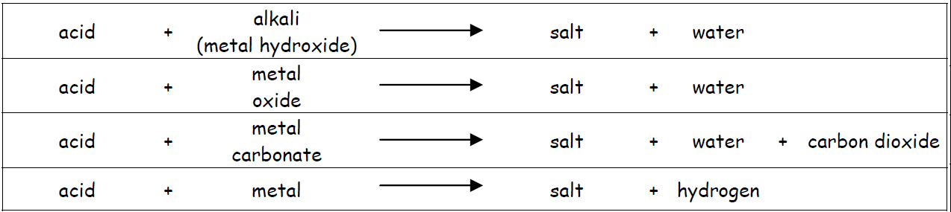
To name the salt formed in reactions, we have to use the name of the acid and base.
- The neutraliser provides the first name of the salt formed.

Neutraliser Name | Sodium hydroxide | Potassium oxide | Calcium Carbonate
First Name of Salt | Sodium | Potassium | Calcium

- The acid provides the second name of the salt formed.

Acid Name | Hydrochloric acid | Sulfuric acid | Nitric acid
Second Name of Salt | …chloride | …sulfate | …nitrate

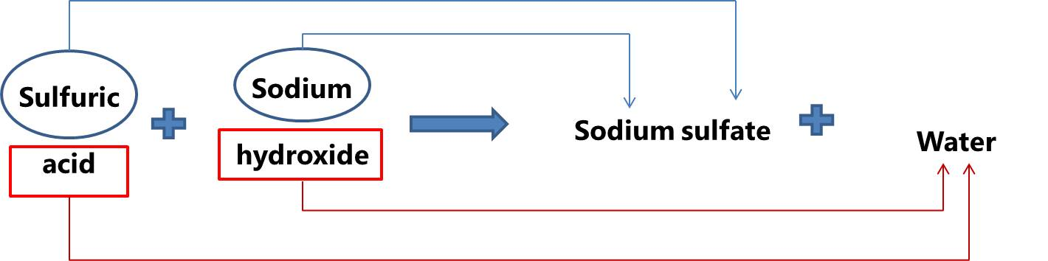

Reactions of Acids – Revision

Acids can take part in a number of different chemical reactions. The most common reaction an acid will take part in is a NEUTRALISATION reaction.
This is a reaction in which an acid will react with another chemical producing water these chemicals are called BASES. When any base is dissolved in water the solution is called an ALKALI.

In national 5, the four types of bases you need to know are

metal hydroxides, such as sodium hydroxide or potassium hydroxide

metal oxides, such as calcium oxide and iron oxide.

metal carbonates, such as sodium carbonate and copper carbonate.

ammonia, also known as nitrogen hydride which has the chemical formula NH_{3.}

These react with acids producing water along with another substance known as a salt. To be classed as a neutralisation reaction, the acid must react to form water. When the base is a metal carbonate, carbon dioxide gas is also produced.

ACID + METAL HYDROXIDE → SALT + WATER

ACID + METAL OXIDE → SALT + WATER

ACID + METAL CARBONATE → SALT + WATER + CARBON DIOXIDE

ACID + AMMONIA → SALT + WATER

Naming salts
The name of a salt is made up of two parts. The first part comes from the BASE and the second part from the ACID.

The metal part of the salt name is simply the name of the metal element used to make the base. The only exception is ammonia solution which forms an ammonium salt.
Base | First Part of Salt Name
sodium hydroxide | sodium
calcium oxide | calcium
copper carbonate | copper
ammonia solution | ammonium

The second part of the salt name is derived from the acid as follows:
Name of acid | Formula | Second Part of Salt Name
hydrochloric acid | HCl | chloride
nitric acid | HNO₃ | nitrate
sulphuric acid | H₂SO₄ | sulphate

You must learn this table including the chemical formulae of the acids!

Name the salts formed during the following neutralisation reactions.
(a) hydrochloric acid + sodium hydroxide ___________________________________
(b) sulphuric acid + potassium hydroxide ___________________________________
(c) hydrochloric acid + magnesium oxide ___________________________________
(d) nitric acid + zinc(II) oxide ___________________________________
(e) sulphuric acid + copper carbonate ___________________________________
(f) hydrochloric acid + sodium carbonate ___________________________________

Complete the following word and chemical equations:
(a) hydrochloric acid + sodium hydroxide →

HCl + NaOH →

(b) sulphuric acid + magnesium oxide →

H₂SO₄ + MgO →

(c) nitric acid + zinc (II) carbonate →

HNO₃ + ZnCO₃ → Zn(NO₃)₂

Ions in an Acid

When an electric current is passed through the acid the ions will go to the electrode of the opposite charge. If we analyse what is formed at each electrode we can get some more information about the ions which are present in acids.

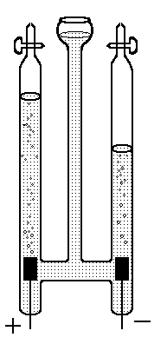
platinum electrodes
collecting gas
sulphuric acid
A piece of equipment known as a Hofmann voltameter is used to collect the gases which form at each electrode.
The gas at the negative electrode is the same regardless of the acid used and this tells us that the positive ion must always be the same.
In the space below describe the test which is carried out on the gas at the negative electrode:

The gas which is collected at the negative electrode when passing electricity through an acid is ______________.
This means that all acids must contain the ______________ ion.
What is really going on during Neutralisation?

Water is always formed in a neutralisation reaction regardless of the acid and the base used. This would imply that the same reaction is taking place each time.

In order to better understand this reaction, we must look at the ions involved.

Acids and Alkalis
Let’s examine the reaction of hydrochloric acid and potassium hydroxide. First we must write the chemical equation for the reaction:

HCl_{(aq)} + KOH_{(aq)} → KCl_{(aq)} + H₂O_{(l)}

For each of the ionic substances in solution we can write an ionic formula as these compounds will have dissociated:

H⁺_{(aq)} + Cl⁻_{(aq)} + K⁺_{(aq)} + OH⁻_{(aq)} → K⁺_{(aq)} + Cl⁻_{(aq)} + H₂O_{(l)}

As you can see there are ions which appear on both sides of the equation, these are called SPECTATOR IONS as they do not take part in the reaction.
If we cancel these ions we will be left with the actual reaction which is taking place:

H⁺_{(aq)} + Cl⁻_{(aq)} + K⁺_{(aq)} + OH⁻_{(aq)} → K⁺_{(aq)} + Cl⁻_{(aq)} + H₂O_{(l)}

The actual reaction is H⁺_{(aq)} + OH⁻_{(aq)} → H₂O_{(l)}

Find the actual reaction taking place in the following reactions by rewriting the equation without the spectator ions.
- H⁺_{(aq)} + Cl⁻_{(aq)} + Na⁺_{(aq)} + OH⁻_{(aq)} → Na⁺_{(aq)} + Cl⁻_{(aq)} + H₂O_{(l)}

- H⁺_{(aq)} + NO₃⁻_{(aq)} + NH₄⁺_{(aq)} + OH⁻_{(aq)} → NH₄⁺_{(aq)} + NO₃⁻_{(aq)} + H₂O_{(l)}
Complete the following:
From these equations we can see that the reaction taking place during neutralisation of any acid with any alkali is that the ____________ ion (H⁺_{(aq)}) of the acid reacts with the ____________ ion (OH⁻_{(aq)}) of the alkali forming ___________.

Acids and Metal Carbonates

The same process can be done for the reaction of acids with metal carbonates.

Consider the reaction of hydrochloric acid and sodium carbonate:

2HCl_{(aq)} + Na₂CO_{3(aq)} → 2NaCl_{(aq)} + H₂O_{(l)} + CO_{2(g)}

Rewrite the ionic equation without spectator ions to discover the actual reaction taking place:

2H⁺_{(aq)} + 2Cl⁻_{(aq)} + 2Na⁺_{(aq)} + CO₃²⁻_{(aq)} → 2Na⁺_{(aq)} + 2Cl⁻_{(aq)} + H₂O_{(l)} + CO_{2(g)}

Actual reaction is

Complete the following:
When a dilute acid is neutralised by a metal carbonate, the ______{(aq)} ion of the acid reacts with the CO₃²⁻_{(aq)} ion of the metal carbonate to form water and the gas ___________ ___________.

Acids and Metals

Although not a neutralisation reaction, acids can also react with metals. For example sulphuric acid and magnesium can react as follows:

H₂SO_{4(aq)} + Mg_{(s)} → MgSO_{4(aq)} + H_{2(g)}

Rewrite the ionic equation without spectator ions to discover the actual reaction taking place:

2H⁺_{(aq)} + SO₄²⁻_{(aq)} + Mg_{(s)} → Mg²⁺_{(aq)} + SO₄²⁻_{(aq)} + H_{2(g)}

Actual reaction is

Why is the reaction of magnesium with acid not considered a neutralisation reaction?

Titration

Titration is a very accurate and precise method of measuring how much of one chemical is required to react fully with another. Acid-base titrations are commonly used to work out the concentration of an acid by neutralising a known volume and concentration of a base.

Apparatus

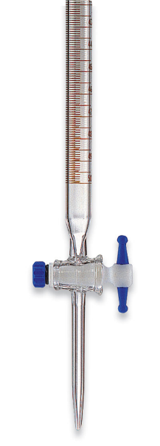
C
B
A
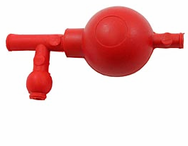

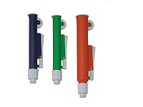

A B

- What is the name of the three pieces of apparatus used?

A –

B –

C –

- Describe how you would detect the “end point” in an acid-base titration?

- Describe two ways to ensure that your titration is as accurate as possible.
Calculations from Balanced Equations

Having completed a titration we must next carry out a calculation to find the unknown concentration of the solution we are investigating.

This is a type of calculation which is used throughout Chemistry, not just with titrations, it can also be used to find out how much of a product will be formed from a given mass of a reactant. (Unit 3)

Vinegar is a dilute solution of ethanoic acid in water.

For a solution of vinegar, name the solute and the solvent used.

Example 1
Let us consider a titration to calculate the concentration of ethanoic acid in a sample of vinegar. The results of a titration are shown.
 | Rough Titre | 1st Titre | 2nd Titre
Final burette reading (cm³) | 21.1 | 41.7 | 31.5
Initial burette reading (cm³) | 0 | 21.1 | 10.1
Volume used (cm³) | 21.1 | 20.6 | 20.4
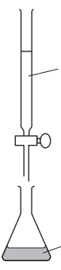
sodium hydroxide
0.1 mol l⁻¹
20 cm³
vinegar and indicator

The balanced equation for the reaction is

NaOH(aq) + CH₃COOH(aq) → CH₃COONa(aq) + H₂O
(ethanoic acid
found in vinegar)

Using the results of the titration, calculate the concentration of ethanoic acid, in mol l⁻¹, in the vinegar sample.

The steps to answer this question are
- Calculate the average volume used in the titration

Remember only to use the concordant results.
Remember
Concordant results are within 0.2 cm³ of each other

Average volume = (20.6 + 20.4) ÷ 2
= 20.5 cm³

- Calculate the number of moles.

Look carefully at the labels in the diagram and your average volume. For one of the two solutions used you will have both the concentration and the volume. In this example it is the sodium hydroxide solution. You can use these values to calculate the number of moles.

NaOH CH₃COOH
conc = 0.1 mol l⁻¹ (from diagram) conc = unknown
vol = 20.5 cm³ (average volume) vol = 20 cm³ (from diagram)

NaOH is our ‘known’ chemical and CH₃COOH is our ‘unknown’ chemical.
Remember vol in litres
20.5 cm³ = 20.5 ÷ 1000 = 0.0205 l
Moles of NaOH n = CV
= 0.1 x 0.0205
= 0.00205 moles

- Use the balanced equation to identify the molar ratio of ‘known’ substance to ‘unknown’ substance.
Then use your calculated moles of the ‘known’ substance to calculate the number of moles of the ‘unknown’ substance.

NaOH(aq) + CH₃COOH(aq) → CH₃COONa(aq) + H₂O(ℓ)

‘known’ : ‘unknown’
The ratio here is one to one, we can use the number of moles we calculated in the last step like this
NaOH : CH₃COOH
1 mole : 1 mole

0.00205 moles : 0.00205 moles

- Use your calculated number of moles of the ‘unknown’ substance and the volume from the question to calculate the concentration.
Remember vol in litres
20 cm³ = 20 ÷ 1000 = 0.02 l
Conc of ethanoic acid

C = n ÷ V
= 0.00205 ÷ 0.02
= 0.1025 mol l⁻¹
= 0.10 mol l⁻¹
Not all chemical reactions have a one to one ratio like the first example does. Often, the balanced equation gives us a different ratio.

Example 2
A student carried out a titration to determine the concentration of a solution of sodium hydroxide.
 | Rough Titre | 1st Titre | 2nd Titre
Final burette reading (cm³) | 15.7 | 31.7 | 47.9
Initial burette reading (cm³) | 0 | 15.7 | 31.7
Volume used (cm³) | 15.7 | 16.0 | 16.2
25 cm³
sodium hydroxide and indicator
Sulphuric acid
0.25 mol l⁻¹

The balanced equation for the reaction is

H₂SO₄(aq) + 2 NaOH(aq) → Na₂SO₄(aq) + 2 H₂O(ℓ)

Using the results of the titration, calculate the concentration of sodium hydroxide, in mol l⁻¹, in the sample.
The steps to answer this question are

- Calculate the average volume used in the titration

Remember only to use concordant results.

Average volume = (16.0 + 16.2) ÷ 2
= 16.1 cm³
- Calculate the number of moles.

Look carefully at the labels in the diagram and your average volume. For one of the two solutions used you will have both the concentration and the volume. In this example it is the sodium hydroxide solution. You can use these values to calculate the number of moles.

NaOH H₂SO₄
conc = unknown conc = 0.25 mol l⁻¹ (from diagram)
vol = 25 cm³ (average volume) vol = 16.1 cm³ (from diagram)

H₂SO₄ is our ‘known’ chemical and NaOH is our ‘unknown’ chemical.
Remember vol in litres
16.1 cm³ = 16.1 ÷ 1000 = 0.0161 l
Moles of H₂SO₄ n = CV
= 0.25 x 0.0161
= 0.004025 moles

- Use the balanced equation to identify the molar ratio of ‘known’ substance to ‘unknown’ substance
Then use your calculated moles of the ‘known’ substance to calculate the number of moles of the ‘unknown’ substance

H₂SO₄(aq) + 2 NaOH(aq) → Na₂SO₄(aq) + 2 H₂O(ℓ)

‘known’ : ‘unknown’
H₂SO₄ : 2 NaOH(aq)
1 mole : 2 mole
0.004025 mol : 0.004025 x 2 = 0.00805 mol

- Use your calculated number of moles of the ‘unknown’ substance and the volume from the question to calculate the concentration.
Remember vol in litres
25 cm³ = 25 ÷ 1000 = 0.025 l
Conc of sodium hydroxide
C = n ÷ V
= 0.00805 ÷ 0.025
= 0.322 mol l⁻¹
= 0.32 mol l⁻¹

Complete the following questions:

- A student carried out a titration to determine the concentration of a solution of hydrochloric acid.

 | Rough Titre | 1st Titre | 2nd Titre
Final burette reading (cm³) | 20.7 | 40.6 | 20.1
Initial burette reading (cm³) | 0 | 20.7 | 0
Volume used (cm³) | 20.7 | 19.9 | 20.1
10 cm³
hydrochloric and indicator
sodium hydroxide
0.1 mol l⁻¹

The balanced equation for the reaction is
HCl(aq) + NaOH(aq) → NaCl(aq) + H₂O(ℓ)

Using the results of the titration, calculate the concentration of hydrochloric acid, in mol l⁻¹, in the sample.
- A student carried out a titration to determine the concentration of a solution of hydrochloric acid.

 | Rough Titre | 1st Titre | 2nd Titre
Final burette reading (cm³) | 14.3 | 28.8 | 29.1
Initial burette reading (cm³) | 0 | 14.3 | 14.5
Volume used (cm³) | 14.3 | 14.5 | 14.6
25 cm³
hydrochloric acid and indicator
sodium carbonate
0.4 mol l⁻¹

The balanced equation for the reaction is

2 HCl(aq) + Na₂CO₃(aq) → 2 NaCl(aq) + H₂O(ℓ) + CO₂(g)

Using the results of the titration, calculate the concentration of hydrochloric acid, in mol l⁻¹, in the sample.

