
Beath High School
Chemistry Department

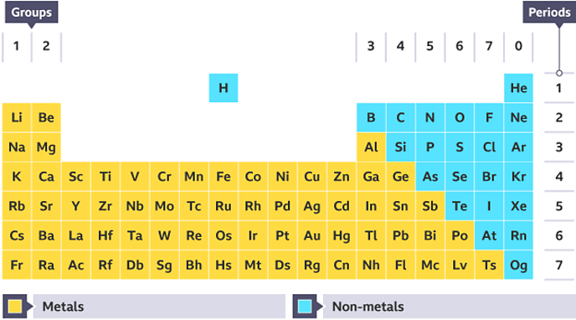

Elements of the Periodic Table
Metals

Pupil Name:
Class:

Recap from S3

Atoms, Elements, and the Periodic Table
Reactions can be described using word and formula (or chemical) equations.

- Word Equations
Describe chemical reactions using words. For example:

calcium + nitric acid calcium nitrate + hydrogen

- Formula (or chemical) Equations
Describe chemical reactions using the chemical formulae for the substances involved. For example:

Ca + HNO₃ Ca(NO₃)₂ + H₂

How to Balanced Equations (from S4)

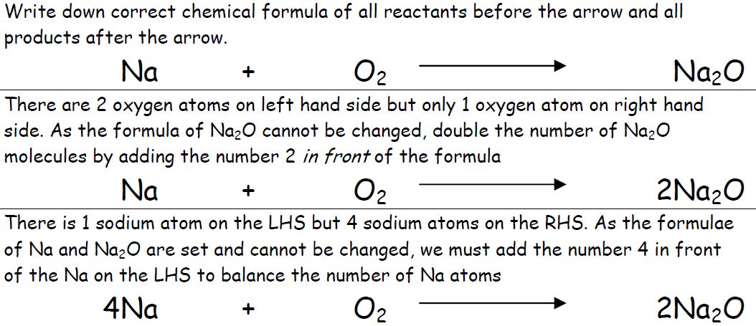

Metals

Over three quarters of the Periodic Table are metallic elements.
Metals have many common physical properties.
Some examples of physical properties include
- density – this is a measure of mass per unit volume (grams per cubic centimetre or g cm⁻³).
- conduction of heat
- conduction of electricity
- malleability – the ability to be beaten into different shapes
- ductility – the ability to be drawn or stretched into a wire
- strength.
These properties make them suitable for specific uses in our everyday lives.

Physical Property | Use
high density | sinkers in fishing
 | bridges and buildings
good malleability
 | radiators
 | electrical wiring
Complete the table below linking everyday uses of a metal based with a physical property that the metal possesses.



The cost of iron metal is low, around £50 per tonne, whereas aluminium is expensive at around £850 per tonne. Despite this most aeroplanes are made primarily of aluminium.

Using your data booklet, suggest why aluminium is still used to make aeroplanes despite the cost.

Metallic Bonding

Metals generally have high melting and boiling points and, with the exception of mercury, are solids at room temperature. This would suggest that the bonding in metals is strong.

The bonding in metals is different from covalent and ionic bonding and is known as metallic bonding.

Metals form giant lattice structures in which their outer electrons are free to move. Metallic bonding is the attraction between these delocalised electrons and the positive metal ions.

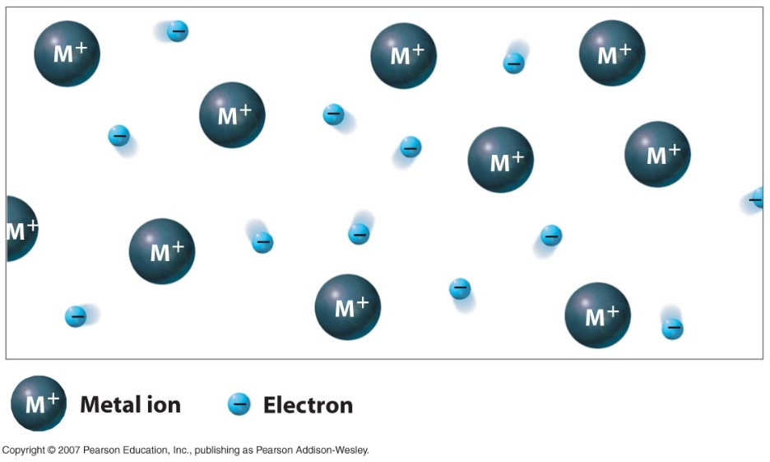

Suggest why metals are good conductors of electricity both as a solid and as a liquid.


Chemical Properties
Check test 1.10

From observations of the rates of chemical reactions it is possible to place metals in an order of reactivity. An order of reactivity is always given from the most reactive to the least reactive.
Metals and Oxygen

Some metals react with oxygen to form a metal oxide.

metal + oxygen → metal oxide

Place the four metals, iron, copper, zinc and magnesium, in order of reactivity:

_______________, _______________, _______________, _______________

For the reaction of magnesium with oxygen, write a word equation, balanced chemical and ionic equation.

Metals and Acids

Some metals react with acids forming a salt and hydrogen gas.

metal + acid → salt + hydrogen

Place the metals, iron, tin, copper, magnesium and zinc, in order of reactivity:

______________, ______________, ______________, ______________, ______________

For the reaction of magnesium with sulphuric acid, write a word equation, balanced chemical and ionic equation.

Metals and Water

Some metals react with water forming a salt and hydrogen gas.

metal + water → metal hydroxide + hydrogen

Place the metals, lithium, sodium, magnesium, potassium and calcium, in order of reactivity:

______________, ______________, ______________, ______________, ______________

For the reaction of lithium with water, write a word equation, balanced chemical and ionic equation.

Reactivity Series

The reactivity series lists metals in order of reactivity as well as showing which metals will react with oxygen, acid and water.
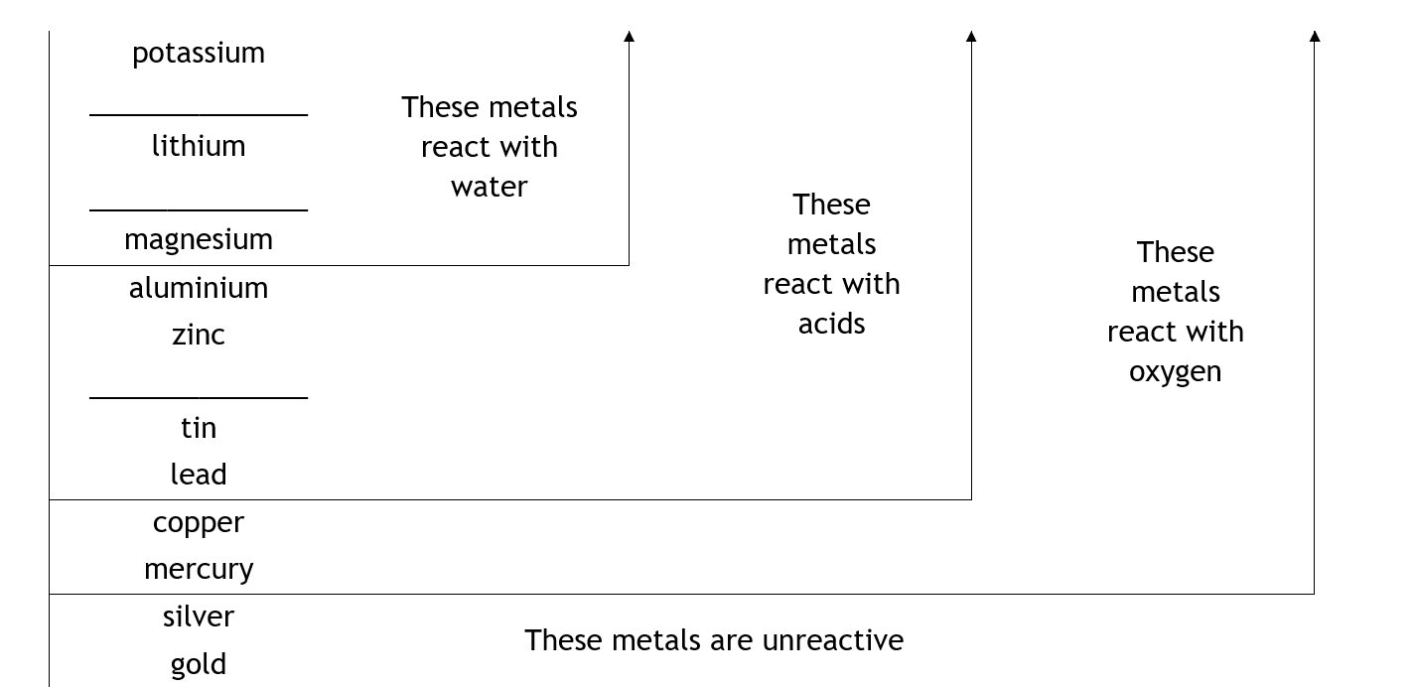
Using the results from the experiments, fill in the missing elements in the reactivity series below.

Questions

- Name a metal which reacts with oxygen but not with acid.

- Describe a use of the metals silver and gold; suggest why they are suitable for this use. (Consider both physical and chemical properties)

- Sodium metal should never be added to hydrochloric acid. Suggest a reason why.

Check test 1.11
Corrosion

When some metals are left in the open air, they tend to break up at the surface. The metal object gradually wears away as the surface flakes off.
The surface of the metal changes from an element to a compound.
This process is called corrosion and in the special case of iron it is called rusting.
Rusting results in the iron losing its strength.

Corrosion is when a metal reacts with water and oxygen to form a compound. The corrosion of iron is called rusting.


Complete the results for the experiment you set up in class.

Test tube A | Test tube B | Test tube C
Iron in a test tube of air with the moisture of the air removed by a drying-agent | Iron immersed in water which has been boiled to drive out any dissolved air and covered with a film of oil to keep air out | Iron in contact with air and water.

An iron nail rusts when both ______________ and _____________ are
present. If either ______________ or _______________ is absent the iron
nail will not rust.

Oxygen and water are both needed for the corrosion of a metal to occur

Rusting

The corrosion of iron is called rusting. It is a chemical reaction between the reactants iron, oxygen and water.
When iron reacts it forms iron ions, Fe²⁺(aq). This can be shown as:
Fe Fe²⁺ + 2e⁻
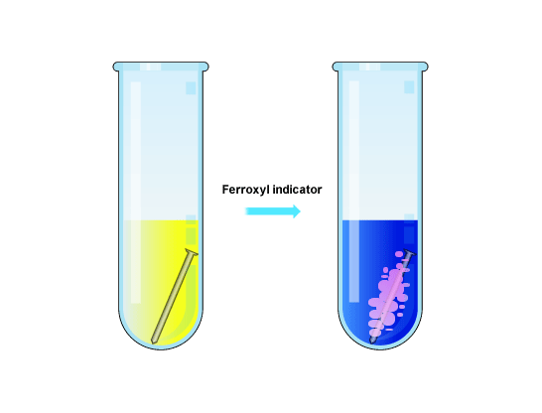
Chemists can detect Fe²⁺ ions by using ferroxyl indicator. This chemical turns blue in the presence of Fe²⁺ ions.

blue
yellow

Ferroxyl indicator changes from yellow to blue in the presence of iron ions (Fe²⁺(aq))

Different metals have different reactivity. As corrosion is a chemical reaction, different metals corrode at different rates.

- Which metals do you think will corrode at the fastest rate? Why?

- Which metals do you think will corrode most slowly? Why?

Preventing Corrosion

Both oxygen (from the air) and water must be present for iron to form rust.
Iron can be protected from rusting by preventing air and water for coming into contact with the surface of the iron.
There are several ways of making a surface barrier to keep out air and water.



Write a short note on each of these methods of protecting iron from rusting; state how it protects and give an example of where it is used.

Painting

Greasing

Plastic coating

Electoplating

Galvanising

Electrochemical Protection against Corrosion

Iron can also be protected against corrosion by attaching the iron to certain other metals.
This method of protection is very different from providing a surface barrier.
From your experiment, colour in the diagrams to show the extent of rusting seen in each dish

Complete the following:

The iron nail on its own ___________ quite quickly. The iron nail attached to
_____________ and the nail attached to ______________ did not rust. The iron nail attached to ________________ rusted quickly. Therefore, attaching an iron nail to _______________ or ________________ stops the iron nail from rusting. Iron does not rust when it is attached to more ______________ metals.

Answer the following questions:

- Give two reasons why galvanizing is commonly used to protect iron.

- Suggest why bags of scrap magnesium are attached to underground pipelines.

Galvanising is a method to protect iron by covering it with a layer of zinc.

Electrolysis

In unit 1 we learned about different bonding and structures and how these related to a substance’s physical properties.

To summarise this, complete the table below by naming the type of bonding in each substance.

Type of Bonding | Conducts as a solid | Conducts as a liquid | Conducts as a solution
covalent molecular | ✖ | ✖ | ✖
 | ✖ | ✖ | ✖
 | ✖ | ✔ | ✔
metallic |  |  | doesn’t form solutions

Electrolysis is defined as the breaking down of a compound, usually into its elements, using electricity.

Using the definition of electrolysis, suggest what type of compound we can carry out electrolysis on. What state must the compound be in? Explain why the compound has to be in the state you have chosen.

In electrolysis the ions in a solution or melt are attracted to the electrode of the opposite charge.
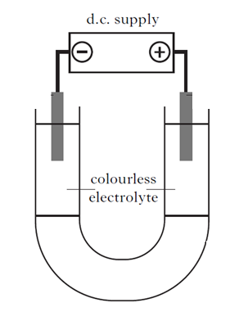
By using coloured ions we can show this movement.

Copper(II) chromate is green because it contains blue copper(II) ions and yellow chromate ions. When the power supply is switched on, the coloured ions move to the electrode of opposite charge, causing the colourless electrolyte to change colour.

Colour the diagram to show how the ions would move in this experiment.

A D.C, or direct current, supply is one where the electrons flow in the wires in only one direction. The electrons flow from the negative terminal on the supply to the electrode to which it is attached making this the negative electrode. Electrons flow from the other electrode to the positive terminal on the supply making this the positive electrode.

As each electrode has a permanent charge, the ions will move toward only one electrode. When the ion gets to the electrode it either gains or loses electrons to form a product. Each product forms at a different electrode.

The use of a D.C supply allows the products of the electrolysis to be identified.

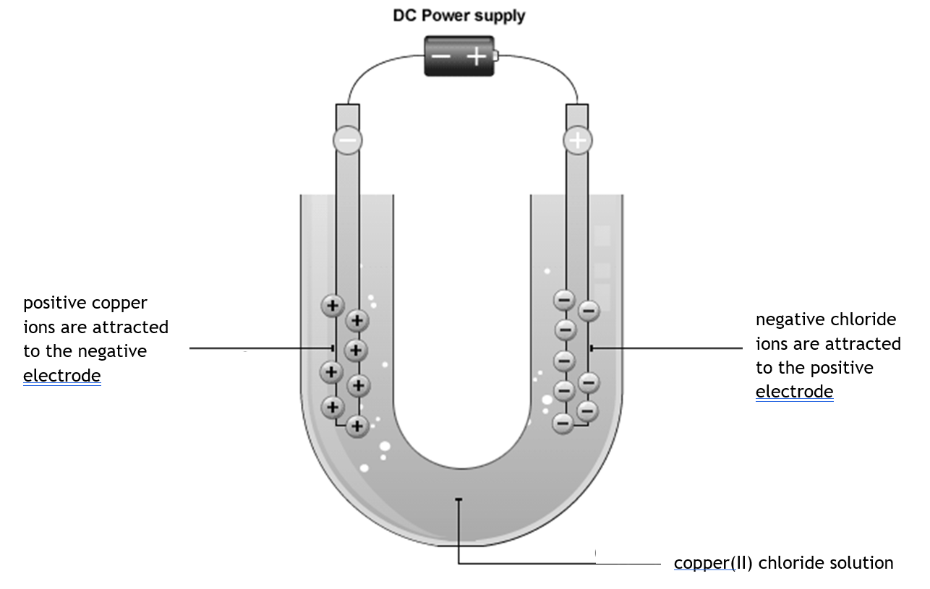
What happens when the ions reach the electrode?

In this experiment the compound copper(II) chloride is being broken down into copper and chlorine.
During the process, ions are being attracted to the electrode of their opposite charge. Positive copper(II) ions are attracted to the negative electrode where they gain electrons, forming copper atoms.
This can be shown by an ion-electron half equation:
Cu²⁺(aq) + 2e⁻ → Cu(s)
Negative chloride ions are attracted to the positive electrode where they lose electrons, forming chlorine atoms which join in pairs to make chlorine molecules.
This can be shown by an ion-electron half equation:
2Cl¯ → Cl₂ + 2e⁻
During the electrolysis of copper(II) chloride solution what would be observed at each electrode?

Displacement Reactions

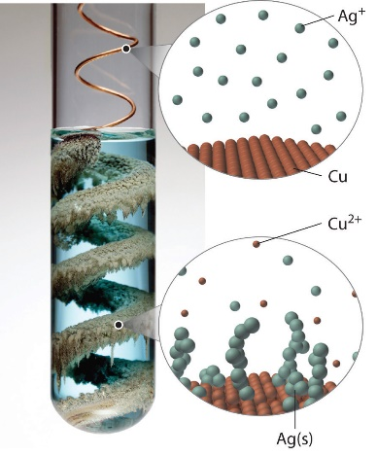
An example of redox is a displacement reaction, where metal atoms react with a solution containing ions of another metal.

e.g. calcium will displace iron from iron(II) sulphate solution.

Ca(s) + FeSO₄(aq) → Fe(s) + CaSO₄(aq)

We can omit the spectator ions to see the reacting species:

Ca(s) + Fe²⁺(aq) + SO₄(aq) → Fe(s) + Ca²⁺(aq) + SO₄(aq)

Ca(s) + Fe²⁺(aq) → Fe(s) + Ca²⁺(aq)

This reaction is in fact the reduction of calcium atoms and the oxidation of iron(II) ions. These are the two ion-electron half equations.

Ca(s) → Ca²⁺(aq) + 2e⁻ (Oxidation)

Fe²⁺(aq) + 2e⁻ → Fe(s) (Reduction)

The electrochemical series, which can be found on page 10 in your data booklet, places metals in order of how easily they lose electrons to form ions. The higher the metal in the series the more easily it loses electrons.

The electrochemical series can be used to predict whether a displacement reaction will occur. If the metal being added is higher in the series than the metal ions in solution, then a displacement reaction will take place.

An easy way to remember this is the MAD rule.
Metals
Above
Displace
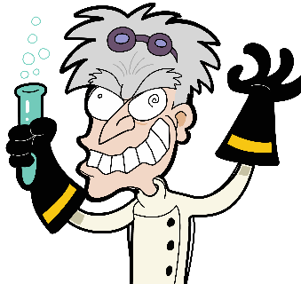

For the reaction of zinc and copper(II) sulphate:

Zn(s) + CuSO₄(aq) → Cu(s) + ZnSO₄(aq)

  - Write the equation omitting any spectator ions

  - Write the two ion-electron half equations

  - State which of the two reactions is an oxidation reaction and which is reduction reaction

Using the electrochemical series, predict whether these metals will react with the solutions given. Place a  in the boxes where a reaction will take place.

Metal | Added to a solution of
Metal | sodium sulphate | zinc sulphate | copper sulphate | silver(I) nitrate
magnesium
tin
copper

Metals with acids

When a metal reacts with an acid, hydrogen gas is produced. This is also an example of a displacement reaction as hydrogen ions are displaced from the acid.

e.g. Mg(s) + H₂SO₄(aq) → H₂(g) + MgSO₄(aq)

This gives the equations

Mg(s) → Mg²⁺(aq) + 2e⁻ (Oxidation)

2H⁺(aq) + 2e⁻ → H₂(g) (Reduction)

Only metals above hydrogen in the electrochemical series will react with dilute acids.

Metal Ores
Metals such as gold and silver are found uncombined in the earth because they are so unreactive. As a result of this, these elements were among the first to be discovered, see page 7 of the data booklet.
Other metals are found in compounds called ORES and have to be extracted.
Ores are naturally-occurring compounds of metals from which metals can be extracted.
The three main types of ore are metal carbonates, metal oxides and metal sulphides.

Common name | Chemical name | Metal present
Haematite | iron oxide
Bauxite | aluminium oxide
Galena | lead sulphide
Malachite | copper (II) carbonate

The reaction involved in extracting a metal from its ore is a reduction reaction.

Extraction by heat alone

Some metal ores will simply break down when heated, for example mercury oxide.

metal oxide → metal + oxygen

mercury(II) oxide → mercury + oxygen

Write a balanced chemical equation for this reaction.

In this reaction the mercury ions (Hg²⁺) in mercury(II) oxide gain two electrons to form mercury atoms.
Hg²⁺ + 2e⁻ → Hg

This is an example of a reduction reaction as electrons are gained.
Which test could be carried out to verify that this reaction has taken place?

Extraction with carbon

Some metal ores require another chemical to be present in order to extract the metal.

The other chemical causes the metal ore to be reduced, they are known as a reducing agents.

An example of this is the use of carbon in extraction of copper from its ore.

metal oxide + carbon → metal + carbon dioxide

copper(II) oxide + carbon → copper + carbon dioxide

Write a balanced chemical equation for this reaction.

Write an ion-electron half equation for the reduction of copper(II) ions in this reaction.

Another example of a reducing agent is carbon monoxide which is used in the extraction of iron in a chemical plant known as a blast furnace.
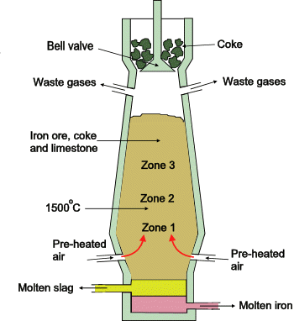

This is a diagram of a blast furnace.

Iron is extracted from its ore by mixing it with carbon in the presence of air.

The carbon reacts with the air to form carbon monoxide which then reacts with iron oxide forming iron and carbon dioxide.

Electrolysis

Other metal ores require electricity in order to extract the metal. These metals use the process of electrolysis.
The metal ore is first melted and then a large electric current is passed through the molten ore.

An example of this is the extraction of aluminium from its ore.

metal oxide → metal + oxygen

aluminium oxide → aluminium + oxygen

Write a balanced chemical equation for this reaction.

Write an ion-electron half equation for the reduction of aluminium in this reaction.

You have now learned about the reactivity series of metals and the three methods of extracting a metal from its ore.

- What is the relationship between the reactivity of the metal and how easily the metal is extracted from its ore?

- In the electrolysis of aluminium oxide the ore has to be melted before the aluminium can be extracted.
  - Why must the aluminium oxide be molten before it will conduct electricity?

  - At which electrode will the aluminium form?

Making Electricity

As we have seen redox reactions involve the loss and gain of electrons. If these electrons move through wires then an electrical current is being produced.

An electrochemical cell is a system which produces electricity from chemicals.

A simple electrochemical cell consists of two metals and an electrolyte.
Salt solution
The electrochemical series can be used to predict the direction of electron flow as well as comparing which pairs of metals will produce the largest voltage.

Direction of electron flow
The direction of electron flow will always be from the metal highest in the electrochemical series to the metal lower down.
“Electrons flow from above to below”

Size of voltage
The pair of metals furthest apart in the electrochemical series will produce the largest voltage.

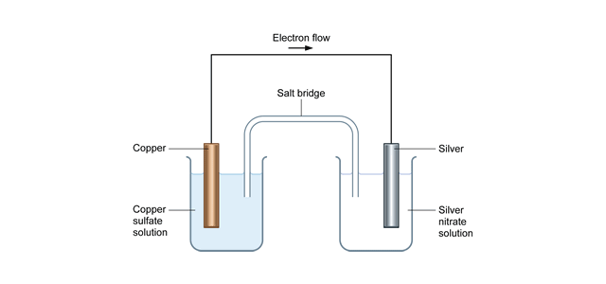
Cells will often have two electrolytes present, these cells require the use of an ion-bridge which completes the circuit by allowing ions to flow between the two solutions.
ion bridge
electron flow
copper
copper(II) sulphate solution
silver
silver(I) nitrate solution

In order to write ion-electron half equations for the reactions taking place at each electrode we must find each equation in the electrochemical series. The higher of the two equations will go in reverse, as the oxidation reaction.

In this cell the copper atoms are losing electrons (oxidation) to form copper(II) ions and the silver(I) ions are gaining electrons (reduction) to form silver atoms.

Cu(s) → Cu²⁺(aq) + 2e⁻ (Oxidation)

Ag⁺(aq) + e⁻ → Ag(s) (Reduction)

Complete the following diagram by showing the direction of electron flow.
ion bridge

zinc
zinc(II) sulphate solution
magnesium
magnesium sulphate solution

Write the two ion electron half equations for the cell.

Use the electrochemical series to decide which of the following pairs of metals will produce the largest voltage.

- copper / zinc or copper / tin
- lead / magnesium or lead / zinc
- zinc / nickel or nickel / iron

If you were to weigh the electrodes before and after the cell was set up, how would the masses of the electrodes change?

Cells with non-metals

Some electrochemical cells will contain non-metals too. These will always have a carbon electrode and the non-metal in the solution will take part in the reaction.
ion bridge
electron flow
carbon
iodine solution
carbon
sodium sulphite solution
e.g.

Check test 1.12
This cell involves the reaction between iodine and the sulphite ion.

SO₃²⁻(s) + H₂O(l) → SO₄²⁻(aq) + 2H⁺ + 2e⁻ (Oxidation)

I₂(aq) + 2e⁻ → 2I⁻(g) (Reduction)
ion bridge

carbon
sodium iodide solution
carbon
bromine solution
Complete the following diagram by showing the direction of electron flow.

Write the ion electron half equations for the reaction at each electrode.

Writing Redox Equations

An equation showing the overall reaction can be written by combining the ion-electron half equations for the reduction and the oxidation reaction. This is known as a redox equation.

In order to combine the equations, the number of electrons in each equation must be the same, this may involve multiplying one or both of the equations.
There are two electrons in each equation so they can be combined
e.g.
Ca(s) → Ca²⁺(aq) + 2e⁻ (Ox)

Fe²⁺(aq) + 2e⁻ → Fe(s) (Red)

Ca(s) + Fe²⁺(aq) → Ca²⁺(aq) + Fe(s) (Redox)

Notice that electrons do not appear in the redox equation.

e.g.
The silver equation must be doubled to balance the electrons
Cu(s) → Cu²⁺(aq) + 2e⁻ (Ox)

Ag⁺(aq) + e⁻ → Ag(s) x2 (Red)

So
Cu(s) → Cu²⁺(aq) + 2e⁻ (Ox)

2Ag⁺(aq) + 2e⁻ → 2Ag(s) (Red)

Cu(s) + 2Ag⁺(aq) → Cu²⁺(aq) + 2Ag(s) (Redox)

e.g.
Both equations must be multiplied to make 6e.
Al(s) → Al³⁺(aq) + 3e⁻ x2 (Ox)

Zn²⁺(aq) + 2e⁻ → Zn(s) x3 (Red)

So
2Al(s) → 2Al³⁺(aq) + 6e⁻ (Ox)

3Zn²⁺(aq) + 6e⁻ → 3Zn(s) (Red)

2Al(s) + 3Zn²⁺(aq) → 2Al³⁺(aq) + 3Zn(s) (Redox)

Write a redox equation for the following ion-electron half equations.

- Cl₂ + 2e⁻ → 2Cl⁻
2Br⁻ → Br₂ + 2e⁻

- Fe²⁺ → Fe³⁺ + e⁻
MnO₄⁻ + 8H⁺ + 5e⁻ → Mn²⁺ + 4H₂O

- Cu → Cu²⁺ + 2e⁻
NO₃⁻ + 4H⁺ + 3e⁻ → NO + 2H₂O

- The reaction between magnesium and silver(I) ions.

- The reaction between aluminium and lead(II) ions.

Check test 1.13

