
Beath High School
Chemistry Department

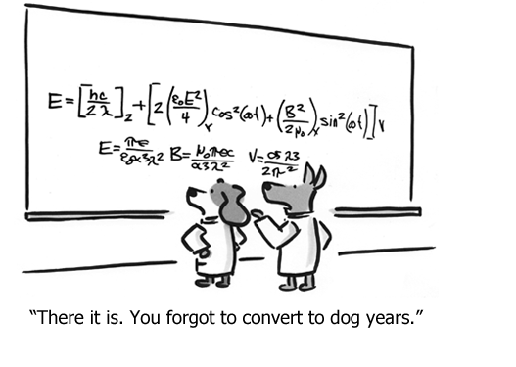

Elements of the Periodic Table
The Mole!

Pupil Name:
Class:

Recap from S3

Atoms, Elements, and the Periodic Table
- Atoms are made of three sub-atomic particles
protons
neutrons
electrons
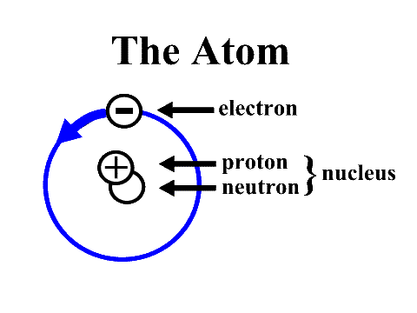
- Protons and neutrons are found in the nucleus of the atom.
Electrons orbit around the nucleus.
Particle | Mass | Charge
Proton | 1 amu | +1
Neutron | 1 amu | 0
Electron | 0 | -1

- The Atomic Number of an atom is the number of protons the atom has.

- The Mass Number of an atom is the total sum of the number of protons and neutrons it has.

mass no. = no. of protons + no. of electrons

- Atoms have no overall charge and are said to be neutral because
the number of protons = the number of electrons and so the charges cancel out.

1st energy level holds | 2nd energy level holds | 3rd energy level holds | 4th energy level holds
2 electrons | 8 electrons | 8 electrons initially | 8 electrons initially
** Electron arrangements can be found on page 6 of the data booklet**

- Elements in the same group have the same number of outer electrons e.g. Group 1 – The Alkali Metals.
Lithium Sodium Potassium
2,1 2,8,1 2,8,8,1
Elements with the same number of electrons in their outer shell have similar chemical properties

- The symbol of an element can be written showing the mass number and atomic number. This is called nuclide notation.

- The number of protons, neutrons and electrons in neutral atoms can be calculated by doing the following:

- Isotopes are atoms of the same element which have:
the same atomic number but a different mass number
the same number of protons but a different number of neutrons.

e.g.

Gram Formula Mass

Earlier in S3, you learned that every atom of an element has mass, due to protons and neutrons in the nucleus, and that an average of all possible isotopes is called the Relative Atomic Mass or R.A.M.

Using these masses and the chemical formula it is possible to calculate the Gram Formula Mass or GFM.

Due to the incredibly small size of atoms, it is not logical to try and measure the mass of one atom or even a few million atoms. Instead, we measure the mass of one mole of atoms. The term mole simply represents a number, an extremely large number and by measuring this quantity of atoms and molecules we can measure sensible and easy to handle masses.

The GFM is defined as the mass of one mole of a substance.

To calculate the GFM you must start with the correct chemical formula.

- First, write down the chemical formula of the relevant substance

e.g. H₂O

- Using the data booklet, note the RAM of each element in the substance

e.g. H = 1 O = 16

- Add up the total mass of the substance taking into account the chemical formula

e.g. H₂O : 2 x H = 2 x 1 = 2 Total = 18
1 x O = 1 x 16 = 16

The GFM of water is 18 which means that one mole of water has a mass of 18g.

Note that if the formula has brackets then the number out of the brackets multiplies everything inside of the brackets. e.g. Mg(NO₃)₂ is 1 x Mg, 2 x N and 6 x O.

Calculate the gram formula mass of the following substances

- nitrogen N₂ | - nitrogen dioxide NO₂
- sodium nitrate NaNO₃ | - silicon tetrachloride SiCl₄
- copper(II) chloride CuCl₂ | - calcium hydroxide Ca(OH)₂
- lead(IV) oxide PbO₂ | - aluminium bromide AlBr₃


Check test 1.7
Percentage Composition

Percentage composition is a calculation that chemists use to determine what percentage of a compound is made up of a certain element.

The steps for calculating the percentage by mass of hydrogen in water would be as follows

- Calculate the gram formula mass of the compound:

H₂O – 2 x H = 2 x 1 = 2
1 x O = 1 x 16 = 16

GFM = 18 g

- The total mass of the element in question, in this case hydrogen, is calculated:

H₂O contains 2 x H = 2 x 1 = 2 g

The percentage is calculated as

= $\frac{\text{2}}{\text{18}}\text{ x 100}$

= 11.1 %

- Calculate the percentage of sodium in sodium carbonate.

Na₂CO₃ – 2 x Na = 2 x 23 = 46
1 x C = 1 x 12 = 12
3 x O = 3 x 16 = 48

GFM = 106 g

2 x Na = 2 x 23 = 46 g

% mass = (46 ÷ 106) x 100 = 43.4 %

Calculate the percentage of

a) Carbon in CH₄ | b) lithium in Li₃O
c) silicon in silicon dioxide | d) copper in copper(II) carbonate

The Mole

Within everyday life we have words that tell us the number of certain numbers, like:

Pair : 2 Trio : 3 Dozen : 12 Bakers Dozen : 13

In chemistry we use a fixed amount called a mole, like a dozen it is a fixed number it just happens to be very large 602,000,000,000,000,000,000,000! This is because atoms and molecules are so small we need a colossal number of them to be able to weigh them.
This number is also called Avogadro’s Number/Constant and can be shortened to 6.02 x 10²³. Instead of writing this large number every time, we use the word mole.

6.02 x 10²³ = 1 mole

Mass and Moles

Knowing the formula of a substance, you can now calculate its GFM.

This forms a relationship with the mass of a substance (m) and the number of moles (n) of a substance as shown on page 1 of the data booklet

number of moles = mass of a substance / GFM

This can be rearranged to give
mass of a substance = number of moles x GFM

e.g. If you were asked to weigh out 2 moles of sodium chloride, what mass would you collect?

m = n x GFM GFM = NaCl
= 2 x 58.5 = 23 + 35.5
= 117 g = 58.5

e.g. If you measured out 50 g of calcium carbonate, how many moles of calcium carbonate have you collected?

n = m / GFM GFM = CaCO₃
= 50 / 100 = 40 + 12 + (3 x 16)
= 0.5 mol = 100

Calculate the mass of:

- 0.1 mol of O₂ | - 5 mol of NaBr
- 3.5 mol of CuCl₂ | - 0.5 mol of K₂SO₄

Calculate the number of moles in:

- 10 g of H₂ | - 12.8 g of SO₂
- 20 g of He | - 12.7 g of I₂

Check test 1.8
Making Solutions

When making a solution there are three key words which we must be able to use.

Solute – This is the chemical which is dissolved in a liquid
Solvent – This is the chemical into which the solute is dissolved.
Solution – This is the mixture formed when a solute is dissolved in a solvent.

- Saline solution is made by dissolving sodium chloride into water. For this solution identify the solute and the solvent.

- Sparkling wine is wine with carbon dioxide gas dissolved in it. For sparkling wine, name the solute and the solvent

Concentration

Concentration (C) is a measure which is used to describe solutions. It describes the quantity of chemical dissolved in a given volume. The concentration of a solution is normally given as the number of moles of solute dissolved in a litre of a solvent, the units of concentration is mol l⁻¹ (moles per litre).

This forms a relationship with the volume of a solution (V) and the number of moles (n) of a substance as shown on page one of the data booklet.
number of moles = concentration x volume

This can be rearranged to give

concentration = number of moles / volume

and

volume = number of moles / concentration

The volume must be in litres before being used in the calculation.
To change a volume in cm³ into litres we must divide by 1000.

e.g 100 cm³ = 100 ÷ 1000 = 0.1 litres

Convert the following volumes into litres:

- 75 cm³ = | - 150 cm³ =
- 10 cm³ = | - 700 cm³ =

If you were asked to make a 500 cm³ solution containing 2 moles of sodium chloride, what concentration would this solution have?

c = n / v 500 cm³ = 500 / 1000
= 2 / 0.5 = 0.5 litres
= 4 mol l⁻¹

e.g. If you had 750cm³ of a 1.5 mol l⁻¹ solution, how many moles of the chemical would you have?

n = c x v 750 cm³ = 750 / 1000
= 0.75 x 1.5 = 0.75 litres
= 1.125 mol

Calculate the concentration of a 800 cm³ solution containing:

- 1.5 moles of MgCl₂ | - 5 mol of NaBr
- 3.5 mol of CuCl₂ | - 0.5 mol of K₂SO₄

Calculate the number of moles in a 200 cm³ solution with a concentration of:

- 2 mol l⁻¹ | - 1.4 mol l⁻¹
- 0.01 mol l⁻¹ | - 0.05 mol l⁻¹

Concentration and Mass

If we look at both of our calculations side by side we can see that they have one variable in common, the number of moles (n).

With this common link, we can now know more about a solution by using both calculations together.

e.g. If you were asked to make a 500 cm³ solution of sodium chloride with a concentration of 1.4 mol l⁻¹, what mass of sodium chloride would you need?

n = c x v 500 cm³ = 500 / 1000
= 1.4 x 0.5 = 0.5 litres
= 0.7 mol

m = n x GFM GFM = NaCl
= 0.7 x 58.5 = 23 + 35.5
= 40.95 g = 58.5

e.g. If you were to make 750cm³ of a potassium sulphate (K₂SO₄) solution using 17.4 g of solid potassium sulphate, what concentration would the solution have?

n = m / GFM GFM = K₂SO₄
= 17.4 / 174 = 78 + 32 +64
= 0.1 mol = 174

c = n / v 750 cm³ = 750 / 1000
= 0.1 x 0.75 = 0.75 litres
= 0.075 mol l⁻¹
Calculate the mass of magnesium chloride (MgCl₂) required to make a 1.5 litre solution with a concentration of:

- 2 mol l⁻¹ | - 1.4 mol l⁻¹
- 0.01 mol l⁻¹ | - 0.05 mol l⁻¹

Calculate concentration of a 350 cm³ solution containing:

- 20.6 g of sodium bromide (NaBr) | - 4 g of ammonium nitrate (NH₄NO₃)
- 6.38 g of copper(II) sulphate | - 21.2 g of sodium carbonate

Check test 1.9

