
Beath High School
Chemistry Department

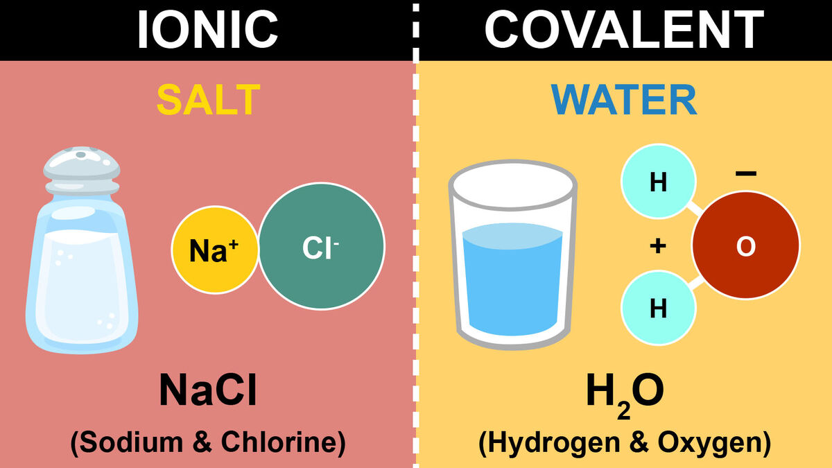

Elements of the Periodic Table
Covalent vs Ionic

Pupil Name:
Class:

Recap from S3

How elements combine
- Compounds are substances formed when atoms of two or more elements join together.

- The name of compounds that have all the elements named ends in ide.
e.g. sodium chloride, potassium hydrogen carbide.

- Where there are metals and non-metals in the compound the metal is always named first.

- Compounds that contain more than two elements plus the element oxygen end in ate or ite.

e.g. copper carbonate contains the elements; copper, carbon and oxygen.
Sodium sulphite contains the elements sodium, sulphur and oxygen

- Prefixes in front of elements within a compounds is used to inform the number of each present.
Mono – 1
Di – 2
Tri – 3
Tetra – 4

- There are two types of compound; covalent and ionic.

- Covalent compounds form when non-metals join together.

- Non-metals share their outer electrons to form covalent bonds between the atoms.

- Each covalent bond involves the sharing of two electrons.

- Groups of non-metal atoms joined together called molecules.

- Covalent compounds made of molecules have low melting points and boiling points.

- Covalent compounds can be found as solids, liquids or gases at room temperature.

- Covalent compounds do not conduct electricity.

- A diatomic molecule is one which is made up of two atoms. Several elements exist as diatomic molecules.

Hydrogen Nitrogen Oxygen Fluorine Chlorine Bromine Iodine Astatine
H₂ N₂ O₂ F₂ Cl₂ Br₂ I₂ At₂

- Ionic compounds are formed when atoms gain or lose electrons. Charged particles called ions are formed.

- Metals lose electrons to form positive ions.

- Non-metals gain electrons to form negative ions.

- Atoms lose or gain electrons to get a full outer shell of electrons.

- Ionic compounds can only conduct electricity, when molten or in solution because the lattice of ions gets broken up and it allows the ions move about.

- The ions must be free to move about for the substance to conduct electricity.

Bonding and Structure

As you have learnt in S3, compounds can be separated into two types, known as
covalent and ionic based on the type of chemical bond that causes their formation. The only true way to classify a compound as covalent or ionic compounds is by its ability to conduct electricity.
Covalent compounds cannot conduct electricity in any state.
Ionic compounds can conduct electricity but only when liquid or in solution.

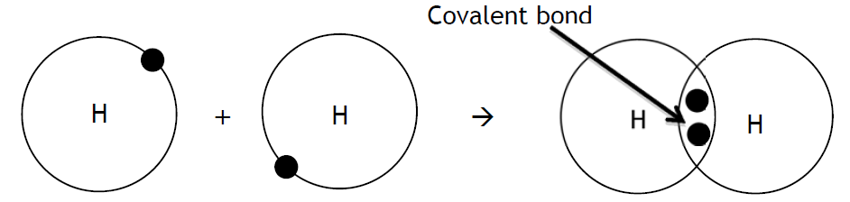
Remember, a covalent substance is one where atoms are joined together by one or more covalent bonds, which is formed when two atoms share a pair of electrons. This is done in order for each atom to have an electron arrangement similar to that of a noble gas, with a full outer electron shell.
Each hydrogen has an electron arrangement of 1, but because they are sharing their electrons, now have the full complement of 2 (like He)
Electron Arrangement = 1
Electron Arrangement = 1

Valency and Covalent Substances

When covalent compounds are formed, atoms share electrons with one another in order to achieve a full outer shell. Every electron shared becomes part of a pair (a covalent bond), which allows atoms to gain the share of electrons from other atoms until a full outer shell is achieved.

Since covalent compounds normally form between non-metal elements we will examine groups 4 to 0.

Complete this table:

Group | 4 | 5 | 6 | 7 | 0
Example element | C | N | O | F | Ne
Outer electrons |  | 5
Electrons needed to complete outer shell |  | 3
Valency Number |  | 3
Valency number of an atom is number of bonds an atom needs to make to be stable (covalent compounds), or how many electrons will be lost or gained by atoms to become stable (ionic compounds)

Writing Chemical Formulae

As we learnt in S3, if there is a prefix within the name of the covalent molecule or compound, we use that to tell us the number of each element present within them.
eg. carbon dioxide CO₂ dinitrogen tetraoxide N₂O₄

What happens if there is no prefix?
This is where we use the valency for each element present and ‘drop and swap’ method.
First of all, we need to know the valency of the elements within the periodic table.
Group | 1 | 2 | 3 | 4 | 5 | 6 | 7
Valency | 1 | 2 | 3 | 4 | 3 | 2 | 1

From finding out the valency of the elements within the compound we can then find out the chemical formula by a simple cross over

eg. carbon chloride eg. carbon oxide
C O
Group 4 6
Valency 4 2
Cross

C₂ O₄
Simplify C O₂

C Cl
Group 4 7
Valency 4 1
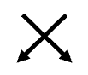
Cross

C Cl₄

For ions within compounds, such as Sulphate, take their charge as their valency (found in data booklet pg8)
i.e SO₄²⁻ valency = 2 PO₄³⁻ valency = 3

For Roman numerals for the transition metal, such as Copper (II), their valency is derived from that numeral.

i.e. Copper (II) valency = 2 Tin (lV) valency = 4
Check test 1.1
Check test 1.2
Shapes of Covalent Molecules

Covalent molecules come in different shapes.

Based on the number of bonds and their orientation around the central atom are four shapes which you should be able to name.

- Four atoms bonded to a central atom:

e.g. Carbon hydride, CH₄
This molecule has a tetrahedral shape

- Three atoms bonded to a central atom:

e.g. Nitrogen hydride, NH₃
This molecule has a trigonal pyramidal shape

- Two atoms bonded to a central atom:

e.g. Water, H₂O
This molecule has an angular shape

- One atom bonded to another (diatomic)
e.g. Hydrogen chloride, HCl
This molecule has a linear shape

Note that these drawings are meant to represent a three-dimensional shape and so a dashed line is used to represent a bond which goes away from the reader and a dark wedge is used to represent a bond which comes toward the reader.
- For each of the following compounds, write the chemical formula and predict which shape of molecule it will form.

- Nitrogen bromide

- Hydrogen sulphide

- Iodine bromide

- Silicon hydride

- Carbon dioxide, CO₂ has two oxygens bonded to a carbon atom but has the following structure:

Suggest a name for the shape of a carbon dioxide molecule.

Attraction and Repulsion

When any two charged particles are close together they will interact with one another, either attracting or repelling each other.

If both particles are positive or both are negative then they will repel one another.
e.g. two protons will repel one another.

If the particles have opposite charges then they will attract one another.
e.g. a proton and an electron will be attracted to one another.

Like charges repel and opposite charges attract

So when two atoms come together, how can the covalent bond hold the two atoms together? Why don’t the two positive nuclei repel one another and fly apart?

This is because a balance is reached between attraction and repulsion. The two positive nuclei will repel one another but they both have a shared attraction for the pair of bonding electrons. As a result, the two atoms are held in a stable formation.

Complete the diagram, showing the repulsion of the two nuclei and their shared attraction for the bonding electrons:

+
+

Covalent Structures

As we have seen, some compounds exist as covalent molecular compounds. These molecules have very weak forces of attraction between the molecules but strong covalent bonds inside the molecules.
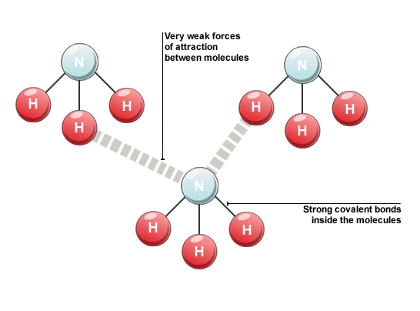
When melting or boiling a covalent molecular substance it is only the weak forces of attraction that must be broken, not the strong covalent bonds.
As a result covalent molecular compounds have low melting and boiling points and can exist as solids, liquids and gases at room temperature.

Some covalent substances exist as giant three-dimensional covalent networks. This is where the atoms are joined together by covalent bonds but rather than being in molecules the atoms bond with one another in a continual way.

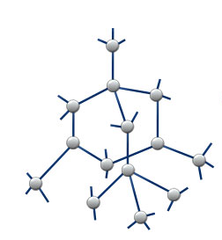
Carbon can exist in many different forms, one of which is diamond. Diamond is a three-dimensional network of carbon atoms where each carbon has four covalent bonds joining it to 4 different carbons.

When melting or boiling a covalent network substance it is only the strong covalent bonds that must be broken.

As a result, covalent network compounds have very high melting and boiling points and can only exist as solids at room temperature.
Molecule v Network

Physical Properties
Carbon and silicon are both found in group four of the periodic table and both form covalent compounds with oxygen. Let’s compare carbon dioxide with silicon dioxide:
Carbon dioxide  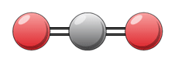 | 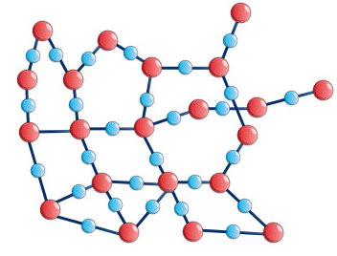  Silicon dioxide
Exists as covalent molecules | Exists as a covalent network
Gas at room temperature | Solid at room temperature
Melting Point: -78 °C | Melting point: 1700 °C
Boiling Point: -57 °C | Boiling point: 2230 °C

Chemical Formulae

For covalent molecular substances the chemical formula tells us the number of atoms of each element present in the molecule
e.g.
carbon dioxide is CO₂ this tells us that there is one carbon atom and two oxygen atoms in the molecule. Water is H₂O and this tells us that there are two hydrogen atoms and one oxygen atom in the molecule.

For covalent network substances the formula tells us the ratio of the atoms in the network, not the definite number present.
e.g. silicon dioxide is SiO₂, this tells us that there is one silicon atom for every two oxygen atoms in the network
Summary – Covalent Substances

covalent | network (x3) | conduct | pair | solid
molecular (x3) | electrons (x2) | elements | attraction | ratio

Covalent substances can be either ____________________ or compounds. They are formed when atoms form ____________________ bonds. A covalent bond is described as a shared ____________________ of ____________________ between two atoms. A covalent bond holds the atoms together due to the two nuclei having a shared ____________________ for the pair of ____________________.

Covalent compounds can be easily distinguished from ionic compounds, as they cannot ____________________ electricity in any state.

A covalent substance can form one of two structures, it can be either a covalent ____________________ or ____________________. These two structures are distinguished by their physical properties; covalent ____________________ have low melting and boiling points and can exists as solids, liquids or gases at room temperature, while covalent ____________________ have very high melting and boiling points and only exist as ____________________ at room temperature.

The formula of a covalent ____________________ substance gives the exact number of atoms present inside the molecule, whilst a covalent ____________________ structure gives the ____________________ of atoms in the network.

Ionic Bonding

An ionic substance is one that is made up, not of atoms, but of ions. As covered previously an ion is a charged particle, formed when an atom either gains or loses electrons.

An ionic bond is simply an electrostatic attraction between a positive and a negative ion.

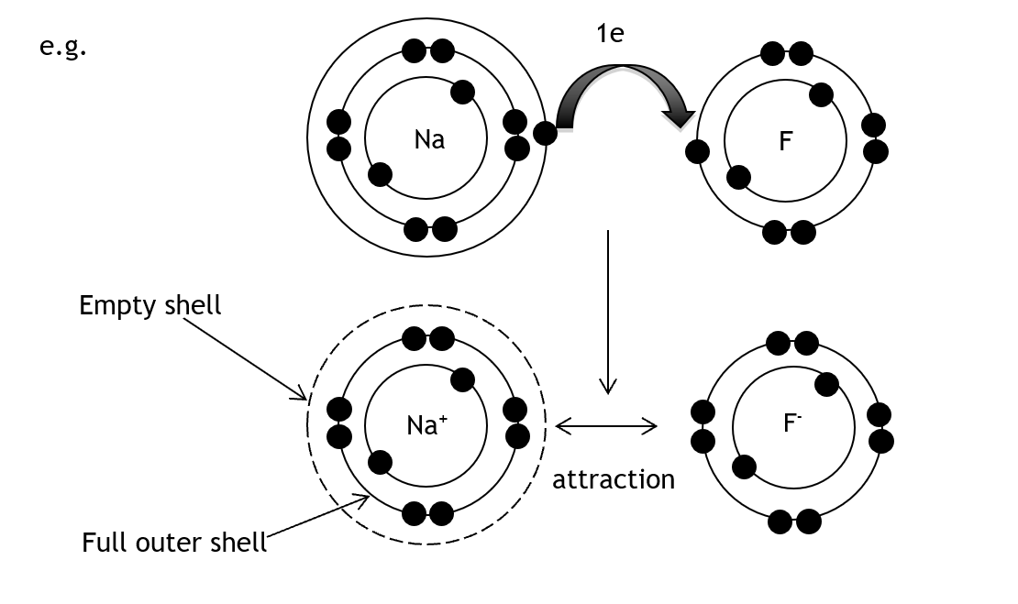

Another key difference from covalent bonding is that ionic bonding can only occur in compounds, not in elements.

Ionic Structure

The structure adopted by ionic compounds is known as a crystal lattice structure. Each ion is surrounded by the ion of opposite charge forming a very rigid and well-ordered structure.

Different compounds will form lattices of different shapes and it is this arrangement of ions that causes ionic compounds to form crystals of various shapes.

Sodium chloride forms a cubic shaped crystal lattice where every sodium ion and every chloride ion is surrounded on six sides by an oppositely charged ion.

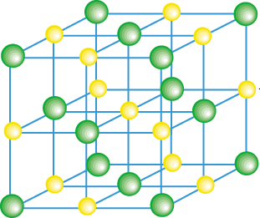
When melting or boiling an ionic substance it is the strong ionic bonds that must be broken.
As a result, ionic compounds have high melting and boiling points and only exist as solids at room temperature.

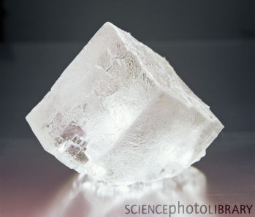
This is an image of a sodium chloride crystal. You can see that it forms a cubic shape, just like the lattice shape above.
Although ionic compounds have high melting points they are lower that that of a covalent network. Below is a comparison of sodium chloride and silicon dioxide
 | Sodium chloride | Silicon dioxide
Structure | crystal lattice | covalent network
Melting point / °C | 801 | 1700
Boiling point / °C | 1413 | 2230

Many ionic compounds will dissolve in water, they are said to be soluble. The reason for their solubility is that, when added to water, the crystal lattice structure breaks down and the ions are free to move in the solution.

Valency and Ionic Compounds

For ionic compound the valency number is the number of electrons that must be lost or gained to form a full outer shell. Group 4 and 0 atoms do not form ions.

Group | 1 | 2 | 3 | 4 | 5 | 6 | 7 | 0
Example element | Na | Mg | Al | No Ions | P | S | Cl | No Ions
Outer electrons | 1 | 2 | 3 | No Ions | 5 | 6 | 7 | No Ions
Electrons gained or lost |  | 2  lost |  | No Ions |  |  | 1 gained | No Ions
Charge |  | 2+ |  | No Ions |  |  | – | No Ions
Valency |  | 2 |  | No Ions |  |  | 1 | No Ions

Electricity and Structure

Ionic substances have a rigid crystal lattice structure, however when they are melted or dissolved this rigid structure is lost.

This image shows sodium chloride dissolving. When added to water the ions are surrounded by water molecules and are able to leave the lattice structure.

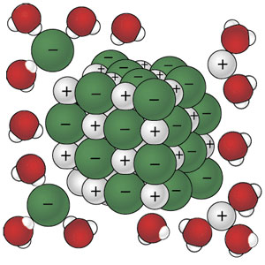

Ionic compounds can conduct electricity only as a liquid or when in solution because they have ions that are free to move.
Solid ionic compounds contain ions, but these ions are rigidly held in place and are unable to move

Covalent compounds cannot conduct electricity, as they contain no ions.
Summary – Ionic Compounds

positive | oppositely | soluble | attraction | crystal
high | negative | atoms | ion | electrons

Ionic substances are made up of ions not ____________________. An ____________________ forms when an atom either gains or loses ____________________. During a chemical reaction this involves one atom losing its electrons, forming a ____________________ ion, to another atom, forming a ____________________ ion.

An ionic bond is the ____________________ that the positive and negative ions have for one another.
The structure of an ionic compound is known as a ____________________ lattice structure and consists of a well-ordered, three-dimensional lattice of ____________________ charged ions.

When an ionic substance is melted or boiled, strong ionic bonds must be broken and, as a result, these substances have ____________________ melting and boiling points. A liquid (or molten) ionic compound has lost its rigid and well-ordered structure and the ions are able to move over one another and flow.

Another way to break down the lattice structure is to dissolve the substance. If the substance is ____________________ in water then the lattice structure is lost and the ions are again able to flow in the solution.

Check test 1.3

Ionic Formulae

When working with an ionic compound it is important to be able to understand and write an ionic formula. An ionic formula gives both the charge on the ions in the compound and the ratio of the ions in the crystal lattice.
Writing an ionic formula links together two skills you already have:

- To write a chemical formula using valency rules, group ions and Roman numerals where appropriate

- To work out the charge of an ion using the periodic table and electron arrangements and write the symbol for the ion.

e.g. sodium chloride

- Write the formula
Na Cl → Na Cl → Na Cl
1 1

1 1

- Write the symbols for the ions

Na – 2,8,1 – loses 1 e – Na⁺
Cl – 2,8,7 – gains 1 e – Cl⁻

To write the ionic formula you simply write the ions in the ratio of the chemical formula:

Na Cl is in the ration 1:1 which gives an ionic formula of
Na⁺ Cl⁻

If any ion is in the formula with a number other than one it must be put into brackets.

e.g. Magnesium bromide is MgBr₂ the ions are Mg²⁺ and Br⁻ so the ionic formula is
Mg²⁺(Br⁻)₂

Give the ionic formula of the following compounds:

- magnesium nitrate | - sodium oxide
- aluminium oxide | - iron (II) sulphide

Check test 1.4

Chemical Equation

Chemical reactions are often described in the form of a chemical equation. A chemical equation is just like a word equation, except written with chemical formulae.
When writing a chemical formula it is important to first write a word equation, then simply replace each chemical name with its chemical formula.

Note that if any of the seven diatomic elements are present as elements, their formula reflects the fact that they are diatomic. e.g. hydrogen is written as H₂.

For example:

magnesium + bromine → magnesium bromide

Mg + Br₂ → MgBr₂

soidum hydroxide + hydrochloric acid → sodium chloride + water

NaOH + HCl → NaCl + H₂O

For each of the following word equations, write the formula equation:

- zinc + copper (II) chloride → zinc(II) chloride + copper

- lithium sulphate + barium chloride → lithium chloride + barium sulphate

- carbon + oxygen → carbon dioxide

- iron (II) oxide + carbon monoxide → iron + carbon dioxide

Showing the State

When writing chemical formulae, it can be useful to also show the state of matter in which the chemical would be. This is done using state symbols after the chemical formula.
State of Matter | State symbol
solid | (s)
liquid/molten | (l)
gas | (g)
in solution (aqueous) | (aq)

For example if solid sodium reacts with water to form hydrogen gas and a solution of sodium hydroxide, we could describe this reaction as:

Na(s) + H₂O(l) → NaOH(aq) + H₂(g)

- Complete the following examples to show their state symbol.
- solid sulphur | - liquid nitrogen
- ice | - magnesium chloride solution

- Write a formula equation including state symbols.

- Copper(II) chloride solution reacts with sodium carbonate solution to form sodium chloride solution and solid copper(II) carbonate.

- Copper(II) carbonate powder reacts with hydrochloric acid solution (HCl) to form copper(II) chloride solution, water and bubbles of carbon dioxide.
Check test 1.5

Finding a Balance

As you have seen, a chemical reaction can be described through the use of both word equations and formula equations. These two methods rely on the same idea, reactants go into the reaction and products come out.

When you look at some formula equations you might notice that not everything is balanced. For example let’s look at the reaction of hydrogen and oxygen to make water:
hydrogen + oxygen → water

H₂ + O₂ → H₂O

As you can see diatomic molecules of hydrogen and oxygen react together to form a water molecule. We can show this as a diagram:

= an atom of hydrogen = an atom of oxygen

H₂ + O₂ → H₂O

There is an imbalance between the reactants and the products, as there are two hydrogen atoms and two oxygen atoms on the reactants side, but only one oxygen atom and two hydrogen atoms on the products side. This means that the equation needs to be balanced.

In order to balance an equation, you must follow some rules:

- First count the number of atoms of each element on both sides of the equations, this can be noted down in a small table.

H₂ + O₂ → H₂O
H | O
2 | 2

H | O
2 | 1

- By looking at your count, decide which elements are lacking and whether they are lacking as reactants or products.

There is a shortage of oxygen on the products side.

- Next you can add reactants or products to the equation in order to correct the imbalance. Whenever you add something you must recount including the atoms you have added.

Note that only complete ‘formula units’ can be added, you cannot just add an atom of an element unless it is a reactant or product of the reaction.

H₂ + O₂ → H₂O
H | O
2 | 2
+H₂O
H | O
2 | 1
4 | 2

- Now you can repeat step 2 and 3 until the count is equal on both sides.

There is a shortage of hydrogen on the reactants side.

H₂ + O₂ → H₂O
H | O
2 | 2
4 | 2
+H₂ +H₂O
H | O
2 | 1
4 | 2

- The count is now balanced, with four hydrogen atoms and two oxygen atoms on either side.
You can now rewrite the equation totalling up the number of each reactant and product, as with formulae the number 1 need not be written.

2H₂ + O₂ → 2H₂O

This is a balanced equation.

Check test 1.6

Balance the following equations:

- H₂ + Cl₂ → HCl

- CH₄ + O₂ → CO₂ + H₂O

- CO + O₂ → CO₂

- Al(OH)₃ + HCl → AlCl₃ + H₂O

- Fe + O₂ → Fe₂O₃

