
S3 Chemistry Homework
Name _______________________
Teacher______________________
Results
Exercise | Due Date | Score
Exercise 1 |  | N4 /8 ; N5 /9
Exercise 2 |  | N4 /8 ; N5 /9
Exercise 3 |  | N4 /10 ; N5 /10
Exercise 4 |  | N4 /7 ; N5 /10
Exercise 5 |  | N4 /10 ; N5 /10
Exercise 6 |  | N4 /9 ; N5 /11
Exercise 7 |  | N4 /8 ; N5 /11
Exercise 8 |  | N4 /9 ; N5 /11
Exercise 1
Nat. 4
1. What does this symbol mean?
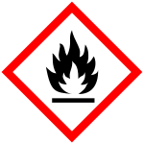
(1)

2.
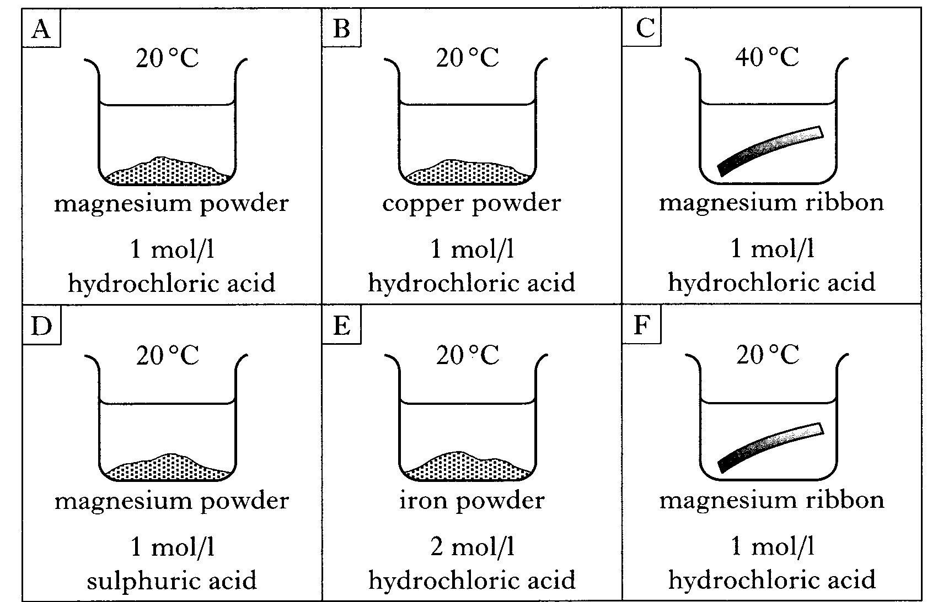
(a) Identify the 2 experiments which should be compared to show the effect of particle size on the reaction rate.

(1)
(b) State which factor is being studied if experiments C and F are compared.

(1)

3. The graph below shows the volume of carbon dioxide released when an excess of powdered marble chips react with dilute acid.

Explain why the slope of the graph levels out after 60 seconds.

(1)

4. If a copper and sulfur mixture is warmed, a red glow is seen to spread through the mixture and this continues even when the initial warming has stopped. A black solid, copper sulfide, remains at the end.
(a) Give 2 pieces of evidence that suggest that a chemical reaction has taken place.

(2)
(b) What name is given to the type of chemical reaction in which heat is given out?
(1)
(c) Write a word equation for the reaction
(1)
Nat. 5
5. A student measured the speed of a reaction between marble chips and dilute acid. As the marble chips reacted, the balance recorded a change in mass. At the end of the reaction, all of the calcium carbonate had been used up.
Time (min) | 0 | 15 | 30 | 45 | 60 | 75 | 90
Mass loss (g) | 0 | 0.81 | 1.29 | 1.50 | 1.61 | 1.70 | 1.70

(a)  (b) | Draw a graph of the student’s results.    (4)  Estimate the time taken, in minutes, for the reaction to finish  (1)
(c) Calculate the average rate of reaction, in gmin⁻¹, between 15 and 45 minutes. Show your working clearly.

(2)
6. The following graph shows the results of two chemical reactions, A and B.
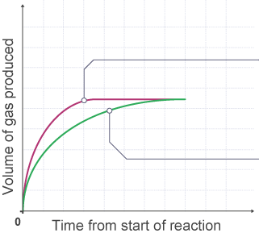
B
A
A student’s description of reaction A is shown:
“We added 3 g of powdered zinc into 10 cm³ of sulfuric acid with a concentration of 1 mol l⁻¹ at 20 °C.”
Suggest two changes to experiment A which could give the graph shown for experiment B.
1.

2.
(2)
Exercise 1
Marks = N4 / 8 ; N5 / 9
Teacher’s comment -

Exercise 2
Nat. 4
1. Three unlabelled bottles containing colourless liquids are known to be citric acid, distilled water and sodium hydroxide solution.
Describe how you would identify which was which.

(2)
2. Different compounds are shown in the grid below.
B
A
C

carbon dioxide

sodium oxide

aluminium oxide

F
E
D

calcium hydroxide

sulfur dioxide

hydrogen oxide

(a) Which 2 boxes show oxides that are acidic?
F
E
D
C
B
A
(1)
(b) Which 2 boxes show oxides that dissolve in water to produce alkalis?
F
E
D
C
B
A
(1)

3. A student had indigestion caused by too much hydrochloric acid in his stomach. To cure this, he took an antacid tablet containing magnesium carbonate.
(a) What happens to the pH of the hydrochloric acid during the reaction?

(1)
(b) A general word equation to describe the reaction of any acid with a metal carbonate is shown below.
(i) Fill in the missing word.
Acid + Metal Carbonate _________ + water + carbon dioxide
(1)
(ii) How would the student prove it was carbon dioxide gas that is produced? (i.e. what is the chemical test for carbon dioxide?)

(1)
(c) On the label of a hydrochloric acid bottle, the following hazard symbol was found. What does it mean?
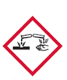________________ (1)

Nat. 5
4. Which of the following is not an example of a salt (circle one)
A Sodium chloride | B Potassium nitrate
C Lithium sulfate | D Magnesium oxide
(1)
5. Name the salt formed in the following reactions:
(a) Hydrochloric acid + potassium hydroxide ___________________
(b) Sulfuric acid + calcium hydroxide ___________________
(c) Lithium hydroxide + nitric acid _____________________
(d) Sodium hydroxide + sulfuric acid ______________________
(4)
6. Identify the 2 bases from the table below (circle 2 letters)
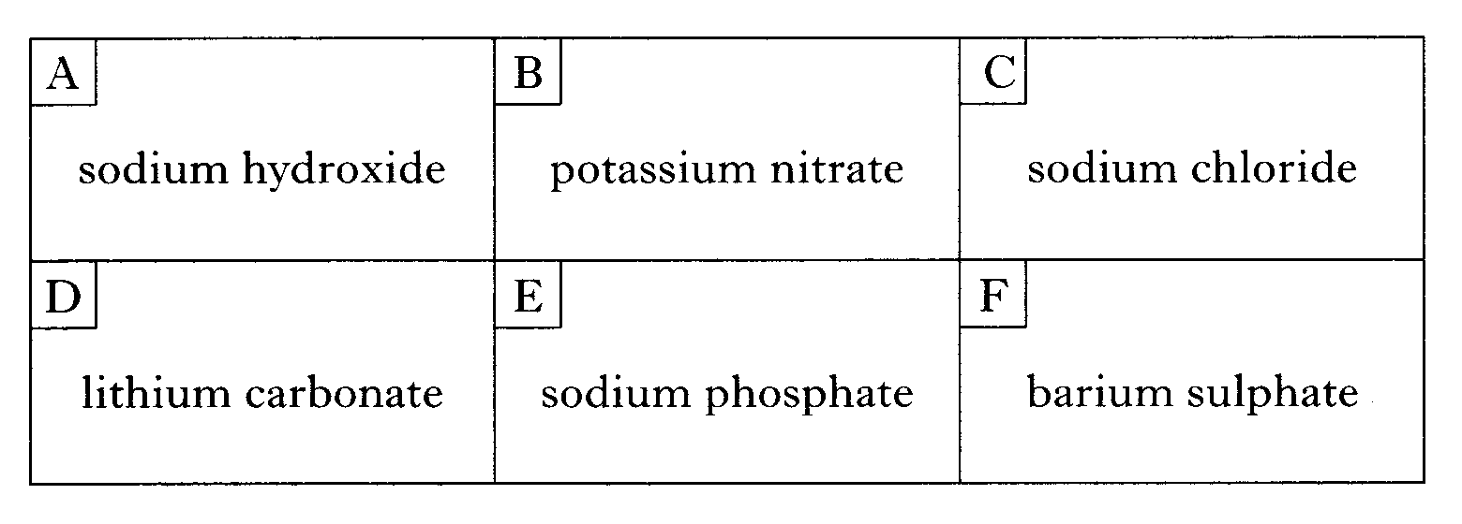

barium sulfate

(2)
Exercise 2
Marks = N4 / 8 ; N5 / 9
Teacher’s comment -

7. (a) Which acid would you use to make sulfate salts?
(1)
(b) When an acid reacts with a base, what type of chemical reaction takes place?

(1)
Exercise 3
Nat. 4
1. Complete the following table to show the masses and charges of the sub-atomic particles.
Name of particle | Mass (amu) | Charge
Proton
Electron
Neutron
(3)
2. Explain why atoms are electrically neutral.

(1)
3. Name an element that is a member of:
- the alkali metals _____________
- the halogens ______________
- the noble gases ______________ (3)

4.
(a) Explain what is meant by the atomic number of an atom.

(1)
(b) An atom has atomic number 23 and mass number 51.
(i) Which element is this?
(1)
(ii) The number of electrons in this atom is __________
(1)

Nat. 5
5. Name the elements with the following electron arrangements:
(i) 2,8,1 _____________ (ii) 2,8,8 ______________
(iii) 2,4 ____________ (iv) 2,8,8,2 ____________ (4)
6. Write the full symbol notation for the following atoms:
- An oxygen atom with 10 neutrons

- An atom with atomic number 6 and 7 neutrons

- An atom with 17 protons and 20 neutrons

(3)
7. ²⁵ Mg and ²⁴ Mg are two different kinds of magnesium atom.
₁₂
₁₂
- What word is used to describe these types of atoms?

(1)
- Explain why they can be regarded as atoms of the same element?

(1)
(c) The relative atomic mass of magnesium is 24.3. Which is the most common of the two types of magnesium atom?
(1)
Exercise 3
Marks = N4 / 10 ; N5 / 10
Teacher’s comment -

Exercise 4
Nat. 4
1. (a) Explain what is meant by the mass number of an atom.

(1)
(b) An atom has atomic number 17 and mass number 35.
(i) Which element is this?
(1)
(ii) For this atom, how many of each sub-atomic particle would be found?
- protons __________ (1)
- neutrons ________ (1)
- electrons __________ (1)

2. Background radiation can be either naturally occurring, or artificial.
Name a source of
- natural radiation ______________________ (1)

- artificial radiation ____________________ (1)

Nat. 5
- Match each type of radiation, by drawing a line to the correct answer
γ
Slow moving positively charged particle, attracted to the negative plate.
β
Electromagnetic radiation (travels at speed of light).
No deflection

α
Fast moving negatively charged particle, attracted to the positive plate.

(1)
2. Which type of radiation can be stopped with a thin sheet of aluminium foil?
(1)
3. Complete each of the following nuclear equations, by writing the correct symbol in the space provided
Rn
222
86
+
He
4
2
(a)

Bi
210
83
+
e
0
-1
(b)

Bi
214
83
+
e
0
-1
(c)
(3)
4. State what is meant by the half-life of a radioisotope.
(1)
The half-life of ¹⁴C is 5,730 years.
How long would it take for a 100g sample to decay to 12.5g?
5.

(2)
6. A sample was found to have an initial reading of 32 counts per minute; this had reduced to 4 counts per minute after 48 hours. What is the half-life of the sample?

(2)
Exercise 4
Marks = N4 / 7 ; N5 / 10
Teacher’s comment -

Exercise 5
Nat. 4
- (a) Explain what is meant by a diatomic molecule

(1)
(b) Give three examples of diatomic elements.

(1)
2. When the following elements react, name the compound they form:
(a) iron and sulfur ________________________ (1)
(b) magnesium and chlorine ___________________________ (1)
(c) zinc, sulfur and oxygen __________________________ (1)
(d) lead, carbon and oxygen _________________________ (1)

3. Which elements are found in:
(a) aluminium sulfide _______________________________ (1)
(b) magnesium nitrate _________________________________ (1)
(c) hydrogen chloride _________________________________ (1)
(d) lithium sulfite ______________________________________ (1)
Nat. 5
4. In a hydrogen molecule the atoms share 2 electrons in a covalent bond.
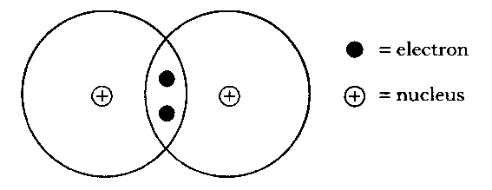
H
H

H
(a) Explain how the covalent bond holds the 2 hydrogen atoms together.
(1)
(b) (i) Showing all outer electrons, draw a similar diagram to represent a molecule of fluorine.

(2)
(ii) Draw another diagram to represent a molecule of ammonia, NH₃.

(2)
5. Use the data book page 9 to predict whether the following substances will be a conductor or an insulator of electricity.
(a) (i) Solid carbon dioxide _________________ (1)
(ii) Liquid lithium bromide _______________ (1)
(iii) Liquid ammonia ___________________ (1)
(b) (i) What temperature would lithium bromide need to be heated to, in order to become a liquid? You should use your data book.

(1)
(ii) Another substance, zinc nitrate, conducts electricity only in solution or as a melt; predict the type of bonding found in zinc nitrate.
Exercise 5
Marks = N4 / 10 ; N5 / 10
Teacher’s comment -

(1)
Exercise 6
Nat. 4
1. Explain why coal can be described as a
(i) fossil fuel – (your answer should explain both words)
(1)

(ii) finite resource -

(1)
2. In a paraffin burner, heat is produced when the paraffin burns.
(Paraffin is a hydrocarbon).
(a) What term is used to describe a reaction which produces heat? (1)
(b) Which gas is used up when paraffin burns?
(1)
(c) Which two elements are found in a “hydrocarbon”
(1)
(c) Explain why it is dangerous to burn paraffin in a poorly ventilated room.
(1)
3. In a catalytic converter, nitrogen dioxide and carbon monoxide are changed into the harmless gases nitrogen and carbon dioxide.
Write a word equation for this reaction.

(1)

4. In the first stage of the refining of crude oil it is separated into fractions.
(a) What name is given to this method of separation?
(1)
(b) What is meant by the word 'fraction'?
(1)
Nat. 5
5. What are the two products when paraffin burns in plenty of air?
(1)
6. The burning of a fuel is an example of a _________________ reaction. (1)
7. (a) Explain what is meant by the term “viscosity”

(1)
(b) With increasing molecular size, the fractions from crude oil become more / less viscous. (circle one) (1)

8. The table below shows the composition of a North Sea Oil sample.
Percentage | Gases | Petrol | Kerosene | Diesel | Residue
% | 5 | 20 | 10 | 19

What percentage of the oil was Residue?

(1)

9. A student carried out an experiment to measure the energy given out when a fuel burns.

Starting temperature ( ºC) | 20
Highest temperature ( ºC) | 34
Volume of water in can (cm³) | 250
Specific heat capacity of water (kJ kg⁻¹ ºC⁻¹) | 4.18
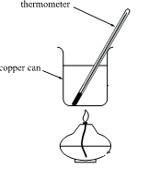

Calculate the energy in kJ given out by the fuel in this experiment.

(3)
10. In an experiment, the enthalpy change for the combustion of methanol is 10.5 kJ. The volume of water heated was 150ml. What was the temperature rise?

(3)

Exercise 6
Marks = N4 / 9 ; N5 / 11
Teacher’s comment -

Exercise 7
Nat. 4
1. (a) The molecular formula for the first four alkanes are as follows:
CH₄ C₂H₆ C₃H₈ C₄H₁₀
What is the general formula for the alkanes?

(1)
(b) For the next alkane in the series, write it’s
(i) Name_______________
(ii) Full structural formula

(iii) Shortened structural formula

(3)
2. Complete these formulae (which are for alkanes) – write the correct answer in the space

(i) C₁₇H___
(ii) C₈H___
(iii) C₅₀H___ (3)

3. Another hydrocarbon exists called heptyne. How many carbon atoms would you find in a molecule of heptyne?

(1)
Nat 5.
4. With increasing molecular size, the fractions from crude oil increase their boiling point. Explain why.

(1)
5. (a) Explain the meaning of the term “isomer”.

(1)
(b) Draw the structural formula and name two isomers of C₄H₁₀
(i) (ii)

(2)
6. Name the following compound

___________________________ (1)

7. Draw the full structural formula for the following
(a) 3-ethyloctane

(1)
(b) 2,2-dimethylhexane

(1)
8. When drawing the shortened structural formula of a branched alkane, the branch is usually written in a bracket after the carbon to which it is joined.
e.g. 4-methylheptane would be drawn as
CH₃CH₂CH₂CH(CH₃)CH₂CH₂CH₃

Draw both the full AND shortened structural formula for
(a) 3-methylpentane

(2)
(b) 2,4-dimethylhexane

(2)
Exercise 7
Marks = N4 / 8 ; N5 / 11
Teacher’s comment -

Exercise 8
Nat 4.
1. (a) Certain hydrocarbons are described as being saturated. Explain what is meant by the term “saturated”.

(1)
(b) Consider this list of hydrocarbons:
butane, ethene, octane, methane, butene
Name the hydrocarbons which are
(i) saturated
(1)
(ii) unsaturated
(1)
2. Which of the following could be the molecular formula of an alkene?
A. C₁₂H₂₆ B. C₁₀H₂₂ C. C₁₄H₂₆ D. C₉H₁₈
Letter ___________ (1)
3. Draw the FULL structural formula for the second alkene in the series (think carefully about this!)

(1)
4. Complete these formulae (which are for alkenes)
(i) C₁₅H____
(ii) C₄₆H___ (2)

5. Describe a chemical test, including the colour change, which you could use to tell propane and propene apart.

(2)
Nat. 5
6. Draw the full structural formula for each of the following compounds:-
  - (i) Cycloheptane

(1)
(ii) Hex-2-ene

(1)
7. When bromine is added to oct-2-ene, which is “unsaturated”, what type of chemical reaction takes place?

(1)
8. The dienes are a homologous series of hydrocarbons with 2 C=C units per molecule. The first 4 members of the series have the following formulae.
C₄H₆, C₅H_{8,} C₆H_{10,}C₇H₁₂
(a) Suggest a general formula for the dienes.

(1)
(b) Suggest the formula for the next member of the dienes

(1)
(c) What is meant by the term “homologous series”?

(1)
9. For the molecule below, give the following:-
CH₃CH₂C(CH₃) ₂CH₂CH₃

(i) Name:

(ii) Chemical (or molecular) formula:

(iii) Full structural formula

(iv) To which homologous series does it belong?

(v) Describe what would happen if bromine solution was added to a sample of this compound.

(5)
Exercise 8
Marks = N4 / 9 ; N5 / 11
Teacher’s comment -

