
Beath High School
Chemistry Department

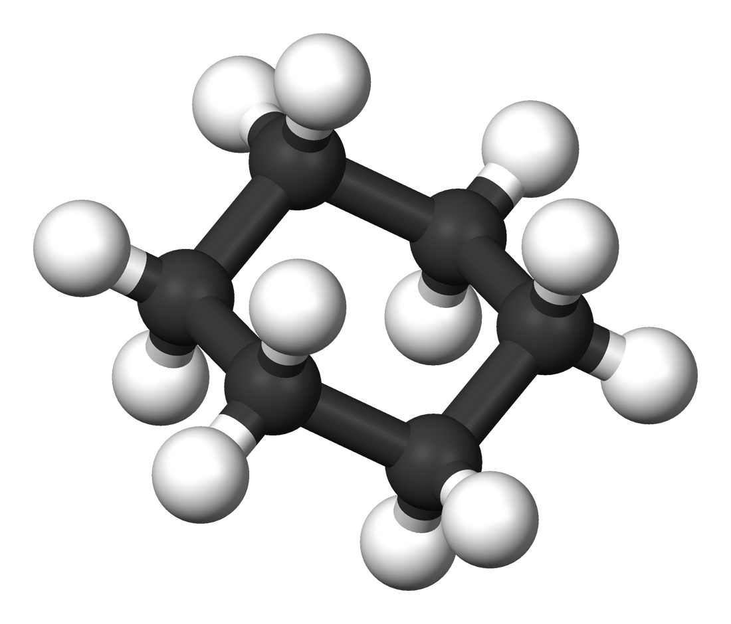

The Dependence for Fossil Fuels
Homologous Series

Pupil Name:
Class:

Alkanes

The study of carbon based compounds such as hydrocarbons is known as organic chemistry. Around 90% of all known compounds are organic and this is possible because carbon atoms are able to join together to make chains.

The simplest group of hydrocarbons are called the alkanes. Each alkane has its own name and the names are made up of two parts.

- The Prefix
This is the first part of the name and it tells us the number of carbon atoms present in the compound.

Number of carbon atoms | Prefix
1 | meth-
2 | eth-
3 | prop-
4 | but-
5 | pent-
6 | hex-
7 | hept-
8 | oct-
You must learn these eight prefixes and their meanings as they will also be used for other groups of chemicals.

For 1 – 4 it may help to make up a phrase to learn the prefixes for example
Monkeys
Eat
Proper
Butter

From 5 – 8 these prefixes match the names of the shapes. e.g. a pentagon is a five sided shape.

TIP: All of the alkane names can be found, in order in the data booklet.

- The Suffix
This is the part of the name which identifies the group of chemicals to which the compound belongs.

All alkanes end with the suffix -ane

No. Carbon atoms | Name | Chemical Formula | Full Structural Formula
1 | methane | CH₄ | `
2
3
4
5
6
7
8

Using the information in the table complete these formulae by showing the number of hydrogen atoms.

C₂₂H C₁₄₉H C₂₃H C₄₁H

General Formula
The general formula is used to show the relationship between the number of carbon atoms and the number of hydrogen atoms present in each molecule.

The general formula for the alkanes is C_{n}H_{2n+2}

Structural Formulae
There are two types of structural formulae which can be drawn; the full structural formula and the shortened structural formula. These both show how the atoms are joined together. The shortened structural formula refers to each individual carbon and states what is attached to each.
CH₂
CH₃
Example:
CH₃

CH₃CH₂CH₃

Full structural formula Shortened structural formula

Write the full and shortened structural formula for

- butane 2. hexane

Properties and Uses

Like all hydrocarbons, the alkanes are not soluble in water.
They are flammable and as such are commonly used as fuels.
Homologous Series

The alkanes are an example of a group of hydrocarbons known as a homologous series.

A homologous series is defined as a group of chemicals with
- the same general formula,
- similar chemical properties and
- a gradual change in physical properties.

You will learn about other homologous series throughout this unit.

Physical Properties

The definition of a homologous series states that the chemicals will show a “gradual change in physical properties”. We can see this by looking at fractional distillation, where properties such as viscosity and ease of evaporation can be linked to the chain length of the molecules.

In Unit 1 we learned that to melt or boil covalent molecular compounds we do not break the covalent bonds but rather we break the “forces of attraction” between the molecules. As molecules get bigger, these forces get stronger and so more energy is needed to break them, this results in an increase in melting and boiling point.

These forces are known as “intermolecular forces of attraction”.
The word intermolecular simply means between molecules.

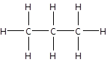
intermolecular forces of attraction

e.g.

Isomers

Isomers are molecules with the same chemical formula
but different structural formula.

Butane has two isomers:

“straight chain” isomer “branched chain” isomer

Take care, when drawing isomers, that you have in fact drawn a new structure. Single bonds have the ability to freely rotate and, as such, even though a molecule may look different it may still be the same.

Examples of structures which are not isomers, they are the same:

and

, and


Pentane has three isomers. Draw a structure for the three isomers of pentane.

Systematic Naming

In order to differentiate between isomers, each structure can be given its own unique name.
The rules for systematically naming alkanes are as follows.

- Identify the longest chain of carbons in the molecule. The name of the molecule will be based upon the alkane with this number of carbons.
This molecule has a five membered chain and so its name will be based on pentane.
e.g.

- Number the carbons so that any branches are on the smallest number of carbon possible.
5
1
3
4
e.g. not
2
4
3
2
1
5

- Any carbons which are not in the longest chain are part of a branch. Branches are named and their position given.

Branches are named based on their size. They have the same prefixes as used by the alkanes and the suffix –yl. For example a one carbon branch, as seen in the above example, is named methyl.

If more than one branch of the same size is present then greek prefixes (di, tri, tetra etc.) are used to show the number. For example two methyl branches would be dimethyl.

- The name is put together as follows
Longest chain: pentane
Branches: on number 2 C there is a methyl branch
so
2-methylpentane

Examples

Longest chain: pentane
Branches: on number 2 and 4 C there is a methyl branch
so
2,4-dimethylpentane

Longest chain: hexane
Branches: on number 2 C there is a methyl branch and on number 4 C there is an ethyl branch
so
2-methyl,4-ethylhexane

Name the following structures

1. 2.

3.

Alkenes

The alkenes are another homologous series of hydrocarbons. They are named, just like the alkanes, with a prefix giving the number of carbons and a suffix identifying the homologous series.

The alkenes all end with the suffix –ene.

The structure of the alkanes is different from the alkanes in that they contain a carbon to carbon double bond.

Due to the presence of the carbon to carbon double bond, the alkenes are described as being unsaturated. The alkanes are therefore described as being saturated.

Tip: single = saturated double = unsaturated

First member

As each member of the alkene series has a carbon to carbon double bond, there is no alkene with only one carbon. As a result the smallest alkene is named ethene and has the chemical formula C₂H₄.
e.g. Note: Each carbon still makes 4 bonds.
The double bond counts as 2 bonds.

General Formula

Complete the table on page 10. Using the information in the table complete these formulae by showing the number of hydrogen atoms.

C₂₂H C₁₄₉H C₄₁H C₂₈H

The general formula for the alkenes is C_{n}H_{2n}

No. Carbon atoms | Name | Chemical Formula | Full Structural Formula
2 | ethene | C₂H₄
3
4
5
6
7
8

Testing for Unsaturation

To test for unsaturation, a chemical can be shaken with bromine solution. The bromine solution will be decolourised immediately if a chemical is unsaturated.

The reaction with bromine is an example of an addition reaction.

In an addition reaction the bromine molecule is added to the alkene across the double bond with one bromine atom bonding to each of the carbons which were double bonded.

For example this addition reaction is known as bromination

+

The product of this reaction is called 1,2- dibromopropane

Alkanes from Alkenes

It is possible to make alkane molecules from alkenes by carrying out an addition reaction, this time with hydrogen.

This addition reaction is known as hydrogenation.

e.g.

+

As with the earlier example of an addition reaction, the hydrogen atoms are added across the double bond.

Properties and Uses

The alkenes are not soluble in water.
They are commonly used to make polymers which are plastics (Unit 3) and to make alcohols.
Cracking
Alkenes can be made from alkanes by a process known as cracking.

Cracking is a process where large molecules are broken up into smaller more useful ones. This process is usually carried out with the use of a catalyst, usually aluminium oxide, which allows the process to be carried out at a lower temperature.

Cracking can be carried out in the lab using the following apparatus:
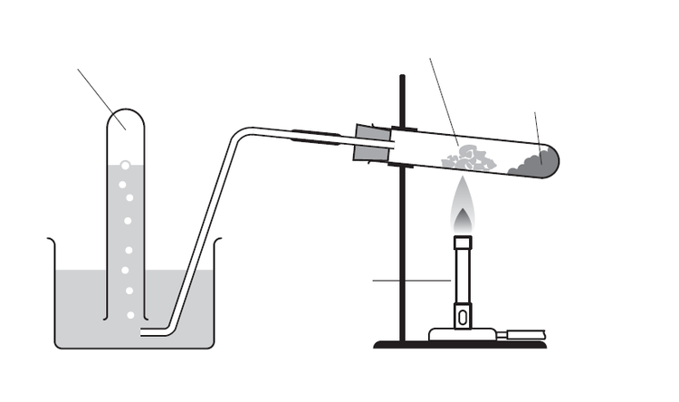
bunsen
burner
wool soaked in paraffin
catalyst
product gas
When an alkane is cracked, one alkane and at least one alkene are formed as there are not enough hydrogen atoms in the original alkane molecule to form more than one alkane.
e.g.

C₇H₁₆ C₄H₁₀ C₃H₆

C₇H₁₆

Cracking is particularly useful when the fractional distillation of crude oil produces a high quantity of a large fraction which is not heavily in demand. This fraction can be converted into a more useful fraction such as petrol. Octane is cracked to produce pentane and one other chemical, X. Name and draw a full structural formula for chemical X.

Systematic Naming

As with the alkane series, the alkenes can form isomers which each have their own systematic name. Isomers of alkenes can differ in the position of the double bond and in the branches present.

The rules for systematically naming alkenes are as follows.

- Identify the longest chain of carbons in the molecule. The name of the molecule will be based upon the alkene with this number of carbons.
This molecule has a five membered chain and so its name will be based on pentene.
e.g.

- Number the carbons so that the double bond is attached to the smallest number of carbon possible.
5
1
3
4
e.g. not
2
4
3
2
1
5

Note: Numbering must be for the double bond and not for any branches which may be present.

- Name any branches.

- The name is put together as follows
Longest chain: pentene
Branches: none
Double bond: between number 1 and 2 C
so
pent-1-ene

Examples
Longest chain: pentene
Branches: on number 2 and 4 C there is a methyl branch
Double bond: between number 2 and 3 C
so
2,4-dimethylpent-2-ene

Longest chain: hexene
Branches: on number 5 C there is a methyl branch
Double bond: between number 2 and 3 C
so
5-methylhex-2-ene

Name the following structures

1. 2.

3.

4. Draw the structure of the product of the reaction between hex-3-ene and bromine. (You may wish to draw hex-3-ene first)

Cycloalkanes

The cycloalkanes are another homologous series of hydrocarbons. As with the alkanes and the alkenes, their names contain a prefix which identifies the number of carbon atoms in the molecule. Unlike the other two series, the cycloalkanes have a prefix and a suffix to identify the homologous series.

The cycloalkanes all have names which start cyclo- and end –ane.

Cycloalkanes are saturated hydrocarbons with a cyclic or ring structure rather than a long chain structure.

First member

As each member of the cycloalkane series has a cyclic structure, there is no cycloalkane with one or two carbons. As a result the smallest cycloalkane is named cyclopropane and has the chemical formula C₃H₆.
e.g. Note: Each carbon still makes 4 bonds.

Complete the table on page 24. Using the information in the table complete these formulae by showing the number of hydrogen atoms

C₂₂H C₁₄₉H C₃₀₄H C₆₆H

The general formula for the cycloalkanes is C_{n}H_{2n}

Note that this general formula is the same as the general formula of the alkenes. This means that for any cycloalkane there is at least one isomer which is a member of the alkene series.

Properties and Uses
The cycloalkanes are insoluble in water but they do dissolve other chemicals which are also insoluble in water and so make good solvents. They are also used in fuels.
_{No. Carbon atoms} | _{Name} | _{Chemical Formula} | _{Full Structural Formula}
₃
₄
₅
₆
₇
₈

