
Beath High School
Chemistry Department

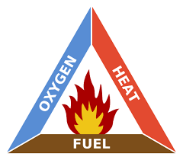

The Dependence for Fossil Fuels
Fuels and Energy

Pupil Name:
Class:
What is a Fuel?

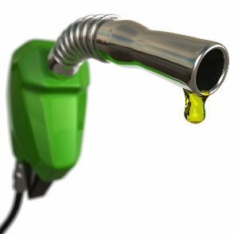
A fuel is any substance which has stored energy, and will release energy when burned

We use many fuels in our everyday lives, from the petrol we put in our cars to the food that we eat.

In the space below, list two fuels and give an example of what we use these fuels for.

Name of Fuel | Use of Fuel

What makes a fuel good?

Scientists are always looking for ways to improve fuels, but what makes a fuel ‘good’? How can we compare fuels with one another?

How a fuel performs is only consideration, other factors such as price and environmental impact are also important.


Rank the following properties of a fuel in order of what you think are the most important for a fuel. Rank them from one to five where one is the most important. Does your partner agree? Try to convince them to change their mind?
- Environmental impact
- Temperature of flame when burned
- Rate of burning
- Toxicity
- Price

Fossil Fuels

Crude oil, natural gas and coal are examples of fossil fuels. These are fuels which are formed from material which lived millions of years ago.

Formation of Coal
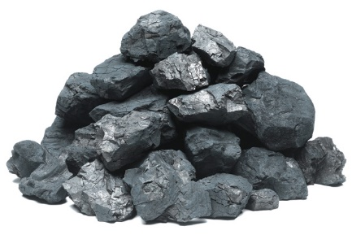
Hundreds of millions of years ago large trees died and fell into swamps where they started to rot. The rotting trees were covered in sand and mud. Eventually the mud and sand were changed into rocks. The heat and pressure of the earth and the rocks changed the rotting vegetation, first into peat and then into coal. This explains why coal is usually found deep underground.

Formation of Crude Oil and Gas
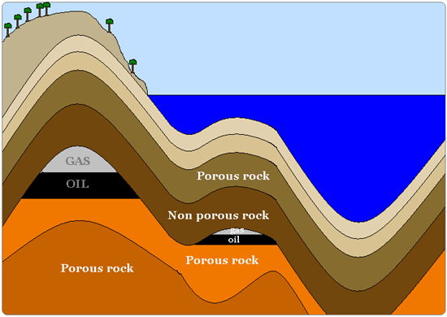
Hundreds of millions of years ago the seas were filled with tiny organisms. These organisms died and settled on the sea bed and were covered with sand. The sand then changed into sandstone and subjected the dead organisms to pressure and heat. This changed the organisms into oil.
Natural gas is almost always found with crude oil.

In the space below, summarise the similarities and the differences between the formation of coal compared to the formation of oil and gas.

Due to the length of time needed for fossil fuels to form, our supplies will one day run out. Fossil fuels are therefore described as a finite resource.

It is believed that our current supplies of gas will run out in 2030, crude oil in 2040 and coal in 2300. Discuss with a partner what age will you be when they run out? How do you think this will affect your life?

Crude Oil

Crude oil is not one chemical, in fact it is a mixture of many dissolved solids and liquids called hydrocarbons.

A hydrocarbon is a compound which contains atoms of hydrogen and carbon only.

Crude oil itself is not very useful, it must first be separated into groups of chemicals by a process known as fractional distillation.

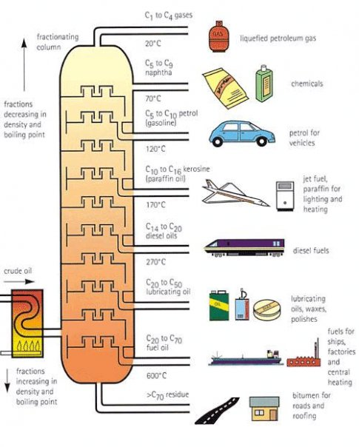
C₁ – C₄
Fractionating column
C₁ – C₄
Refinery gas
liquefied petroleum gas
20 °C
C₅ – C₉
Fractions increase in viscosity
C₅ – C₉
Naphtha
chemicals
70 °C
C₉ – C₁₀
C₅ – C₁₀
Petrol (Gasoline)
petrol
for cars
120 °C
C₁₁ – C₁₆
Paraffin
jet fuel, paraffin for lighting and heating

170 °C
C₁₇ – C₂₀
Diesel
diesel fuels
Crude oil
270 °C
C₂₁ – C₅₀
Lubricating oil
lubricating oils, waxes, polishes
400 °C
C₅₁ – C₇₀
Fuel oil
fuels for ships, factories and central heating

600 °C
> C₇₀ Residue
bitumen for roads and roofs

The process separates the chemicals in crude oil using the differences in their boiling point.

Firstly the crude oil is heated until the compounds boil and they rise up the column. The compounds are collected in different parts of the column, based on the temperature at which they condense back to liquids (boiling point).

Compounds are separated into groups of hydrocarbons, with similar boiling points. These are called fractions
Complete this table using the diagram on page 4.
Uses
Ease of Evaporation | Easiest |  |  |  |  |  | Hardest
Flammability | Most flammable |  |  |  |  |  | Least Flammable
Boiling point range (°C) | Below 20 | 20 - 70 |  |  |  |  |  | 600+
colour | colourless |  | pale yellow | yellow | brown | dark brown | dark brown | black
No of Carbon atoms |  |  |  |  | 14 - 20
Fraction | Gas | Naphtha | Petrol | Kerosene | Diesel | Lubricating oil | Fuel oil | Residue
Physical Properties

Each fraction varies from the others in its physical properties. Examples of the physical properties which we can compare are shown in the table on the previous page.

Another physical property is viscosity, which is a measure of the ease with which a liquid flows. The more viscous a liquid is, the more slowly it flows. Imagine pouring washing up liquid and then pouring water, washing up liquid is far more viscous than water and so flows more slowly.

Linking statements

By comparing each of the fractions in crude oil statements can be made that link properties together. For example

“The higher the number of carbons in the molecules, the higher the viscosity of the fraction.”

Using the table on page 5, write a similar statement linking together

- boiling point and colour

- flammability and number of carbons in the molecules

- chain length and ease of evaporation

- viscosity and boiling point

Molecules which contain lots of carbons form long chains of carbon atoms surrounded by hydrogen atoms.
Suggest a reason why increasing the length of the chain would increase the viscosity of the chemical.

Combustion Reactions

Combustion, or burning, is the name given to the type of reaction where a substance reacts with oxygen to produce energy. There are two types of combustion, complete and incomplete combustion. This is dependant on how much oxygen is present.

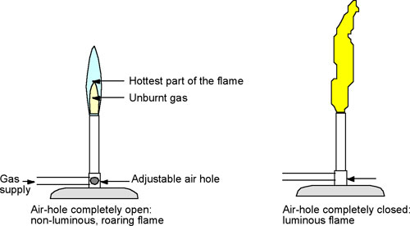
When the air hole is open, more oxygen mixes with the gas and complete combustion is achieved. The flame is blue and hot.

When the air hole is closed, less oxygen mixes with the gas and incomplete combustion is achieved. The flame is yellow and less hot.

Complete Combustion

When a hydrocarbon is burned in a plentiful supply of oxygen (air), the products of the combustion can be identified using the following apparatus
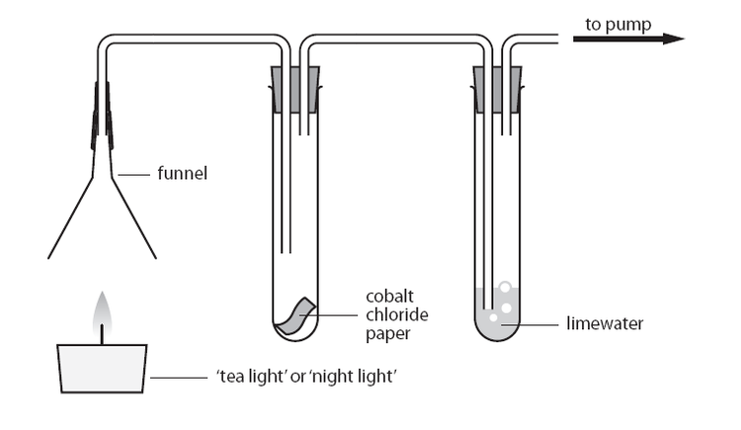
candle
cobalt chloride
limewater
funnel
to pump

The products of the complete combustion of a hydrocarbon are __________ ___________ and _______________.

Incomplete Combustion

When a fuel burns in a limited supply of oxygen (air), the products also include the black solid ____________ and the poisonous gas _____________ _____________.

Products of Combustion

The products of a combustion reaction can help us to identify which elements were present in the chemical being combusted.

During a combustion reaction, each element present will form a different product by joining to oxygen.

e.g. fuel + oxygen → carbon dioxide + water

The production of carbon dioxide tells us that carbon must have been present in the fuel.

The production of water tells us that hydrogen must have been present in the fuel.

The fuel may also have contained oxygen but because it is reacted with oxygen it is not possible to tell.

Fossil fuels, because they form in the earth, are full of impurities. One such impurity is sulfur compounds such as hydrogen sulfide.
Explain fully why failure to remove these compounds before burning could result in the formation of acid rain.

Calculating Energy

When selecting a fuel, one property which is important is the quantity of energy released when the fuel is burned, this cannot be measured directly but it can be calculated by using this energy to heat water.

To calculate energy we first need to know the specific heat capacity of water which is given the symbol ‘c’. This is a measure of how much energy is needed to increase a 1 kg of water by 1 °C and is given as 4.18 kilojoules.

Specific heat capacity of water (c) = 4.18 kJ kg⁻¹ °C⁻¹

If we heat up water using a fuel, and record the mass of water used and how much the temperature of the water is changed, we can calculate the energy using the equation

E_{h} = c m ΔT

E_{h} is heat energy. | m is the mass of water in kg.
c is the specific heat capacity of water. | ΔT is the temperature rise.

Note that because water has a density of 1 g cm⁻³, 1 cm³ has a mass of 1 g and 1 litre has a mass of 1kg.

Example:
An experiment was set up as shown in the diagram with 200 cm³ of water.
thermometer
glass beaker
The temperature of the water rose by 12 °C. Calculate the energy released by the fuel.

c = 4.18 kJ kg⁻¹ °C⁻¹
m = 200 cm³ = 200 g = 0.2 kg

E_{h} = c m ΔT
= 4.18 kJ kg⁻¹ °C⁻¹ x 0.2 kg x 12 °C
= 10.032 kJ

When carrying out this experiment there is an assumption that all the energy released by the fuel is absorbed by the water.
Suggest improvements to the experimental setup that could improve the results.

Examples:

- Methanol was burned and the heat energy given out increased the temperature of 100 cm³ of water from 22 °C to 32 °C. Calculate the energy released.

- Calculate the energy released when methane was burned and the energy given out increased the temperature of 200 cm³ of water from 18 °C to 28.6 °C.

- A sample of a fuel was found to give out 11.1 kJ of energy. The sample was used to heat 200 cm³ of water at 20 °C. Calculate the final temperature of the water.

- 0.25 g of ethanol was burned and the heat given out increased the temperature of half a litre of water from 20.1 °C to 23.4 °C.
  - Calculate the energy released.

  - Estimate the energy which would be released if 5 g of ethanol had been used.

Pollution from Fossil Fuels

Fossil fuels provide us with many of the chemicals we need to live our everyday lives, from fuels to plastics and medicines to cosmetics. Fossil fuels are, however, a major source of pollution.

Burning fossil fuels

When any carbon based fuel is burned, carbon dioxide is formed. CO₂ is a greenhouse gas and increased levels of CO₂ from burning fossil fuels can cause global warming which in turn could have a huge impact on our weather patterns.

Coal and oil form in the earth over hundreds of millions of years and as a result they are full of impurities. When we burn fossil fuels, these impurities burn too and some can cause problems for the environment.

An example of this is sulfur which forms _________________ __________________ gas when it burns. This in turn is a major cause of ________________ _______________.

Write a word equation for the combustion of sulfur.

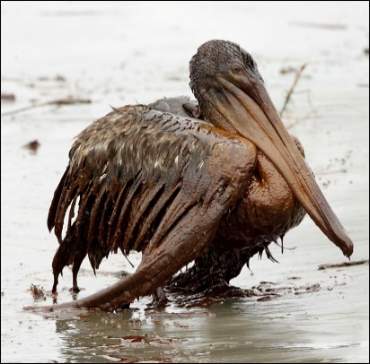
Obtaining and Transporting Fossil Fuels

A lot of oil is found at sea or in remote parts of the world. As a result oil is transported by pipelines or in large tankers to where the oil is needed. Unfortunately this can result in oil being spilled into the sea and this can have a devastating effect on wildlife.

