
Beath High School
Chemistry Department
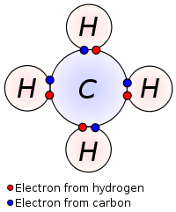

The History of the Atom
How Atoms and Elements Combine

Pupil Name:
Class:
Compounds

In the first topic, you found out that the simplest substances which are known are called elements.
When two or more of these elements react together, the new substance formed is called a compound.

A compound is a substance which is made up of two or more elements chemically joined together.

In a mixture the substances are not joined. The substances can be either elements or compounds.

Elements, compounds, and mixtures can be drawn using pictures of dots representing particles.
An element will have each of its dots the same.
A compound will have different dots joined together with a line.
A mixture will have different dots not joined with a line or a mixture of different joined dots.

Using this information label each box to show the arrangement of particles in:
- an element
- a compound
- a mixture of elements
- a mixture of compounds
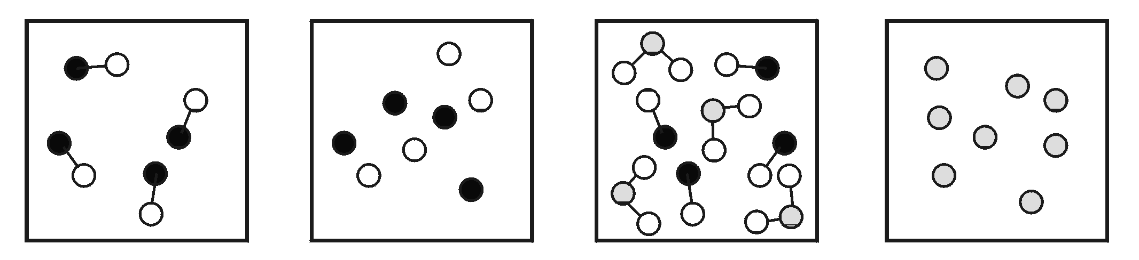


Activity 2.1

Naming Compounds

Most compounds with a name ending in -ide contain the two elements indicated by the name, e.g. sodium chloride contains sodium and chlorine.
The name ending -ite or -ate indicates that the compound contains oxygen in addition to the two elements named, e.g. copper carbonate contains copper, carbon and oxygen.

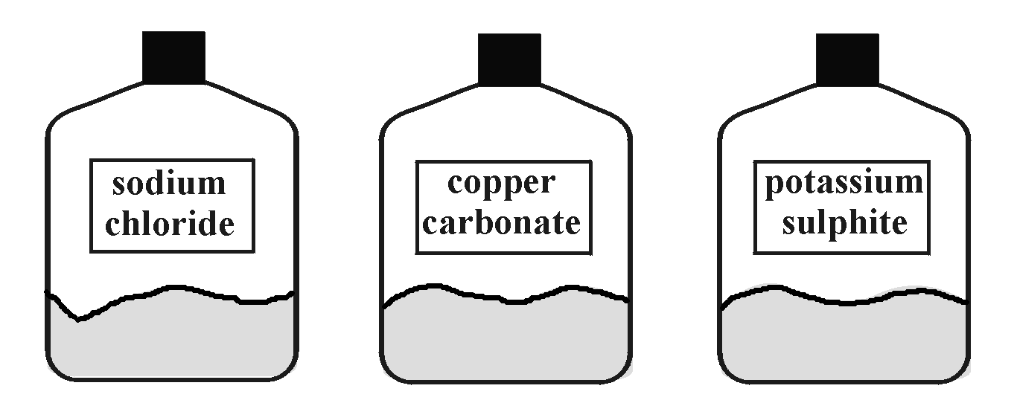

Can you identify the elements in each compound name shown on the bottles.

Complete the table to show the name of compound or the elements present.

Name of compound | Elements present
sodium chloride | sodium and chlorine
copper carbonate | copper, carbon and oxygen
 | iron and chlorine
 | zinc and oxygen
potassium nitride
calcium carbonate
 | sodium, sulphur and oxygen
.


Check test 2.6
Activity 2.2
Covalent Bonding

Covalent compounds are formed when a pair of electrons is shared between atoms.
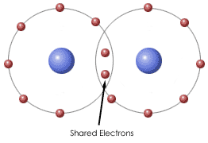

The shared pair of outer electrons is called a covalent bond. It is a strong bond.
Covalent compounds can exist as molecules. The diagrams below show examples of atoms sharing their outer electrons to form molecules
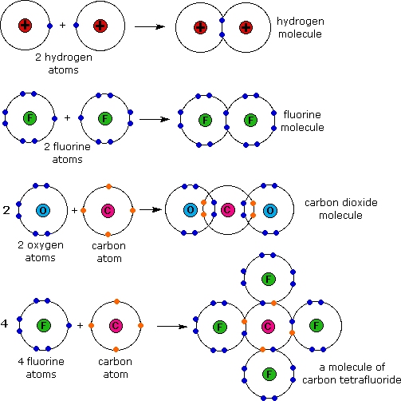

Covalent bond: strong bond formed from the sharing of a pair of electrons between atoms

There are also examples of substances where two or more covalent bonds form between the same two atoms, these are known as double and triple covalent bonds.
For example, oxygen and nitrogen both exist as diatomic molecules, nitrogen has five outer electrons and oxygen has six outer electrons.
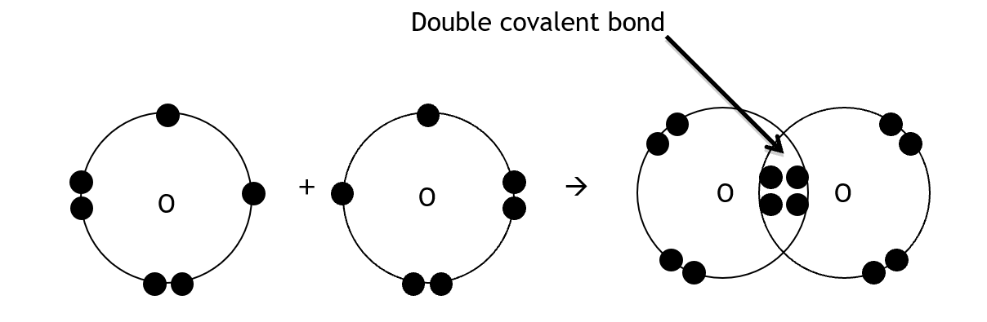
When an oxygen atom forms a diatomic molecule, it must share two of its electrons with another oxygen atom, this forms a double covalent bond.

When a nitrogen atom forms a diatomic molecule it must share three of its electrons with another oxygen atom, this forms a triple covalent bond.
Complete this diagram by adding the electrons to show a triple covalent bonded nitrogen molecule:
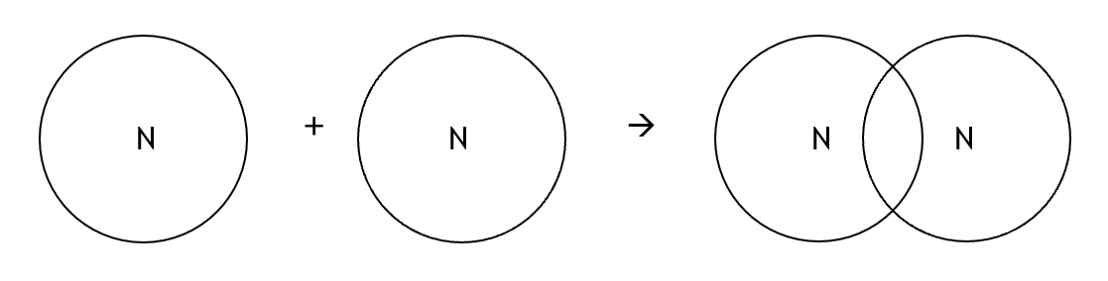
Draw another diagram for the formation of hydrogen chloride:

Diatomic Elements

When two atoms join together they form a molecule. A molecule can be of an element, where all atoms are the same, or a compound, where the atoms are different.
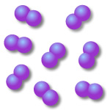
There are seven elements that, under normal conditions, exist as “diatomic molecules”. This means that two of their atoms join together to form a molecule

When these seven are present as an element their formula is written to reflect the fact that they exist as diatomic molecules.

You must learn these seven elements, they are:
- Hydrogen, H₂ | - Chlorine, Cl₂
- Oxygen, O₂ | - Bromine, Br₂
- Nitrogen, N₂ | - Iodine, I₂
 | - Fluorine, F₂

Where do you find these elements on the Periodic Table?

Write down a way that will help you memorise these elements.

Writing Chemical Formula: The basics

There are some compounds which have names that show how many of each atom of each element is present in the compound. These names have prefixes in them; a prefix is a small word that is written before the name of the element, e.g. phosphorus trihydride has the prefix ‘tri’ before the hydride.
This table shows the prefixes that are commonly used in chemical names.
Prefix | Meaning | Example | Chemical formula
mono | 1 | carbon monoxide | CO
di | 2 | carbon dioxide | CO₂
tri | 3 | phosphorus trihydride | PH₃
tetra | 4 | carbon tetrachloride | CCl₄
penta | 5 | phosphorus pentachloride | PCl₅

Many compounds have no prefixes in their names. To write the formula of these compounds the valency of the atoms of the elements in the compound is used to work out the correct formula.
The valency of an atom in an element is the number of bonds that it can form with other atoms. This is related to the number of outer electrons in the atom and, therefore, can be worked out from the group in the Periodic Table.

Group | 1 | 2 | 3 | 4 | 5 | 6 | 7 | 0
Number of outer electrons
Valency | 1 | 2 | 3 | 4 | 3 | 2 | 1 | 0

Chemical Formula – Using Valency

If the valency of an atom is known, the formula of the compound can be worked out using a series of simple steps.
Valency: the number of bonds that an atom can form with other atoms.

Example 1
Write the formula for phosphorus chloride.
P Cl
Step 1: write the symbols for each element
3 1
P Cl
Step 2: write the valency of each above the symbol

Step 3: simplify if necessary
3 1
P Cl
Step 4: crossover the valency to the bottom
Step 5: write the formula PCl₃


These simple steps can be followed to write the formulae of different compounds.
Work out the formulae of these compounds.
- nitrogen chloride
- sodium fluoride
- magnesium bromide
- potassium oxide
- aluminium nitride

Properties of Covalent Bonding
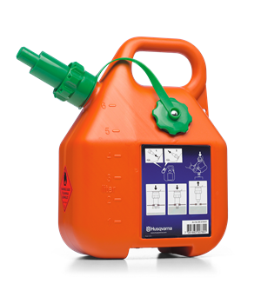

Covalent bonding is found in several compounds.


blood

water

petrol

Some Properties of Covalent Compounds

Melting and Boiling Points:
Covalent molecular compounds tend to be liquid or gas at room temperature.
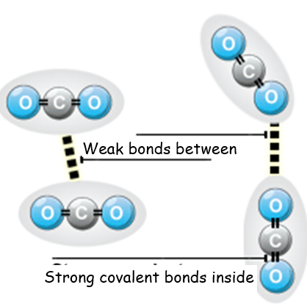
When a covalent molecular substance melts (and boils) it is the weak bonds between the molecules which break not the strong covalent bonds inside the molecules. This process requires a relatively ____________ quantity of energy.
Covalent molecular substances, therefore, have _________ melting points and boiling points.

Conductivity:
Covalent compounds do not conduct electricity as they have no ions present.

Solubility:
Some covalent compounds do not dissolve in water but do dissolve in other solvents.


Activity 2.3 + 2.4

Ionic Bonding

Some substances are made up of ions.
Ions are particles which have a charge. Ions are formed when electrons are transferred between atoms.

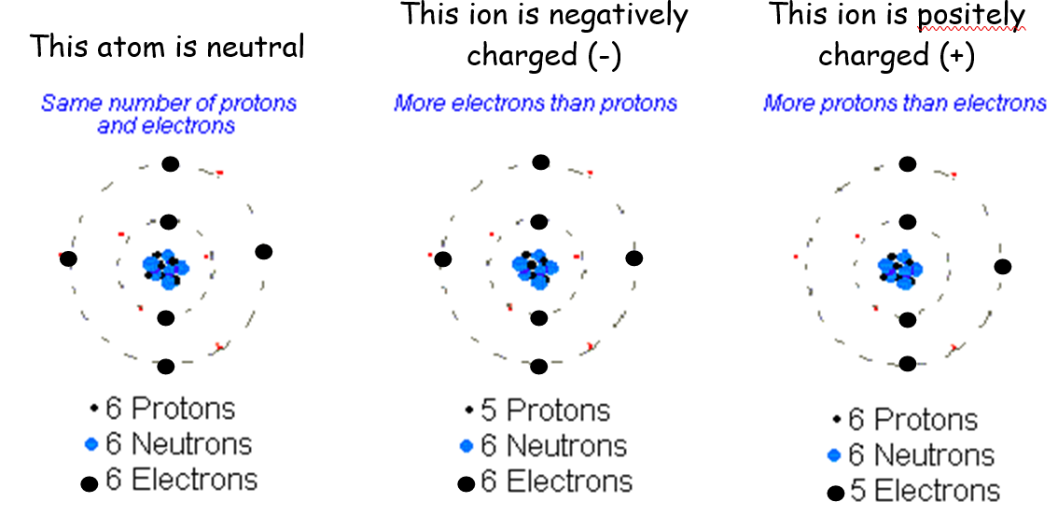
There are two types of ions, ones with a positive charge and others with a negative charge.
Common salt (sodium chloride) is made of ions.

The ions are held together because the negative ions are attracted to the positive ions: oppositely charged ions are attracted to each other.
The bonds holding the oppositely charged ions together are strong; they are ionic bonds.
Substances like sodium chloride, which are made up of ions, are called ionic compounds.
Ionic bond: strong bond formed by the attraction of oppositely charged ions between positive metal ions and negative non-metal ions

The only test to determine whether a compound is ionic or covalent is to test its conductivity. If a compound conducts in solution or as a melt, it is ionic. If it does not, it is covalent.
Activity 2.5 + 2.6
Check test 2.7
The only test to determine whether a compound is ionic or covalent is to test its conductivity. If a compound conducts in solution or as a melt, it is ionic. If it does not, it is covalent.
The only test to determine whether a compound is ionic or covalent is to test its conductivity. If a compound conducts in solution or as a melt, it is ionic. If it does not, it is covalent.

