
Beath High School
Chemistry Department

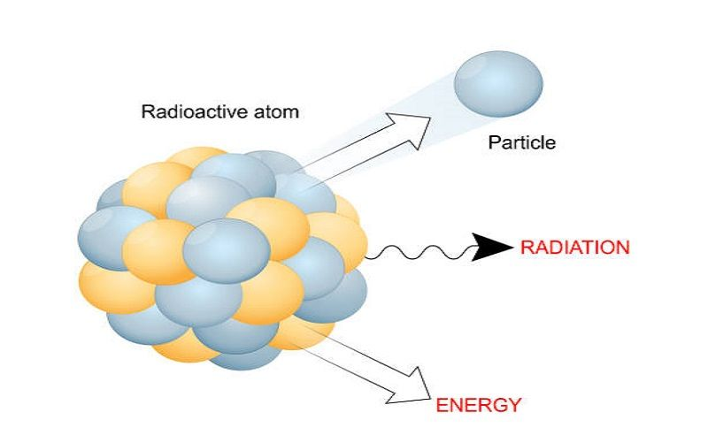

The History of the Atom
Nuclear Chemistry

Pupil Name:
Class:
Formation of Elements

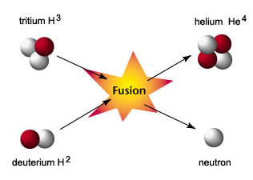
All of the elements in the Periodic Table have been created in the stars from hydrogen and helium. The temperature and pressure in the stars is so great that the nuclei of atoms of hydrogen and helium can fuse together to form heavier nuclei, releasing vast quantities of energy. This process is called nuclear fusion. All 92 naturally occurring elements, including those found in our bodies, originated in the stars.

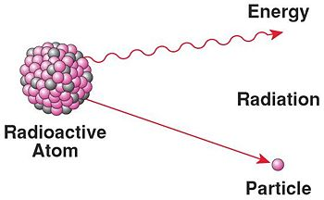
The nucleus of all atoms (apart from some atoms of hydrogen) contains both protons and neutrons. The nuclei of some atoms are unstable, i.e. they spontaneously break up (decay) with the emission of radiation. This ’happening’ is known as radioactivity.

The branch of chemistry associated with changes in the nucleus is known as nuclear chemistry. Reactions in the nucleus are quite unlike other chemical reactions where the nuclei remain intact and only the outer electrons are involved in the chemical changes.

Background Radiation
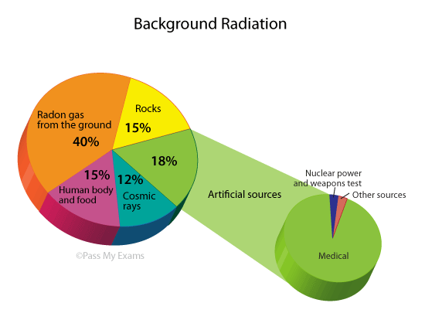
The radiation that is all around is known as background radiation; this varies from place to place. Natural radiation comes from space (cosmic radiation). Artificial radiation is a result of human activity, e.g. the use of radioisotopes in medicine and in nuclear reactors. Accidents in nuclear power stations, e.g. at Fukushima and Chernobyl, can lead to greatly increased levels of background radiation
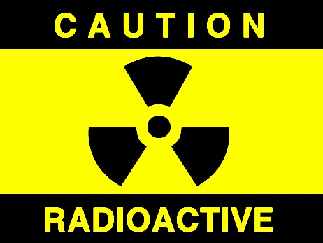
Uses of Radioisotopes

There are many uses of radioisotopes including

Examining body tissues
e.g. ¹³²I is used to check the health of the kidneys.

Sterilisation
e.g. Gamma radiation can be used to sterilise food or medical equipment.

Detecting flaws
e.g. ⁶⁰Co can be used to take X-ray images of welding.

Smoke detectors
e.g. A small piece of ²⁴³Am emits alpha particles at a receiver. Even a small amount of smoke blocks the alpha particles and the alarm sounds.

Carbon-14 Dating
¹⁴C is a naturally occurring isotope of carbon with a half-life of 5700 years.

¹⁴C from the atmosphere, in CO₂, is constantly incorporated into plants during photosynthesis. This makes its way into all animals when they eat plants.

When an organism, plant or animal, dies it no longer takes in ¹⁴C and the levels drop by beta emission.
The age of a sample from a tree or bone, for example, can be determined from the remaining ¹⁴C content using its half-life.

Nuclear Power
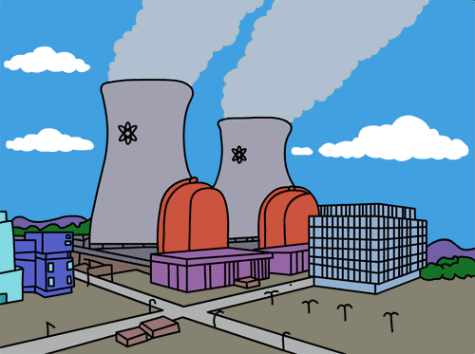
The energy released in a nuclear reaction can be used to produce electricity. They are a good alternative to fossil fuels as they produce no greenhouse gases or sulphur dioxide which can cause acid rain and they will last longer than fossil fuels. Also a nuclear power plant produces more energy per year than a power plant which burns fossil fuels.
Atomic Structure – Revision

There are three sub-atomic particles in an atom called ___________, ____________ and ______________. Their properties are shown in the following table.

Sub-atomic Particle | symbol | charge | mass / a.m.u | Position in the atom
 |  | +1
 |  |  | 0

Give a definition of the following terms:

Atomic Number:

Mass Number:

Isotopes:

Carbon has many isotopes, the three most common isotopes are carbon-12, carbon-13 and carbon-14, where the number is the mass number of the isotope. These can be represented by the following nuclide notations:

C C C

There are three isotopes of hydrogen.
name of isotope | protium | deuterium | tritium
number of neutrons |  |  | 2
symbol | 1  1  H
Radioactivity

Radioactivity was discovered by Henri Bequerel in 1896, when he found, quite by chance, that some uranium salts had ‘fogged’ a wrapped photographic plate. Since no light could have penetrated the wrapping, he concluded that the uranium salts were emitting an invisible radiation. This phenomenon was called radioactivity.

Radioactivity happens when the nucleus of an isotope of an atom is unstable. These nuclei spontaneously disintegrate (decay) with the emission of radiation and the release of energy. This process continues until the nucleus becomes stable.
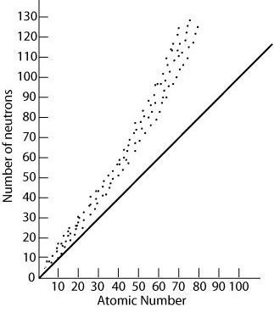
This is quite unlike ordinary chemical reactions where the nuclei remain intact and only the outer electrons are involved in the chemical changes.

The stability of an atom depends on the relative numbers of protons and _______________ in its nucleus.
band of stability

This diagram shows that a band of stability can be plotted, when the number of protons is plotted against the number of ___________________ for all stable naturally occurring nuclei (each dot is a stable nucleus). The black line is a plot of when the number of protons and neutrons in the nucleus is equal.
n = p

We can see that the lighter stable nuclei have approximately equal numbers of neutrons and protons but as the nuclei become heavier, the number of neutrons increases more rapidly than the number of ______________________ .

Protons will _______________ each other in the nucleus and so as there are more protons present the ________________ are able to dampen this effect and stop the nucleus from flying apart.

Nuclei which lie outside the stability band are unstable and therefore radioactive. They will disintegrate with the emission of radiation. until the unstable radioactive nuclei form ______________ nuclei, i.e. nuclei with neutron to proton ratios which lie inside the ________________ band.
Types of Radiation

There are three types of radiation - alpha (α), beta (β) and gamma (γ).

The particles that make up alpha radiation are helium nuclei, each containing two protons and two neutrons.

The particles in beta radiation are electrons. Beta particles are formed in the nucleus when a neutron breaks up into protons and electrons.
p
1
1
n
1
0
e
0
-1
+

As soon as they form, these high energy electrons are ejected from the nucleus as beta radiation.

While alpha and beta radiations are made up of particles, gamma radiation consists of electromagnetic waves and therefore has no mass.

The following diagram shows how the three different types of radiation are affected in by an electric field.

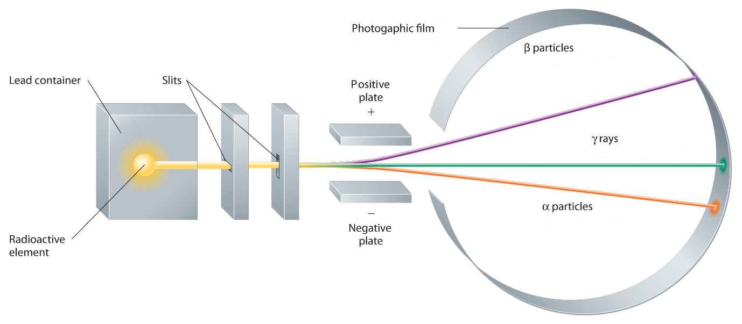
As you can see from the above diagram, alpha particles are deflected in one direction by a small amount, beta particles in the other direction by a larger amount and gamma rays are not deflected at all.
Suggest why each type of radiation behaves as it does in the presence of an electric field:

Stopping Radiation

Alpha, beta and gamma radiations have different abilities to pass through air and other materials.
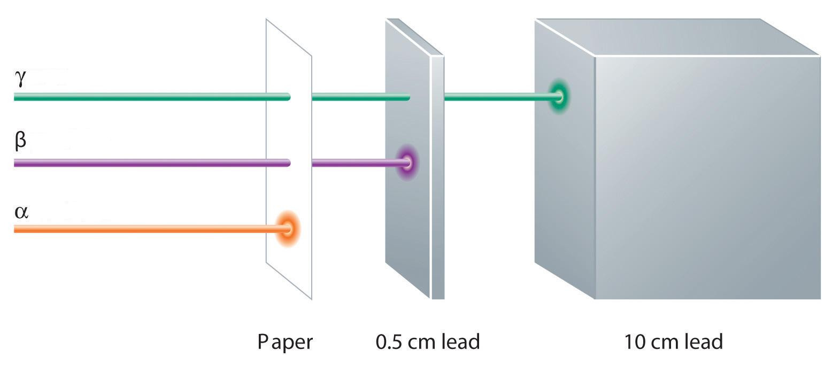
Paper Aluminium Lead

Alpha radiation can only travel a few centimetres in air and can be stopped by a piece of paper.
Beta radiation can travel a few meters in air and can be stopped by a thin piece of metals such as aluminium or lead.
Gamma radiation can travel around one hundred metres in air and is stopped by a thick piece of lead.

The most energetic type of radiation is
The least energetic type of radiation is

Nuclear Equations

With the exception of gamma radiation, all nuclear activity involves particles from the nucleus. This means that we can use nuclide notation to represent nuclear equations.
All nuclear equations must be balanced. This means that the total mass numbers and atomic numbers for the reactants and the products must be equal.

Alpha Decay
Alpha radiation is a helium nucleus containing two protons and two neutrons.
An alpha particle has the symbol ,

As a result the mass number of the original isotope will go down by four and the atomic number by two.

e.g. Thorium-232 decays by alpha emission to form Radium-228.

Note the total mass number on each side is 232 and the total atomic number is 90.

Beta Decay
Beta radiation is an electron formed from the breaking down of a neutron, a proton is also formed.
A beta particle has the symbol ,

As a result the mass number will remain the same and the atomic number will increase by one.

e.g.Radium-228 decays by beta emission to form Actinium-228.

Note the total mass number on each side is 228 and the total atomic number is 88.

Gamma Emission
Gamma emission is energy, not a particle, and as such has no effect on either the mass number or atomic number.

Summary:

Type of emission | Symbol | Effect on  mass number | Effect on  atomic number
alpha |  | decrease by 4
beta |  |  | increase by 1
gamma | γ | no effect

- Write a nuclear equation for
  - alpha decay of polonium-210

  - beta decay of strontium-90

  - alpha decay of radium-226

- Part of a radioactive decay series is shown below.
β decay β decay

  - Identify isotopes X and Y

  - Which type of decay occurs between isotope X and isotope Y?
Half-Life

The radioactive activity of a radioactive isotope, or radioisotope, is measured by the number of nuclear decays which occur each second or minute.

The half-life, t_{½}, of a radioactive sample is the time taken for the radioactive activity, or the mass of a sample, to fall to half of its initial value.

The half-life for an isotope is constant, no matter how much of the sample is left.
This means that the time taken for 100 g to decay to 50 g is equal to the time taken for 10 g to decay to 5 g.

The following graph shows the activity of an isotope over time.
This is called a ‘decay curve’ and the shape will always be the same regardless of the isotope.
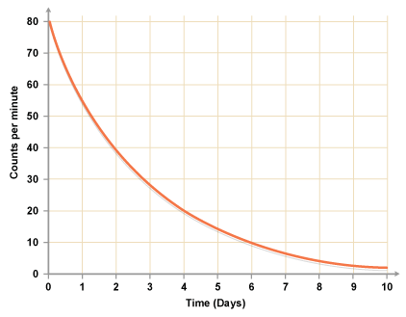
From this graph the time taken for the activity to half is ________ days.
This is the half-life, t_{½}, of the isotope.

Complete the table to show how the mass of radioactive phosphorus-32 changes over time. The half-life of phosphorus-32 is 14 days.

Time (days) | Mass of phosphorus-32 (g)
0 | 32
14
28
42
56
70
84
98
Draw a line graph of mass of phosphorus-32 versus time.

The rate of decay depends only on the mass number of the radioisotope present. Different isotopes of the same element will have a different half-life
e.g. fermium-252 has a half-life of one day and fermium-253 has a half-life of three days.

Some isotopes have a very short half-life, e.g. radon-220, t_{½} = 55 seconds.
Some isotopes have a very long half-life, e.g. uranium-238, t_{½} = 4.51 billion years.

Unlike ordinary chemical reactions half-life is not affected by changes in temperature, pressure or by the presence of a catalyst.

The half-life of an isotope is only reliant on its nucleus and so it is the same whether the isotope is an atom, an ion or a part of a compound.

Half-life Calculations

- A radioisotope of phosphorus has a half-life of 14 days.
A sample of the radioisotope has a mass of 80 g.
Calculate the remaining mass of the sample of the radioisotope after 56 days.

Since one half-life is 14 days then 56 days is 56/14 = 4 half-lives

Half-lives | Mass
0 | 80g
1 | 40g
2 | 20g
3 | 10g
4 | 5g

- The initial radioactivity of a sample of a radioisotope was 100 counts/minute.
If the activity fell to 25 counts/minute in 24 days, what is the half-life of the radioisotope?

Half-lives | Activity
0 | 100 counts/minute
1 | 50 counts/minute
2 | 25 counts/minute

25 counts/minute = two half-lives = 24 days
t_{½} = 12 days

- A radioisotope has a half-life of 7000 years.
How long will it take for 48 g of the radioisotope to decay to leave 6 g?

Half-lives | Mass
0 | 48g
1 | 24g
2 | 12g
3 | 6g

t_{½} = 7000

3 half-lives = 3 x 7000
= 21 000 years

- For each of the following pairs, state whether or not both species have the same half-life.

  - 1 g Pb-212 and 100 g Pb-212

  - 1 g Pb-212 and 1 g Pb²⁺-212

  - 1 mole Pb-210 and 1 mole Pb-212

  - 1 mole lead-210 and 1 mole lead-210 oxide.

- The initial radioactivity from a sample of actinium chloride is 120 counts/minute. If the half-life of actinium is 6 hours, how long will it take for the sample of the chloride to reach a reading of 15 counts/minute?

- A radioisotope used in a hospital has a half-life of 1.5 hours. It has a count rate of 8000 counts per minute at 9am.

  - What would the count rate be at 1.30pm on the same day?

  - An aqueous solution of a compound containing the radioisotope was prepared. What effect would this have on the half-life?

- Samples of radium oxide and radium sulphate both contain the same radioisotope. Why does a 1g sample of the oxide show a different intensity of radiation from the sulphate?


Check test 2.5

