
Beath High School
Chemistry Department
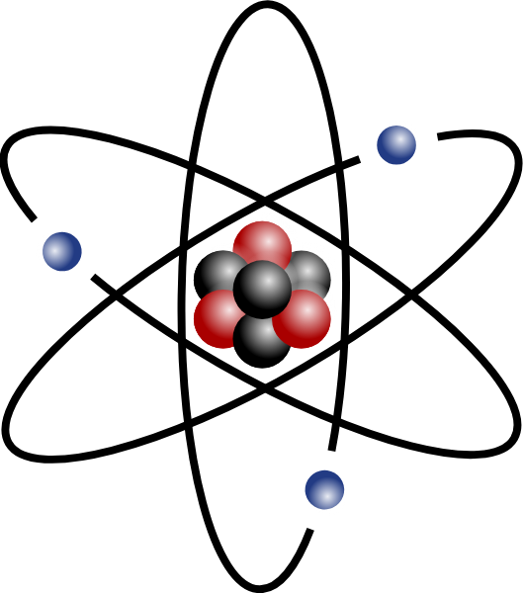

The History of the Atom
Atoms, Elements
and
The Periodic Table

Pupil Name:
Class:
The Periodic Table
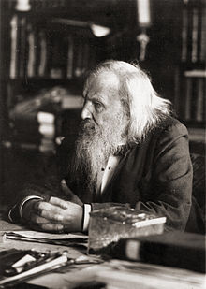
The Russian chemist, Dimitri Mendeleev (1839 – 1907), arranged all of the known elements in to a periodic table. Mendeleev was so sure of his periodic table that he even left gaps where he believed elements were yet to be discovered.

Using his Periodic Table Mendeleev was able to predict the properties of elements yet to be discovered. Mendeleev predicted that there should be an element between silicon and tin and he predicted its properties. He called this as yet undiscovered element eka-silicon. When germanium was discovered his predictions proved very accurate:

Property | Predicted for eka-silicon | Germanium
Relative atomic mass | 72
Density (g/cm³) | 5.5
Colour | grey | grey
Reaction with acid | very little | very little

The modern periodic table is based on the one originally drawn by Mendeleev. In the modern periodic table the elements are arranged in rows called PERIODS and columns called GROUPS and each element is given a unique:

- Atomic Number – The elements in the periodic table are arranged in order of increasing atomic number.

- Symbol – This short hand is used to represent one atom of an element.

Complete the following table using your data booklet:

Element | Symbol | Atomic Number
Iron | Fe
Carbon |  | 6
 |  | 18
 | Pb
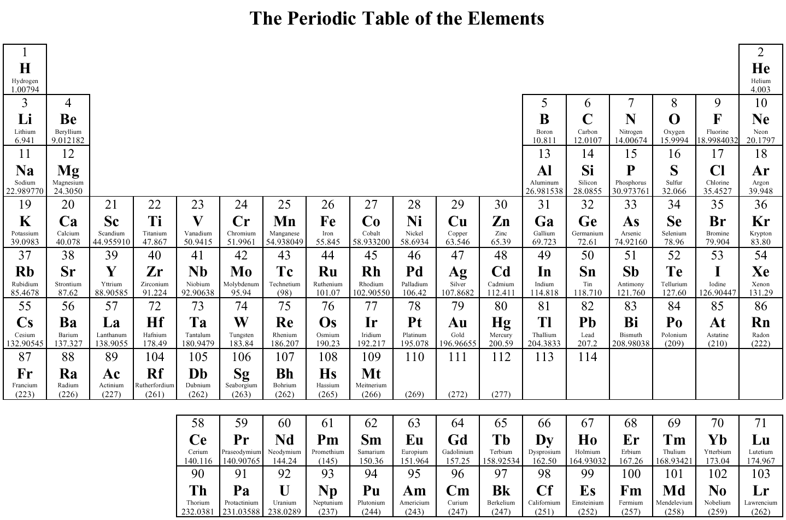
Periodic Table Revision
Using different colours of pencil, shade in the elements which belong to:
Group 1 ☐ Group 2 ☐ Group 3 ☐ Group 4 ☐ Group 5 ☐

Group 6 ☐ Group 7 ☐ Group 0 ☐ Transition Metals ☐

Add a line to the periodic table separating metal and non-metal elements

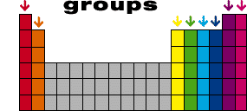
Group Names
7 8
3 4 5 6

1
2

Group 1 is known as the alkali metals.
Group 2 is known as the alkaline earth metals
Group 7 is known as the halogens
Group 0 is known as the noble gases

State of matter at a given Temperature

In order to find out what state of matter a substance is in at any given temperature you must first know the substance’s melting and boiling points. These two temperatures can then be compared to the given temperature (e.g. room temperature):
boiling point
melting point

temperature
gas
liquid
solid

- If the given temperature is below both the melting and boiling point then the substance will be a ________________.
- If the given temperature is above both the melting and boiling point then the substance will be a ________________.
- If the given temperature is between the melting and boiling point then the substance will be a ________________.
e.g. Water – melting point = 0 °C, boiling point = 100 °C

Temperature / °C | State
-23
46
127

Periodic Table Revision
Use your data book to find the melting and boiling point of the elements and, using different colours of pencil, shade in the elements that, at room temperature (25 °C), are a:

Solid ☐ Liquid ☐ Gas ☐


a
Check test 2.1
Atoms

All matter is made up of tiny particles called atoms. Chemists have devised a picture or model of what an atom looks like. This model has been changed through the years to fit new evidence discovered by scientists.

The model of the atom that we have today looks like this:
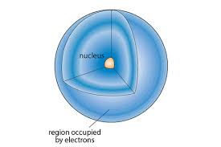

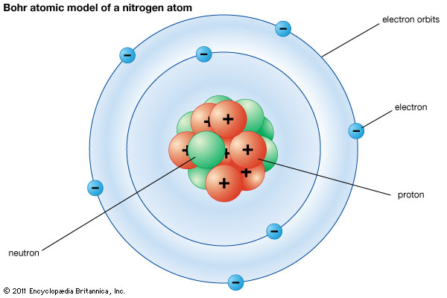

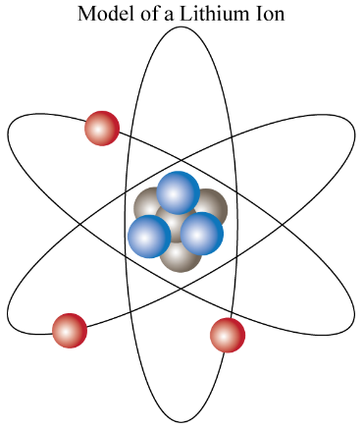

Each of these similar models suggest that most of the atom is empty space.
At the centre of the atom is a small ‘core’ called the NUCLEUS.
The nucleus consists of two types of particles; PROTONS (p) and NEUTRONS (n).
Around the nucleus are very fast moving small particles called ELECTRONS (e).

Particles in the Atom

Protons, neutrons and electrons are called sub-atomic particles. They can be described by their mass and their charge.
Protons have an atomic mass of 1 amu (atomic mass unit) and a charge of one positive.
Neutrons have an atomic mass of 1 amu and no electrical charge.
Electrons have negligible (very small) mass and a charge of one negative.

Complete this table using the information about the structure of the atom.

Name of particle | Symbol | Approximate mass (amu) | Charge | Where it is found in the atom

Atomic Number

Atoms of different elements contain different numbers of protons in their nuclei. This number is called the atomic number. Every element has a different atomic number.
Atomic Number: The number of protons in the nucleus of an atom

Each proton has a positive charge so the nucleus also has a positive charge.
However, atoms have an overall neutral charge. This is because, in every atom the number of positive protons is balanced with the same number of negative electrons moving around the nucleus i.e. the number of electrons equals the number of protons.
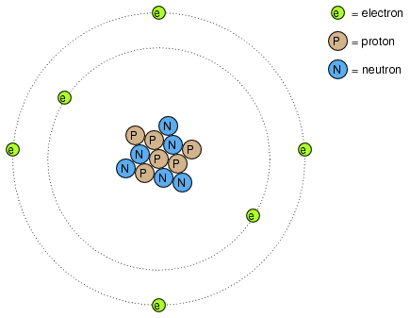
Count the number of protons and electrons – what do you notice?

Using the periodic table in your data book (page 8), complete this table.

Atomic number | Element name | Positive charge on nucleus | Number of electrons
12 | magnesium | 12+ | 12
 | silver
35
 |  |  | 1
16
 |  | 23+
 |  |  | 92

Check test 2.2
Mass Number

You now know that atoms have a positive nucleus of protons and neutrons with negative electrons moving around the outside of the nucleus.
The mass of the atom is determined by the number of protons and neutrons in the nucleus. These two sub-atomic particles both have an atomic mass of 1 amu. Electrons have negligible mass and so are not included in the mass of an atom. The number of protons plus the number of neutrons in the nucleus of an atom is called the mass number.
Mass Number: The number of protons plus neutrons in the nucleus of an atom

Scientists often write the atomic number and mass number of an atom in the following way.
mass number
atomic number
symbol

For example,
23
11
Na
sodium has a mass number of 23 and
an atomic number of 11.

15
7
N
nitrogen has a mass number of 15 and
an atomic number of 7.
Complete this table by calculating the number of protons, neutrons and electrons and by writing the correct symbol.

Symbol | Atomic number | Number of protons | Number of electrons | Mass number | Number of neutrons
23  11  Na |  | 11 | 11 |  | 12
3  Li | 3 |  |  | 7
24 |  |  | 12
 |  | 17 |  |  | 20
Isotopes

Atoms of the same element can have different numbers of neutrons in their nuclei. This means the mass number will not be the same for all the atoms in the element. Atoms of the same element with different mass numbers are called ISOTOPES.
H
1
1
H
2
1
H
3
1
Hydrogen has 3 isotopes:

The first isotope of hydrogen has no neutrons. The second has 1 neutron and the third has 2 neutrons.
Cl
37
17
Cl
35
17
Chlorine has 2 isotopes:

Answer the following questions:

- Give the definition of an isotope.

- Make a table showing the number of protons, neutrons and electrons in both of the chlorine isotopes.

- Isotopes must always have the same number of protons, why is this the case?

Relative Atomic Mass

Most atoms exist in nature as a mixture of two or more isotopes meaning that an average value of the element’s atomic mass must be used.

This average atomic mass is known as the relative atomic mass and values for selected elements can be found in your data booklet.

In most cases this average mass does not work out to be a whole number and some elements are quoted as having a mass that is not a whole number, for example chlorine is quoted as having a R.A.M of 35.5. The R.A.M is an average value, as clearly it is not possible to have half of a proton or neutron.

Relative Abundance

If the mass numbers of the possible isotopes and the relative atomic mass are known then the relative abundance can be deduced. This tells us whether one of the isotopes is more common or whether they are roughly equal.

To work out which isotope is more abundant you need to recognise which of the isotope masses the R.A.M is closer to. If the R.A.M is equally close to both masses the isotopes are said to have roughly equal abundance. For example:
Cl
37
17
Cl
35
17
Chlorine has 2 isotopes:

Chlorine has a relative atomic mass of 35.5.
Cl
35
17
35.5 is closer to 35 than 37 (two isotope masses) and so is the more common isotope.
Answer the following questions:

- Lithium has two isotopes, one with a mass of 6 and one with a mass of 8. Use your data booklet to decide which of the two isotopes is more abundant?

- Oxygen has two isotopes with masses of 15 and 18. Which of the two is more abundant?

Check test 2.3
Electron Arrangement

Most of an atom is empty space. Electrons move through this space. The electrons are arranged according to how much energy they have. They are arranged in levels of increasing energy. This is called the electron arrangement.
Electron arrangement: the arrangement of electrons in energy levels around the nucleus

There is a limit to the number of electrons that each energy level can hold; two in the first, eight in the second, eight in the third, then two in the fourth. The lowest energy level is nearest to the nucleus and is filled first. Once it is filled, the next electron must enter the next higher energy level further from the nucleus.
first energy level
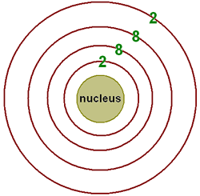

second energy level

third energy level

fourth energy level

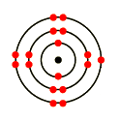
Electron ‘target diagrams’ can be drawn for different atoms to show the electron arrangement around the nucleus.
35
17
Cl
This is the electron target diagram for

There are seventeen electrons
arranged around the nucleus.

Complete these target diagrams to show the electron arrangement around each nucleus.

Ca
S
Al
C
Electrons and The Periodic Table

The arrangement of the periodic table is directly related to the sub-atomic particles within the atom. As you have already seen the elements are arranged in order of increasing atomic number, which is the number of protons in the nucleus. You have also seen that elements are arranged in groups such as the alkali metals in group 1 and the halogens in group 7.

Complete the electron arrangements for these two groups:

Alkali Metal | Electron Arrangement |  | Halogens | Electron Arrangement
Lithium | 2,1 |  | Fluorine | 2,7
Sodium |  |  | Chlorine
Potassium

Look at these electron arrangements and you will see that the electron arrangement is similar to all others in the group. This similarity is with the outer electrons.

Each member within a group of elements has the same number of outer electrons.

Electrons and Chemical Properties

The alkali metals react with water, having seen the alkali metals reacting with water note your observations below:

Alkali Metal | Observation
Lithium
Sodium
Potassium

All elements within a group of the periodic table have similar chemical properties.
Elements within the same group have both similar chemical properties and the same number of outer electrons.

This shows that it is the outer electrons that take part in chemical reactions and as such are responsible for the chemical properties of an element.

The Noble Gases

The noble gases are very unreactive. Given that we know that the outer electrons give rise to an element’s chemical properties, what is it about the noble gases’ electron arrangements that make them so stable?

Noble Gas | Electron Arrangement
Helium | 2
Neon | 2,8
Argon | 2,8,8
Krypton | 2,8,18,8
Xenon | 2,8,18,18,8

Each member of the noble gases has a “full” outer electron shell and this gives rise to their chemical stability.
Other elements in the periodic table will react in order to achieve this “full” outer shell and become chemically stable.

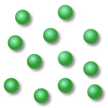
The noble gases are described as “monatomic gases” because they exist as single atoms in the gaseous state.

Check test 2.4

