
Beath High School
Chemistry Department

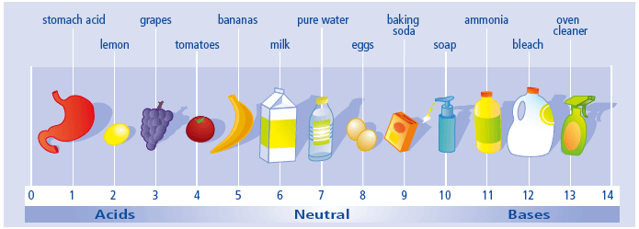

The Science of Chemical Reactions
The Reactions of Acids and Bases

Pupil Name:
Class:
Common Acids and Bases

Acids and bases are in common use in the home and in the laboratory as well as in industry. A base is often called a neutraliser.
Measuring pH
How acidic (or how alkaline) a solution is can be measured using the pH scale.
The pH scale ranges from below 0 and rises to above 14.
However, most common household solutions will have pH of between 1 and 14.
Universal indicator, pH paper or a pH meter can be used to find the pH of a solution.
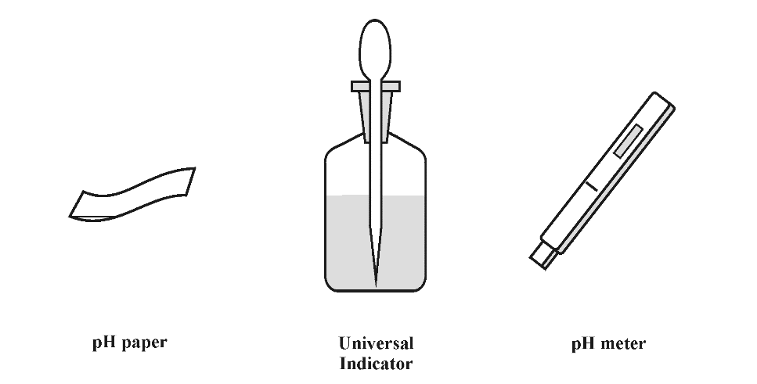
- Solutions with pH=7 are neutral.

- Solutions with pH less than 7 are acidic.

- Solutions with pH greater than 7 are alkaline.

Find the names of some laboratory and household acids and bases to complete your table.

Laboratory acids | Household acids | Laboratory bases | Household bases
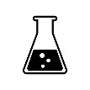
Activity 6
Non-Metal Oxides

Carbon, nitrogen and sulphur are non-metals.
Samples of carbon and sulphur were burned in gas jars containing oxygen to form the gases carbon dioxide and sulphur dioxide.
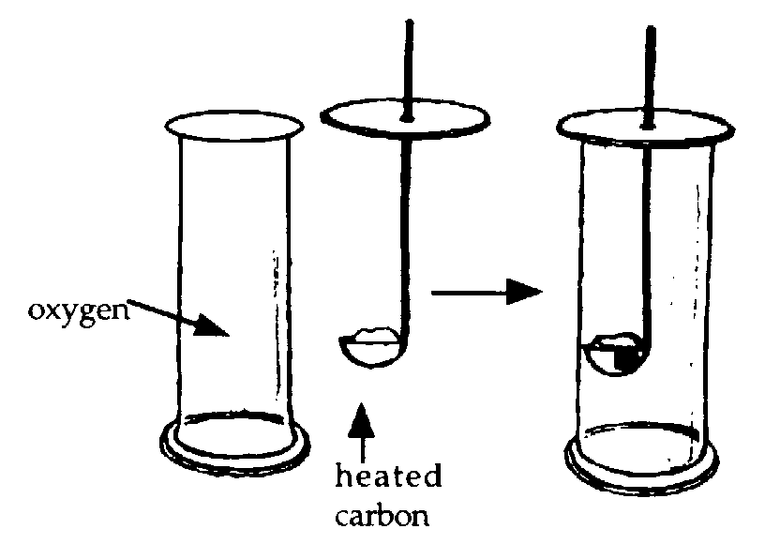

The word equations for these reactions are :

carbon + ______________ carbon dioxide
____________ + _____________ sulphur dioxide

1. Complete the following by scoring through the incorrect answer.
Sulphur dioxide and carbon dioxide both dissolve in water forming acidic/ alkaline solutions.

2. Copy this statement into your jotter:
When non-metals oxides are dissolved in water they form acidic solutions.
They are called acidic oxides.
When non-metals oxides are dissolved in water they form acidic solutions.
They are called acidic oxides.

When non-metals oxides are dissolved in water they form acidic solutions.
They are called acidic oxides.

Metal Oxides

Metals react with oxygen in the air to form metal oxides.

metal + oxygen metal oxide

Draw the apparatus you used to carry out this experiment.

- Write out word equations for two of the metals you tested.

- Write a conclusion from your results for this experiment.

- Copy this statement into your jotter:
When metals oxides are dissolved in water they form alkaline solutions.
They are called basic oxides.
An insoluble oxide will not affect the pH of water.
The Reaction of Acids with Bases - Neutralisation

Use the word bank to complete the sentences.

metal up salt pH carbonates hydroxides down

When an acid reacts with a base, the pH of the acid moves ____ towards 7 and the pH of the base moves _________ towards 7. Bases can be _________ oxides, metal _______________ and metal __________________ .
Water, which has a ____ of 7, is produced in the reaction.
The other product of the reaction is a ___________.
BASE + ACID SALT + WATER
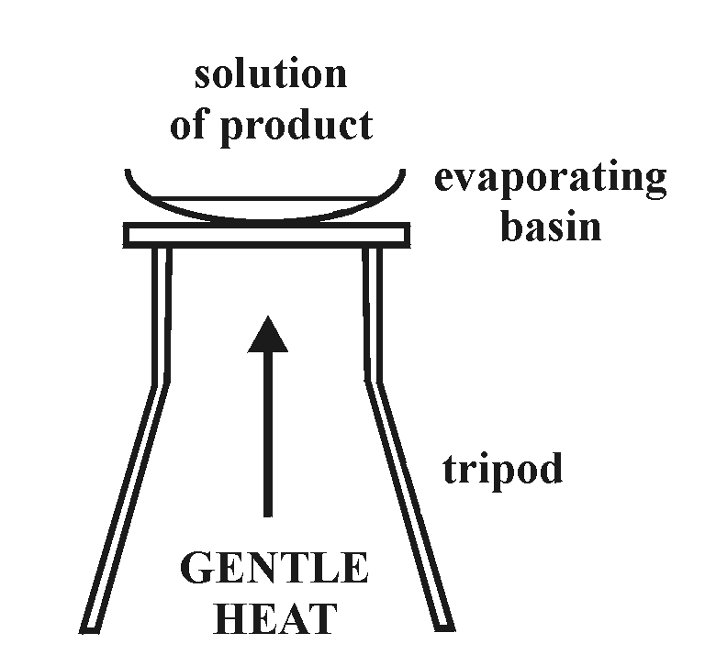

Evaporating off the water leaves behind a pure, dry sample of the __________ .

Activity 7 + 8
Naming Salts

As well as water, salts are formed when acids are neutralised by bases.
BASE + ACID → SALT + WATER

Name of acid | Name of salt formed
hydrochloric | ……………… chloride
sulphuric | ……………..sulphate
nitric | ………………..nitrate
The name of the salt comes from the base and the acid.
The first part of the name comes from the metal of the base, e.g. sodium hydroxide forms sodium salts, potassium oxide forms potassium salts.
The second part of the name comes from the acid as shown in the table.

Examples
1. The reaction of sodium hydroxide with hydrochloric acid produces sodium chloride.
2. The reaction of sulphuric acid with calcium oxide produces calcium sulphate.
Name of acid | Name of base | Name of salt formed
hydrochloric acid | sodium hydroxide
nitric acid |  | sodium nitrate
 | potassium hydroxide | potassium sulphate
 |  | potassium chloride
nitric acid | lithium hydroxide
sulphuric acid |  | lithium sulphate
3. Magnesium nitrate is formed by the reaction of magnesium oxide with nitric acid.

Complete the table by filling in the name of the acid, base or salt.

Metal carbonates also neutralise acids to form water but also carbon dioxide.
In addition, a salt is again produced.

METAL CARBONATE + ACID → SALT + WATER + CARBON DIOXIDE

Examples
1. Sodium carbonate reacts with hydrochloric acid to form sodium chloride, water and carbon dioxide.

2. Sulphuric acid reacts with magnesium carbonate to form magnesium sulphate, water and carbon dioxide.

3. Potassium nitrate, carbon dioxide and water are produced by the reaction of potassium carbonate with nitric acid.

e.g. Potassium + nitric acid → potassium nitrate + water + carbon dioxide
carbonate

Now in your jotter, write word equations for the following acid/base reactions.

- The reaction of hydrochloric acid with lithium carbonate.

- The reaction of sulphuric acid with lead carbonate.

c) The reaction of nitric acid with potassium hydroxide

- The reaction of hydrochloric acid with magnesium oxide


Check test 1.4

Acid, Alkali and Neutral

All acids and alkalis conduct electricity which means that they must contain ions. Ions are atoms that have positive and negative charges, due to electrons being lost or gained. Water too, even in its purest form, conducts water and so it too must contain ions. These ions are produced by the splitting of a very few water molecules into ions, known as dissociation, as shown by the equation below.
H₂O(l) ⇌ H⁺(aq) + OH⁻(aq)
The double arrow means that the reaction can go in both directions. It is reversible.

Each water molecule that splits up gives one hydrogen ion (H⁺) and one hydroxide ion (OH⁻). This means in pure water, the number of H⁺ ions must be equal to the number of OH⁻ ions.

This allows us to form a definition for acidic, alkaline and neutral solutions:

A neutral solution contains equal quantities of H⁺ ions and OH⁻ ions.
An acidic solution contains more H⁺ ions than OH⁻ ions.
An alkaline solution contains fewer H⁺ ions than OH⁻ ions.

Complete the following sentences.
In water and any neutral solution, the concentration of hydrogen ions is _____________ to the concentration of hydroxide ions. The pH is _____. In acid solutions the concentration of ______________ ions is greater than the concentration of ______________ ions. The pH is ______________ than 7. In alkali solutions, the concentration of ______________ ions is greater than the concentration of ______________ ions in water or neutral solutions. The pH is ______________ than 7.

Neutralisation in Action

Complete the blanks in the following statements using words from the following list.

acid acidic base decreased digest
excess fish indigestion lakes neutralises
oxygen stung vinegar


1. Reducing soil acidity

A farmer needs to know the pH of his soil in order for his crops to grow as well as possible. If the pH of the soil is too low, and therefore too __________, the growth of his crops will be affected. He _____________ the acids in the soil by adding measured quantities of the chemical lime (calcium oxide).
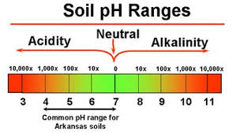

2. Reducing acidity in lochs and lakes
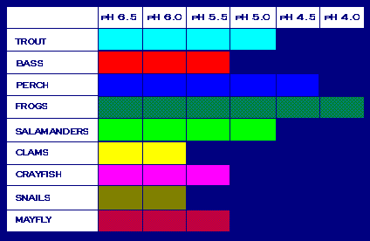
Lochs and _________ can become too acidic. This encourages the growth of algae which decreases the _____________ content in the water. Eventually this could lead to the death of __________ and other living things in the water. The acidity of the water can be _________________ by adding lime which neutralises the acids in the water.
3. Treatment of indigestion

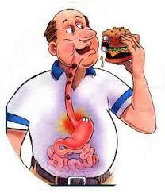
The stomach contains hydrochloric acid to help us ___________ our food. Stomach _______________ is caused by too much acid in the stomach. Indigestion tablets or powders contain chemicals which will neutralise the __________ acid and relieve the pain.

4. Bee and wasp stings

When you are ___________ by a bee it injects acid into your skin. The sting can be neutralised by using a common household ____________ like sodium bicarbonate.
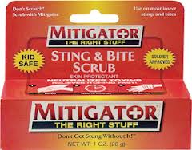
A wasp sting is alkaline, so an ________ is needed to neutralise it. Household acids which may be used are lemon juice or _______________.

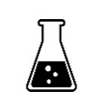
Activity 9 + 10
Check test 1.5

Food Acid Challenge

Write your notes for your challenge on this page.
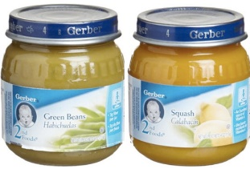
Topic: From your class discussion, choose an acid which is used in food or drink.



Research: Use suitable resources (textbooks, newspapers, internet) to find out:

- in which foods the acid is used?

- why the acid is used?

- what effect on health does it have?

- would it be beneficial to remove it from the food?

- One other interesting fact about your acid.


Presentation: Present your work in a way that you can communicate your findings to your class.

When non-metals oxides are dissolved in water they form acidic solutions.
They are called acidic oxides.
When non-metals oxides are dissolved in water they form acidic solutions.
They are called acidic oxides.
When non-metals oxides are dissolved in water they form acidic solutions.
They are called acidic oxides.
When non-metals oxides are dissolved in water they form acidic solutions.
They are called acidic oxides.

