
Beath High School
Chemistry Department

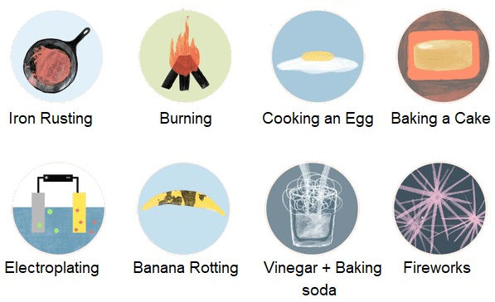

The Science of Chemical Reactions
Chemical Reactions: The Basics

Pupil Name:
Class:

What is Chemistry?

If you were to look up the word “Chemistry” in the dictionary this is what you might find:
chem·is·try
noun /keməstrē/
The branch of science that deals with the identification of the substances of which matter is composed; the investigation of their properties and the ways in which they interact, combine, and change; and the use of these processes to form new substances.

What does this mean to you? What does Chemistry bring to today’s society?

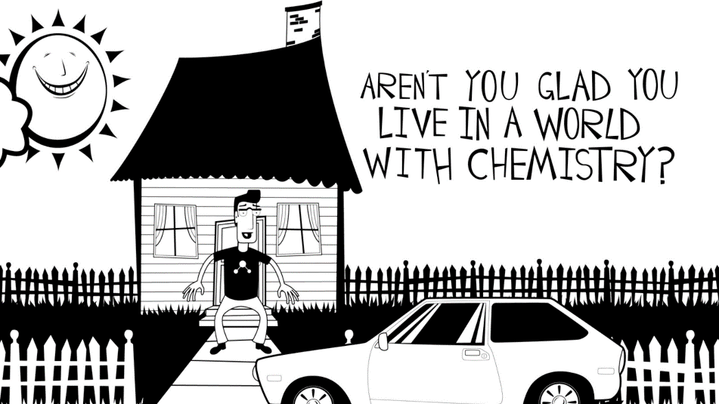
Without chemists, our world would be a very different place.

We would have no paper, plastic, metals, fuels, food, cosmetics, in fact the list of things produced with the help of chemistry is endless.

Imagine a day without Chemistry. What everyday things would you miss? What would the effect be on your life?

Laboratory Safety
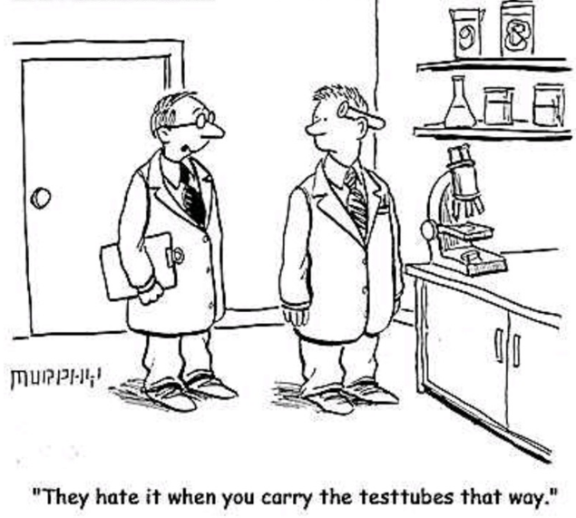

Safety Rules

Safety is very important when working in a laboratory. There are a number of safety rules that you must follow in order to ensure the safety of yourself and others.

In the space below make a list of the rules you know from your experience of working in a science laboratory:

Hazards

When handling chemicals in the lab you will be alerted to possible dangers by the presence of hazard symbols.

Collect a set of hazard cards and work with a partner to assign each hazard symbol to a name and description.
Complete the table below when you have checked your answers:

Hazard Symbol | Name of hazard | Description of hazard
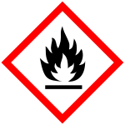
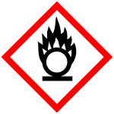
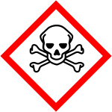
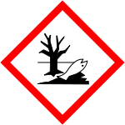
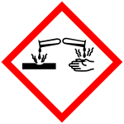
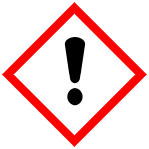
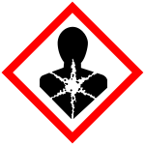

You will see these hazard symbols on bottles of chemicals and activity sheets. This will alert you to any potential dangers you face.

Why are symbols used instead of words to alert you to hazards?
Chemical Reactions

Chemistry is all about chemicals and how they combine. It is important to be able to identify when a chemical reaction is taking place.
The signs of a chemical reaction are:
1.
2.
3.
4.

Seeing one or more of these signs does not mean that a chemical reaction is definitely taking place.

Take boiling or freezing water as examples, you will see a gas being produced when water is boiled and a solid forming when it is frozen. Are these chemical reactions?

The answer is no, the one true sign of a chemical reaction is the formation of a new substance.

Energy Changes

Everyday we make use of chemical reactions that involve energy changes. Reactions involving a change in temperature can be classed as one of two types of reaction:

An EXOTHERMIC reaction – one in which energy is released. The mixture and its surroundings will become hotter.
An ENDOTHERMIC reaction – one in which energy is absorbed. The mixture and its surroundings will become colder.
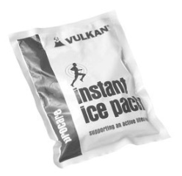
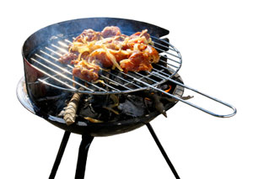
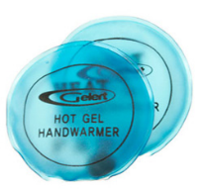

These are some examples of everyday products that work because of an exothermic or endothermic reaction.


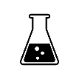
Check test 1.1
Activity 1 + 2
Factors Affecting the Rate of Reaction

Not all chemical reactions happen at the same rate. Everyday chemical reactions vary in rate from an explosion that is over in seconds to the formation of fossil fuels that takes place over hundreds of millions of years.

As a chemist there are occasions when changing the rate becomes important, whether it be speeding up a chemical reaction which is of use to us or slowing down a chemical reaction that is causing us a problem.

Think of an example of an occasion where you might want to:
a. speed up a chemical reaction -
b. slow down a chemical reaction -
There are three factors that can affect the rate of a chemical reaction, they are:

- Particle size – The reactant could be a lump of a chemical or you could react a powder instead. The powder would have a larger surface area.

What is the surface area of a cuboid with dimensions 1 cm x 2 cm x 1 cm?
This cuboid has:
4 surfaces measuring 1cm x 2 cm =
2 surfaces measuring 1cm x 1 cm =
Total =
1 cm
1 cm
2 cm

Now cut the cuboid in half forming 2 cubes measuring 1 cm x 1 cm x 1 cm, what is the surface area now?
These 2 cubes each have:
6 surfaces measuring 1 cm x 1cm =
Total =

1 cm
1 cm
1 cm
1 cm
1 cm
1 cm

Particle size can also be described as the surface area, as the particle size gets smaller the surface area _______________________________________.
- Temperature – Either heating or cooling the reaction.

- Concentration – By either using a different concentration of a chemical or by adding or taking away some of a reactant.

Having investigated the effect of particle size, temperature and concentration on the rate of reaction, enter your results below:

As the particle size of a reactant increases-
As the surface area of a reactant increases -
As the temperature of a reactant increases -
As the concentration of a reactant increases -

Remember that for the result of each of these experiments the opposite is true, for example:
As the temperature of a reactant decreases -

Activity 3
Check test 1.2

Catalysts

Complete the following passage using the following words:

catalysts | pollution | unchanged
poisoned | temperatures | speeds

The rate of a chemical reaction can also be increased by using substances called ______________. A catalyst alters the speed of a reaction, but is not used up in the reaction. Catalysts are very important in making chemicals on an industrial scale. Using a catalyst ______________ up the reaction and, in industry, saving time saves money.

Catalysts can also allow reactions to take place at lower ______________, therefore, companies avoid huge fuel bills arising from heating the reactants. Catalysts are often transition metals e.g. iron is a catalyst in the preparation of ammonia, and nickel is used in the manufacture of margarine.

Since catalysts are normally ______________ during the reaction, they can be used many times over. Eventually they may become covered by particles of another substance and lose their ability to work. We say they have been "______________".

Catalysts are also used in the battle against ______________ from car exhausts. All exhausts of new cars are fitted with a catalyst, in the form of a platinum coated network of tiny honeycombed tubes. This catalyst acts on the exhaust gases - particularly unburnt petrol, carbon monoxide and oxides of nitrogen - and changes them into harmless carbon dioxide, water and nitrogen.

Mass of Catalyst

Unless poisoned, a catalyst will remain unchanged by a chemical reaction. This means that the mass of the catalyst will also remain unchanged.

For example if 10 g of manganese dioxide is used as a catalyst for the decomposition of hydrogen peroxide then _______________ will be present when the reaction is over.
Activity 4
Measuring Rate

It is not always enough to know whether a reaction is fast or slow. Sometimes we want to know the rate of a reaction. That is how fast the reaction happens. To find the rate we have to take measurements throughout the course of a reaction, for example the amount of reactant used, or amount of product produced.

These results are often presented in the form of a graph.

10g of magnesium ribbon was reacted with excess 1 mol/l hydrochloric acid producing hydrogen gas. The volume of hydrogen gas produced was measured at regular intervals and the results are shown below:

time / s | 0 | 30 | 60 | 90 | 120 | 150 | 180 | 210 | 240 | 270 | 300 | 330 | 360
volume of H₂ / cm³ | 0 | 8 | 14 | 20 | 25 | 29 | 33 | 36 | 38 | 39 | 40 | 40 | 40

Draw a graph of these results:

The steepness of the slope on the curve tells us how fast a reaction is going, the steeper the curve, the faster the reaction.
The plateau (flat part of the curve) tells when the reaction is over and how much product has been produced.
Using your graph, answer the following questions:

- State and explain what happens to the rate of the reaction as time goes on?

- How long does it take for the reaction to finish?

- What is the total volume of hydrogen gas produced?

- Using a different colour of pencil, add a line to your graph to show how the curve would change if the reaction was repeated using:

  - 5g of magnesium ribbon with excess 0.5 mol/l hydrochloric acid.

  - 10g of magnesium powder with excess 1 mol/l hydrochloric acid.

Calculating Average Rate of a Reaction
Activity 5

The average rate or speed of a chemical reaction can be defined in terms of the change in some property of a substance involved in the reaction divided by the time it takes for this change to occur.

If the property monitored is volume – either of a reactant or of a product – the average rate of the chemical reaction can be expressed as:

The units of volume are cubic centimetres and if time is expressed in seconds then the units of rate are cm³ s⁻¹.

The rate expression shows that the rate of a reaction is inversely proportional to time meaning that that, for a fixed change in volume, then the shorter the time, the faster the rate of the reaction.

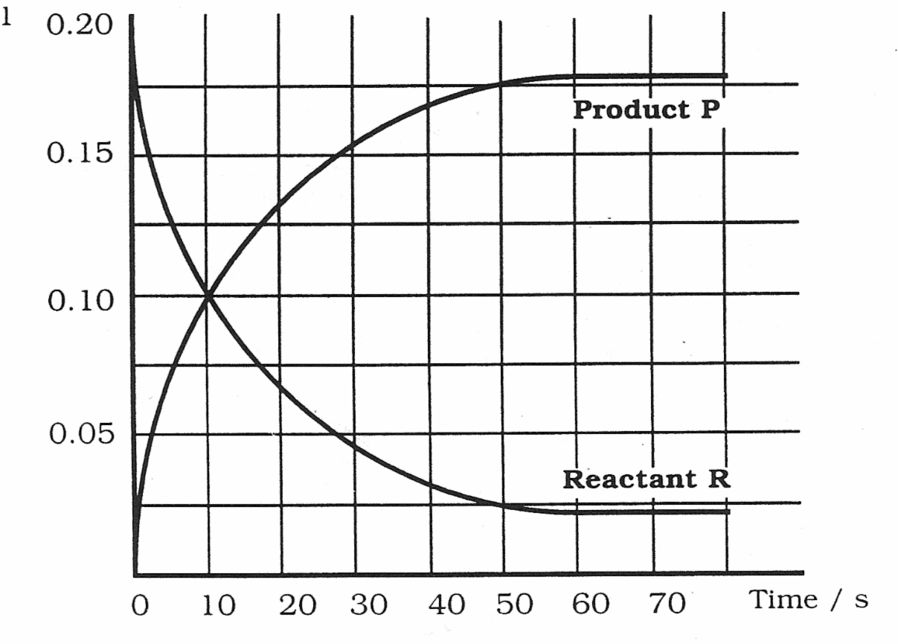
The following graph shows how the mass of a reactant R and product P change during a reaction.

Mass / g

The average rate of the reaction over the first 10 s can be calculated as follows either for R or for P:

Rate = change in mass of R OR = change in mass of P
change in time change in time

= 0.20 - 0.10 (from the graph) = 0.10 - 0 (from the graph)
10 - 0 10 - 0

= 0.10 = 0.01 g s⁻¹ = 0.10 = 0.01 g s⁻¹
10 10

Note the units used for rate can change depending on what is measured as well as the units of time used.

Use the table on page 8 to calculate the rate of each reaction during:

- 0 - 90 seconds

- 90 - 180 seconds

- 180 - 270 seconds

Remember the units of the quantity measured and the time taken determine the units of rate.
e.g.

units = g s⁻¹ units = cm³ s⁻¹
Check test 1.3
Word Equations

A word equation is a chemist’s way of quickly describing the course of a chemical reaction. It involves identifying which chemicals are used the reaction, known as REACTANTS and the chemicals which are produced by the chemical reaction, known as PRODUCTS.
Symbols are also used:
+ is used when there is more than one reactant or product
is used to separate the reactants from the products, this means ‘reacts to give’
Other than symbols, only the names of chemicals can appear in a word equation, descriptions of colour or state should never be written.

e.g the reaction of grey aluminium powder and purple iodine produces aluminium iodide.
aluminium + iodine aluminium iodide

e.g. carbon dioxide is formed when carbon monoxide reacts with oxygen

carbon monoxide + oxygen carbon dioxide

Write word equations for the following reactions:

- Magnesium burns brightly in oxygen to form magnesium oxide.

- Iron metal is formed when iron oxide reacts with carbon monoxide. Carbon dioxide gas is also produced.

- Magnesium reacts with a blue solution of copper chloride forming solid copper and a colourless magnesium chloride solution.

