
Beath High School
Chemistry Department
Higher Chemistry
Unit 1: Chemical Changes and Structure

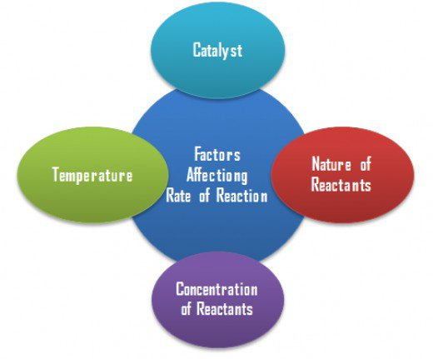

Unit 1: Chemical Changes and Structure
Key Area: Controlling the Rate
Course Notes

Name
Class
N₅

Controlling the Rate
- The rate of a chemical reaction can be altered by changing surface area, temperature, concentration or by using a catalyst.
- A catalyst takes part in a reaction but is not itself used up, e.g. if 10g of catalyst were added to a reaction you would be able to recover 10g of catalyst at the end of the reaction.
- The results obtained in mass loss or volume of gas produced experiments can be used to calculate the average rate of reaction.
- The units of average rate can be determined from the variable changed over a period of time. i.e. mass loss: gs⁻¹ or volume of gas produced: cm³ s⁻¹

Why do Chemical Reactions Occur?
For a chemical reaction to take place, the reactant particles must c________. This is called the collision theory.
For a successful collision to take place particles require:
- A minimum energy called the A__________ Energy (E_{A})
- The Correct G___________.
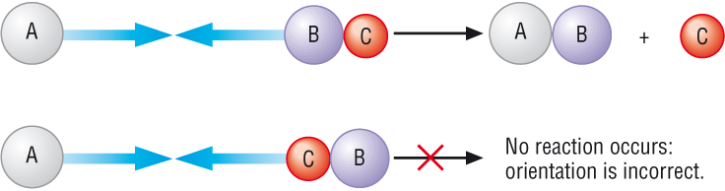

Figure 1: Diagram showing the requirement for correct activation energy and geometry for a successful collision to occur.

Any factor which increases the number of c__________ between the particles of the reactant is likely to increase the r______ of the reaction.
We can use the collision theory to explain the factors which affect reaction rate.

What is Reaction Rate?
Chemical reactions occur at different r______. Chemists need to have an understanding of the factors that affect the rate of chemical reaction. Once they have an understanding they can look at ways to:
- Increase the rate of the reaction– this will result in the product being made more quickly and may increase profit
- Decrease the rate of the reaction – if a reaction is too fast there is a risk of thermal explosion.
The rate of a chemical reaction can only be determined by experiment. In this unit we are going to look at the different experiments you can carry out to allow you to establish the rate of a reaction.
Factors that Affect Reaction Rate
Concentration
Adding a Catalyst
Particle Size
Temperature
Factors that affect reaction rate

The c_________ theory explains why each of these factors can change the rate of a chemical reaction.
Particle Size
As the surface area of a reactant increases, the area of contact between the reactants i_________ which increases the number of possible c_________ between the reactant particles. This will increase the number of s___________ collisions and so the overall reaction rate will i__________.
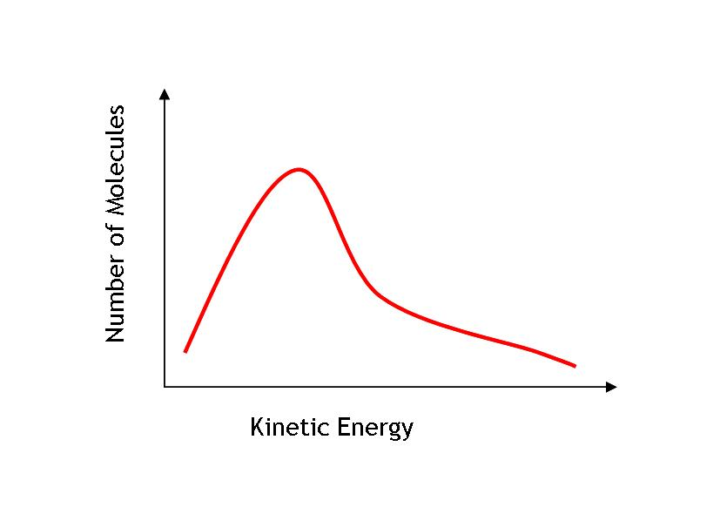
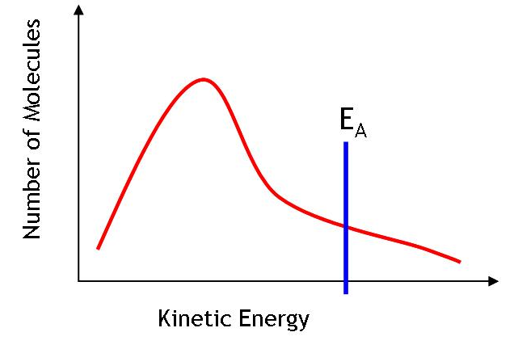
Energy distribution diagrams can be drawn to show the variation in kinetic e_________ of particles at a given temperature. Although the energies of individual particles are always changing, the overall picture remains the s______.

The a_________ e_________ can be labelled on energy distribution diagrams. The area to the right of the E_{A} line shows the number molecules that have sufficient kinetic energy to overcome the activation energy.

Temperature
Temperature can be regarded as a measure of the average k________ energy of particles in a substance. At higher temperatures particles have ______ kinetic energy. This will increase both the number of collisions and the force which particles collide with. As a result, there will be more successful collisions and so an ___________ in reaction rate
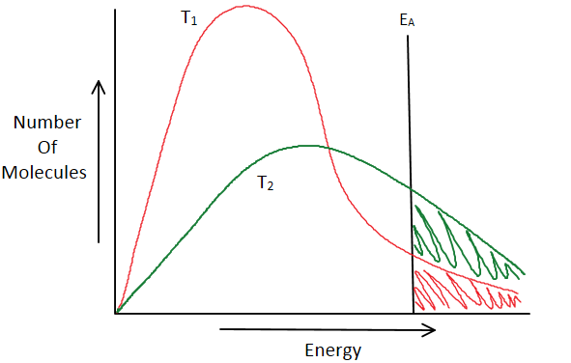
Within a reaction, if temperature is increased, the molecules will ______ more energy. The molecules will inevitably have the sufficient energy to overcome the a_____________ e_________.

T₂ represents an increase in temperature and as noticed, there is a _________ shaded area of molecules that have overcame the activation energy for a successful collision.

Concentration
As the concentration of a reactant increases the reactant particles are pushed c_______ together which increases the n_______ of c___________. This increases the number of successful collisions and results in an increase in the reaction rate.
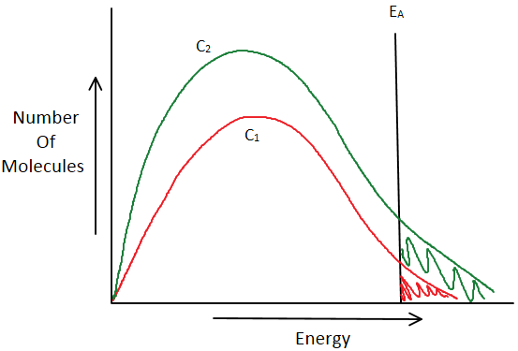
As concentration increases, _____ particles are being added to the reaction.
More particles, increased probability of s__________ collisions.

C₂ shows a reaction when concentration has been increased. As noticed the line is ________ when compared to C₁, because more particles have been added.

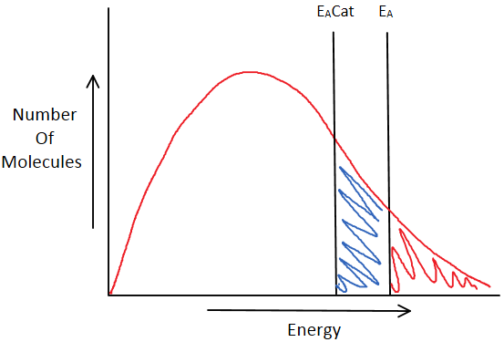
A catalyst is a substance that _________ ___ a chemical reaction without itself being used up in the reaction. Catalysts speed up chemical reactions by decreasing the activation energy. This means that more particles have energy equal to or greater than the required activation energy, which means more successful collisions can occur and therefore the reaction rate increases.

Average Reaction Rate
The rate of a chemical reaction may be expressed in terms of the changes in concentration(s) of either reactant(s) or product(s) over a period of time. This is called the average rate of reaction.
Average rate can be calculated by measuring changes in m_____, v_________ or p__.
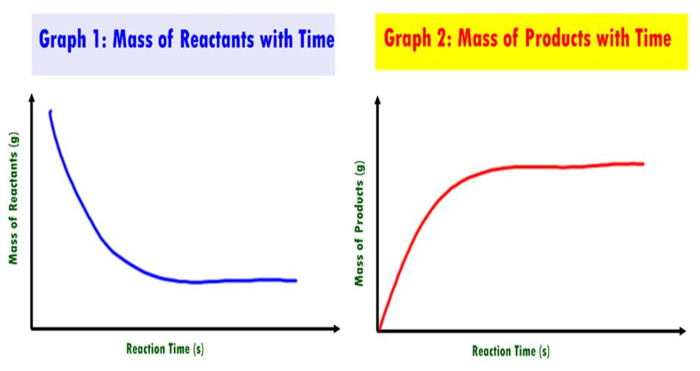

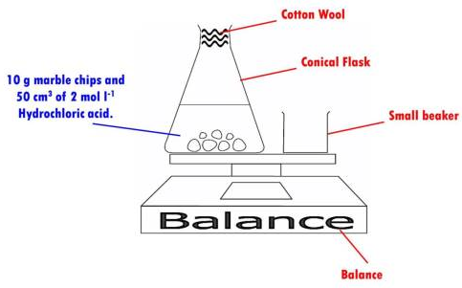
An example of an experiment that can be carried out in the lab to do this is the reaction of marble chips (calcium carbonate) with hydrochloric acid. You would measure the _______ loss over a period of time. The following apparatus could be used:

Average reaction rate can also be expressed in terms of the volume of gas produced over a period of time. To calculate rate using this method you would measure the volume of gas produced in a reaction over a period of time. The following apparatus could be used:
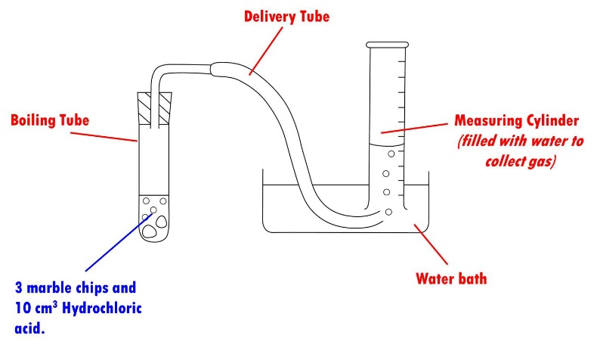

Using a graduated tube, e.g. a measuring cylinder, to collect gas formed.

Using a gas syringe to collect gas formed. This is a more a________ way of collecting gas formed than using a measuring cylinder.
This method is used for collecting soluble gases.

The rate of the reaction can be calculated from the results obtained in such reaction. As the readings are being taken over a period of time, this type of rate is called the a_______ rate of reaction.(Unit 1 Nat 5)

Average rate is calculated by dividing the change in mass or volume by the change in time.
The unit of average rate depends on the measurement taken.
1. Mass 2. Volume
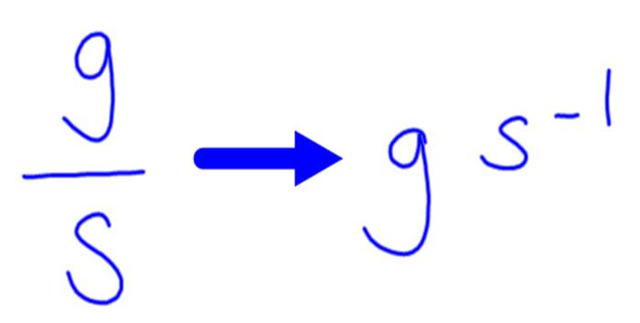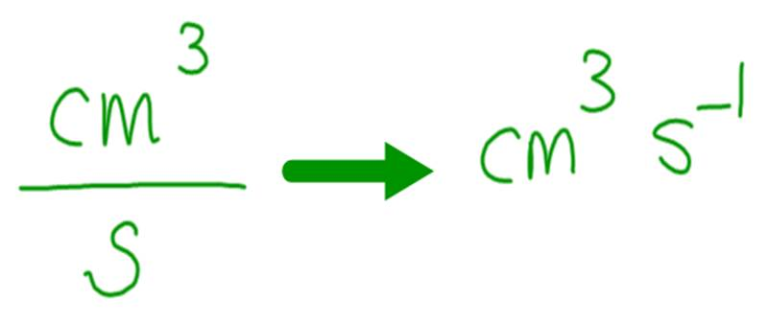





Relative Reaction Rate

In reactions where it is difficult to measure a change such as mass, volume or pH - the total time taken for the reaction can be used to calculate the r__________ rate.

This is particularly useful in reactions where a sharp c________ c________ can be used to indicate the end point of the reaction.

Relative rate is reciprocal of time.

relative rate =

1
time

Example:
The time take for a piece of magnesium ribbon to completely react with dilute hydrochloric acid is 120s. Calculate the relative rate for this reaction.

Rate = 1/t
= 1/120
= 0.0083 s-1

Key area check test – Calculating Rate of Reaction
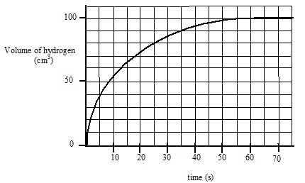
1. The graph below shows the volume of hydrogen gas released when a 10cm strip of magnesium (mass = 0.1g) was added to 30cm³ of 1 mol l⁻¹ hydrochloric acid.

(a) Calculate the average rate of reaction
i) over the first 15 seconds ii) between 20 and 30 seconds

(b) How long did it take for the reaction to stop?

(c) The graph shows that the rate of reaction changes as the reaction proceeds. Explain why it changes in this way.
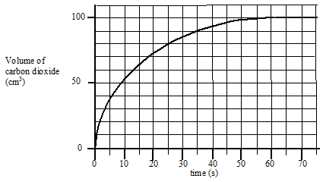
2. The results shown below were obtained when 0.42 g of powdered chalk was added to 20 cm³ hydrochloric acid, concentration 2 mol l⁻¹ (an excess of the acid).

(a) Sketch the graph and add a solid line to the graph to show what would happen if 0.42g of chalk lumps was used instead of powdered chalk.

(b) Add a dotted line to the graph to show what would happen if 20 cm³ of 3 mol l⁻¹ hydrochloric acid was used instead of 2 mol l⁻¹ hydrochloric acid.

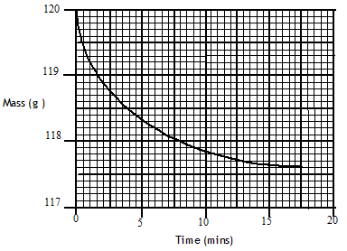
3. Marble chips (calcium carbonate), reacted with excess dilute hydrochloric acid.
The rate of reaction was followed by recording the mass of the container and the reaction mixture over a period of time. The results of the experiment are shown in the following graph.

(a) Write a balanced equation for the reaction.

(b) Give a reason for the loss of mass of the container.

(c) Calculate the average rate of reaction over the first five minutes.

(d) Why does the average rate of reaction decrease as the reaction proceeds?

4. A pupil was investigating the effect of temperature on the rate of a chemical reaction and obtained the following data.
Temperature (ºC) | 15 | 25 | 33 | 37 | 44
Time for reaction to  finish (s) | 154 | 66.7 | 40 | 30.3 | 22.2
Relative rate ( .......... )

(a) Copy the table and calculate the relative rate of reaction at each temperature and add them to the table, putting the correct units in the brackets.

(b) Plot a graph of relative rate against temperature.

(c) Predict what the relative rate of the reaction will be at 50 ⁰C.

(d) Use the graph to estimate the time for the reaction to finish at 40 ⁰C.
Reaction Profiles
What are Reaction Profiles?
A potential energy diagram is used to show the p________ for a reaction. These involve plotting the reaction pathway against potential e_________. On these diagrams we can label:
- The activation energy for the forward reaction (E_{a forward})
- The activation energy for the reverse reaction (E_{a reverse})
- The change in potential energy, between reactants and products, called the enthalpy change ( H)
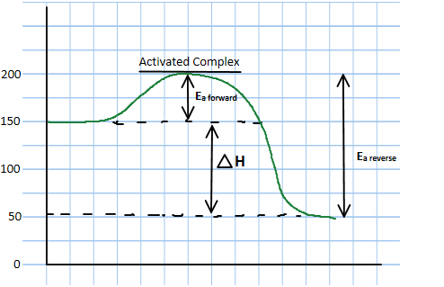
Potential Energy

Reaction Pathway

The potential energy involved in reactants becoming products is called E________.
An activated complex is a highly energetic, un_______ complex which is formed as an intermediate as a reaction proceeds from reactants to products. Because activated complexes are highly unstable, they only exist for a s_____ p_______ of t_____.
Activated Complex – a highly energetic and unstable complex formed between reactants and products.

For collisions to be s__________, the reactant particles must collide with energy equal to or greater than the a___________ energy.
Consider the decomposition of a diatomic molecule, XY, into its elements.

2XY_{(g)} X_{2(g)} + Y_{2(g)}

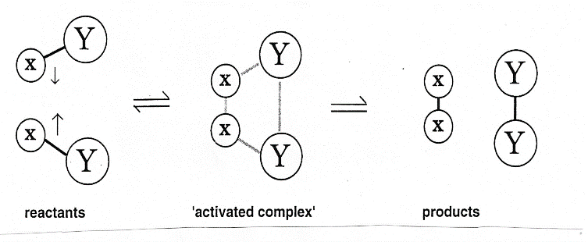
As the molecules collide the X – Y bonds are weakened and partial bonds are set up between the X atoms and between the Y atoms.
The activated complex represents an intermediate stage between the r________ and the p__________. It is formed at the top of the activation energy barrier and because of its _____ energy it is a very u__________ arrangement of atoms.

Reaction Profile – Exothermic Reactions
In exothermic reactions, energy is released to the s__________. This means that the products have ______ potential energy than the reactants. A potential energy diagram for an exothermic reaction is shown in the diagram below.
Reaction Pathway
Potential Energy
Exothermic Reactions
- ΔH is always negative.

Reaction Profile – Endothermic Reactions
In endothermic reactions, energy is ________ ___ from the surroundings. This means that the products have more p_________ e_______ than the reactants. A potential energy diagram for an endothermic reaction is shown in the diagram below.
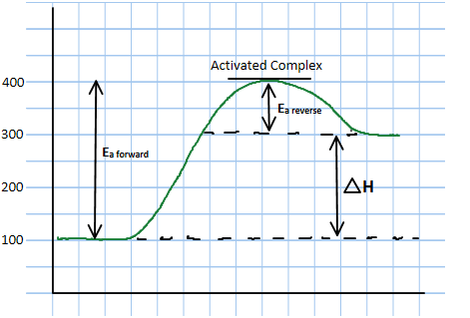
Reaction Pathway
Potential
Energy
Endothermic Reactions
- ΔH is always positive.

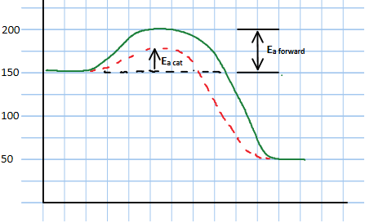
Reaction Profile – Use of a Catalyst

Catalysts _________ the rate of a reaction by lowering activation energy and providing an easier, alternative p__________. This can be shown on a potential energy diagram.
Potential Energy
Reaction Pathway

Key area check test: Calculations involving Potential Energy diagrams.

H = H_{P} – H_{R}
H = 50 – 150

= -100 kJ
H = H_{P} - H_{R}

Potential Energy

Reaction Pathway

Mark E_{a} and ∆H on the PE diagrams and then calculate the value of each for the forward reaction

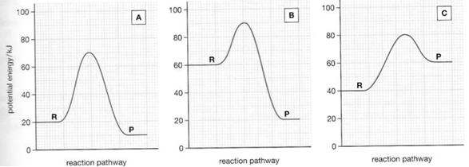

Mark E_{a} and ∆H on the PE diagrams for the reverse reaction and then calculate the value of each

