

Beanstalk FNC
Improvement Plan
2026/2027

Information for
parents/carers

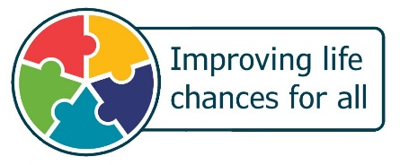

Nursery Context
- Beanstalk Family Nurture Centre is a dispersed service that comprises of 2 separate standalone buildings which provide 2 different models of delivery of early learning and childcare for up to 256 3–5 year olds and 40 2-year-olds within the local community.
- The buildings are situated only a 5-minute walk apart in the Abbeyview Community.
- We are one of 7 Family Nurture Centres across Fife.
- Current roll across both buildings totals 120 children, the roll will increase throughout the year.
- We currently have 6 playrooms, 3 in each building, and these serve 8 cohorts of children.
- 1 additional playroom that is currently being utilised by the Family Team.
- The operational models are:
49-week model (AM or PM sessions)
Term time (9am - 3pm).
- All rooms have access to outdoor play areas which are well used and open for the whole session.
- We are currently staffed with 1 full-time Acting Headteacher, 1 full time Depute Head of Centre, 1 full-time Acting Principal Teacher, 1 Early Years Lead Officer (shared with Lynburn ELC), 3 full-time Senior Early Years Officers, 2 part-time Senior Early Years Officers, 35 Early Years Officers, 3 Apprentice Early Years Officer and 3 Pupil Support Assistants.
- We also have a Family Team that consists of a full-time Family Worker (Senior EYO) and 3 childcare practitioners.
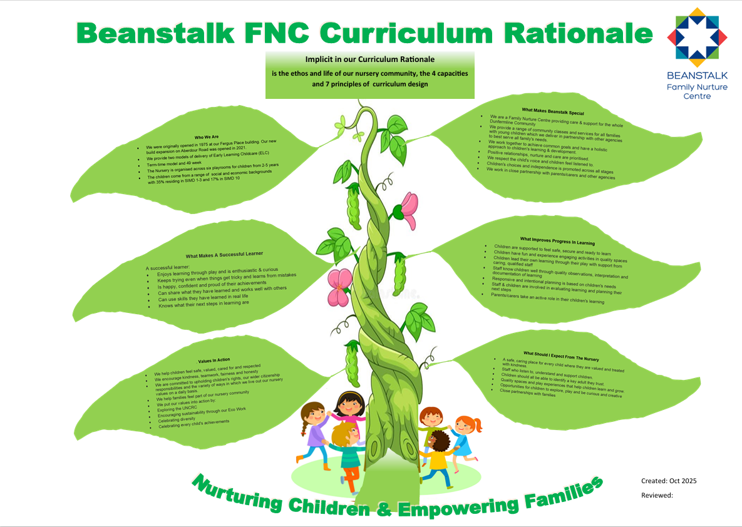

At Beanstalk FNC we recognise the significant relationship between effective self-evaluation and nursery improvement.

An inwards, outward, forward approach help us answer the three key questions at the heart of self-evaluation:
- How are we doing?
- How do we know?
- What are we going to do now?

Nursery Improvement Priorities 2026/2027
- Increase progress across the curriculum and develop skills for life and learning. | - Develop consistency and a shared understanding of how to document learning, teaching and assessment.
Expected impact:  - All stakeholders will understand Beanstalk’s Curriculum rationale, including the vision, values and aims.  - Almost all children will become more engaged and independent learners through the meaningful use of digital technology.  - All children will experience high quality ‘Think Equal’ sessions, which will provide a holistic understanding of social equality, gender, racial and religious equality, social and emotional health and well-being and global citizenship, based on social-emotional learning.  - Staff will become familiar with skills for life and learning (meta-skills) and begin to create opportunities for children to recognise, understand and explore their meta-skills development through the 4 contexts for learning. | Expected impact:  - All 3-5 playrooms will consistently be planning, delivering and evaluating high-quality learning, teaching and assessment with increased pace and challenge (differentiation).  - All 3-5 staff will use the refreshed learning, teaching and assessment expectations as part of their daily practice, to improve the consistency of learning, teaching and assessment for children across the nursery.  - All children’s learning and development will be tracked appropriately using robust tracking systems to track progress over time across all curricular areas (3-5) and across developmental milestones (2-year olds).  - Parents will be better informed about their children’s learning, and more able to engage with this, and support learning at home.

Self-evaluation and feedback

As the year progresses, we will evaluate how we are doing and evidence our progress within each priority.



Within the nursery foyer we have an area called 'Improving Together', where our
improvement priorities are on display and on the sideboard, we have our feedback
book along with our "Question of the moment". The Question of the moment are
focused questions for parents and carers to tell us how we are doing, please take the
time to visit this area. This is an opportunity for you to share your thoughts, for us to
take that on board and action so that we can continue to grow, learn and improve

Within our setting we have our improvement priorities are on display and we also have our feedback books positioned in the near vicinity along with our "Question of the moment". These are focused questions for parents and carers to tell us how we are doing, please take the time to visit this area. This is an opportunity for you to share your thoughts, for us to take that on board and action so that we can continue to grow, learn and improve together.

We use a ‘You said, We did’ or ‘We asked, You said, We did’ approach. These are displayed in the nursery and will also be shared via our termly newsletters.

As we collate your feedback, we gather it in the above-mentioned feedback book called ‘Parent/Carer Consultation’ floorbook, please feel free to look through it.

As a staff team we regularly reflect on our practice and the day-to-day running of the nursery and consider developmental work alongside our improvement journey and document these in floorbooks as well.

