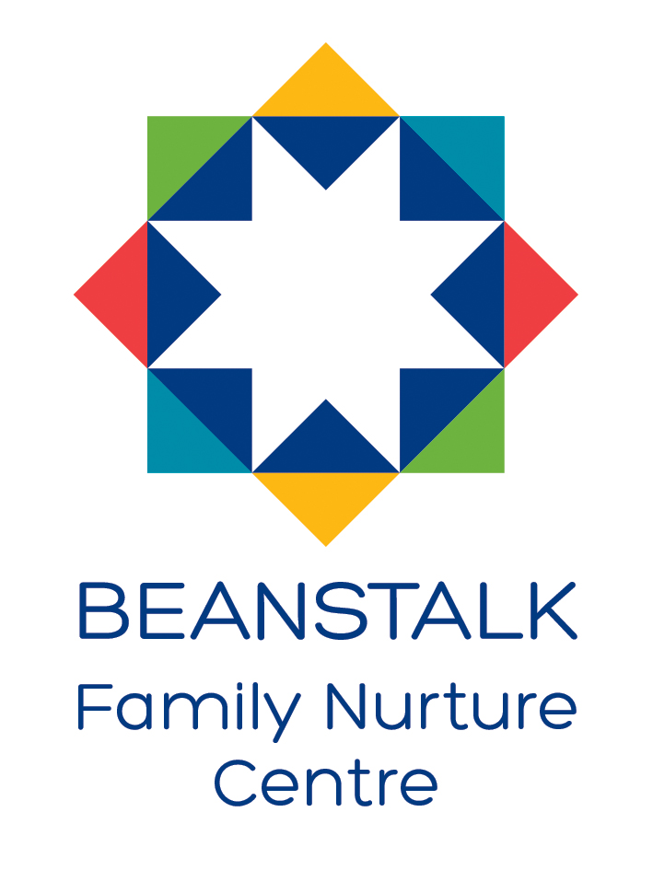

**IMPROVEMENT PLAN FOR 2024/25**

**IMPROVEMENT PLAN PRIORITIES & WORK PLANS**

|  |  |  |  |  |  |
| --- | --- | --- | --- | --- | --- |
| FOCUSED PRIORITY 1 | Review current planning, tracking, and monitoring systems to ensure the best learning outcomes for all children | | | | |
| LINKS TO NATIONAL IMPROVEMENT FRAMEWORK:  Teacher & Practitioner Professionalism  Curriculum & Assessment  ELC Improvement | | | **LINKS TO HGIOELC: 1.1, 1.3, 2.3, 3.2** | | |
| EDUCATION DIRECTORATE IMPROVEMENT PLAN: Equality & Equity/Achievement | | | | | |
| Expected Impact | **Strategic Actions Planned** | **Responsibilities** | | **Measure of success** | **Timescales** |
| A.   * Learning experiences are developmentally appropriate and tailored to meet all children’s individual and diverse learning needs. | * Evaluate current planning for learning processes. * Review current Daily/Responsive and long-term planning formats with all staff. * Review approaches to personalised support for individuals. | * PT, DHoC & all EYOs * PT, DHoC & all EYOs * PT, DHoC & EYLO | | * High quality weekly and daily planning in place in all playrooms. * All children are fully supported to follow interests. * Learning is visible in displays/Learning Walls and in children’s’ personal learning journeys. * Pre and post evaluation using SSTEW Scale Subscale 4 | * Twilight sessions Sep-Oct 2024 * Twilight sessions Sep-Oct 2024 * Dec 2024 |
| B.   * Staff use appropriate and creative ways to involve all children in the planning of their learning experiences and take an active part in setting their next steps. | * All Learning Experiences to be carefully planned involving children to follow their interests and better meet their needs. * Staff will record children’s views and opinions in a variety of ways using learner committees learning walls, mind maps etc. * Embedding systems in place to support children to identify and plan their next steps in learning. | * PT, DHoC & all EYO’S * Seniors & All EYO’S * PT, Seniors, All EYO’s | | * Increased level of children’s participation in planning. * children more able to discuss what they are learning. * All staff are skilled in making children aware of learning, how they are doing it and the process of learning is made explicit visually and verbally. * All Staff, parents/carers and children are sharing and discussing learning. * Pre and post evaluation using SSTEW Scale Subscale 4 | * Twilight sessions Oct -Dec 2024 * Dec 2024 * Aug 2024 |
| C.   * Improved tracking systems will allow for better monitoring and evaluation of children’s progress across the whole curriculum. | * Engage with the New FC digital tracking system “Progress” to support the tracking of learning, ensuring key staff are trained effectively on its use. * Further develop the current tracking spreadsheet which captures all aspects of children’s learning including their ELiPs scores, CfE levels, Leuvens scores and attendance. * Review how we use the data collected to identify any gaps for learners and plan bespoke interventions. | * HT & PT * PT, DHoC, EYLO * PT, DHoC, EYLO & All EYO’S | | * New “Progress” tracking system embedded and being effectively used by key staff. * Increased staff confidence when discussing children’s progress and planning their next steps in learning. * Staff more secure in identifying gaps in learning for individuals and putting in place bespoke planning to support learning. * Pre and post evaluation using SSTEW Scale Subscale 4 | * Aug 2024 * Sep 2024 * Aug 2024 |
| D.   * Moderation of the learning cycle across all teams will impact pace and challenge, improving outcomes in learning for children. | * Staff Peer moderation will take place across the session evaluating other Playrooms within the setting focussing on Planning/Learning Walls/PLJs. * Link with other Standalone Nursery Settings to peer-evaluate with a focus on planning & PLJs. | * HT & All EYO’s * HT & All EYO’s | | * Looking outwards will allow staff the opportunity to be more reflective and critically evaluate their own practice to support improvement. * Staff’s skills and knowledge with regards to the learning cycle will increase improving outcomes for children. * Pre and post evaluation using SSTEW Scale Subscale 4 | * Twilight sessions Jan - March 2025 * March 2025 |
| Ongoing Evaluation |  | | | | |

|  |  |  |  |  |  |
| --- | --- | --- | --- | --- | --- |
| FOCUSED PRIORITY 2 | Identify and problem solve around existing barriers to learning to ensure all children achieve success | | | | |
| LINKS TO NATIONAL IMPROVEMENT FRAMEWORK:  Curriculum & Assessment  ELC Improvement | | | **LINKS TO HGIOELC:**  **1.2, 2.2, 2.3, 3.4, 2.6, 3.2, 3.3** | | |
| EDUCATION DIRECTORATE IMPROVEMENT PLAN: Equality & Equity/Achievement/Health & Wellbeing/Attendance & Engagement | | | | | |
| Expected Impact | **Strategic Actions Planned** | **Responsibilities** | | **Measure of success** | **Timescales** |
| A.   * Children who face additional challenges in their learning due to their needs or context will benefit from personalised planning and interventions designed to improve their learning outcomes | * Provide bespoke Staff training opportunities with support from other agencies in Nurture, de-escalation, Up, Up and Away document, Total Communication Approach, Sensory Profiling etc. * Evaluate all Playrooms using “How Nurturing Is Our School” toolkit to review current practice and environments and create action plan to work toward achieving the “Nurturing Schools Award”. * Embed a consistent approach to the use of Kodaly, Emotion Work, mindfulness and yoga across the whole centre. | * PT & DHoC * Educational Psychologist * ASSIST Team * Inclusion Team * PT, EYLO, All staff * Seniors, All Staff | | * Staff are more skilled and confident in meeting the needs of all children. * Consistent approaches in place support all children to thrive and achieve their learning outcomes in a safe predictable environment. * Evidence in Individual Child Plans and Personal Learning Journeys * Achieve “Nurturing Schools Award”. * Pre and post Evaluations using ECERS 13 | * Input from EP   at November 2024 In-Service Day on Supporting Learner’s Needs – focussing on universal strategies & bespoke interventions   * Twilight sessions Sept-Oct 2024 * August 2024 |
| B.   * Children will experience a unique, rich, play based, broad curriculum to challenge, motivate and support their learning and meet all their development needs. | * Review Beanstalk’s Curriculum Rationale and shared working framework. * Co-create an updated Beanstalk curriculum rationale, reflective of our community post-covid/implementation of 1140 hours, taking into consideration the views of all stakeholders. | * HT & All EYO’s * All Stakeholders * HT | | * All stakeholders will contribute towards the Rationale and understand what the Beanstalk is trying to achieve through its curriculum. * The curriculum will reflect the service users, the needs of the local community and will promote equity and raise attainment for all children. | * Nov 2024 * Jan 2025 |
| C.   * Families are feeling fully informed and involved in planning for individual’s needs to support their learning and to ensure effective transitions | * Review the planning of current monitoring, review system, & systems for reporting to parents/carers etc with all stake holders. * Review procedures for transitions into nursery, within nursery and onwards to other settings and P1 | * PT & DHoC & All EYOs * PT & DHoC & All Seniors | | * All stakeholders feel valued, included and their views reflected when planning for individuals. * Transitions into nursery, within nursery and onward to other settings and P1 are highly effective and meet the needs of all children and families. * Evidenced in Parent/Carer & Partner feedback/   questionnaires etc. | * Sept 2024 * Sept 2024 |
| D.   * Universal Family Support offered is diverse to allow the whole community to feel included. * Targeted support is tailored to meet the needs of individual families. | * Promote “50 things to Do in Fife before you are 5” App with all families and use data to track engagement with this. * The Family Worker & team will understand from the data and evaluations-formal and informal- gathered from families both in the centre and from the wider community, what is working well, what we need to improve and where the gaps in our provision are. * Review strategies and recording systems to identify when targeted support is required for individual children and their families and what package of support/intervention can be offered. | * Family Worker & Family Team * Family Worker & Family Team * Other support agencies * HT, DHoC & Family Worker | | * Evidence from analysis of data. * Parents will have a greater awareness of their role as their child’s first educator. * Parents will be supported with ideas and provided with resources on how to develop learning at home. * Improved tracking and monitoring of the impact of interventions put in place to support children and families in a holistic way. | * Sept 2024 * Oct 2024 * Jan 2025 |
| Ongoing Evaluation |  | | | | |

|  |  |  |  |  |  |
| --- | --- | --- | --- | --- | --- |
| FOCUSED PRIORITY 3 | Review the Core Provision and spaces within the learning environment to ensure it meets the needs of all children | | | | |
| LINKS TO NATIONAL IMPROVEMENT FRAMEWORK:  Curriculum & Assessment  Parent/Carer Involvement and Engagement | | | **LINKS TO HGIOELC:**  **1.1, 1.2, 1.5, 2.2, 2.3, 2.4, 2.7, 3.1 & 3.2** | | |
| EDUCATION DIRECTORATE IMPROVEMENT PLAN: Equality & Equity/Achievement/Health & Wellbeing/Attendance & Engagement | | | | | |
| Expected Impact | **Strategic Actions Planned** | **Responsibilities** | | **Measure of success** | **Timescales** |
| A.   * Core provision and spaces within the Learning environment will be rich in quality literacy & numeracy experiences, provide challenge, promote children’s curiosity and enquiry. * Spaces are planned carefully and creatively to provide flexibility to support all children’s needs. * The Learning Environment and spaces within the playrooms will allow all children to relax, play and take part in a wide range of cultural and artistic activities. | * Revision of Tina Bruce’s 10 principles of play and links to Froebelian based practice using the new CI document “Spaces to Grow and Thrive”. * Staff will further develop their knowledge on how pedagogical theory about play links to daily practice. * Staff will identify aspects of daily practice which link to pedagogy. * Staff will develop their understanding about the links between Realising the Ambition and pedagogy and building upon the revised Delivering a Quality Curriculum Course. | * HT, DHoC * All EYOs * All EYOs * All EYOs | | * Staff’s increased knowledge on how pedagogical theory about play links to daily practice will ensure better outcomes for all children. * Staff’s deeper understanding about the links between Realising the Ambition and pedagogy and building upon the revised Delivering a Quality Curriculum Course will ensure a richer learning environment to provide increased pace and challenge for all children. * Pre and post evaluations using ECERS 22, 23 & 24 | * November 2024 In-service Day (Pm) |
| B.   * Outdoor learning and learning within the community will be planned for ensuring all children gain access to a variety of wider learning opportunities. | * Revision of outdoor provision currently being offered by engaging with the CI guidance in the “Out to Play” document. * Staff training to further skills relating to science & maths to further develop learning opportunities in the outdoor provision. * Embed and further develop the Intergenerational Partnership working with the residents of Gillies Court and establish links with the new Daycare Centre opening at Aberdour Road. | * EYLO, SEYOs * All Staff * WEA (Workers Educational Association) Staff * SEYOs | | * The outdoor areas will be richer and provide more opportunities and challenge for all children. * Staff will be more confident in their role in setting up quality provision outdoors to support children with more risky play and to develop skills across the curriculum. * Staff will understand the importance of intergenerational working through partnership with Gillie Court Residents and Daycare Centre, fostering relationships with the wider community. | * In-service Day 4 (Feb 2025) -Input from WEA (Workers Educational Association) on Developing Maths & STEM skills * Jan 2025 |
| C.   * Children will experience calm, relaxing mealtimes throughout their nursery session allowing them to have positive food experiences. | * Staff will use the Improvement Methodology Tools to analyse data and create tests of change which will lead to increased and more effective snack and lunch time experiences * Staff training to further skills relating to meal provision linking to CI guidance “Food Matters” * Children will be supported to build on their independence skills during snack and meal times. * Children will be involved in planning, buying and making snack allowing them to build on their knowledge and skills. | * SEYOs & EYLO * All EYO’s * EYLO * All EYO’s * Seniors & All EYO’s | | * Lunch and snack routines are well organised and provide clear structure and rhythm to the day. * Snack and mealtimes are valued as an inclusive learning experience for all children where there are opportunities for socialisation and development of skills. * Children will be more independent, make choices and be more involved in the preparation/clearing away of snacks/meals. * Pre and post evaluations using ECERS 10 | * Nov 2024 * Twilight sessions Oct – Dec 2024 * Aug 2024 |
| D.   * Children will be able to apply their knowledge and understanding to further their learning about their key rights under UNCRC. | * Continue to work towards gaining the Silver Award for Rights Respecting Schools * Further develop current practices across the centre to include more children’s voice in planning and implementation of events. | * DHoC & All EYO’s * All EYO’s | | * Achievement of the Silver Award for Rights Respecting Schools * Evaluation of participation across the four arenas from staff, families and children. * Evidence in Planning formats and Beans Talkers Planning record. * Evidence in children’s PLJs. | * June 2025 * Jan 2025 |
| Ongoing Evaluation |  | | | | |