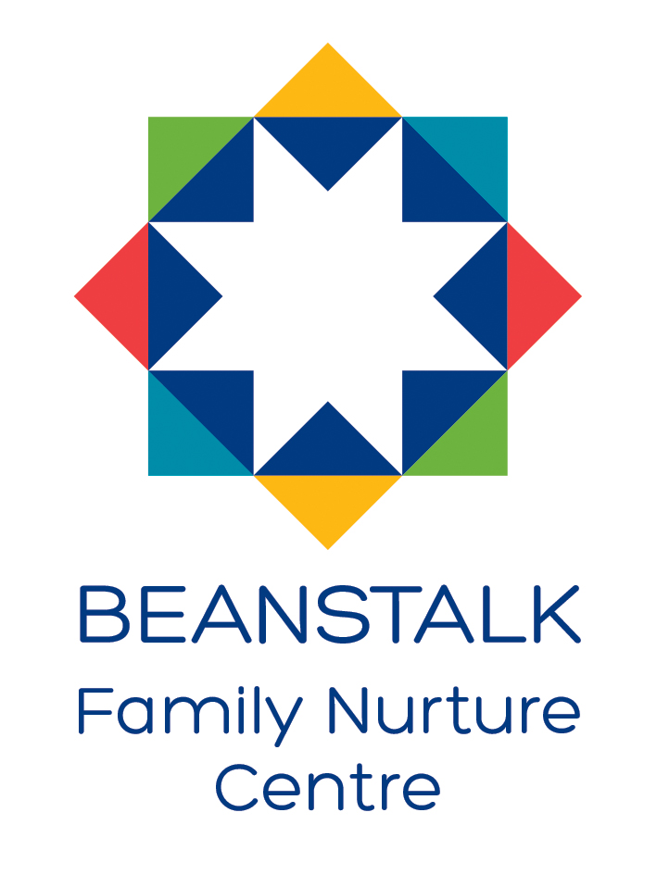

IMPROVEMENT PLAN FOR 2023/24

IMPROVEMENT PLAN PRIORITIES & WORK PLANS
FOCUSED PRIORITY 1 | Promote equality and diversity for all learners
LINKS TO NATIONAL IMPROVEMENT FRAMEWORK:  Teacher & Practitioner Professionalism |  |  | LINKS TO HGIOELC: 1.2, 1.3, 2.4, 2.7, 3.1
Expected Impact | Strategic Actions Planned | Responsibilities |  | Measure of success | Timescales
A.  - All Practitioners encourage and embrace diversity, equity and inclusion ensuring our nursery is a safe, caring, supportive environment for all.  - All Practitioners are confident with the Nurture Centre’s vision, values and Aims and what this look like in practice. | - Staff training about unconscious bias to raise awareness of this.  - Identify and address barriers to participation and learning.  - Analysis of the language and terms used with children by adults.  - Review Nurture Centre Vision, values and aims  - Revisit self -regulation approaches e.g. Solihull, Emotion works, Mindfulness practices, ensuring consistency among the whole staff team.  - Create a “Nurturing Approaches” Staff Handbook. | - Head Teacher  - All staff  - Head Teacher  - Depute Head of Centre  - Principal Teacher  - Early Years Lead Officer  - Principal Teacher  - Equity & Diversity Working Party  - Educational Psychologist |  | - Staff feedback through professional discussion  - Feedback from all stakeholders (Questionnaires etc.)  - Revised Vision, Values and Aims are embedded in practice  - Staff feedback through professional discussion  - Nurturing Approaches Handbook shared with all staff who know approaches to use.  - How Nurturing Is Our School? Toolkit | - August 2023  In-Service Day 1  - August 2023  In-Service Day 1  - Twilight sessions October 2023  - October 2023
B.  - Resources in all playrooms are inclusive, support diversity and are non-discriminatory ensuring all learners and their families feel respected and included. | - Review of all resources to ensure they are diverse, inclusive, non-stereotyping and are promoting all minority groups positively.  - Build up understanding with all practitioners on how to diversify traditional stories, songs & rhymes.  - Review the playroom environments, ensuring the spaces are balance to include calm, sensory spaces making them accessible to all. | - All practitioners  - Depute Head of Centre  - Early Years Lead Officer  - Depute Head of Centre  - Early Years Lead Officer  - All Practitioners |  | - ECERS – E (Gender equality and awareness 14) & (Race equality and awareness 15)  - Leuven’s before and after scores  - Staff feedback through professional discussion  - Staff feedback through professional discussion | - November 2023  - August 2023  - November Twilight sessions 2023
C.  - Sustain a culture of inclusion where all members of our community feel valued, respected and included at Beanstalk FNC  - All staff are aware of the Independent Care Review and feel confident in delivering the Promise. | - Review equality and diversity policy taking onboard all stakeholders views.  - Ensuring Beanstalk’s Family Work Programme is reflective of the needs of the whole community including all minority groups.  - All staff understand the foundations of “The Promise”.  - Care experienced children/families are identified and supported according to their needs. | - Depute Head of Centre  - Early Years Lead Officer  - Senior Early Years Officer Family Worker  - Depute Head of Centre  - All Seniors  - All Practitioners |  | - Stakeholders questionnaires understanding “lived experiences” of our community  - ECERS – 3 (Promoting acceptance of diversity 26) & (Promoting acceptance of diversity 28) & (Provision for children with disabilities 37)  - ITERS -3 (Promoting acceptance of diversity 23)  - Staff feedback through professional discussion  - Stakeholders questionnaires understanding “lived experiences” of our community | - December 2023  - December 2023  - August 2023
Ongoing Evaluation

FOCUSED PRIORITY 2 | Learners will improve their problem solving, creativity and thinking skills through rich opportunities in STEM and Digital Technologies.
LINKS TO NATIONAL IMPROVEMENT FRAMEWORK:  Curriculum & Assessment |  |  | LINKS TO HGIOELC:  1.2, 2.2, 2.3, 3.4, 2.6, 3.2, 3.3
Expected Impact | Strategic Actions Planned | Responsibilities |  | Measure of success | Timescales
A.  - Practitioners will have a clear understanding of what in terms of the curriculum, we need to achieve with STEM to be able to offer richer learning experiences and challenge for learners within the playrooms.  - All learners will have richer learning experiences within the Playrooms & outdoor areas offering challenge and skills progression in STEM supporting them make good developmental progress.  - Learners will show more perseverance, resourcefulness, skills and confidence when tackling a problem or facing a new situation in their STEM learning. | - Carry out a full audit of current STEM & Digital Technology resources over both settings.  - Identify current practice/knowledge & understanding of practitioners and build on areas where there are gaps.  - Staff training in STEM & Digital Technologies and the implementation throughout the learning environment to provide more STEM challenge for learners across the learning environment.  - Peer evaluation of playrooms over the year with a focus on STEM using the ECERS & ITERS documentation | - All Seniors  - Head Teacher  - Principal Teacher  - Depute Head of Centre  - Early Years Central Training from PL Team  - Head Teacher  - Principal Teacher  - All Practitioners |  | - Pre and Post Audits of STEM  - Evidence from ECERS (Art 20) & (Sand & Water 23) & (Nature/Science 25)  - Evidence from ECERS -E (Science & Environment 10-12C) & &  - Evidence from ITERS (Art 16)  &(Nature/Science 20)  - Staff feedback through professional discussion  - Evidence in PLJ, Planning, Learning Walls, Playroom observations  - Staff feedback through professional discussion | - By October 2023  - By October 2023  - November Inset Day 3 – STEM  - November 2023  January 2024  May 2024
B.  - Practitioners will be knowledgeable and skilled in assessing each child’s achievement in Digital technologies and planning appropriate next steps in learning in order to share with parents.  - Learners will be offered more opportunities suited to their individual level and will have richer learning experiences offering challenge and skills progression in Digital Technologies | - Training to revise our Digital Technologies Progression Pathways and embed this in practice.  - Work towards achieving the Bronze Digital Wellbeing Award.  - Develop the learning environment to provide more digital technology learning opportunities within the playrooms. | - Head Teacher  - Early years Lead Officer  - Head Teacher  - Early years Lead Officer  - STEM Working party  - STEM Working party  - Head Teacher  - Principal Teacher  - Depute Head of Centre |  | - Staff feedback through professional discussion  - Achievement of Digital Award  - Evidence from ECERS -E (Use of TV/Video/Computers 27)  - Evidence from ITERS (Appropriate use of Technology 22)  - Keyworker observations of significant learning in PLJ’s | - In-service days Feb 2024 – staff training  - Digital Technology  Twilight training sessions Term 4  - June 2024 – skills progressions completed & implemented & resources being utilised  - By November 2023
C.  - A robust tracking and monitoring system will be in place to assess individual learner’s progress across the curriculum to ensure they are achieving their best outcomes.  - All Practitioners will be more confident when contributing to Learning Consultations for their key groups and planning next steps for individuals leading to more pace and challenge for learners. | - Review our current tracking system ensuring all learner’s individual needs are being met and challenge and pace are the main focus for planning learning.  - Review current learning consultations programme  - Establish peer-moderation of Planning & PLJs across Playrooms/buildings | - Head Teacher  - Principal Teacher  - Depute Head of Centre  - Early Years Lead Officer  - Principal Teacher  - Head Teacher  - All staff  - Principal Teacher  - Depute Head of Centre |  | - Robust tracking spreadsheet evidencing progress over time for all learners  - Evidence of progress in PLJs  - Evidence ECERS 3 (Individualized teaching and learning 29)  - Evidence ECERS-E (Planning for Individual Learning Needs 13)  - Feedback from Peer - moderation of Planning & PLJs across playrooms/buildings | - October 2023  - October 2023  - Twilight training sessions Term 2
Ongoing Evaluation
FOCUSED PRIORITY 3 | Develop Skills for Life and increase opportunities for Learner Participation to enhance thinking and leadership skills.
LINKS TO NATIONAL IMPROVEMENT FRAMEWORK:  Curriculum & Assessment  Parent/Carer Involvement and Engagement |  |  | LINKS TO HGIOELC:  1.2, 2.2,2.3, 2.7, 3.2 & 3.3
Expected Impact | Strategic Actions Planned | Responsibilities |  | Measure of success | Timescales
A.  - Practitioners will value pupil voice in the learning cycle ensuring Learner’s interests are fully developed using appropriate lines of enquiry.  - Practitioners will develop skills in pre-assessment discussions to fully understand what Learner’s already know and build on this appropriately ensuring pace and challenge.  - Learners will be able to articulate their knowledge and what it is they are learning.  - Parents/Carers will be more involved with their child’s learning and understand their role as their child’s primary educator | - Expand on the use of Learner Committees across both settings to harness the views and opinions of Learner’s.  - Review current planning formats to ensure Pupil Voice is prioritised.  - Develop the use of Mind mapping and Learning Walls to ensure all Practitioners are confident in this approach.  - Learners are fully involved in assessment and in setting their own next steps in learning.  - Parents/carers are encouraged to participate in fun shared learning experiences delivered in a variety of ways across the session. | - All Seniors  - Principal Teacher  - Depute Head of Centre  - Head Teacher  - Principal Teacher  - Head Teacher  - Principal Teacher  - Early Years Lead Officer  - Early Years Lead Officer  - All Seniors |  | - Improvement methodology – tracking of learner participation and progress through a number of different enquiries.  - Staff professional discussions reviewing effectiveness of new planning formats.  - Learning Walls and the visible documentation of lines of enquiry – ensuring access for learners of learning across the year to allow revisiting of previous topics.  - Monitoring of PLJ’s  - Learner questionnaires/ involvement in target setting.  - Number of parents/carers participating with shared learning experiences.  - Feedback from parents/carers | - August 2023  - September 2023 Twilight Training Sessions  - September 2023 Twilight Training Sessions  - December 2023  - Ongoing from August 2023
B.  - Practitioners will fully understand the UNCRC and the link to daily practice.  - Learners will be able to apply thinking and leadership skills to further their learning and will be aware of their key rights under UNCRC.  - Learners will be empowered to use their voice as active members of the community and achieve the Rights Respecting School award | - Re-visit the key principles of UNCRC with all Practitioners.  - Practitioners will support Learners through play and discussion to be aware of some of their key rights under UNCRC and support Learners be able to articulate these in simple terms.  - Learners will be fully involved in the four arenas of participation in all aspects of nursery life e.g. Snack routines – taking snack outdoors, more independence at mealtimes, staff recruitment, to include more child’s voice across all learning areas.  - The learning environment both indoors and outdoors will be carefully evaluated to ensure that all Learners are included and supported to ensure equity for all.  - Work towards achieving the Bronze Rights Respecting School award. | - Depute Head of Centre  - All Seniors  - All practitioners  - All Practitioners  - Principal Teacher Early Years Lead Officer  - UNCRC Working party  - Depute head of Centre |  | - Staff professional discussions reviewing the UNCRC principles and how we are implementing these in our service.  - Evidence in PLJ’s and Planning  - Evaluation of participation across the four arenas from practitioners, families and learners.  - Evidence in Beans Talkers Responsive Planning record  - Learning environment evaluation and staff professional dialogue  - Achievement of Bronze Rights Respecting School Award | - Jan 2024 -  Twilight training session  - Ongoing from August 2023  - Ongoing from August 2023  - Starting August 2023
C.  - Practitioners will have a clear understanding of the value of enterprise opportunities for Learners. They will inspire enterprising entrepreneurial learning across the curriculum and deliver this consistently.  - Learners will gain an understanding of the world of work and the role they can play in society.  - Learners will progress in their knowledge and skills in financial education to gain skills for life, learning and work. | - Practitioner’s trained in supporting skills to Develop the Young Workforce and understand the value of Learner participation in enterprising opportunities.  - Practitioner’s involved in the creation of a Beanstalk Enterprising Framework to ensure a clear progressive pathway for learners.  - Create more enterprising opportunities within the learning environment ensuring that learner’s voice remains central to the process.  - Learners will be responsible for planning and implementing real events within nursery to allow them to develop a variety of skills including an understanding of finances. | - Early Years Lead Officer  - Enterprise Working party  - All Seniors  - All practitioners  itioners |  | - Staff professional discussions about what developing the young workforce looks like in nursery.  - Creation of Enterprising Framework linked to DYW skills for Beanstalk FNC to support long term planning  - Evidence of enterprise activities in PLJ’s and Planning  - Evidence in PLJ’s, Planning and Learning Walls  - Evidence in Beans Talkers Responsive Planning record | - Jan 2024 Twilight training session  - June 2024  - June 2024
Ongoing Evaluation

