Other Curricular Areas
Expressive Arts
Social studies
Science
Technologies
Religious Moral education

Information for Parents

Working Together to Achieve More


Expressive Arts
“The inspiration and power of the arts play a vital role in enabling our children and young people to enhance their creative talent and develop their artistic skills.”
Expressive Arts: Principles and Practice

Learning in, through and about the expressive arts enables children and young people to:
- be creative and express themselves in different ways
- experience enjoyment and contribute to other people’s enjoyment through creative and expressive performance and presentation
- develop important skills, both those specific to the expressive arts and those which are transferable
- develop and appreciation of aesthetic and cultural values, identities and ideas and, for some, prepare for advance learning and future careers by building foundations for excellence in the expressive arts.

Children will learn about the expressive arts through experiences in:
- art and design
- dance
- drama
- music

What are the features of effective learning and teaching in the expressive arts?
- investigate and use a variety of media and techniques such as painting, drawing, printing and modelling with fabrics, clay and other materials
- express thoughts, feelings in pictures, paintings and models
- use role play or puppets to recreate and invent situations
- use verbal and non-verbal language in role play
- listen and respond to sounds, rhythms, songs and a variety of music
- make music by singing, clapping and playing percussion instruments
- use instruments by themselves and in groups to invent music that expresses their thoughts and feelings
- move rhythmically and expressively to music
- participate in simple dances and singing games

At Nursery we aim to develop your child expressively and aesthetically by providing a variety of different resources and play activities.

Imaginative Role Play
Dough

Clay and
Dough

Painting

Junk
Modelling
Explore a beat
Dressing
Up
Movement and Dance

Puppet
Theatre
Songs and
Rhymes

Playing
Instruments

There are many ways in which you can support your child’s expressive and aesthetic development.

- provide shoes and hats for dressing up

- make musical instruments from junk materials
- homemade play dough
(ask nursery staff for the recipe)

- listening to a wide range of music

- singing and dancing

- collect materials for collage

- printing with objects from around the house

- act out favourite stories and rhymes

Social Studies
“Through social studies, children and young people develop their understanding of the world by learning about other people and their values, in different times, places and circumstances; they also develop their understanding of their environment and of how it has been shaped.… With greater understanding comes the opportunity and ability to influence events by exercising informed and responsible citizenship.”
Social Studies Principles and Practice

Learning in, through and about the social studies enables children and young people to:
- Develop their understanding of the history, heritage and culture of Scotland, and an appreciation of their local and national heritage within the world
- Broaden their understanding of the world by learning about human activities and achievements in the past and present
- Develop their understanding of their own values, beliefs and cultures and those of others
- Develop an understanding of the principles of democracy and citizenship through experience of critical and independent thinking
- Explore and evaluate different types of sources and evidence
- Learn how to locate, explore and link periods, people and events in time and place
- Learn how to locate, explore and link features and places locally and further afield
- Engage in activities which encourage enterprising attitudes
- Develop an understanding of concepts that encourage enterprise and influence business
- Establish firm foundations for lifelong learning and for further specialised study and careers.

The social studies experiences and outcomes have been structured under the three main organisers:
- people, past events and societies
- people, place and environment
- people in society, economy and business.

What are the features of effective learning and teaching in the Social Studies?
- active learning which provides opportunities to observe, explore, experiment and play
- use of relevant contexts and experiences familiar to children and young people
- appropriate and effective use of technology
- building on the principles of Assessment is for Learning both collaborative and independent learning
- discussion and informed debate
- interdisciplinary learning experiences
- learning outdoors, field trips, visits and input by external contributors.
Children and young people as they learn within the social studies will develop a range of skills including:
Observing, describing, recording

Comparing
Exploring and evaluating

Curiosity and problem solving
Critical thinking and analysing
Using maps

There are many ways in which you can support your child’s development in Social studies.
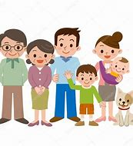
- Talk about the past with older generations

- Label what you are seeing when you are out walking e.g. hill, river, road, railway
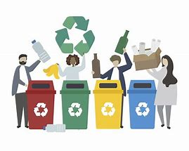
- Explore recycling - what goes in what bin?

- Discuss the weather and how it feels and what to wear

- Talk about what you can buy as you visits different shops e.g. groceries, shoes, clothes etc
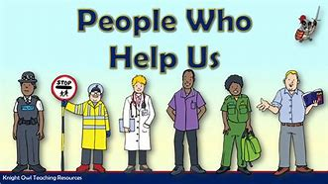
- Point out people working e.g. binmen, ambulance, police etc

Science
“Through learning in the sciences, children and young people develop their interest in, and understanding of, the living, material and physical world. They engage in a wide range of collaborative investigative tasks, which allows them to develop important skills to become creative, inventive and enterprising adults in a world where the skills and knowledge of the sciences are needed across all sectors of the economy!
Science Principles and Practice

Learning in, through and about Science enables children and young people to:
- develop a curiosity and understanding of their environment and their place in the living, material and physical world
- demonstrate a secure knowledge and understanding of the big ideas and concepts of the sciences
- develop skills for learning, life and work
- develop skills of scientific inquiry and investigation using practical techniques
- develop skills in the accurate use of scientific language, formulae and equations
- recognise the role of creativity and inventiveness in the development of the sciences
- apply safety measures and take necessary actions to control risk and hazards
- recognise the impact the sciences make on their lives, the lives of others, the environment and on society
- develop an understanding of the Earth’s resources and the need for responsible use of them
- express opinions and make decisions on social, moral, ethical, economic and environmental issues
- based upon sound understanding
- develop as scientifically literate citizens with a lifelong interest in the sciences
- establish the foundation for more advanced learning and, for some, future careers in the sciences and the technologies.

The Science experiences and outcomes have been structured under the five main organisers:
- Planet Earth
- Forces, electricity and waves
- Biological systems
- Materials
- Topical science
What are the features of effective learning and teaching in the Science?
- active learning and planned, purposeful play
- development of problem-solving skills and analytical thinking skills
- development of scientific practical investigation and inquiry
- use of relevant contexts, familiar to young people’s experiences
- appropriate and effective use of technology, real materials and living things
- building on the principles of Assessment is for Learning
- collaborative learning and independent thinking
- emphasis on children explaining their understanding of concepts, informed discussion and communication.
Children and young people as they learn within the science will develop a range of skills including:
Ask questions
Plan & Design
carry out experiments
Observe and collect evidence
Record evidence
Report findings

There are many ways in which you can support your child’s development in science.
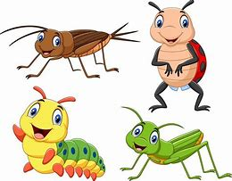
- Talk about animals with anyone that has an animal they care for.
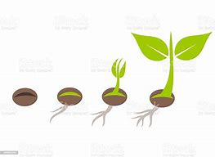
- Grow things together to explore how plants grow from seed.
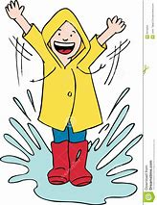
- Explore weather changes when going to nursery e.g. puddles, frost, ice etc

- Use your senses when eating, smell something, hear noises or see something new and talk about likes and dislikes

- When out and about explore different sensory material e.g. sticks, leaves etc
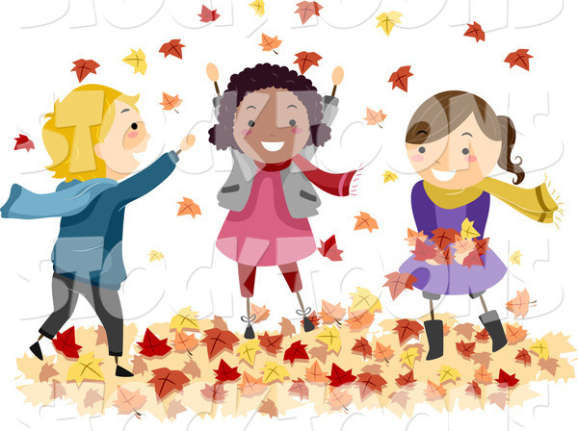

Technologies
The technologies framework offers challenging activities which involve research, problem solving, exploration of new and unfamiliar concepts, skills and materials, and the rewarding learning which often results from creating products which have real applications. It provides progression in cognitive skills. Children and young people will develop their creativity and entrepreneurial skills and be encouraged to become innovative and critical designers of the future. These attributes are essential if, in the future, our children and young people are to play a major part in the global economy and embrace technological developments in the 21st century.
Technologies Principles and Practice

Learning in, through and about technology enables children and young people to:

- develop understanding of the role and impact of technologies in changing and influencing societies
- contribute to building a better world by taking responsible ethical actions to improve their lives, the lives of others and the environment
- gain the skills and confidence to embrace and use technologies now and in the future, at home, at work and in the wider community
- become informed consumers and producers who have an appreciation of the merits and impacts of products and services
- be capable of making reasoned choices relating to the environment, to sustainable development and to ethical, economic and cultural issues
- broaden their understanding of the role that information and communications technology (ICT) has in Scotland and in the global community
- broaden their understanding of the applications and concepts behind technological thinking, including the nature of engineering and the links between the technologies and the sciences
- experience work-related learning, establish firm foundations for lifelong learning and, for some, for specialised study and a diverse range of careers.

The Technology experiences and outcomes have been structured under the five main organisers:

- Digital Liteacy
- Food and textile Technology
- Technological Developments in society and business
- Craft, design, engineering and graphics.
- computing science

What are the features of effective learning and teaching in the Technology?
- curiosity and problem-solving skills, a capacity to work with others and take initiative
- planning and organisational skills in a range of contexts
- creativity and innovation, for example though ICT and computer aided design and manufacturing approaches
- skills in using tools, equipment, software and materials
- skills in collaborating, leading and interacting with others
- critical thinking through exploration and discovery within a range of learning contexts
- discussion and debate
- searching and retrieving information to inform thinking within diverse learning contexts
- making connections between specialist skills developed within learning and skills for work
- evaluating products, systems and services
- presentation skills.

Children and young people as they learn within the Technology will develop a range of skills including:

In a range of digital technologies
Curiosity and problem solving

Food techniques e.g. mixing, spreading
Design and construction
Recycling

Engineering

There are many ways in which you can support your child’s development in technology.

- Explore digital technology together using safe digital options

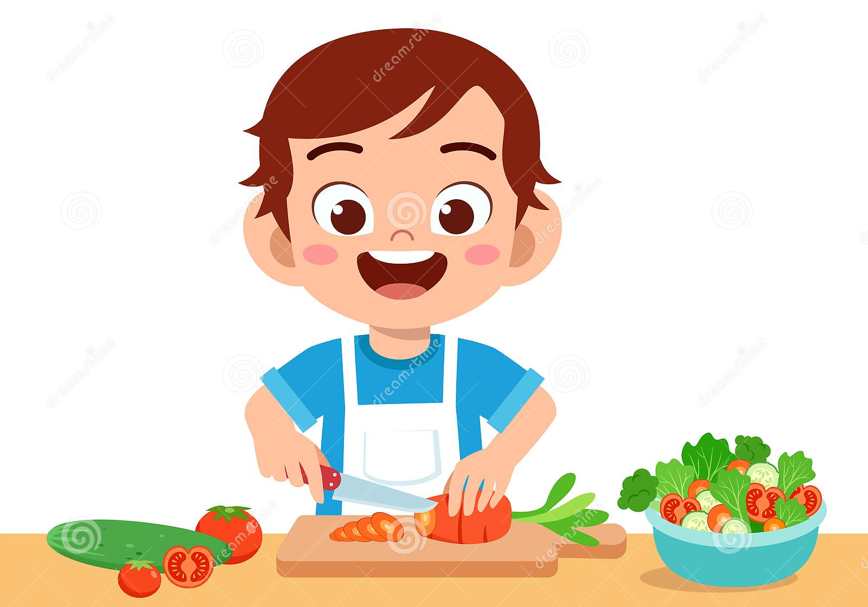
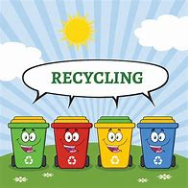
- Explore with food preparation together safely e.g. mixing dough, slicing vegetables/fruit,

- Ask your child to join you when recycling the rubbish

- Offer you child materials both natural and manmade to create pictures and models.

Religious and Moral Education
Religious and moral education enables children and young people to explore the world’s major religions and views which are independent of religious belief and to consider the challenges posed by these beliefs and values. It supports them in developing and reflecting upon their values and their capacity for moral
judgement. Through developing awareness and appreciation of the value of each individual in a diverse society, religious and moral education engenders responsible attitudes to other people. This awareness and appreciation will assist in counteracting prejudice and intolerance as children and young people consider issues such as sectarianism and discrimination more broadly.
Religious and Moral Education Principles and Practice

Learning in, through and about religious and moral education enables children and young people to:
• recognise religion as an important expression of human experience
• learn about and from the beliefs, values, practices and traditions of Christianity and the world
religions selected for study, other traditions, and viewpoints independent of religious belief
• explore and develop knowledge and understanding of religions, recognising the place of Christianity in the Scottish context
• investigate and understand the responses which religious and non-religious views can offer to questions about the nature and meaning of life
• recognise and understand religious diversity and the importance of religion in society
• develop respect for others and an understanding of beliefs and practices which are different from their own
• explore and establish values such as wisdom, justice, compassion and integrity and engage in the development of and reflection upon their own moral values
• develop their beliefs, attitudes, values and practices through reflection, discovery and critical evaluation
• develop the skills of reflection, discernment, critical thinking and deciding how to act when making moral decisions
• make a positive difference to the world by putting their beliefs and values into action
• establish a firm foundation for lifelong learning, further learning and adult life

The Religious and Moral Education experiences and outcomes have been structured under the three main organisers:

- Christianity
- World Religions selected for study
- Development of beliefs and values

What are the features of effective learning and teaching in the Religious and Moral Education?
- sensitively take account of and value the religious and cultural diversity within their own local communities, using relevant contexts which are familiar to young people
- actively encourage children and young people to participate in service to others
- develop, through knowledge and understanding and discussion and active debate, an ability to understand other people’s beliefs
- draw upon a variety of approaches including active learning and planned, purposeful play
- encourage the development of enquiry and critical thinking skills
- create opportunities for the development of problem -solving skills
- build in time for personal reflection and encourage discussion in depth and debate
- provide opportunities for collaborative and independent learning
- take account of the faith background, circumstances and developmental stage of the children and young people and their capacity to engage with complex ideas
- recognise and build on the considerable scope for connections between themes and learning in religious and moral education and other areas of the curriculum
- make appropriate and imaginative use of technology
Children and young people as they learn within will Religious and Moral Education develop a range of skills including:
Respect for others
Fairness
Understanding traditions

There are many ways in which you can support your child’s development in Religious and Moral Education.

- Talk about traditions that are important to celebrate in your family’s life.
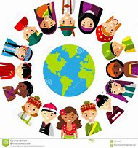
- When topic arise talk about other people’s cultures and beliefs


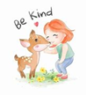
- Talk about what is fair and unfair.

- Talk about kindness, being caring and sharing.

