Child Protection & Safeguarding

Information for Parents/Carers


“Child Protection is everyone’s job and everyone’s responsibility”



All children and young people in Fife have a right to be cared for and protected. We all have a part to play to ensure that children are safe, and their needs are met.

Here in Fife, we believe that
“child protection is everyone’s job and everyone’s responsibility”.

The protection of children within our nursery and local community is paramount and is the responsibility of us all.

All children in Scotland have the right to be protected from abuse or neglect.

At Beanstalk Family Nurture Centre we work hard to ensure that effective child protection procedures are in place wherever there is a likelihood or risk of a child coming to significant harm.

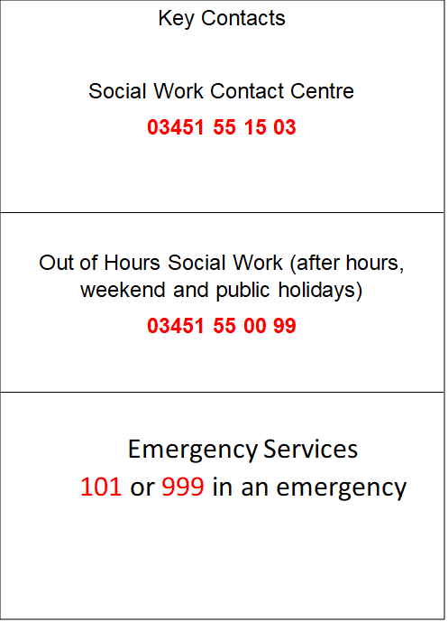
The Child Protection Co-Ordinators for our centre:

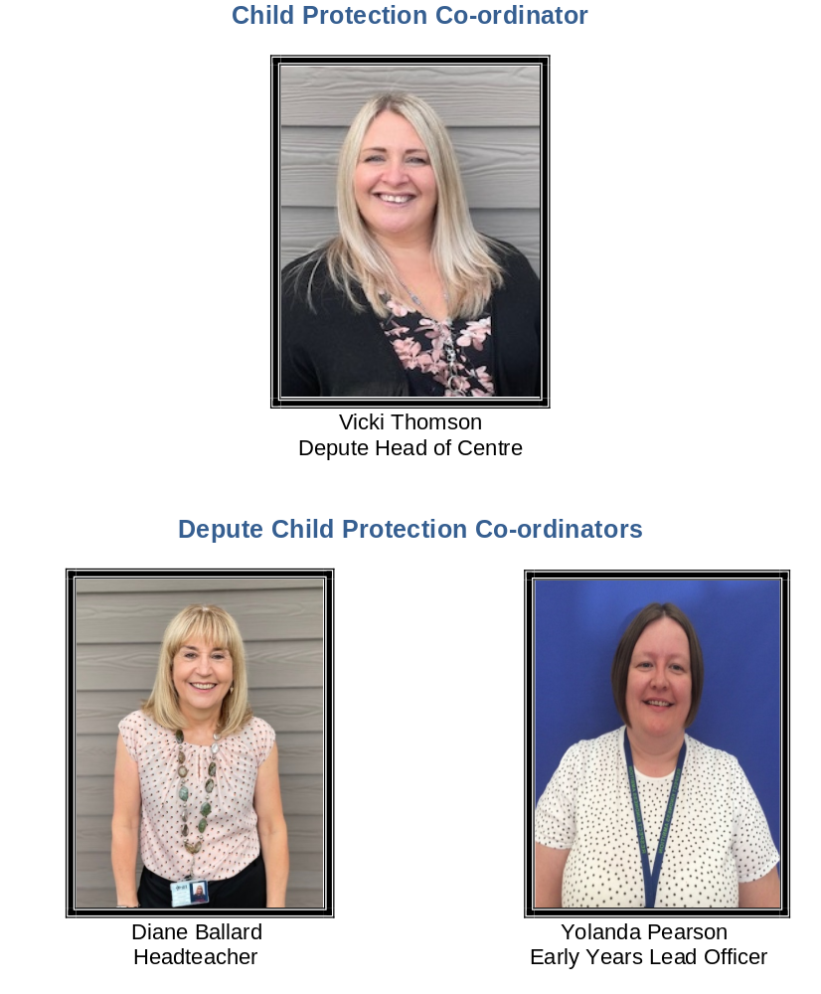
Worried about a child?
If you see behaviour that is of concern, or if a child or young person tells you something worrying, you need to do something about it and speak to someone.
You can speak to a teacher, health visitor, social worker or police officer.
However, if you think a child has been harmed, telephone the Social Work Contact Centre on 03451 55 15 03, from Monday to Friday, 9am to 5pm.
Out-with these hours, please call them on 03451 55 00 99.

You can call the police on telephone number 101, 24/7.

If you consider a child(ren) or young person to be in immediate danger,
do not wait, call the Police on 999
CHILD PROTECTION & SAFEGUARDING PROCEDURES

At all times we keep the child’s best interests at the centre of any required actions or planning, and in almost all cases liaise closely with family.

Staff know to alert the Child Protection Coordinator in the school immediately should they have a Child Protection Concern.

When the Child Protection Coordinators are made aware of a concern we do the following in most instances.

- Talk to the child. This is our first step if it is appropriate. It can be difficult or inappropriate with such young children. If it is appropriate, the discussion is conducted sensitively to the child, making it clear that any information they share is confidential unless they or someone they know may be in danger.

We take the child’s views into consideration in planning next steps and include them in any subsequent planning to keep them safe.

If we have to share information with other agencies we will discuss this with the young person wherever possible.

The child is offered a quiet, safe environment if they are upset for as long as needed.

- Contact the child’s family. In almost all situations we include the child’s family early in order to support the child so long as they are not part of the concern.

- Consider action & update appropriate agencies. Your child’s health visitor is their named person until they go to school. Therefore, we would contact them to inform them of any concerns or situations. We look at appropriate supports for the child and their family. This is done in conjunction with the child and family.

Any safety planning will include the young person’s opinions and is monitored closely.

- Record the concern. We record the concern securely including the action we take and any monitoring required. The record is kept securely with access limited to the Child Protection Coordinator(s), the Head Teacher and the young person’s named person if different.

- Plan and monitor over time. The Child Protection Coordinator will keep in close contact with the child and their family and manage any supports they require over time.

The Child Protection Coordinator will in almost all instances stay in close contact with the child’s family and plan jointly with them to identify supports.

- In the event of a young person being in immediate danger, we contact the Public Protection Unit to liaise with Police and Social Work.
Parents/carers are always contacted unless doing so may put the young person at greater risk.

NURSERY ETHOS
Beanstalk Family Nurture Centre endeavours to create a positive ethos, which encourages caring, both for children and between children.


Our Health and Wellbeing programme aims to allow children to explore and develop positive attitudes, self-esteem, respect and acceptable behaviour. Through sensitive interactions and daily activities children are encouraged to talk about their worries, safety, health and wellbeing and concerns.
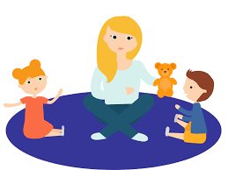

Children can also approach an adult, where appropriate, to discuss any issues which may be sensitive or confidential.

