Term 2 – Primary 2/3 Home Learning Grid
ICT - GLOW  Log into GLOW and access our P2/3 Teams page. Find our class targets and homework grid and give it a thumbs up. Choose a different task to do each week.   | Art – line drawing  This term we will explore the visual element of line. We will look at how the artist Paul Klee uses line in his artworks.  Create your own artwork using only lines.  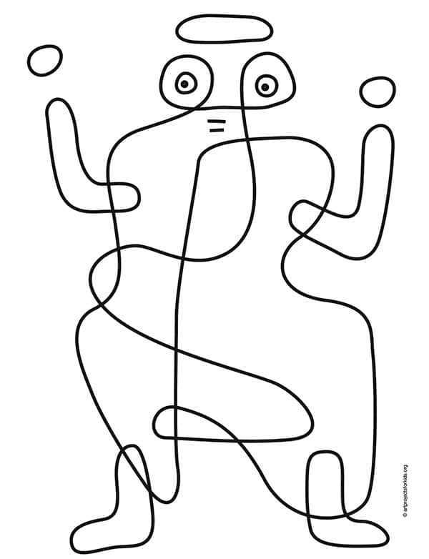 | Topic – Travel and Transport  Make a poster showing different types of transport. Draw a picture and write the word to describe the transport.  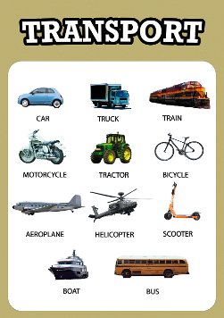
Literacy/HWB – We are all different  Write down a list of things that you are good at or things you find easy.  Write another list of the things you find tricky. These are the things that you find more challenging and will need more practice with. | Numeracy – Doubles and halves  Choose 5 numbers and then double them.  For example:  3 + 3 4 + 4 8 + 8 12 + 12 18 + 18  Challenge:  Double 25 37 90 130 you choose a few | Literary/Topic – Research  Choose one mode of transport and find out some facts about it. You could search the internet, read a book or ask an adult for facts. Your facts could be: what it is called, what it is used for, how it works, when it was invented or the important people involved with it.
Literacy – Reading homework  We read with our group every Tuesday and Thursday. Please make sure you do your reading homework every week. | Numeracy - Fractions  Make a fraction wall to show how a shape can be split into equal parts in different ways.  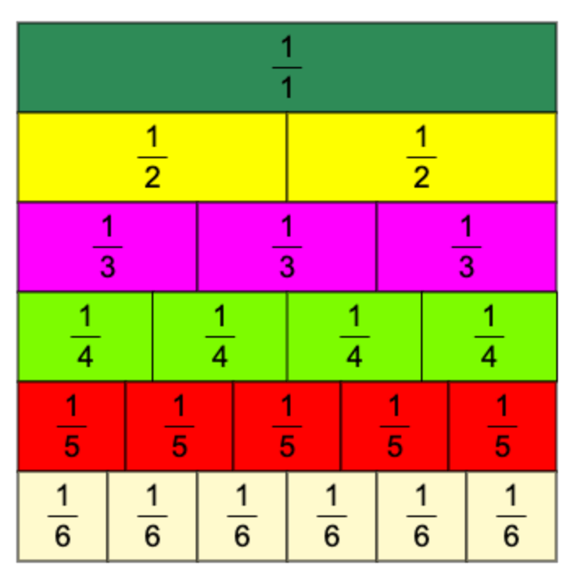 | Numeracy – Fractions  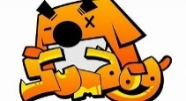  Please log in to Sumdog to complete your personal fractions challenge.

