Term 2 – Primary 6/7 Home Learning Grid
HWB – Regulating Emotions.  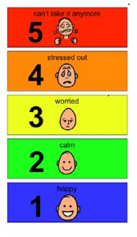  Create a 5-point scale regarding your emotions and ways to deal with these at home. | Art – Design.  Create a picture focusing on a different river in the world. Label the parts of the river using our keywords. E.g. source, floodplain, tributary and ox bow lake. | Topic – Oceans  Create a quiz about the different oceans in the world. Include information and questions we can all learn from. Create 10 questions and be prepared to share these in class.
Literacy – Report Writing  Write a climate report about a region of your choice in the world. Include information about the temperature, climate, place and region. | Numeracy – Money.  Create a budget plan for a Christmas shop for a family of 6. Detail price of food and what meals you are planning with the food you budget for. | Topic – Natural Disasters  Focus on a natural disaster and create a poster about it. E.g. Tsunami, earthquake or volcano.  Include facts and pictures.
Literacy – Reading/Writing  Choose a book that you have read at home and write a book review.  Include information about the author, book title, context of the book, any facts or interesting information and what you liked/disliked. | HWB - Football  Design a football activity we can try out in class.  Add detail about where we will try this activity (outside or inside), equipment needed and any rules. | Numeracy – Division.  Create a division board game to play in class.  Include rules, counters and characters.

