Primary 5/6 Topic Homework Grid – Term 2 – Human Body

Research and Presentation  Task: Research and create an informative fact file or a poster about the body organ or body system of your choice.  Skills: Research skills, summarizing information, public speaking, and use of digital tools.  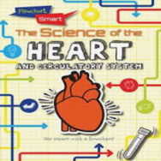 | Record keeping  Task: Keep a record of how long you are watching TV/playing computer games and how long you spend playing/moving about outdoors each day for a week. Then do the following:  - Work out the total watching time for the week.  - Work out the total active time for the week  Compare the two results. What have you found out? | Health and Wellbeing  Task: Explain the importance of keeping fit and create a leaflet or a poster encouraging children to exercise every day.  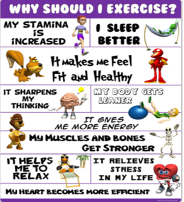  Skills: Research and information gathering, HWB awareness, creativity and design, audience awareness | Literacy  Choose a book that you have recently read and complete one or more of the following tasks:  - Make a WANTED poster for the villain in your story. Include a physical description and a reward for information as well as your contact details.  Skills: descriptive writing, attention to detail, audience awareness  - Find 10 Wow Words and use  them to make a crossword on squared paper  Skills: learning new vocabulary, word selection, creativity and layout  Draw a poster to advertise the book you have read. Make sure you write on the poster why people should read it.  Skills: creativity, visual presentation, audience awareness, persuasion
Symmetrical Art Creation  Task: Create your own symmetrical artwork. You could fold a piece of paper in half, paint on one side, and fold it to transfer the paint onto the other side, creating a symmetrical design.  Challenge! Try drawing a detailed image on one half and carefully mirror it on the other. | Design and Technology  Task: Design a fun game that would help young learners explore different body parts through play.   | Numeracy  - Please log in to Sumdog to complete your personal maths challenge.  - Spend a few minutes each day practicing your times tables and see how fast you can get!  - Play ‘Hit the Button’ or any other times tables games. Ask an adult to test you.  Skills: memory and recall, pattern recognition, focus, concentration

