Balmerino and Wormit Primary Schools Teacher PRD Process

PRD Meeting Checklist
Before the meeting:
- Arrange a date for your PRD meeting.
- If it is your PU year, go into the PU area on My GTCS and request association with me.
- Reflect upon your professional learning since your last PRD meeting – focus on what the impact has been more than on what activities you have done.
- Update your professional learning log on My GTCS by adding new entries:
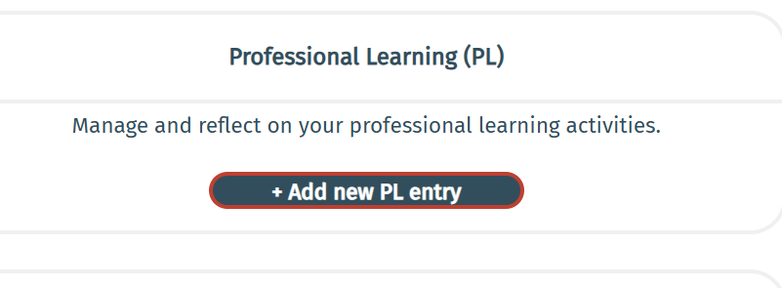

You do not need to log each individual activity you have done – just the significant/impactful learning. I suggest making one entry for each area of development and recording the impact of your learning. This keeps your log linked to your PRD meetings. This log is for your reflection. You do not need to share it with me.
- Carry out a self evaluation of yourself, your skills and your practice against the relevant standard. For teachers early in their career – use the standard for full registration. For those with more experience, use the Standard for career life long learning. You do not need to share your reflection against the standard with me but you do need to be able to talk to it at your meeting.
- Using that information you have gathered, prepare an agenda to talk through at your meetings. In the course of the meeting, I will coach you to answer these questions:
  - Impact of recent Professional Learning (since last PRD)
  - Reflection against the GTCS standard – which standard did you use, what strengths did you identify, what development areas.
  - Areas for Professional Learning moving forward
  - How do you see your career developing in the next 5 Years
  - How are you managing your Work Life Balance?
I have attached a proforma which you can use to prepare your agenda – you can use a different format if you prefer.
- Send your agenda to me via email two days before the PRD meeting. Print a copy to bring to the meetings to talk through.

At the meeting:
- You will talk through your agenda and we will plan your areas for development together.

After the meeting:
- Go back into MyGTCS, record your meeting by adding a new PRD Record.
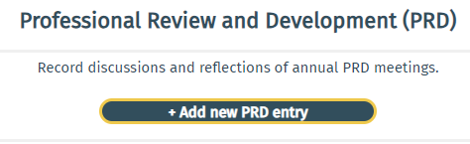

I suggest you upload your agenda to the PRD entry as a record of the meeting and to avoid extra workload.
- Then add your newly identified areas for development:
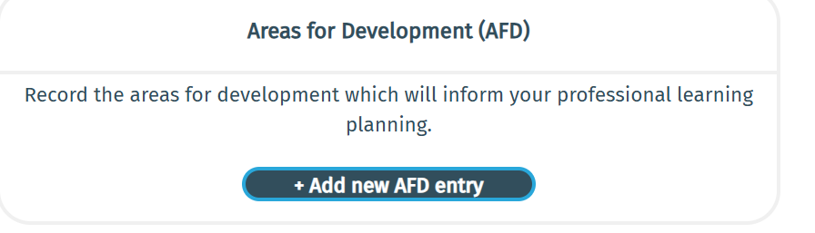
- If it is your PU year, go into the PU section of MyGTCS and submit your PU.

The red sections above, are only done in your PU year. The rest of the sections should be done every year.

