Balmerino Nursery
Handbook

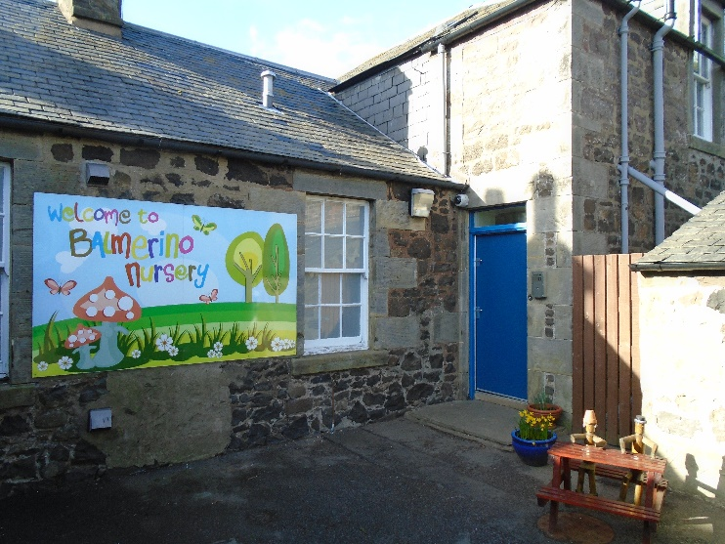

Information for Parents and Carers

Updated: January 2024

General Information

School Name: Balmerino Primary School

Address: Main Road
Gauldry
Fife
DD6 8RP

Telephone Number: 01334 659450

Email Address: balmerinops.enquiries@fife.gov.uk

Nursery Session Times
Nursery hours are 9am - 3pm. Children may arrive from 9am.

Drop off: From 9am a member of staff will be at the Nursery Gate to welcome your child. We will ask you to sign your child in and make a note of who will be picking them up. Your child will then be supported as they wash their hands and leave their belongings in the cloakroom before they play. Unless you have signed up for Stay and Play, we ask that you say goodbye to your child at the door to promote independence and because space is limited inside.

Pick Up: All children must be picked up by 3pm. Children should be picked up at our Nursery door. Please press the buzzer and wait for a member of staff. Staff will see you on our internal screen and will support your child as they get ready to leave. They will then bring them to the door and pass them into your care. We will release your child into the care of any person you have named as a parent or emergency contact. If someone different will be picking up, please let us know at drop-off time or call the school office.

Cloakrooms
Our cloakroom space is very small and so we don’t invite parents to accompany their child into this area. During Covid, when we weren’t allowed to invite parents in at all, we learnt that our children can manage themselves very independently and that drop off and picks are calmer without too many people in a small space.

Stay and Play
We encourage all parents to sign up for Stay and Play sessions. On your stay and play day, you can come into the playroom with your child at 9am and join their play and learning for the first half hour. Please sign up for Stay and Play in advance – this is just to stop the play room getting too busy.

The Nursery Staff and People You May Meet
Mrs Lucy Jess is the Head Teacher at Balmerino and therefore, has overall responsibility for the nursery. Mr Jamie Rose is our Principal Teacher and he works with staff and families in Nursery as needed.

Mrs Angela Kelly, Mrs Natasha McGregor and Mrs Lapeyre are our Early Years Officers. They will work in partnership with you to support your child’s learning. Each child will be allocated a key worker and they will be responsible for maintaining your child’s Personal Learning Journal (PLJ). Mrs Lapeyre will go on maternity leave in February 2024 and we will keep you up to date with staffing changes as a result. Miss Lucy Mathers is our visiting Nursery Teacher who supports the Early Years Officers in delivering the curriculum to offer quality experiences for the children and their families.

We also liaise with other education and health professionals to ensure the very best in learning and health and wellbeing for your child.
- Early Years Development Team
- Health Visitor
- Educational Psychologist
- Speech and Language Therapist
- Paediatrician
- School Nurse

The Curriculum in Nursery
In Balmerino Nursery we follow Curriculum for Excellence (CfE). The nursery staff will plan a curriculum to support your child’s development. Your child will learn through stimulating experiences based around learning through play in the core areas of:

- Literacy
- Maths and Numeracy
- Health and Wellbeing

In addition to these areas, children will learn about:

- Expressive Arts
- Religious and Moral Education
- Science
- Social Subjects
- Technologies

Your child’s interests will be investigated and they will take responsibility for planning some of their own learning. Individual learning may be taken forward in Floor books or more general interests on a Learning Wall. We will let you know on our weekly Sharing My Learning emails what the current interest is, so please share this interest with your child.

Personal Learning Journals (PLJs)
Every child in nursery will have a folder called their Personal Learning Journal. Your child’s keyworker will be responsible for recording your child’s achievements within the PLJ and will include photos and observations to show the learning and progression.

Each term you will be informed of your child’s Next Steps. This shows what your child is working on in nursery at that time. Staff discuss their next steps with your child so that they are always aware of their progress and what they are working on next. We normally have two Parent Chats over the nursery year to keep you informed of your child’s progress. We will inform you in due course when these meetings will be.

You will be asked to complete All About Me and Home Learning sheets with your child before they start which will be included in their folder.

Nursery Aims and Ethos
We aim to create a happy, friendly and safe environment where everyone feels valued and is encouraged to be the best that they can be. We consistently look for ways of involving children to take responsibility for their learning by setting personal next steps and evaluating their own progress.

Medication
Please discuss with staff any medical needs your child has. If prescribed medication is required to be kept on the premises for your child, a form must be completed first. Staff cannot give any medication without this consent so please ensure that this is done before leaving your child.

Emergency contact
In case, for any reason, we have to contact you, please make sure that the school has all your up-to-date contact details and any instructions necessary.

Snack
In Balmerino Nursery we promote healthy eating by providing the children with a choice of healthy snacks. If your child suffers from any specific allergies or dietary needs then please make staff aware prior to your child starting Nursery. We are a nut free school/nursery.

We encourage independence in Nursery and children help plan and choose their snack. We are also part of the Childsmile programme and the children brush teeth once a day in Nursery. If you have any concerns about your child’s dental health or toothbrushing, please speak to their keyworker who can offer advice or sign post you to someone else who can help.

Nursery Contribution
As part of our fundraising, we ask for a small contribution towards Nursery Fund of £1.75 a week. We will request this termly and are are appreciative that families contribute if they can. Examples of what we buy with Nursery Fund are snacks, cooking ingredients and materials to make playdoh or bird cakes. Nursery Fund helps us to enhance the children’s experiences.

Lunch
We serve a lunch everyday in nursery and we encourage all parents to have their child take this meal – it is free and eating the same as peers often encourages your child to try new things. Nursery lunch is chosen and prepared following nutritional advice and you can be confident your child is having a balanced meal. If you do decide to send a packed lunch, we encourage you to follow the same principles we do. Please try to include:
- some fruit or vegetables
- something dairy or dairy equivalent (e.g. cheese or yoghurt)
- something carbohydrate (bread, pasta, rice, potato)
- something protein (meat, fish, beans, lentils)
We don’t regularly serve the following foods and ask that you avoid them in the lunchbox:
- jam and chocolate spread
- chocolates and sweets
- crisps and other salty snacks
To safe guard against choking, we avoid serving the following types of food and ask that you avoid them in the lunchbox particularly if your child has not yet turned 4 and is not used to eating them:
- slippery foods like mango and hot dogs
- very hard foods like raw carrots
- popcorn
Please cut grapes and cherry tomatoes into halves and slice fruit and vegetables rather then cutting into chunks. Please remove the stones from stoned fruits.

Clothing
We ask that all children have a change of shoes for Nursery for reasons of cleanliness and safety. Pull-on gym shoes or trainers with Velcro fastenings are best. We also ask that you provide a pair of wellies to be left in Nursery as we offer outdoor daily play in all weathers. Your child will require either an all-in-one suit or waterproof jacket and trousers for outdoor play and forest visits. These should be left in nursery, or brought in your child’s bag, so that they can be used daily. Please remember to clearly mark all shoes/clothing with your child’s name.

Please provide a spare set of clothes, pants, socks, t-shirt etc, in case of any accidents as children often feel happier with their own clothes if they have to change.

Please do not dress your child in their best clothes! A child who is worried about getting dirty will not be able to make the most of their nursery experience.

Outdoor Learning
Our outdoor garden area is open in all weathers and the children may choose to go out at any time over their session. The children have opportunities to develop skills in the outdoors through a range of activities. We have a mud kitchen, sand pit and a playhouse for imaginative play. There are opportunities for investigation and discovery as children find mini beasts and grow plants. Our children plant and harvest seasonal vegetables for their snack.

Forest Kindergarten
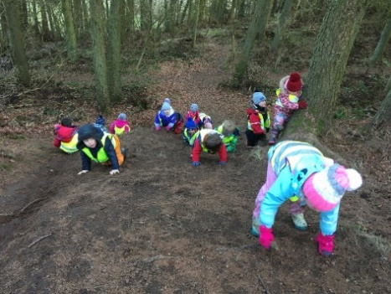
Forest visits are great opportunities for children to develop skills and awareness of their local environment. We normally visit the forest on a weekly basis over the seasons which allows the children to see the changes in the environment. During the forest visits the children have opportunities to develop their physical skills, problem solving, investigating, working co-operatively and becoming risk aware.

For these outings the children should come dressed in warm, waterproof clothes and wellies or stout boots/shoes. A hat and gloves are also beneficial especially in the cooler weather. You will be informed by the nursery staff of the dates and times of these outings.

In the summer term, we make use of Balmerino Beach and need to ask parents for support with transport if they can. You will get information about this in good time.

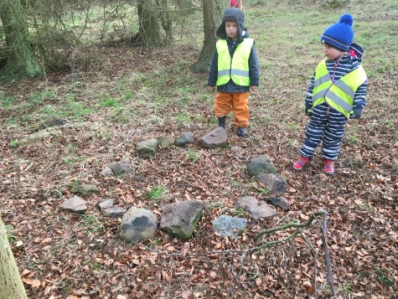
We recommend you check your child regularly for ticks as occasionally, a child can pick one up. More information is available here.
If your child should have a tick at Nursery, we would contact you to come and remove it or seek treatment.
We used to advise you check your child for ticks in the summer months but now that milder winters make the tick season longer, we recommend you are careful all year round.

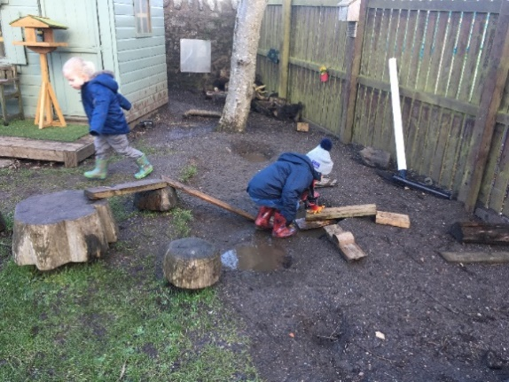
Loose Parts
Children at Balmerino Nursery learn through play and part of that includes the use of loose parts – both inside and in the outdoor area. Loose parts are open ended materials of all sizes and varieties that can be used in a creative and imaginative way. They promote problem-solving, co-operation, communication and negotiation skills.
In Nursery we provide an array of loose parts for use in play such as stones, shells, pine cones, twigs, wood, crates, boxes, logs, ropes, tyres, guttering, etc. Loose parts create a rich environment for learning.

Family Learning Opportunities
At Bookbug you can come along and share stories, songs and rhymes with your child. Younger siblings are also welcome to attend. Our PEEP sessions invite you to come along with your child to informal sessions to explore lots of learning opportunities.

Sun Awareness
Children will have access to outdoors throughout their session. Between March and October, it is therefore important that your child is sent to Nursery in the morning with sun cream applied. Please inform the member of staff at drop off if your child has sun cream applied. A bottle of Tesco Soleil Kids Sun Protect Spray – Factor 50 (dermatologically tested) will be available in Nursery for top ups throughout the day. If this is the first time your child has used this product we ask that you apply it to your child. If your child has an allergy to this sun product, then please make sure you inform staff and provide their own sun cream in a ziplocked bag and clearly named. This must be handed to a member of staff and not kept in their bag. It will be labelled and kept in a safe place. Staff will then use this on your child to top up, if required.
Please be sun aware and make sure your child is protected. A sun hat is advisable and cool long sleeved shirt/t-shirt.

Communication
Every week you can read our Share Our Learning sheet which will let you know what we have been up to in Nursery and our possible lines of developments for the week to come. Please take time to read this and share it with your child. This will be posted on Seesaw and also be emailed to you directly so please make sure the school has your correct email address. Seesaw is a digital platform we use to communicate with you and for sharing learning through the week. You will receive day to day information about the running of the nursery via email as needed and you will be copied into the school weekly information which often has nursery news in it and which keeps you up to date with the school as a whole.

Attendance
Regular attendance at Nursery, while not mandatory, is strongly recommended. Children respond well to a regular routine and the transition to P1 is made easier if they are used to coming to nursery every day. Absences should be notified by phoning the school.

If your child is ill, you should follow the most up-to-date Public Health advice:
- Children with mild symptoms such as a runny nose, sore throat, or slight cough – but who are otherwise well – do not need to stay at home and can continue to attend nursery. They should stay at home if they are unwell and have a high temperature. They can come back to school and nursery, and resume normal activities when they no longer have a fever and they feel well enough to attend.
- Children with a tummy bug should stay home for 48 hours after the last instance of vomiting or diarrhoea.
- Children with chicken pox should stay off until all spots are crusted over (usually about 5 days)
- In the case of other contagious illnesses, parents can seek advice from Mrs Jess at lucy.jess@fife.gov.uk or discuss with their GP.

If your child is poorly at nursery and they are not well enough to complete their session, we will phone and ask you to come and collect them. If we can’t reach the first named parent, we will call the second named and the emergency contacts until we are able to reach one of you. We would do this if your child has the symptoms of a temperature, are tired or lethargic, complain of being generally unwell, are sick or have diarrhoea or have an unexplained rash.

Child Protection
All staff have been trained in Child Protection issues and legislation and we are obliged by law, under the Children’s Act, to report suspicions of physical, mental or emotional abuse to the officers of the Child Protection Unit. Nursery staff liaise with Mrs Jess, who is the school’s designated Child Protection Co-ordinator. Mr Jamie Rose is the Deputy Co-ordinator, and who can provide advice and information in cases of concern.

Involvement with other agencies
We will contact you if we notice your child is experiencing difficulties and feel that help from the Speech and Language Therapist, Educational Psychologist, School Learning Support Service or Occupational Therapist might be appropriate. Similarly, you can discuss any concerns with your child’s key worker. We always discuss issues with parents and seek consent before going to another agency. The only exception to this is if a child is at risk of immediate harm without the intervention of another agency.

Care Inspectorate
The Nursery is subject to inspection by officials from Care Inspectorate, with whom concerns may be raised by contacting them by letter, e-mail or in person at:
Compass House, 11 Riverside Drive, Dundee, DD1 4NY
Telephone: 0345 600 9527
E-mail: enquiries@careinspectorate.gov.scot

Concerns
If your child seems unhappy or appears to have a problem in Nursery, please bring this to the attention of staff as soon as possible, preferably his/her identified key worker.
Changes in routine at home might affect behaviour and should also be brought to our notice and similarly, we will tell you of any difficulties we observe.

Finally, your child’s happiness and security is our main concern and we hope that his/her time at Balmerino Nursery proves to be an extremely happy experience.

Holidays and Inset Days
Our Nursery is closed to pupils on Fife School Holidays and Inset Days. Details are available on the school website.

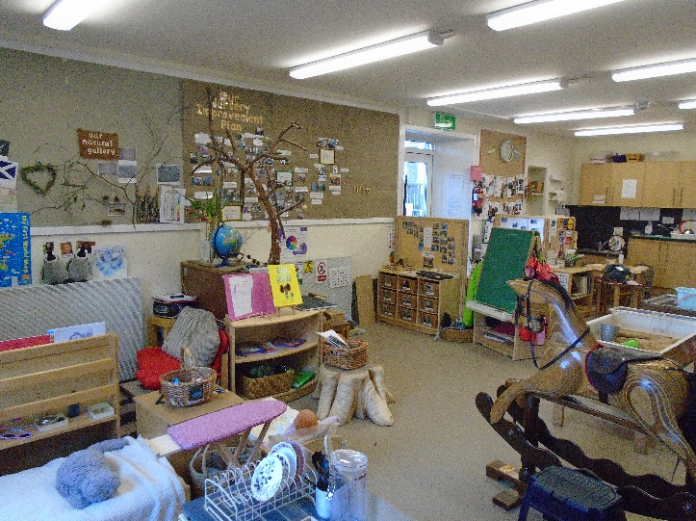

Child centred curriculum in a stimulating environment

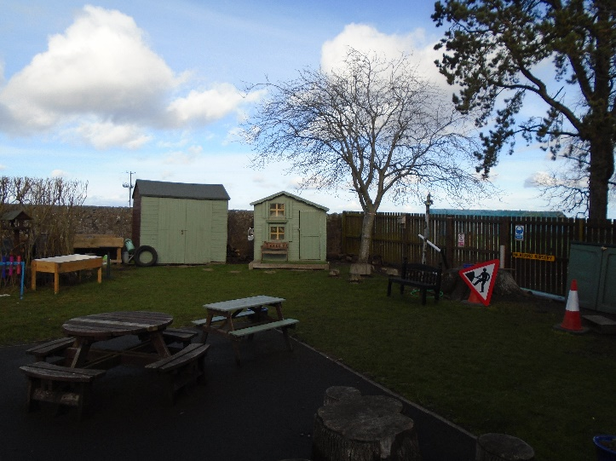

Our Nursery garden for daily outdoor learning experiences

