Balcurvie Primary
Positive Relationships, Positive Behaviour

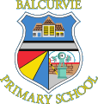

Positive Relationships, Behaviour, Equality, Inclusion and Anti-Bullying Policy
2025-2026

Policy Statement
Balcurvie is a non-denominational school serving the community of Windygates and beyond. Our values: Be Caring, Be Resilient, Work Hard and Work as a Team underpin our policy. This policy aims to promote healthy, positive relationships, inclusion and create a learning environment where everyone feels cared for, valued, supported, safe, engaged and encouraged by everyone to be the best version of themselves.

This policy was created by staff, learners and parents. It underpins our school vision and values, whilst promoting inclusion for all through the principles of Getting it Right for Every Child. It embodies the principles of tolerance and compassion towards others with an overarching aim to challenge bullying in any form.
Working together, we will consider the appropriate strategy to support our learners to make positive behaviour choices through the following categories:
- Equality and Inclusion
- Positive Relationships
- Resilience
- Self-Regulation
- De-escalation
- PATHS (Promoting Alternative Thinking Strategies)
- Restorative Approaches
- Anti-Bullying Policy and Practice.
Equality and Inclusion for All
Everyone in the Balcurvie community aims to protect, nurture, respect and include the needs of every child, through the principles of GIRFEC, and the Wellbeing Indicators, to ensure children are:
- Safe
- Healthy
- Achieving
- Nurtured
- Active
- Respected
- Responsible
- Included
Every child will be treated fairly and with compassion. Under the Equalities Act 2010, we endeavour to eliminate discrimination, promote equality of opportunity and support our learners to be tolerant and kind towards one another. Everyone in the Balcurvie community has a legislative duty to every child and family, not to discriminate on the following grounds:
- Age
- Sex
- Race
- Marriage and Civil Partnerships
- Pregnancy and Maternity
- Gender Reassignment
- Disability
- Sexual Orientation
- Religion or Belief
Equality/ Inclusion at Balcurvie
- Balcurvie is a Silver Rights Respecting School. All children are treated equally and fairly in accordance with the UN Charter for the Rights of the Child
- All staff are respectful, supportive and open to the nine protected characteristics of every child
- Children are encouraged to be open about their own thoughts, beliefs and preferences. We will challenge and support them to respect difference and show kindness towards differences
- Staff are expected to ensure that all children are treated equally and that no-one is discriminated against by any member of the school community in relation to the nine protected characteristics
- Staff will work in partnership with parents to nurture their child’s physical and emotional growth
- Staff will plan for and implement learning appropriate to each child’s social, emotional and academic needs.
- We welcome feedback from our community to uphold the principles of healthy, positive relationships

Positive Relationships
At Balcurvie, we believe that positive, respectful relationships are the bedrock of everything we do. Effective learning and teaching are underpinned by positive relationships.
Positive Relationships at Balcurvie
- Staff take time particularly at the start of the academic year, to get to know the children well
- All pupils have a trusted adult whom they feel safe to talk to
- Pupils are praised and awarded for demonstrating our school values Be Caring, Be Resilient, Work Hard, Work as a Team
- Staff model positive relationships and our values
- Mutual respect is evident between all staff and pupils
- Everyone is expected to accept and celebrate differences
- Staff are expected to demonstrate fairness and compassion in their interactions with children
- Staff are expected to build positive relationships with parents
- Pupils are encouraged and supported to build positive relationships with each other

Resilience
As a school we encourage all our young people to reflect on their choices. Staff model and teach positive and effective coping strategies so that children have a toolkit to support them in any challenging or new situations.

How do we promote resilient attitudes at Balcurvie?
Children are encouraged to:
- Take measured risks
- Have a growth mind-set and learn from mistakes
- Have self-belief that they can achieve
- Take and reflect on praise and feedback to improve
- Recognise what stress looks and feels like, that it is normal and have a range of strategies to cope
- Persevere in times of challenge

Self-regulation

Staff will model and teach self-regulation and emotional literacy. Pupils who are experiencing stress or anxiety resulting in a lack of self-regulation will be supported to develop coping strategies.

How do we support our learners to regulate their behaviour at Balcurvie?

Children are supported to self-regulate when faced with a challenge using:
- A three/five-point scale,
- symbolised fix-it folders in every classroom to facilitate independent restoration following conflict
- symbolised, emotional prompts
- restorative scripts used with adults and peers
- calm corners within classrooms and the school
- supported emotional kit-bag sessions
- social stories

De-escalation
Staff take time to get to know pupils and will try to defuse situations before they escalate, using strategies suitable for the child.
How do we de-escalate at Balcurvie?
- Triggers are identified
- Early intervention strategies are used to support pupils and prevent or limit dysregulated behaviour
- Where appropriate, we create a plan to support pupils in managing their responses. This is called a Pro-active Management Protocol
- Situations that occur are reviewed when the pupil is calm enough to do so
- 3/5-Point Scales are bespoke to a child’s physiological response to challenge. De-escalation strategies consider what works best for individual learners

To support this, all children have:

- access to a calm area within the class or outside for a short period of time
- support to talk through challenges, using a restorative approach
- access to a wide variety of calming and sensory resources in each class
- visual prompts and strategies available within classrooms
- time to regulate, relate and repair

Teaching Approaches
When children are calm and ready to talk, staff at Balcurvie use a restorative framework to support children to reflect when things go wrong:
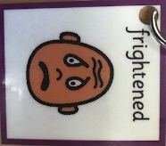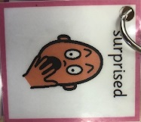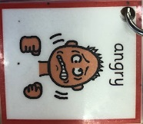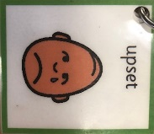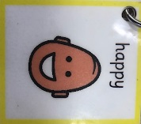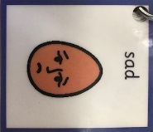
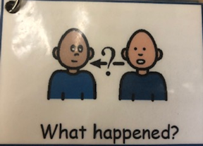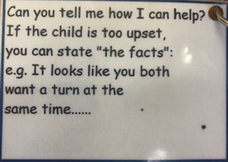
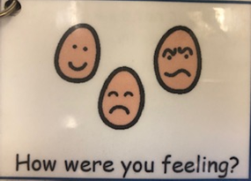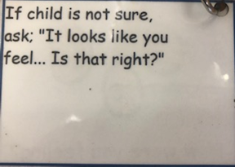
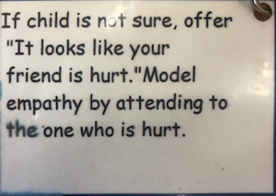
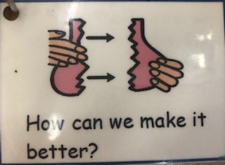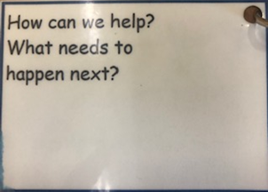
We also support our learners to become independent conflict resolvers through this framework which we use in a Fix-it folder.
Whole School Emotional Literacy Programme
We use the PATHS programme, starting in our Nursery, right through to P7
What is PATHS?
Promoting Alternative Thinking Strategies (PATHS) is our principal resource for teaching emotional literacy. PATHS is a model of Social and Emotional Learning which aims to:
• Recognise and manage emotions
• Develop care and concern for others
• Establish positive relationships
• Make responsible decisions
• Handle challenging situations effectively

PATHS enables children to:
• Increase self-control
• Enhance self-esteem and self-confidence
• Improve communication about emotions and feelings
• Improve understanding of how one’s behaviour affects others
• Enhance motivation and creativity
• Improve logical reasoning
• Improve problem solving skills
• Increase respect for others
Expectations of our school community
We expect everyone to:
• look after themselves
• look after each other
• look after our things
• look after the place that we're in
This will help us to:
• feel healthy, happy, and able to learn
• feel cared for, safe and respected
• feel responsible & show gratitude
• create a place where we can learn
Nurturing Relationships
Relationships | Purposeful, respectful relationships are modelled and developed.
Staff Approach | A consistent staff approach promoting positive behaviour, using positive and restorative language.
Curriculum | Social and emotional aspects of the curriculum are visible and differentiation takes account of needs.
School Organisation | Vision and values are evident in school organisation and robust systems, policies and procedures are in place.
Partnership Working | Other agencies and professionals are engaged in partnership working. Parents are engaged in the life of the school.
Physical Environment | A safe and secure physical environment provides a variety of sensory experiences and quiet spaces in classrooms.
Parents’ Approach | To model and promote positive behaviour and relationships when communicating with others.
Positive School Ethos
Our school community has agreed vision and values. We aspire to achieving potential through Learning, Positive Relationships and Wellbeing. Children are encouraged to make good choices in class, school and the playground. Our restorative approach centres round a positive school ethos where pupils are encouraged and supported to be ready to learn, safe at school and show respect to others.
Strategies to promote a positive school ethos include:
- clan system
- positive rewards
- good news phone calls
- child/pupil of the day postcards
- star writers
- success celebrated in our daily bulletin and at assemblies
- certificates for exemplifying school values and meta-skills
- class reward systems
- celebrating achievement using Seesaw and in-school Balcurvie Blether
- Independent learning
- School newsletter
- Extra-curricular and sports opportunities

From time to time, things can be tricky for your child. All children will experience challenges. Our job is to support them to navigate this. This sometimes happens at an additional level or staged approach to supporting your child. The following statement and infographic outline how we achieve this.

When we don’t manage to meet the expectations, we will:
• focus on repairing relationships and returning to learning as soon as possible
• take responsibility for ourselves, for our actions and for making things right
• accept that we may need help from someone else to do this (peer, adult or parent)
• accept that there may be consequences (beyond a restorative conversation) however these will always be specific to the situation and the individual needs of everyone involved

Anti-Bullying
“Bullying is both behaviour and impact; the impact is on a person’s capacity to feel
in control of themselves. This is what we term as their sense of ‘agency’. Bullying
takes place in the context of relationships; it is behaviour that can make people feel
hurt, threatened, frightened and left out. This behaviour happens face to face and
online.”
Respectme, 2015

Closely linked with the Fife Council and the Children’s Services Directorate’s own anti-bullying policy, we are completely opposed to bullying of any form, and all stakeholders have a duty to identify, report and act upon any instances which may occur. Fife Council’s policy, and therefore this policy also, defines bullying as:
“Behaviour, which may or may not be deliberate, by one person or a group,
which upsets, hurts, harms or injures another, impacting directly on their quality of life. Bullying may take many forms, including verbal, physical and social behaviour, and increasingly it may involve the use of technology, such as mobile phones or
computers. It is likely to be associated with a power difference between those who bully and those who are bullied, to lead to hurt, fear and anxiety, and is often the result of a difference, perceived or real.”
Fife Council Anti-Bullying Policy (2018)
At Balcurvie we may encounter bullying behaviours that involve:
- Name calling, teasing or making fun of someone
- Any form of physical violence
- Having belongings taken, vandalised or damaged
- Being ignored, left out, or isolated
- Having rumours spread about someone, in person or online
- Being humiliated in front of others
- Receiving abusive messages by phone, text or online
- Being targeted because of someone’s personal characteristics

How do we ensure our learners are safeguarded against bullying at Balcurvie?
- Staff and pupils are aware of the distinction between conflict resolution and bullying
- Staff are trained on anti-bullying policy and have a duty to report any incidences formally, using Fife Council guidance and protocol.
- Staff will communicate with all stakeholders involved, including parents and victims of bullying
- Staff communicate concerns to the leadership team who have a legal duty to record any instances of bullying into the SEEMIS bullying and equalities app
- Pupils feel listened to and respected when reporting issues related to bullying; they know their concerns will be taken seriously
- Pupils understand that bullying is unacceptable and that there are strict consequences for any bullying behaviour
A culture that encourages respect, values opinions, celebrates difference and promotes positive relationships will make it difficult for bullying behaviour to flourish or be tolerated.

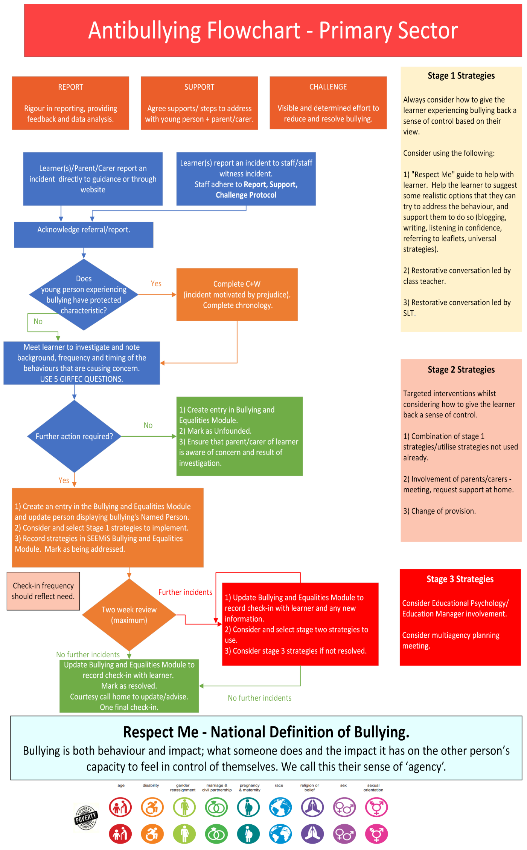
R20

The Charter can be viewed at https://downloads.unicef.org.uk/wp-content/uploads/2019/10/UNCRC_summary-1_1.pdf?_ga=2.226710104.431360749.1585659174-285810119.1525983424

