

|  |
| --- |
|  |

**Safeguarding and Child Protection – Induction Booklet and Checklist**

# Safeguarding and Child Protection Induction for New Staff

# Introduction

The purpose of this safeguarding and child protection induction booklet is to support you in your role at Balcurvie Primary School. It will help you to know what your role and responsibilities are and what to do if you have any concerns about a child or young person.

This booklet should be read in conjunction with your school’s Child Protection, Safeguarding and Wellbeing Policy as well as familiarising yourself with Fife’s Inter-Agency Child Protection Guidance 2016 <https://www.fife.gov.uk/__data/assets/pdf_file/0030/194970/CPC-Inter-Agency-Guidance-Final-Master-27.09.16.pdf>

and National Guidance for Child Protection in Scotland, Scottish Government, 2014

[National guidance for child protection in Scotland 2014 - gov.scot (www.gov.scot)](https://www.gov.scot/publications/national-guidance-child-protection-scotland/)

and

National Guidance for Child Protection in Scotland: protecting disabled children from abuse and neglect 2014

[National guidance for child protection in Scotland: protecting disabled children from abuse and neglect - gov.scot (www.gov.scot)](https://www.gov.scot/publications/national-guidance-child-protection-scotland-2014-additional-notes-practitioners-protecting-disabled-children-abuse-neglect/)

[Child Protection Guidance 2021 (theapsgroup.scot)](https://scotgov.theapsgroup.scot/national-guidance-for-child-protection-in-scotland/)

Completion of this booklet does not replace Child Protection training but will help to support you to carry out your role and responsibilities in safeguarding and child protection effectively until either your school is due to be refreshed and updated in Child Protection Awareness Raising and Response Training or you are able to attend the same session at another Fife education establishment.

All staff working within Fife Council schools and nurseries are required to undertake Child Protection Awareness Raising and Response Training every three years. In addition to this, the awareness of all staff working in Fife Council’s schools and nurseries is refreshed on a biannual basis at the start of and midway through each academic year by a senior member of staff from within the school, normally the Head Teacher or the Child Protection Co-ordinator. (These biannual updates will also include a refresher on Prevent (Raising awareness of children and young people who may be vulnerable to being radicalised).

Further information can be found on Fife’s Child Protection Committee Website [Child Protection | Fife Council.](https://www.fife.gov.uk/kb/docs/articles/health-and-social-care2/help-for-young-people/child-protection) Further information on PREVENT can be found on the Scottish government website - Revised Prevent duty guidance: for Scotland - GOV.UK ([www.gov.uk](http://www.gov.uk))

If at any time you are not sure what to do or feel anxious when dealing with any safeguarding and/or child protection issue, remember you can speak to your Child Protection Co-ordinator/Depute who are:

|  |  |
| --- | --- |
| Name | Tracey McDougall |
| School(s) | Balcurvie Primary School |

**Responsibility of All**

All staff who work and/or come into contact with children and young people, whether permanent, temporary, or voluntary play a crucial role in the support and protection of children as well as in the development of their wellbeing. No single professional can have a

full picture of a child’s needs and circumstances. If children and families are to receive the right help at the right time, everyone who comes into contact with them has a role to play in identifying concerns, sharing information, and taking prompt action.

It is your responsibility to ensure you are familiar with and adhere to the [Fife Council Code of Conduct](https://fifecloud.sharepoint.com/sites/HROnlineHub/Shared%20Documents/Forms/AllItems.aspx?id=%2Fsites%2FHROnlineHub%2FShared%20Documents%2FCC01%20Code%20of%20Conduct%20Policy%20February%202021%2Epdf&parent=%2Fsites%2FHROnlineHub%2FShared%20Documents) and [Fife Council Social Media Guidelines](https://fifecloud.sharepoint.com/sites/HROnlineHub/Shared%20Documents/Forms/AllItems.aspx?id=%2Fsites%2FHROnlineHub%2FShared%20Documents%2FCC14%20Social%20Media%20Guidelines%20July%202021%2Epdf&parent=%2Fsites%2FHROnlineHub%2FShared%20Documents).

Staff working in a school/nursery are often viewed by children and young people as a trusted source of help and support, they are often the first to be aware that families may be experiencing difficulties and are also well placed to observe matters that may indicate a wellbeing or child protection concern. It is therefore essential that all staff understand the responsibilities they have for protecting children and promoting, supporting, and safeguarding their wellbeing.

**All** staff should recognise that they have a duty to:

* **recognise, respond, record and report (the four ‘R’s)**.
* be fully conversant with the Schools/Nursery’s Child Protection, Safeguarding and Wellbeing Policy and Fife’s Interagency Child Protection Guidance.
* undertake Child Protection Awareness Raising and Response Training every 3 years.
* attend biannual update and refresher sessions on Child Protection, Safeguarding and Prevent.
* contribute to the creation of a physically and emotionally safe school/nursery centre environment.
* know how to respond to any safeguarding, wellbeing and/or Child Protection concerns.
* know who the Child Protection Co-ordinator within the school/nursery is and report any safeguarding, wellbeing and/or child protection concerns to them without delay.
* In the absence of the Child Protection Co-ordinator, the staff member with concerns will not delay and will pass their concerns to the recognised depute for child protection within their school/nursery.
* Where the Child Protection Co-ordinator or recognised depute is not available, staff must (without delay) refer their concern themselves to one of the **core agencies** **(Social Work, Police or Health – Contact numbers at end of booklet)**.
* If concerns continue, despite the reassurances of the Child Protection Co-ordinator or another more senior member of staff, a direct referral to one of the core agencies should be made by the member of staff.

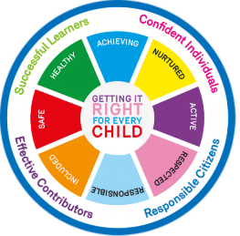

**Responding to Concerns**

Wellbeing / Child Protection concerns may arise in the following circumstances:

* a member of staff has concerns arising from observation of the child’s behaviour or appearance or comments the child has made.
* a child tells a member of staff they have been abused or feel unsafe.
* a third party expresses concerns to a member of staff: this could be another pupil, a parent or carer or member of the public.
* an anonymous allegation is received.

It is also possible that a school’s/nursery’s co-operation might be sought in relation to a child protection investigation which has been initiated outside the school/nursery.

**A Member of Staff has Concerns or a Child Makes a Disclosure**

The suspicions of a staff member may be aroused by the presence of indicators of concern or by a feeling, based on knowledge of the child, that all is not well, or by a mixture of factors. It may be appropriate for a member of staff to ask a child about how an obvious injury was sustained, or why the child appears upset or distressed using open-ended non-

leading questions. Any questions asked should be for clarification purposes and to encourage the child to say what he or she wants in order to establish the basic facts for example:

|  |  |  |  |
| --- | --- | --- | --- |
| **What happened?** | **Where did it happen?** | **When did it happen?** | **Who did it?** |

If the child does not respond, the matter should not be pursued further, and advice should be sought. The testing of evidence is not a matter for school/nursery staff and such an approach by staff could prejudice later investigations.

The role of school/nursery staff is to **recognise, respond, report and record:**

* **Recognise** when the child’s behaviour and demeanour is a cause for concern and **respond.**
* **Report** their concerns immediately to the Child Protection Co-ordinator/Depute.
* **Record** in detail what they have seen and heard, and when they did so, using the child’s own words where possible, and include any other relevant information such as the child’s body language, emotional state, observation of any physical marks on the body etc. **A distinction should always be made between facts, hearsay, and opinion.**

**When Responding to Concerns: REMEMBER**

|  |  |
| --- | --- |
| **DO** | **DON’T** |
| **Stay calm**  **Listen carefully and be supportive**  **Tell the child what you will do next**  **Inform the Child Protection Co-ordinator of your concerns immediately**  **Record in writing what was said.**  **Seek support for yourself**  **Ask open questions**  **Wite it down as the child says it don’t change the wording**  **\*In the event of a disclosure remember that the child or young person trusted you enough to disclose to you\*** | **Dismiss what the child is telling you**  **Ask any leading questions, interrogate the child, put ideas into the child’s head or jump to conclusions**  **Stop or interrupt a child who is recalling significant events**  **Promise the child confidentiality but give assurance that information will be shared only with people who need to know and can help**  **Express an opinion about the alleged perpetrator of the abuse**  **Tell the child everything will be ‘OK’**  **Delay passing it on** |

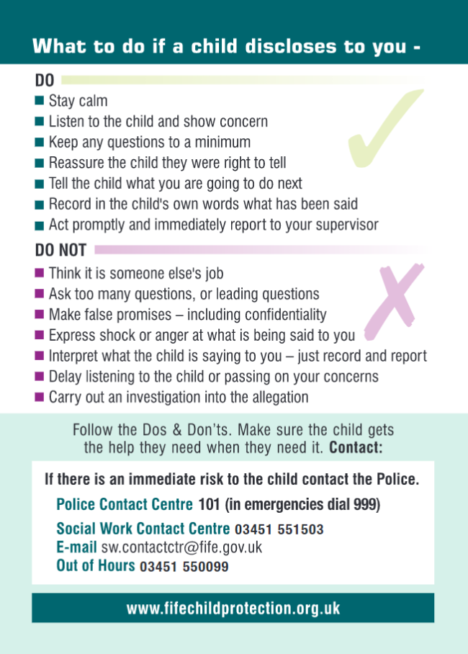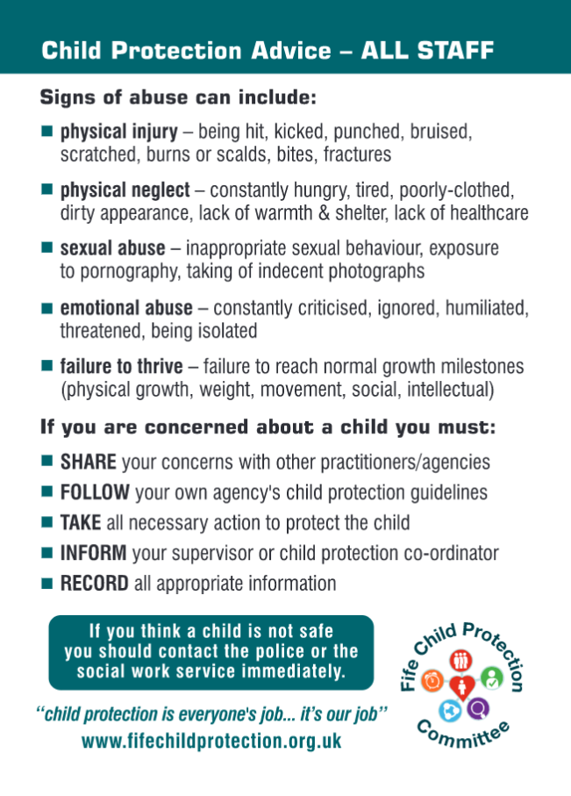

**A Third-Party Expresses Concern**

Research suggests that some adults see schools/nurseries as a preferred contact point if they have concerns about the wellbeing or safety of a child either in the school/nursery their child attends or at another school/nursery. Parents in conflict may also share concerns

about their partner with school/nursery staff. As a result, school/nursery staff may find themselves receiving external information that indicates possible wellbeing and/or child protection concerns. In these circumstances it is important that, as with children disclosing, no guarantee of confidentiality is provided, staff listen carefully and sympathetically, and the matter is treated seriously.

As with a direct approach, a member of staff to whom a third party expresses concern should:

* **Recognise** that a concern is being raised and **respond** to the person expressing the concern.
* **Report** the matter to the Child Protection Co-ordinator.
* **Record** in detail what they have seen and heard and when they did. Actual words used should be quoted where possible. Record the behaviour and demeanour of the person expressing the concerns, where this is done in person.

Where the concerns are expressed by another pupil, it should be remembered that reporting suspicions of concern may be traumatic for that child and appropriate support should be provided.

**Schools/Nurseries Receive an Anonymous Allegation**

Staff in receipt of anonymous allegations about a concern for a child, whether that child is a pupil in the school/nursery or not, should:

* **Record** in writing the words used, so far as possible, where the allegation is by telephone, or retain the paper, where it is in writing.
* **Report** the matter to the Child Protection Co-ordinator.

**Information Sharing and Recording: Wellbeing and /or Child Protection Concerns**

Sharing appropriate information is an essential component of safeguarding and protecting children from harm. To secure the best outcomes for children, staff need to understand when it is appropriate to seek or share information, how much information to share and what to do with that information. Staff also need to consider from and with who, information can, and should, be sought and/or shared. This applies not only between different agencies, but also within schools/nurseries. At the same time, children and their families have a right to know when information about them is being shared. Where possible, their consent should be sought, unless doing so would increase the risk to a child or others or prejudice any current or subsequent investigation.

**Information-sharing for Wellbeing Concerns and Child Protection: General Principles**

1. The wellbeing of a child is of central importance when making decisions to share information with or about them.
2. If you have concerns about a child's wellbeing, or a child is considered to be at risk of significant harm, relevant information **must** always be shared.
3. The reasons why information needs to be shared and particular actions taken should be communicated openly and honestly with children and, where appropriate, their families.
4. At all times, information shared should be relevant, necessary, and proportionate to the circumstances of the child, and limited to those who need to know.
5. When information is shared, a record should be made of when it was shared, with whom, for what purpose, in what form and whether it was disclosed with or without informed consent. Similarly, any decision not to share information should state the rational for why this decision was taken.

Where agencies are acting in fulfilment of their statutory duties, it is not necessary or appropriate to seek consent – for example, where a referral is made to the Children’s Reporter under the Children's Hearing (Scotland) Act 2011, the consent of a child and/or parents/carers does not need to be sought prior to the submission of a report or where there is an allegation or indication that a child is at risk of significant harm, consent is not required to share concerns with one of the core agencies. Under Data Protection law it is perfectly acceptable and lawful to share such information and under these circumstances consent is not required. **There is an important distinction between making the child aware that information will/may be shared and seeking their consent for that sharing.**

**Managing Allegations or Concerning Information about Staff**

**Allegations or Complaints of Abuse against Staff – Where the Information Suggests Possible Abuse or Harm towards a Child**

All staff and volunteers should understand what to do if they receive an allegation against them or an allegation is made to them concerning the behaviour of another member of staff, volunteer, or visitor. **All allegations must be treated seriously, and the response must be prompt.**

Any information, suggestion, allegation, or complaint against a member of staff (including visitors and volunteers) about possible child abuse must be taken seriously. Allegations may be made against members of staff/volunteers currently involved with children but may also be made against staff/volunteers who are no longer part of the service. In all circumstances, the matter must be taken seriously and promptly acted upon.

All allegations against staff, volunteers or visitors must be dealt with transparently, but with considerable sensitivity to the management of information.

**The Code of Conduct - staff (Fife) and Whistleblowing Policy for employees state that, if you have any concerns about staff behaviour where a criminal offence or potential abuse may have taken place, you should immediately alert your line manager who must advise you about the action they take in response to your concerns. In instances where you do not wish to discuss your concerns with your line manager you should alert your Head Teacher/Education Manager or Chief Officer within Education.**

**Don’t think “What if I’m wrong?” think “What if I’m right?”**

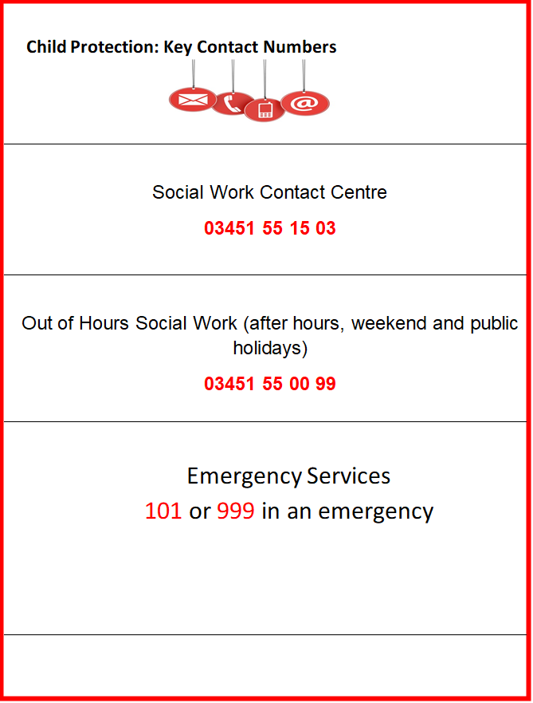



Completion of the emodule **CPC Child Protection and GIRFEC** is mandatory for all new staff.

The emodule can be accessed through ORACLE, which is accessible by clicking on the waffle in the top left of Office 365 as shown below.

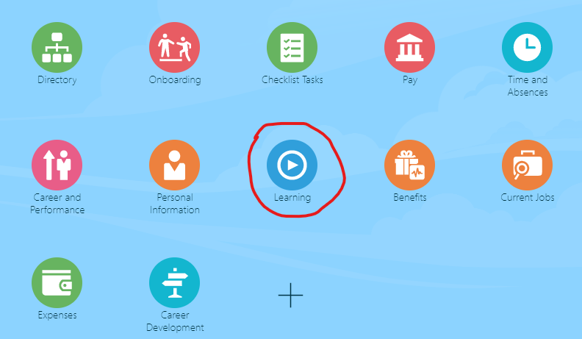

Link to module: <https://ekmu.fa.em3.oraclecloud.com:443/hcmUI/faces/deeplink?objType=WLF_LEARN_LEARNING_ITEM&action=NONE&objKey=learningItemId%3D300001145864372>

**Once you have completed the module please take a screenshot append to the Induction Learning checklist overleaf. This will also appear in your ORACLE learning log.**

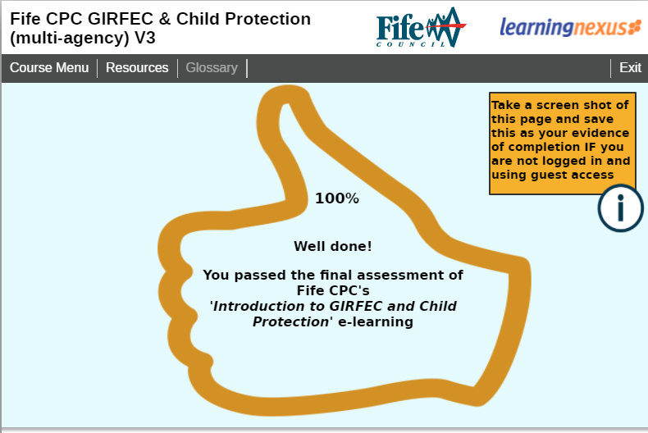

**My School’s Safeguarding and Child Protection Induction:**

**What have I learnt?**

Now that you have undertaken your child protection and safeguarding induction you should be able to answer the following questions:

1. In addition to this induction booklet, what policy and guidance documents should you also familiarise yourself with to help you to know what your role and responsibilities are and what to do if you have concerns about a child or young person?

______________________________________________________

______________________________________________________

______________________________________________________

______________________________________________________

1. Who is your Child Protection Co-ordinator who all concerns should be reported to?

CP Co-ordinator: ____________________________________________

What are their contact details (VOIP/email)?

Contact details: ________________________________________

Who is the depute / alternative person to contact if they are not available?

Depute CP Co-ordinator: __________________________________

What are their contact details (VOIP/email)?

Contact details__________________________________

1. Where can you find your school’s Child Protection and Safeguarding Policy?

­­­­­­­­­­­­­­_______________________________________________________________

_______________________________________________________________

1. What is Prevent?

_______________________________________________________________

1. What are the four ‘R’s’ all school staff should remember when responding to concerns?

__________________ __________________ _________________

1. What should you not do when a child/young person discloses something to you?

_______________________________________________________________

_______________________________________________________________

1. What agencies make up the 3 Core Agencies?

________________________________________________________________________

1. What action must you take if an allegation concerning the behaviour of one of your colleagues towards a child is made to you?

_____________________________________________________________

_____________________________________________________________

|  |  |
| --- | --- |
| Full Name (in print) |  |
| Role |  |
| Signature |  |
| Date  Completed |  |

**Once completed hand a copy to your Child Protection Co-ordinator to be kept with your training records. CPC to counter sign and date.**

|  |  |
| --- | --- |
| Full Name of CPC |  |
| Role | Child Protection Coordinator |
| Emodule evidence attached (tick) |  |
| Signature |  |
| Date  Completed |  |

**This sheet should be stored with the CP Training log and information should be updated to show this in your training log.**