Balcurvie Primary School

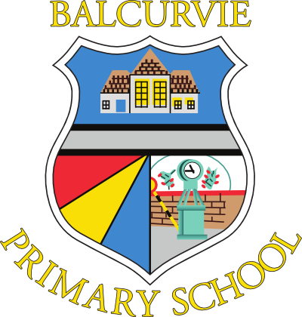

Care & Welfare Child Protection Policy
“Child protection is everyone’s job….…it’s our job”
www.fifechildprotection.org.uk

“The starting point for learning is a positive ethos and climate of respect and trust based upon shared values across the school community, including parents, whether for young people in school or those not in school.”
Curriculum for Excellence: Building the Curriculum 3 (2008)

Care and Welfare ~ Child Protection Policy

Our Ethos
At Balcurvie Primary School, we strive to promote a positive climate where all children can thrive, where they feel safe and secure and where there is a climate of mutual trust and respect which encourages learners, staff and parents/carers to safely express their concerns.

Rationale
The current laws and practices in Child Protection are underpinned by articles from the United Nations Convention on the Rights of the Child, ratified by the UK Government in 1991.
These principles, together with the values and principles of the Getting it Right for Every Child (GIRFEC) agenda, underpin the work and scope for effective Child Protection.
The philosophy of GIRFEC (Scottish Government) seeks to improve the wellbeing of all children and families.
Wellbeing is characterised by 8 indicators;
Safe, Healthy, Active, Nurtured, Achieving, Respected, Responsible and Included (SHANARRI)
Balcurvie Primary School’s Care & Welfare Child Protection Policy is underpinned by Fife’s Care & Welfare Child Protection Policy and Guidance: Standard Circular CWG1 & Child Protection Inter-Disciplinary Guidance (2011).
Scottish Government documents which have informed the development of policy include Protecting Children and Young People - Framework for Standards (2005), Safe and Well (2005), and How Well do we Protect Children and Meet their Needs? (HMIe 2009).

Balcurvie’s responsibilities:
- All staff will adhere to the Fife Council Child Protection policy and are clear about procedures. Contact telephone numbers are available to all staff ~ in the school office, on the child protection notice board in the staffroom and stored on the Allstaff file on the server.

- All documentation is stored in the head teacher’s office and available to any member of staff. Information is also available through the staff notice board.

- Staff have access to the multi-agency and Education Service Child Protection guidelines and appropriate training. School management team will identify and respond to all staff training needs including those of support and ancillary staff. In-house staff updates will be carried out annually or in response to changes in National or Local Authority guidance, policy & practice.

- We will recognise the emotional impact on staff of being involved in a child protection investigation and allow time for support to be given.

- School will identify a designated Child Protection Co-ordinator and a Depute Co-ordinator, one of whom may be a member of the school management team.

Mrs Tracey McDougall (HT) is the Child Protection Co-ordinator at Balcurvie.
Mrs A Wakefield (Teacher) is the Depute Child Protection Co-ordinator.

- We will recognise the time commitment required to carry out the duties of CP Co-ordinator effectively and allow time for the tasks to be undertaken and for regular update meetings. We will endeavour to share good practice and seek support from other co-ordinators.

- All staff have the right and responsibility as an individual to report abuse to Social Work or Family Protection Unit (Public Protection Unit).

- Through our Health and Well-being curriculum, we will strive to equip our pupils with knowledge, skills and understanding to keep themselves and others safe. This will include guidance on drugs, alcohol, bullying and responsible internet use.

- We will monitor, develop and evaluate child protection procedures through regular self-evaluation of school’s practice

- We will liaise with the School Nurse Team on issues of child protection and where appropriate, alert and involve them.

Fiona Crook – Team Leader – Glenrothes & Northeast Fife, Fife-uhb.grothesschoolnurseteam@nhs.net

- We will store all Care and Welfare documentation in a secure place, making sure when children move school and at times of transition, there is a continuation of care and support through liaison with CP co-ordinators at receiving schools.

