Researching Chemistry
Antioxidants
Investigation B
Name:
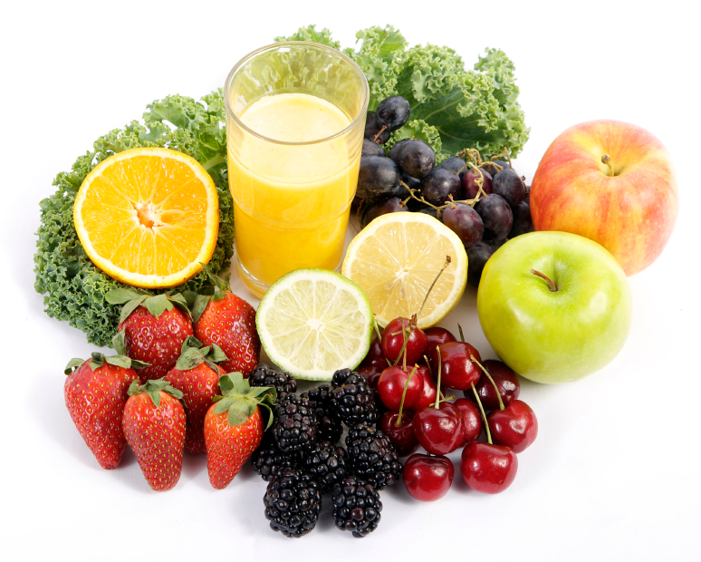
Candidate Number:

This log book will be used to complete and provide evidence for your researching chemistry unit. The information you gather will be used to produce your final assignment report which is worth 20 marks of your final exam. It must be kept safe and must be retained by the school as SQA evidence.

Investigation B

Which tea contains the most antioxidants?

Introduction

Many of the oxidation reactions that occur in the human body are harmful and can lead to disease. It is believed that antioxidants (chemicals that can help prevent oxidation) help to keep the body healthy and even treat disease. Examples of antioxidants include vitamins A, C and E as well as the hormone melatonin.

Food manufacturers are keen to advertise the presence of antioxidants in their products in the hope that the potential health benefits will lead to an increase in sales. In addition, there is a lucrative market in antioxidant supplements sold to promote good health. Medical scientists continue to investigate how beneficial antioxidants really are and what effects they can have on the human body.

Your task in this investigation is to find out which of a variety of teas contains the most antioxidants.

Background research

The first stage of carrying out research in chemistry is to review what is already known about the topic of interest. Chemists use books, scientific papers, journals and the internet to carry out background research.
Your first task in the Researching Chemistry unit is to independently carry out background research into one of the focus questions listed below, which will be assigned to you by your teacher. In school it is likely that you will carry out your background research on the internet.

Once you have completed your background research, you must then complete the unit assessment tasks and store your research evidence in a safe place.

Outcome 1: Research stage
Assessment tasks

- Record at least two sources of information relevant to your focus question. Sufficient detail should be given to allow someone else to find your sources easily. For a website, the URL shown here is perfectly adequate: http://www.biodieselfillingstations.co.uk/.

- Write a brief summary of the information of relevance contained in each of the sources you have identified.

Focus Question | Researcher | Teacher Signature
B1

B2

B3

B4

B5

B6

Focus Questions
B1 Is there any evidence to suggest that drinking tea leads to better health?

Source 1:
Source2:
Evaluation of research:
Why are the sources you used robust, reliable and valid to your investigation?

B2 Why do different types of tea contain different concentrations of antioxidants?

Source 1:
Source2:

Evaluation of research:
Why are the sources you used robust, reliable and valid to your investigation?

B3 Tea contains many compounds such as caffeine. What effects does caffeine have on the human body?

Source 1:
Source2:
Evaluation of research:
Why are the sources you used robust, reliable and valid to your investigation?

B4 Teas and other drinks, such as wines, contain compounds known as tannins. What are tannins?

Source 1:
Source2:

Evaluation of research:
Why are the sources you used robust, reliable and valid to your investigation?

B5 How can tea affect the body’s ability to absorb iron?

Source 1:
Source2:

Evaluation of research:
Why are the sources you used robust, reliable and valid to your investigation?

B6 Green tea is recognised to be very beneficial to health. Describe the health benefits of drinking green tea.

Source 1:
Source2:
Evaluation of research:
Why are the sources you used robust, reliable and valid to your investigation?

Outcome 2 / Outcome 3: Planning, carrying out and writing up experiment
Using the Student Guide, plan how you would carry out your experiment.
Aim:

Apparatus:

Procedure:

Safety:

Results (in an appropriate format):

Analyse your results:
This might include:
- Correctly executed calculations (e.g. average, relative rate)
- Comparison of values with those in the literature
- Experimental observations

Conclusion:

Evaluation of results and procedure:

Learner guide Higher Chemistry Assignment
Read all of this guide before you begin
There are 20 marks in total for this assignment. The assignment should be approximately 800 - 1500 words. You only get one chance at this. No redrafts are allowed.

Heading |  | Tick
Aim | To investigate..
Applying knowledge and understanding of chemistry | Here you should explain how the underlying chemistry relates to your topic.  This might include:  a statement of the chemical principles involved, formulae, chemical equations, calculations, chemical properties related to the bonding present.
Sources: Use at least two sources. Use your experimental data from your researching unit as your first source.

Experimental source and safety | You must include the title, the aim, the results and any safety precautions you took.
Source relevance | Give your sources, for each you must include:  - Where did you get it / who wrote it?  - Why did you choose it?  - Why do you think it is a reliable and valid source?
For each source | Include a relevant piece of information.  e.g.  - A table or results  - A graph  - A diagram  - Some text
Convert this into ONE other form
(ONE OF YOUR SOURCES OF INFORMATION MUST BE CONVERTED INTO A GRAPH, DIAGRAM, CHART OR TABLE)

e.g.
- a line graph (axes, scale, labels, plotting, units)
- a bar chart (axes, scale, labels, plotting, units)
- a table (lines, headings, units)
- do a calculation (show working, units)
- summarise a passage
- diagram (labels)
Double check! | Have you labelled your charts and tables correctly?
Analyse the data / information from both of your sources | Can you carry out any further calculations from your data?  Can you identify or describe any relationships from your information?  Have you compared the information from both sources?  Have they a similar or different perspective (do they agree or disagree with each other)
Conclusion | Write an overall conclusion on your entire report. This must relate to your aim and be supported by your gathered evidence.
Evaluation | This should include an evaluation of your individual sources and an evaluation of the investigation as a whole.  You may include for example:  - significance/interpretation of findings  - validity of sources  - reliability of data/information  - Evaluation of experimental procedure:  - accuracy  - adequacy of repetition  - adequacy of range of variables  - control of variables  - limitations of equipment  - reliability of methods  - sources of errors, uncertainties
References | Ensure you have included your references with enough detail to allow someone else to find it.  e.g. URLs; Book title, author, page
 | Final checks…have you…
 | Have you used headings and listed your references correctly?
 | Is your report easy to read and understand?

